Dinosaurs Stone Age Ancient Egypt Ancient Greece Romans Celts
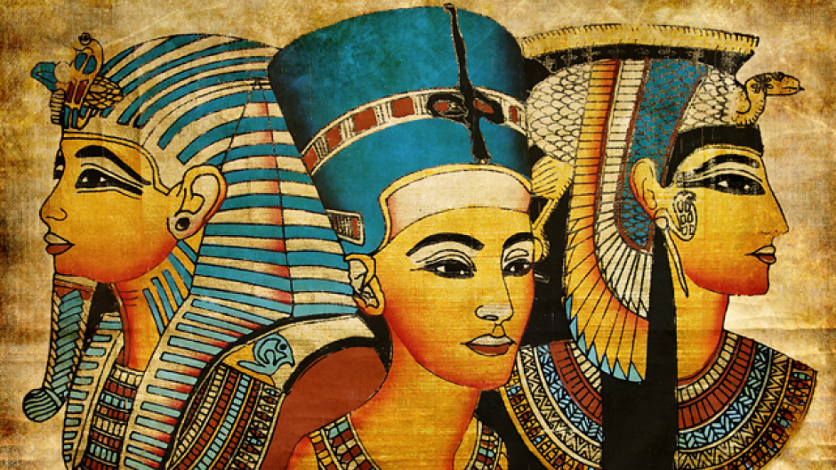
0 Jesus is born
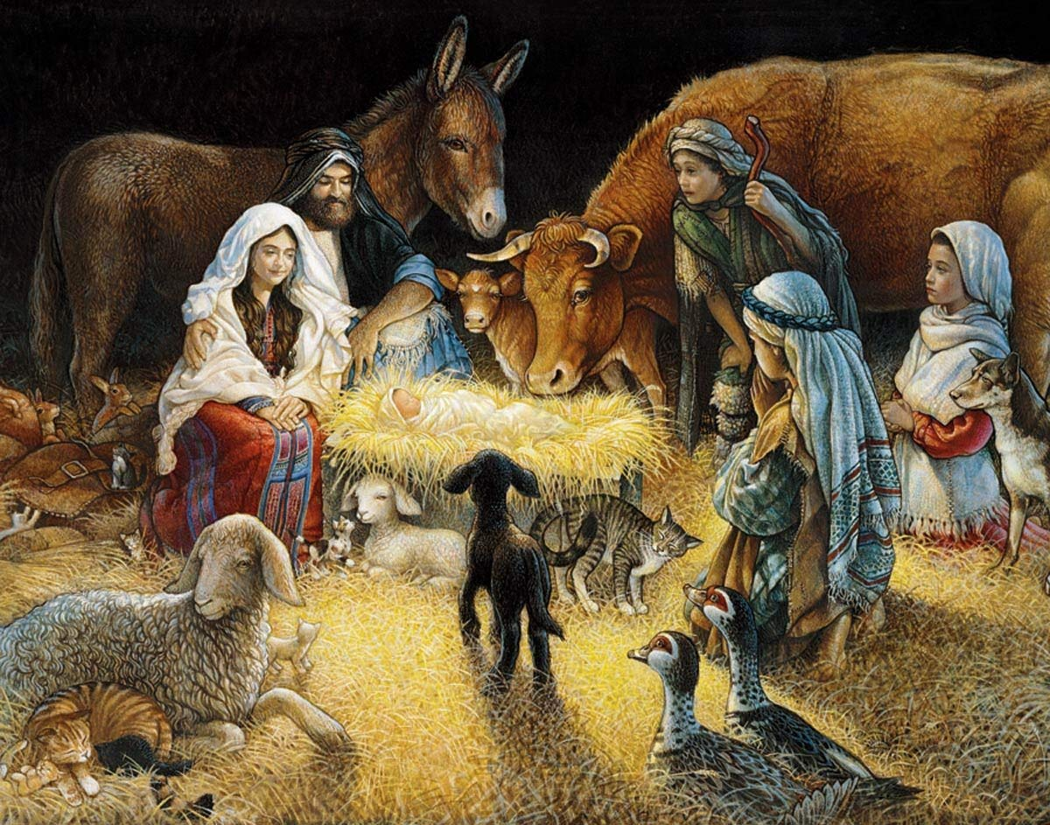
600 BC – 50AD
600BC – 476AD
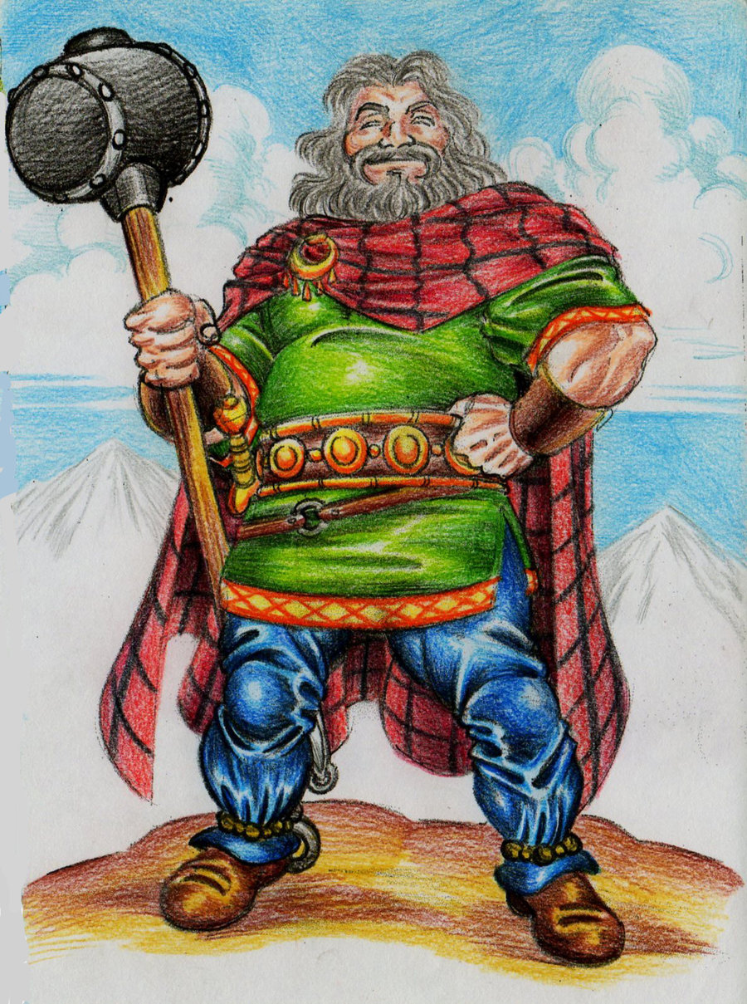


800 BC – 146 BC
4500 BC – 332 BC
200,000 years ago -6,000 years ago

245 Million years ago -
65 Million years ago
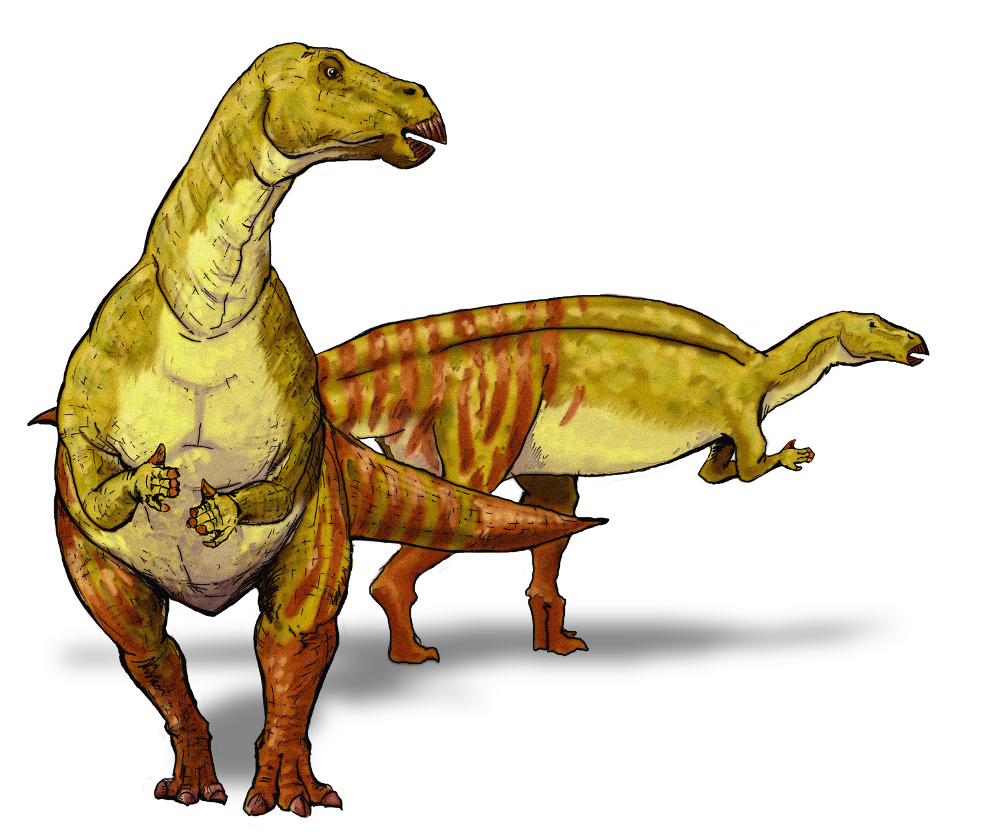

BC means before the birth of Jesus – AD means after the birth of Jesus
This Photo by Unknown Author is licensed under CC BY-SA

Great Fire of London
Normans Tudors Victorians WW I WWII Present Day
Anglo Saxons Vikings






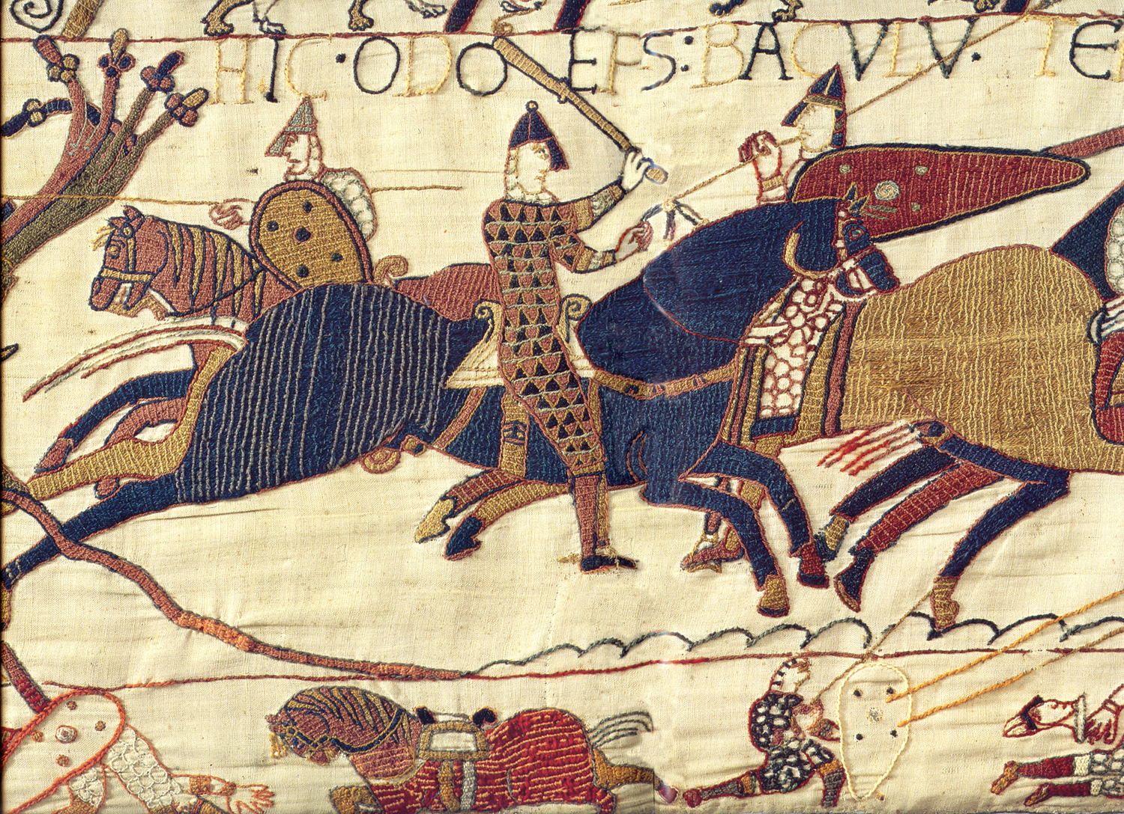
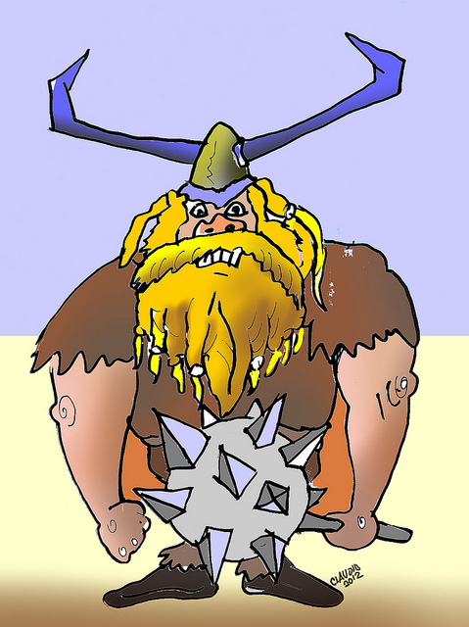
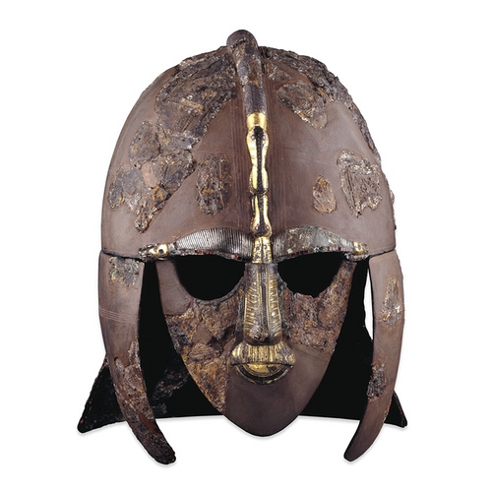


1666
410 -1066
750 - 1060
1066
1485 - 1603
1837 -1901
1914 - 1918

1939 -1945

