
Cluster 1: Making meaning of our lives: These poems explore the concept of personal identity and the experiences in life that shape who we are.
Cluster 2: Connecting with the lives of others: These poems consider human connection through family generations, place and society.
Cluster 3: Living in the World: These poems relate to mankind’s place on the earth, its connection to nature and topical issues for our planet and environment

Assessment points are highlighted in blue
Writing skills connected to AQA Mark Scheme in purple

Week | Learning Objective | Cluster & Big Ideas | Poem and Big Ideas | Homework
1 | To understand how childhood experiences give lasting meaning to our lives | Cluster 1: Making meaning of our lives  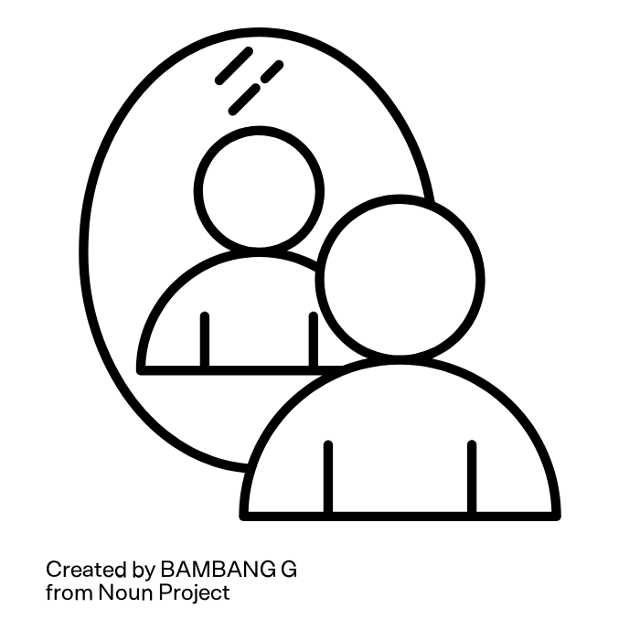  Big Ideas:  Belonging  Identity and work  The past and present  Family and self  Sense of purpose | Thirteen, Caleb Femi, p.20  Little Ideas: identity, race, culture, childhood & past, expectations & reality.  - Hook: Watch Caleb Femi “coping” on Youtube  - Ensure context sheets are explored and stuck in books  - Teach Poem through top 3 quotations and exploration of the title.  - Writing Skill: AO1: List 3 messages that Femi conveys, using critical language | Homework Summary Sheet  and/or  Essential Prep: research & create a storyboard for Malala Yousafzai’s life
2 | To explore the importance of having control and autonomy over our own lives |  | A Century Later, Imtiaz Dharker, p.14  Little Ideas: sense of belonging, identity, cultural shifts, childhood, education  - Hook: Watch Malala’s story on Youtube and read Wilfred Owen Anthem for Doomed Youth  - Ensure context sheets are explored and stuck in books  - Teach Poem through top 3 quotations and exploration of the title.  - Writing Skill: AO1: compare the ideas in Thirteen and A Century Later by using Venn diagram. From this, practise writing some comparative ‘topic sentences’. | Homework Summary Sheet  and/or  Topic sentence practise for 5 new questions
3 | To explore how cultural connection creates elements of our identity |  | Name Journeys, Raman Mundair, p.9  Little Ideas: identity formation, cultural shifts, language, ethnicity, belonging  - Hook: Explore religious references Rama & Sita story  - Ensure context sheets are explored and stuck in books  - Teach Poem through top 3 quotations and exploration of the title.  - Assessment: How does Raman Mundair present the relationship between language and identity in her poem? | Homework Summary Sheet  and/or  Practise paragraph comparing injustice in Thirteen & A Century Later
4 | To explore how ancestry helps us understand ourselves |  | Homing, Liz Berry, p.13  Little Ideas: social mobility, identity, language, family and generations, culture and belonging  - Hook: Exploring homing pigeons and regional accents  - Ensure context sheets are explored and stuck in books  - Teach Poem through top 3 quotations and exploration of the title.  - Writing Skill: AO2: how to write about and analyse importance of sound in poetry and Berry’s use of phonetic dialect | Homework Summary Sheet  and/or  Complete a fact file/ research task on the Peterloo Massacre and its impact.
5 | To understand the self-destruction of mankind |  | England, Percy Bysshe Shelley, p.5  Little Ideas: self-destruction, authority & power, social injustice, purpose of lives, belonging  - Hook: explore a known revolution or Peterloo Massacre and compare to modern revolutions  - Ensure context sheets are explored and stuck in books  - Teach Poem through top 3 quotations and exploration of the title.  - Assessment: How do the poets present ideas about having power over your own life in England 1819 and one other poem you have studied? | Homework Summary Sheet  and/or  Complete Cluster 1 Revision Table
 |  |  | Holidays
1 | To explore the interconnectedness of lives through art | Cluster 2: Connecting with the lives of others  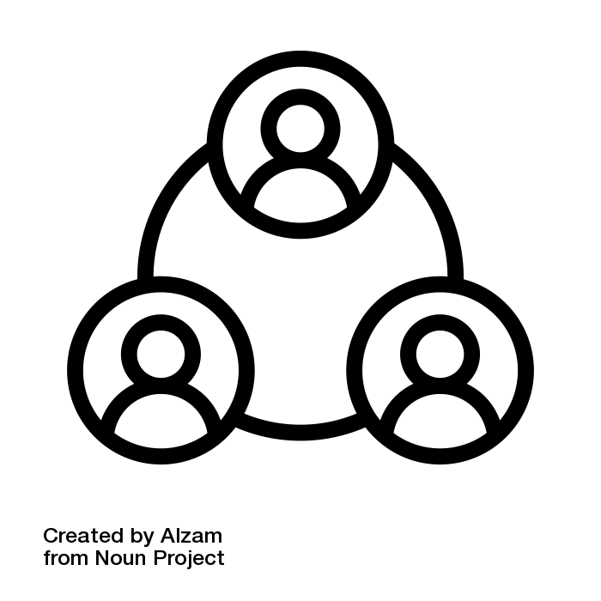  Big Ideas:  Interconnectedness  Communication  Multiculturalism  Relationships  Isolation  Community  Family  Material objects | The Jewellery Maker, Louisa Adjoa Parker, p.15  Little Ideas: materialism, generations and family, relationships, community, interconnectedness  - Hook: watch jewellery being made on Youtube & discuss the soft skills involved  - Ensure context sheets are explored and stuck in books  - Teach Poem through top 3 quotations and exploration of the title.  - Writing Skill: AO2: How to identify poetic structural methods and how to write about them in essays | Homework Summary Sheet  and/or  Imitate Parker’s poem to write your own that celebrates a different type of craft or art
2 | To understand the importance of feeling connected to the past |  | A Wider View, Seni Seneviratne, p.12  Little Ideas: generations and family, connections to the past, interconnectedness, community, isolation  - Hook: get students to select the top 5 things in their local area that give it its identity and/or that have been around for at least 3 generations  - Ensure context sheets are explored and stuck in books  - Teach Poem through top 3 quotations and exploration of the title.  - Writing Skill: how to write comparative thesis statements using comparative connectives e.g. Whilst/ Whereas/ However | Homework Summary Sheet  and/or  Create a character profile of someone in your family who moved places (home or work) and why
3 | To comment on cultural shifts and its impact on others |  | pot, Shamshad Khan, p.11  Little Ideas: belonging, cultural shifts, identity, colonialism, loneliness, (mis)representation  - Hook: Read Macron Report on return of colonial-era objects  - Ensure context sheets are explored and stuck in books  - Teach Poem through top 3 quotations and exploration of the title.  - Assessment: How do the poets present the way that objects carry meaning in pot and The Jewellery Maker? | Homework Summary Sheet  and/or  Research the Windrush generation ahead of next week’s poem
4 | To explore the impact of ignorance and miscommunicati between humans |  | On an Afternoon Train from Purley to Victoria, 1955, James Berry, p.8  Little Ideas: race, communication, connection, misunderstanding, ignorance, identity  - Hook: Windrush generation fact file/ Youtube  - Ensure context sheets are explored and stuck in books  - Teach Poem through top 3 quotations and exploration of the title.  - Writing Skill: AO3: how to subtly embed contextual and authorial intentions and big ideas into analytical paragraphs | Homework Summary Sheet  and/or  Practise paragraph ahead of assessment next week
5 | To understand how disconnection can cause isolation and loneliness |  | In a London Drawingroom, George Eliot, p.7  Little Ideas: isolation, places, environment, interconnectedness, loneliness, divides in humanity  - Hook: images of drawing rooms in Victorian society: discuss purpose/ class  - Ensure context sheets are explored and stuck in books  - Teach Poem through top 3 quotations and exploration of the title.  - Assessment: How do the poets present ideas about human connection in On an Afternoon Train and one other poem you have studied. | Homework Summary Sheet  and/or  Complete Cluster 2 Revision Table
 |  |  | Holidays
1 | To understand that there are many different ways to interact with the world around us | Cluster 3: Living in the World  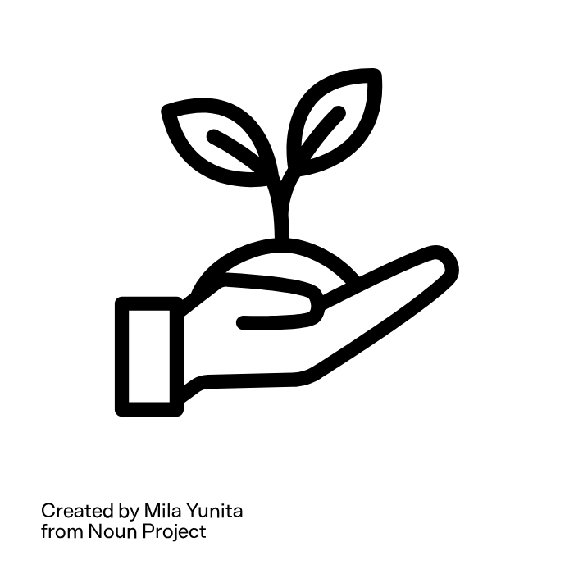  Big Ideas:  Our environments  Man and nature  Solace of nature  Isolation  Mindfulness  Places and home | With birds you’re never lonely, Raymond Antrobus, p.16  Little Ideas: the modern world, man’s care for nature, communication and connection, spirituality, harmony, belonging and family, growth, experience. Hook:  - Hook: sounds of the day; watch Antrobus’s Youtube ‘Dear Hearing World’  - Ensure context sheets are explored and stuck in books  - Teach Poem through top 3 quotations and exploration of the title.  - Writing Skill: development of topic sentences that contain the why: using AO3 within topic sentences | Homework Summary Sheet  and/or  Essential Prep: fact file on the Romantics
2 | To explore Romantic ideas about human's relationship with nature |  | Lines Written in Early Spring, William Wordsworth, p.4  Little Ideas: spirituality & faith, religion, peace, mental health, enlightenment, nature of mankind, conflict  - Hook: explore selection of Romantic paintings- find commonalities  - Ensure context sheets are explored and stuck in books  - Teach Poem through top 3 quotations and exploration of the title.  - Writing Skill: how to better structure paragraphs: writing about both poems within the paragraph and developing an ‘integrated’ comparative approach | Homework Summary Sheet  and/or  Complete Venn Diagram comparing Antrobus and Wordsworth’s feelings towards nature
3 | To explore nature as a source of comfort and inspiration |  | Shall Earth No More Inspire, Emily Bronte, p.6  Little Ideas: rebellion, solitude, loneliness, beauty, heaven & earth, religion, women’s voices, mother nature, mental health  - Hook: match-up of Old English words to current (thee/ thine/ thou/ thy) with focus on direct address in poetry  - Ensure context sheets are explored and stuck in books  - Teach Poem through top 3 quotations and exploration of the title.  - Assessment: How do the poets present the connection between places and mindfulness in Shall Earth No More Inspire Thee and With Birds You’re Never Lonely? | Homework Summary Sheet  and/or  Essential Prep: pre-read and annotate your own thoughts and ideas onto Portable Paradise
4 | To analyse the importance of places and home |  | Portable Paradise, Roger Robinson, p.18  Little Ideas: sense of belonging, places, the environment, family, nature, travel, migration, identity  - Hook: discussion of travel, nostalgia and homesickness: science behind homesickness  - Ensure context sheets are explored and stuck in books  - Teach Poem through top 3 quotations and exploration of the title.  - Writing Skill: How to decide on which poem to use for comparison and how to quickly and efficiently plan for essays | Homework Summary Sheet  and/or  Essential Prep: pre-read and annotate your own thoughts and ideas onto Like an Heiress
5 | To explore a pessimistic perspective of the future of our world |  | Like an Heiress, Grace Nichols, p.19§§§§§§§  Little Ideas: sense of belonging, places, the environment, sustainability, generations, migration, identity, home  - Hook: images of polluted beaches on small islands (e.g. Guyana). Pollution statistics.  - Ensure context sheets are explored and stuck in books  - Teach Poem through top 3 quotations and exploration of the title.  - Assessment: How do the writers present the relationship between humans and nature in Portable Paradise and Like an Heiress? | Homework Summary Sheet  and/or  Complete Cluster 3 Revision Table

