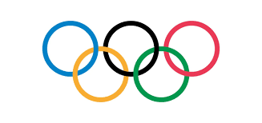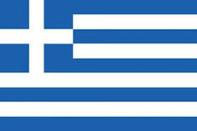
Greece and The Olympics

K  What I already know | W  What I would like to learn | L  What I have learned

