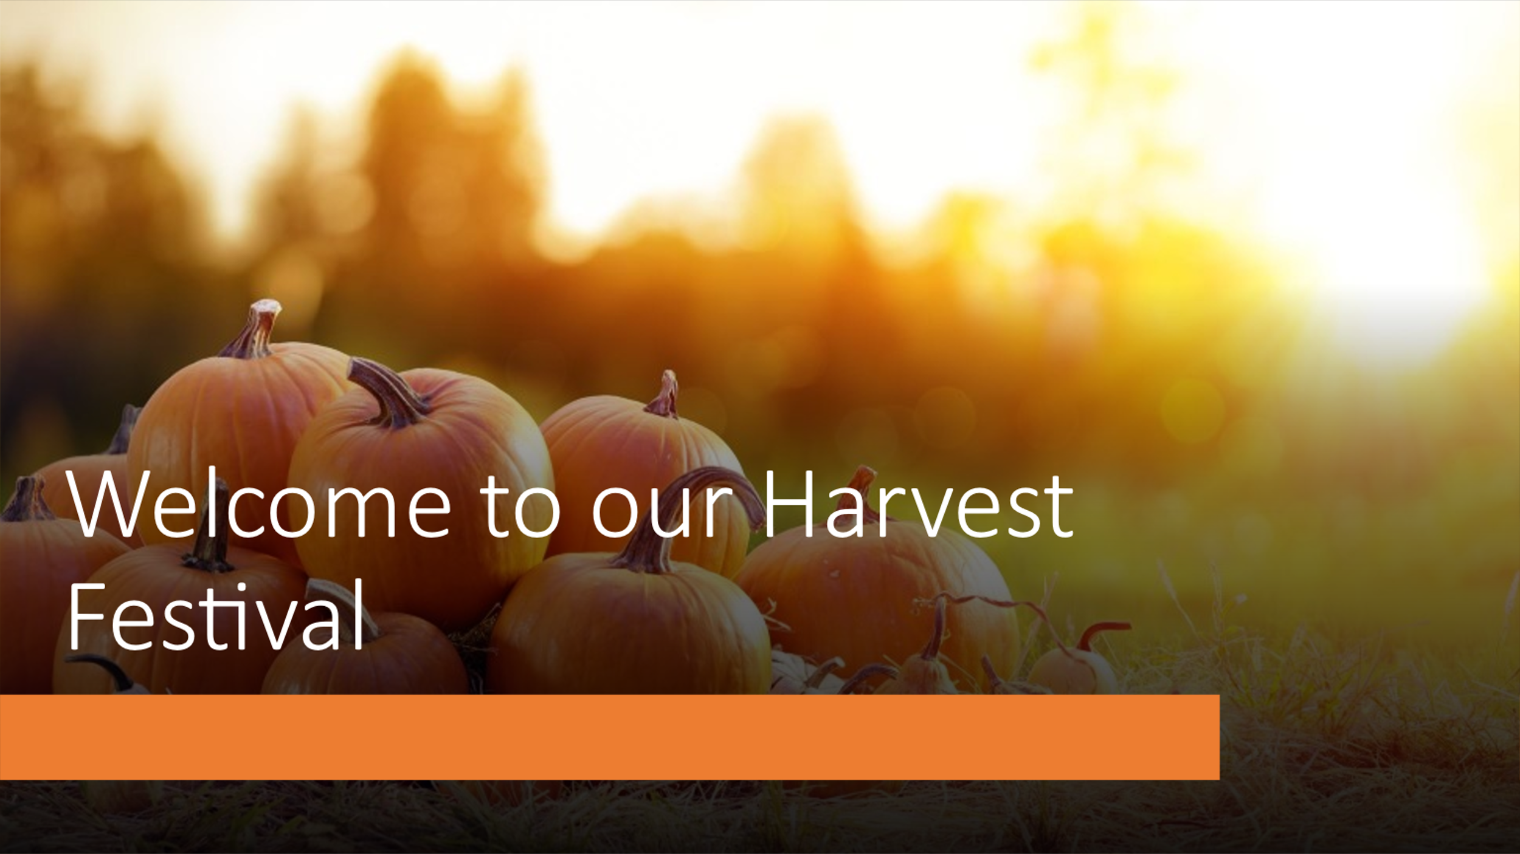
By Rita
Harvest Festival Assembly/Act of Worship resources for Primary schools

