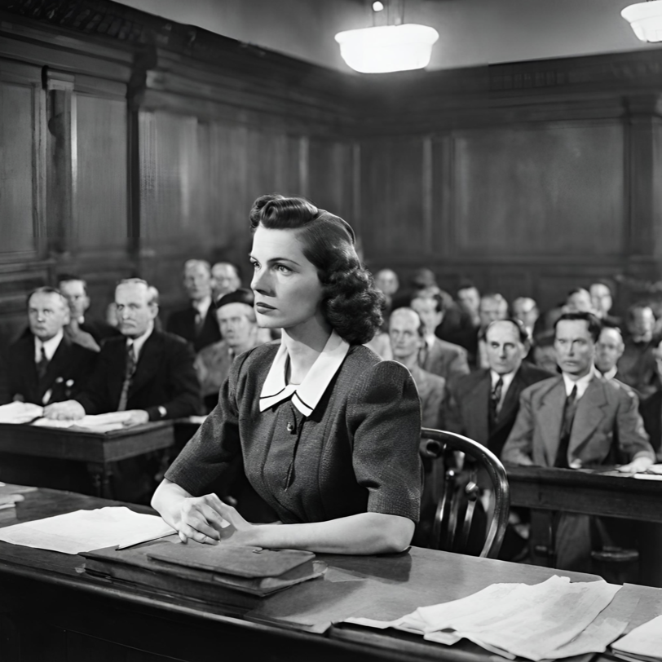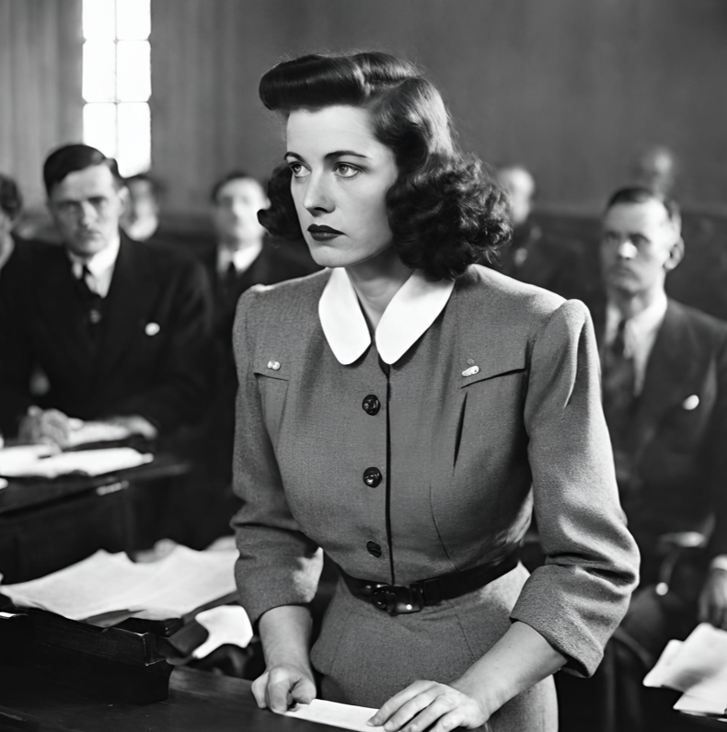

Author / “Publisher”

[Date]

This week, [Name of teacher] at [Name of school], awarded his/her English students with honorary journalism titles for their coverage of Hanna Schmitz, a former Nazi on trial for her role in the deaths of hundreds of Jewish women during the war. For their assignment, students are asked to cover the full timeline of Schmitz’s courtroom drama as it plays out in Bernhard Schlink’s *The Reader*, from the initial proceedings to the final verdict. Students are required to communicate the story in the form of a traditional news article, covering all the basics of the events. Students must comprehensively and creatively answer the questions of who, what, why, where, when, and how? Their articles should showcase proper depth, and cover Frau Schmitz’s case from multiple angles. Students will showcase their knowledge of independent research and reporting by reading examples of newspaper articles, outlining their content, and researching ways to structure ideas to build their story. [Name of teacher] said that he/she was “excited” to give students this opportunity.

# STUDENTS AWARDED JOURNALISM TITLES

# FOR COVERAGE OF FRAU SCHMITZ’S COURT DRAMA

**INTRODUCTION + OPENING QUOTATION:** Facts and figures that will ground the story, including who, what, why, where, when, and how? Answers to these questions must be provided in the opening sentences of the article.

**MAIN BODY + EXPLANATION:** This is the heart of your story. You must decide which other facts and details your reader would like to know. You must make sure you have enough information to answer important questions that a reader would normally have after reading.

**HEADLINE:** A short, attention-grabbing statement about an event (see above).

**BYLINE:** This tells who wrote the story.

### Features of an article

**CLOSING QUOTATION AND CONCLUSION:** Find a quote or closing statement that ends the article in a memorable way. Giving a quote at the end of an article can help round out the story, and sometimes tilt the narrative in the interviewees favor.

**ADDITIONAL INFORMATION:** Be sure to include outside information about a similar story or event to provide readers with a broader frame of reference.

Go over your drafts with your teacher. Make sure to check for spelling and punctuation errors. Read your article aloud to help you catch any awkward or repetitive phrases or sentences that don’t sound right. Once you have polished your article, elect a classmate to help you edit prior to final submission.

Read newspaper articles about murder and war trials for context and comprehension. Be sure to tell your story in a similar fashion. Try to gather at least two quotes from the text.

Your first version of an article is you’re your first draft. This does not mean your article is finished.

Jot down notes to gather ideas for your outline (people, topics, related vocabulary, etc.). Create a Google Doc and share it with your teacher for shared access/assessment.

Research and read sample newspaper articles. Observe introductions (lead sentences), opening quotations, body structure of the articles, closing quotations and conclusions.

Remember: Not ALL elements named above may be present in every news article you read.

**The Herald**

### CONDUCTING RESEARCH