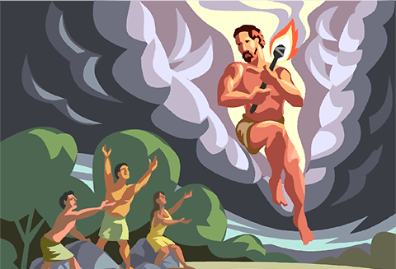
Myths & Legends Booklet

Name: ……………………………….

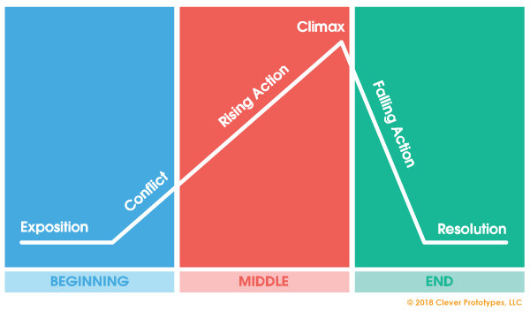
The Narrative Arc

- Exposition:
This is the reader’s introduction to the story. The exposition offers background information to prime the audience for the rest of the story, including introducing the main character(s) (the “who”), setting (the “where”), and circumstances or time period (the “when”).

- Rising action:
This is when conflict begins to ramp up. The rising action usually begins with what’s called an “inciting incident”—the triggering event that puts the main events of the story in motion. This is when the audience starts to see what your story is really about.

- Climax:
This is the highest point of tension in your storyline, and often the point at which all the different subplots and characters converge. Typically, the climax requires the main character to face the truth or make an important choice.

- Falling action:
This is what happens as a result of the protagonist’s decision. During the falling action, the conflict gives way to resolution. Loose ends are tied up, and tension begins to dissipate.

- Resolution:
Also known as a denouement, this is how your story ends. The resolution of a narrative arc isn’t always happy, but it does close the loop and show how the events of the story have changed the characters and the world around them.

The Hero’s Journey

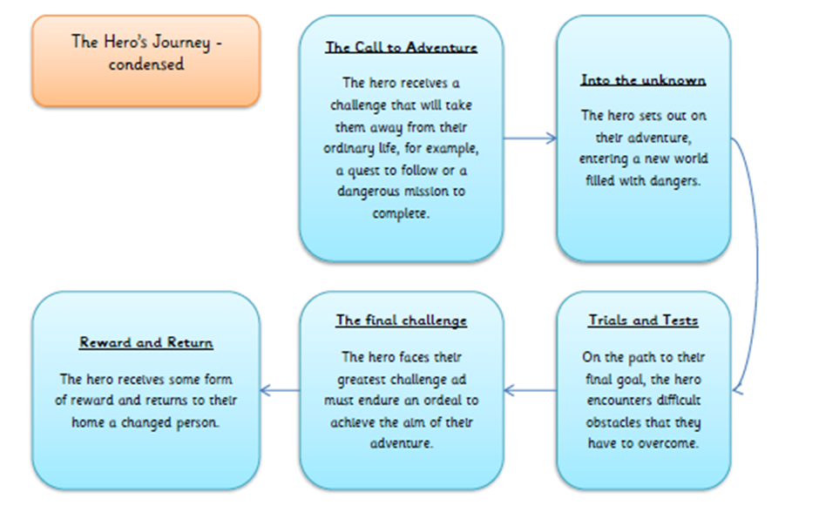

Resource 1: The Story of Creation

These days the origin of the universe is explained by proposing a Big Bang, a single event that instantly brought into being all the matter from which everything and everyone is made.
The ancient Greeks had a different idea. They said that it all started not with a bang, but with CHAOS.
Was Chaos a god – a divine being – or simply a state of nothing ness? Or was Chaos, just as we would use the word today, a kind of terrible mess, like a teenager’s bedroom only worse?
Think of Chaos perhaps as a kind of grand cosmic yawn. As in yawning chasm or yawning void.
Whether Chaos brought life and substance out of nothing or whether Chaos yawned life up or dreamed it up, or conjured it up in some other way I don’t know. I wasn’t there. Nor were you. And yet in a way we were, because all the bits that make us were there. It is enough to say that the Greeks thought it was Chaos who, with a massive heave, or a great shrug, or hiccup, vomit or cough, began the long chain of creation that has ended with pelicans and penicillin and toad-stools and toads, sea-lions, seals, lions, human beings and daffodils and murder and art and love and confusion and death and madness and biscuits.
Whatever the truth, from formless Chaos sprang two creations: EREBUS and NYX. Erebus, he was darkness, and Nyx, she was night. The coupled at once and the flashing fruits of their union were HEMERA, day, and AETHER, light.
At the same time – because everything must happen simultaneously until Time is there to separate events – Chaos brought forth two more entities: GAIA, the earth, and TARTARUS, the depths and caves beneath the earth.
I can guess what you might be thinking. These creations sound charming enough – Day, Night, Light, Depths and Caves. But these were not gods and goddesses, they were not even personalities. And it may have truck you also that since there was no time there could be no dramatic narrative, no stories, for stories depend on Once Upon a Time and What happened Next.
You would be right to think this. What first emerged from Chaos were primal, elemental principles that were devoid of any real colour, characters or interest. These were the PRIMORDIAL DEITIES, the First Order of divine beings from whom all the gods, heroes and monsters of Greek myth spring. The brooded over and lay beneath everything… waiting.
The silent emptiness of this world was filled when Gaia bore two sons all on her own. The first was PONTUS, the sea, and the second was OURANDOS, the sky – better known to us as Uranus, the sound of whose name has ever been the cause of great delight to children from nine to ninety. Hemera and Aether bred too and from their union came THALASSA, the female counterpart of PONTUS the sea.
Ouranos, who preferred to pronounce himself as Ooranoss, was the sky and the heavens in the way that – at the very beginning – the primordial deities always were the things they represented and rules over. You could say that Gaia was the earth of hills, valleys, caves and mountains yet capable of gathering herself into a form that could walk and talk. The clouds of Ouranos the sky rolled and seethed above her but they too could coalesce into a shape that we might recognise. It was so early on in the life of everything. Very little was settled.
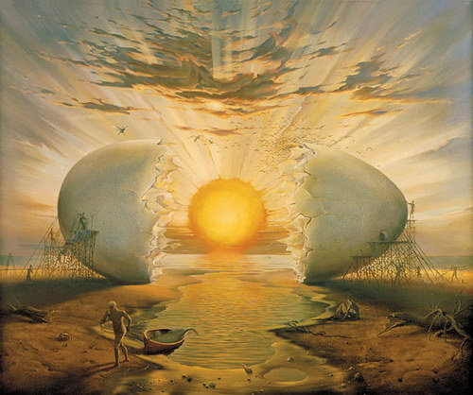

Resource 2: Icarus and The Sun

The king of Crete was ruled by King Minos, whose reputation for wickedness had spread to every shore. One day he summoned to his country a famous inventor named Daedalus.
“Come Daedalus, and bring your son, Icarus too. I have a job for you, and I pay well.”
King Minos wanted Daedalus to build him a palace, with soaring towers and a high, curved roof. In the cellars there was to be a maze of many corridors – so twisting and dark that any man who once ventured in there would never find his way out again. “What is it for?” asked Daedalus. “Is it a treasure vault? Is it a prison to hold criminals?” But Minos only replied, “Build my labyrinth as I told you. I ask you to build, not to ask questions.”
So Daedalus held his tongue and set to work. When the palace was finished, he looked at it with pride, for there was nowhere in the world so fine. But when he found out the purpose of the maze in the basement, he shuddered with horror. For at the heart of the maze, King Minos put a beast – a thing too horrible to describe. He called it the Minotaur, and he fed it on men and women!
The Daedalus wanted to leave Crete at once, and forget both maze and Minotaur. So he went to King Minos to ask for his money.
“I regret,” said King Minos, “I cannot let you leave Crete, Daedalus. You are the only man who knows the secret of the maze and how to escape from it. The secret must never leave this island. So I’m afraid I must keep you and Icarus here a while longer.” “How much longer?” gasped Daedalus. “Oh just until you die,” replied Minos cheerfully. “But never mind. I have plenty of work for a man as clever as you.”
Daedalus and Icarus lived in great comfort in King Minos’ palace. But they lived the life of prisoners. Their rooms were in the tallest palace tower, with beautiful views across the island. They ate delectable food and wore expensive clothes. But at night the door of their fine apartment was locked, and a guard stood aside. It was a comfortable prison, but it was a prison even so. Daedalus was deeply unhappy.
Every day he put seed out on the window sill, for the birds. He liked to study their brilliant colours, the clever overlapping of their feathers, the way they soared on the sea wind. It comforted him to think that they at least were free to come and go. The birds had only to spread their wings and they could leave Crete behind them, whereas Daedalus and Icarus must stay for ever in their luxurious cage.
Young Icarus could not understand his father’s unhappiness. “But I like it here,” he said. “The king gives us gold and this tall tower to live in.” Daedalus groaned. “But to work for such a wicked man, Icarus! And to be prisoners all our days…We shan’t stay. We shan’t.” “But we can’t get away, can we!” said Icarus. “How can anybody escape from an island? Fly?” He snorted with laughter. Daedalus did not answer. He scratched his head and stared out of the window at the birds pecking seed on the sill.
From that day onwards, he got up early each morning and stood at the open window. When a bird came for the seed, Daedalus begged it to spare him one feather. Then each night, when everyone else had gone to bed, Daedalus worked by candlelight on his greatest invention of all.
Early mornings. Late nights. A whole year went by. Then one morning Icarus was woken by his father shaking his shoulder. “Get up, Icarus, and don’t make a sound. We are leaving Crete.” “But how? It’s impossible!” cried Icarus.
Daedalus pulled out a bundle from under his bed. “I’ve been making something, Icarus.” Inside were four great folded fans of feathers. He stretched them out on the bed. They were wings! “I sewed the feathers together with strands of wool from my blanket. Now hold still.”
Daedalus melted down a candle and daubed his son’s shoulders with sticky wax. “Yes, I know it’s hot, but it will cool soon.” While the wax was still soft, he stuck two of the wings to Icarus’ shoulder blades.
“Now you must help me put on my wings, Son. When the wax sets hard, you and I will fly away from here, as free as birds.” “I’m scared!” whispered Icarus as he stood on the narrow window ledge, his knees knocking and his huge wings drooping down behind. The lawns and courtyards of the palace lay far below. The royal guards looked as small as ants. “This won’t work.”
“Courage, son!” said Daedalus. “Keep your arms out wide and fly close to me. Above all – are you listening, Icarus.” “Y-y-yes, Father.” “Above all, don’t fly too close to the sun!” “Don’t fly too close to the sun,” Icarus repeated, with his eyes shut tight. Then he gave a cry as his father nudged him off the window sill.
He plunged downwards. With a crack, the feathers behind him filled with wind, and Icarus found himself flying. Flying! “I’m flying!” he crowed. The little guards looked up in astonishment, and wagged their swords and pointed and shouted, “Tell the king! Daedalus and Icarus are..are…flying away!”
By dipping first one wing and then the other, Icarus found that he could turn from left to right. The wind tugged at his hair. His legs trailed out behind him. He saw the fields and streams as he had never seen them before!
Then they were out over the sea. The seagulls pecked at him angrily, so Icarus flew higher, where they could not reach him. He copied their shrill cry and taunted them: “You can’t catch me!” “Now remember, don’t fly too high!” called Daedalus, but his words were drowned out by the screaming of the gulls. “I’m the first boy ever to fly! I’m making history! I shall be famous!” thought Icarus, as he flew up and up, higher and higher.
At last Icarus was looking the sun itself in the face. “Think you’re the highest thing in the sky, do you?” he jeered. “I can fly just as high as you!” Higher even!” He did not notice the drips of sweat on his forehead: he was so determined to out-fly the sun.
Soon its vast heat beat on his face and on his back and on the great wings stuck on with wax. The wax softened. The wax trickled. The wax dripped. One feather came unstuck. Then a plume of feathers fluttered slowly down.
Icarus stopped flapping his wings. His father’s words came back to him clearly now: “Don’t fly too close to the sun!” With a great sucking noise, the wax on his shoulders came unstuck. Icarus tried to catch hold of the wings, but they just folded up in his hands. He plunged down, his two fists full of feathers- down and down and down.
The clouds did not stop his fall. The seagulls did not catch him in their beaks. His own father could only watch as Icarus hurtled head first into the glittering sea and sank deep down among the sharks and the eels and the squid. And all that was left of proud Icarus was a litter of waxy feathers floating in the sea.
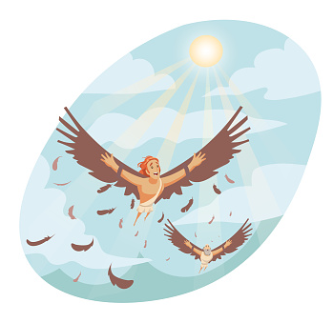





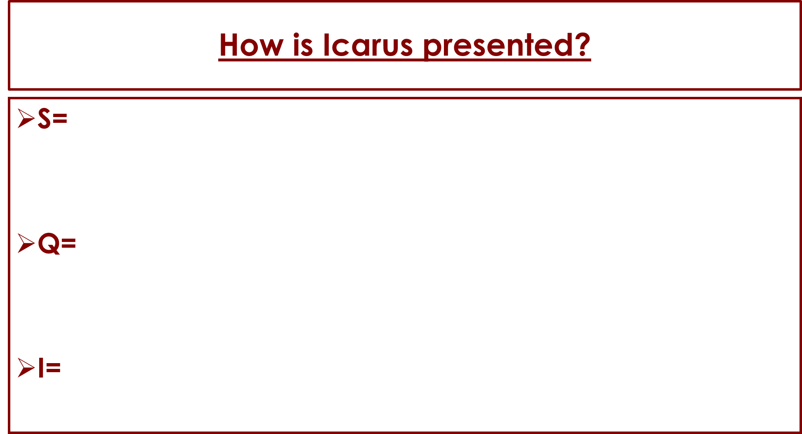

The Narrative Arc – Icarus and The Sun
Exposition | Conflict | Rising Action
Climax | Falling Action | Resolution
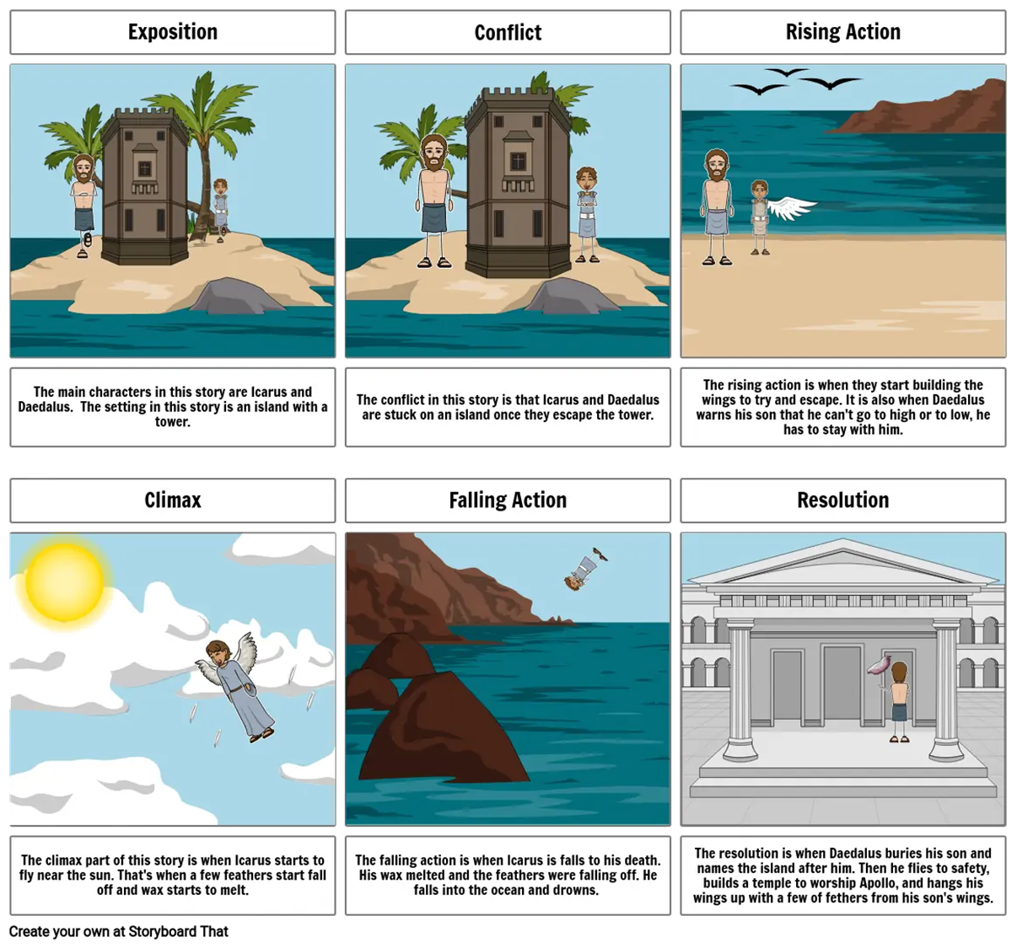

Resource 3: How did Medusa become a ‘monster’?

Once upon a time, a long time ago there lived a beautiful maiden named Medusa. Medusa lived in the city of Athens in a country named Greece -- and although there were many pretty girls in the city, Medusa was considered the loveliest.
Unfortunately, Medusa was very proud of her beauty and thought or spoke of little else. Each day she boasted of how pretty she was and each day her boasts became more outrageous.
On Sunday, Medusa bragged to the miller that her skin was more beautiful than fresh fallen snow. On Monday, she told the cobbler that her hair glowed brighter than the sun. On Tuesday, she commented to the blacksmith’s son that her eyes were greener than the Aegean Sea. On Wednesday, she boasted to everyone at the public gardens that her lips were redder than the reddest rose.
When she wasn’t busy sharing her thoughts about her beauty with all who passed by, Medusa would gaze lovingly at her reflection in the mirror. She admired herself in her hand mirror for an hour each morning as she brushed her hair. She admired herself in her darkened window for an hour each evening as she got ready for bed. She even stopped to admire herself in the well each afternoon as she drew water for her father's horses -- often forgetting to fetch the water in her distraction.
On and on Medusa went about her beauty to anyone and everyone who stopped long enough to hear her -- until one day when she made her first visit to the Parthenon with her friends. The Parthenon was the largest temple to the goddess Athena in all the land. It was decorated with amazing sculptures and paintings. Everyone who entered was awed by the beauty of the place and couldn’t help but think of how grateful they were to Athena, goddess of wisdom, for inspiring them and for watching over their city of Athens. Everyone, that is, except Medusa.
When Medusa saw the sculptures, she whispered that she would have made a much better subject for the sculptor than Athena had. When Medusa saw the artwork, she commented that the artist had done a fine job considering the goddess's thick eyebrows -- but imagine how much more wonderful the painting would be if it was of someone as delicate as Medusa.
And when Medusa reached the altar she sighed happily and said, “My this is a beautiful temple. It is a shame it was wasted on Athena for I am so much prettier than she is – perhaps some day people will build an even grander temple to my beauty.”
Medusa’s friends grew pale. The priestesses who overheard Medusa gasped. Whispers ran through all the people in the temple who quickly began to leave -- for everyone knew that Athena enjoyed watching over the people of Athens and feared what might happen if the goddess had overheard Medusa’s rash remarks.
Before long the temple was empty of everyone except Medusa, who was so busy gazing proudly at her reflection in the large bronze doors that she hadn't noticed the swift departure of everyone else. The image she was gazing at wavered and suddenly, instead of her own features, it was the face of Athena that Medusa saw reflected back at her.
“Vain and foolish girl,” Athena said angrily, “You think you are prettier than I am! I doubt it to be true, but even if it were -- there is more to life than beauty alone. While others work and play and learn, you do little but boast and admire yourself.”
Medusa tried to point out that her beauty was an inspiration to those around her and that she made their lives better by simply looking so lovely, but Athena silenced her with a frustrated wave.
“Nonsense,” Athena retorted, “Beauty fades swiftly in all mortals. It does not comfort the sick, teach the unskilled or feed the hungry. And by my powers, your loveliness shall be stripped away completely. Your fate shall serve as a reminder to others to control their pride.”
And with those words Medusa’s face changed to that of a hideous monster. Her hair twisted and thickened into horrible snakes that hissed and fought each other atop her head.
“Medusa, for your pride this has been done. Your face is now so terrible to behold that the mere sight of it will turn a man to stone,” proclaimed the goddess, “Even you, Medusa, should you seek your reflection, shall turn to rock the instant you see your face.”
And with that, Athena sent Medusa with her hair of snakes to live with the blind monsters -- the gorgon sisters -- at the ends of the earth, so that no innocents would be accidentally turned to stone at the sight of her.
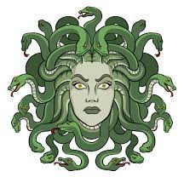


How did Medusa become a ‘monster’?

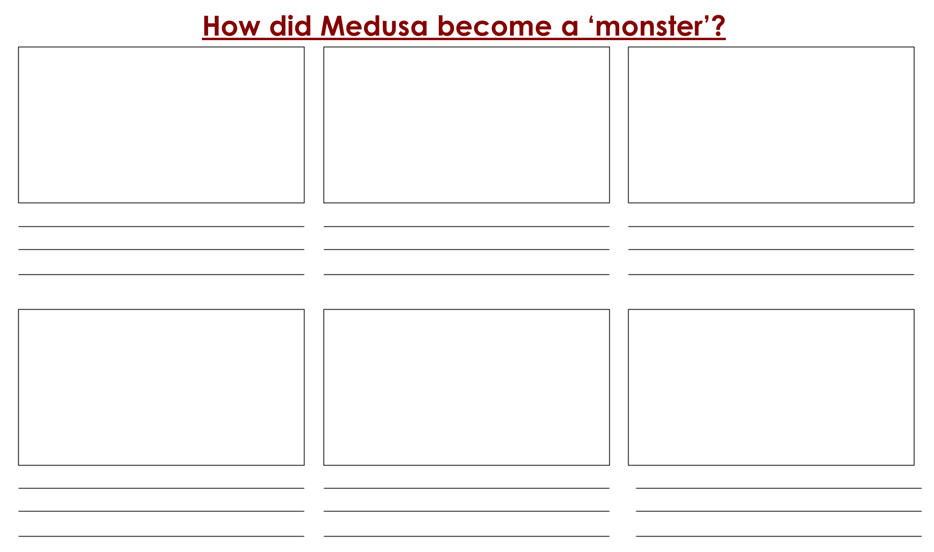

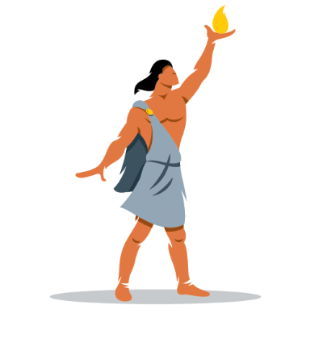
Resource 4: Prometheus Gives Man Fire

Prometheus went out amongst men to live with them and help them and he quickly noticed that they were no longer happy as they had been during the golden days when Kronos, the titan, was king. He found them living in caves and in holes of the earth, shivering with the cold because there was no fire, dying of starvation, hunted by wild beasts and by one another—the most miserable of all living creatures.
"If they only had fire," said Prometheus to himself, "they could at least warm themselves and cook their food; and after a while they could learn to make tools and build themselves houses. Without fire, they are worse off than the beasts."
Prometheus went boldly to Zeus and begged him to give fire to the people, so that so they might have a little comfort through the long, dreary months of winter.
"I will not!" said Zeus, "Not one spark will I share with them! For if men had fire they might become strong and wise like us, and after a while they would drive us out of our kingdom. Besides, fire is a dangerous tool and they are too poor and ignorant to be trusted with it. It is better that we on Mount Olympus rule the world without threat so all can be happy."
Prometheus didn't answer, but he had set his heart on helping mankind, and he did not give up. As he was walking by the seashore he found a tall stalk of fennel. He broke it off and then saw that its hollow centre was filled with a dry, soft substance which would burn slowly and stay alight for a long time. He carried the stalk with him as he began a long journey to the top of Mount Olympus.
"Mankind shall have fire, despite what Zeus has decided," he said to himself. And with that thought, he snuck quietly into Zeus' domain and stole a spark from Zeus' own lightning bolt. Prometheus touched the end of the long reed to the spark, and the dry substance within it caught on fire and burned slowly. Prometheus hurried back to his own land, carrying with him the precious spark hidden in the hollow centre of the plant.
When he reached home, he called some of the shivering people from their caves and built a fire for them, and showed them how to warm themselves by it and use it to cook their food. Men and women gathered round the fire and were warm and happy, and thankful to Prometheus for the wonderful gift which he had brought to them.
One chilly winter evening, Zeus gazed down from Mount Olympus and noticed fires burning cheerfully at the hearths of men and women in every village across the land. It did not take him long to realize that Prometheus had disobeyed him and given fire to men.
Zeus was furious so Prometheus was taken to the Caucasus Mountains, and chained to a rock with unbreakable adamantine chains. Here he was tormented, day and night by a giant eagle tearing at his liver. At night his immortal liver grew anew, but every day the eagle returned, and he had to suffer again.
Questions:
- What happens in the story?
_______________________________________________________________________________________________________________________________________________________________________________________
- What are your opinions of Prometheus?
_______________________________________________________________________________________________________________________________________________________________________________________
- What are your opinions of Zeus?
- _______________________________________________________________________________________________________________________________________________________________________________________

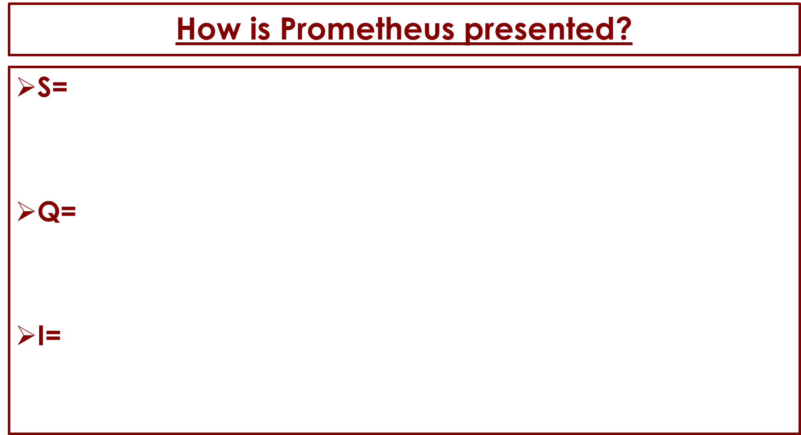

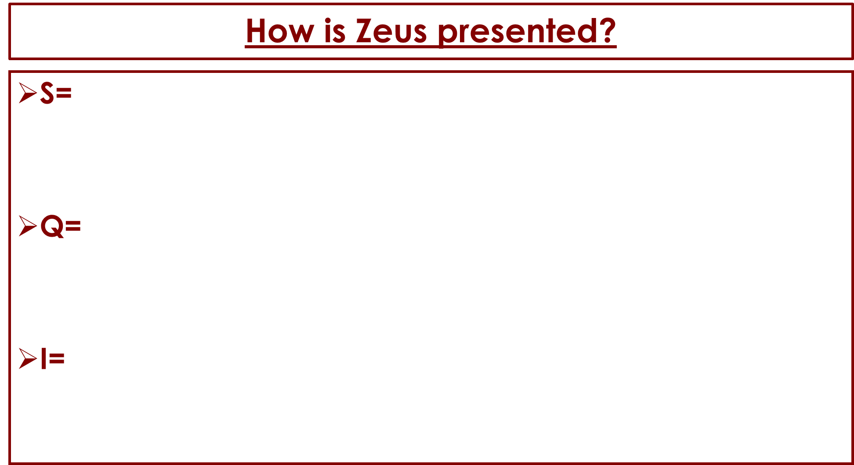

The Narrative Arc – Prometheus Gives Man Fire
Exposition | Conflict | Rising Action
Climax | Falling Action | Resolution

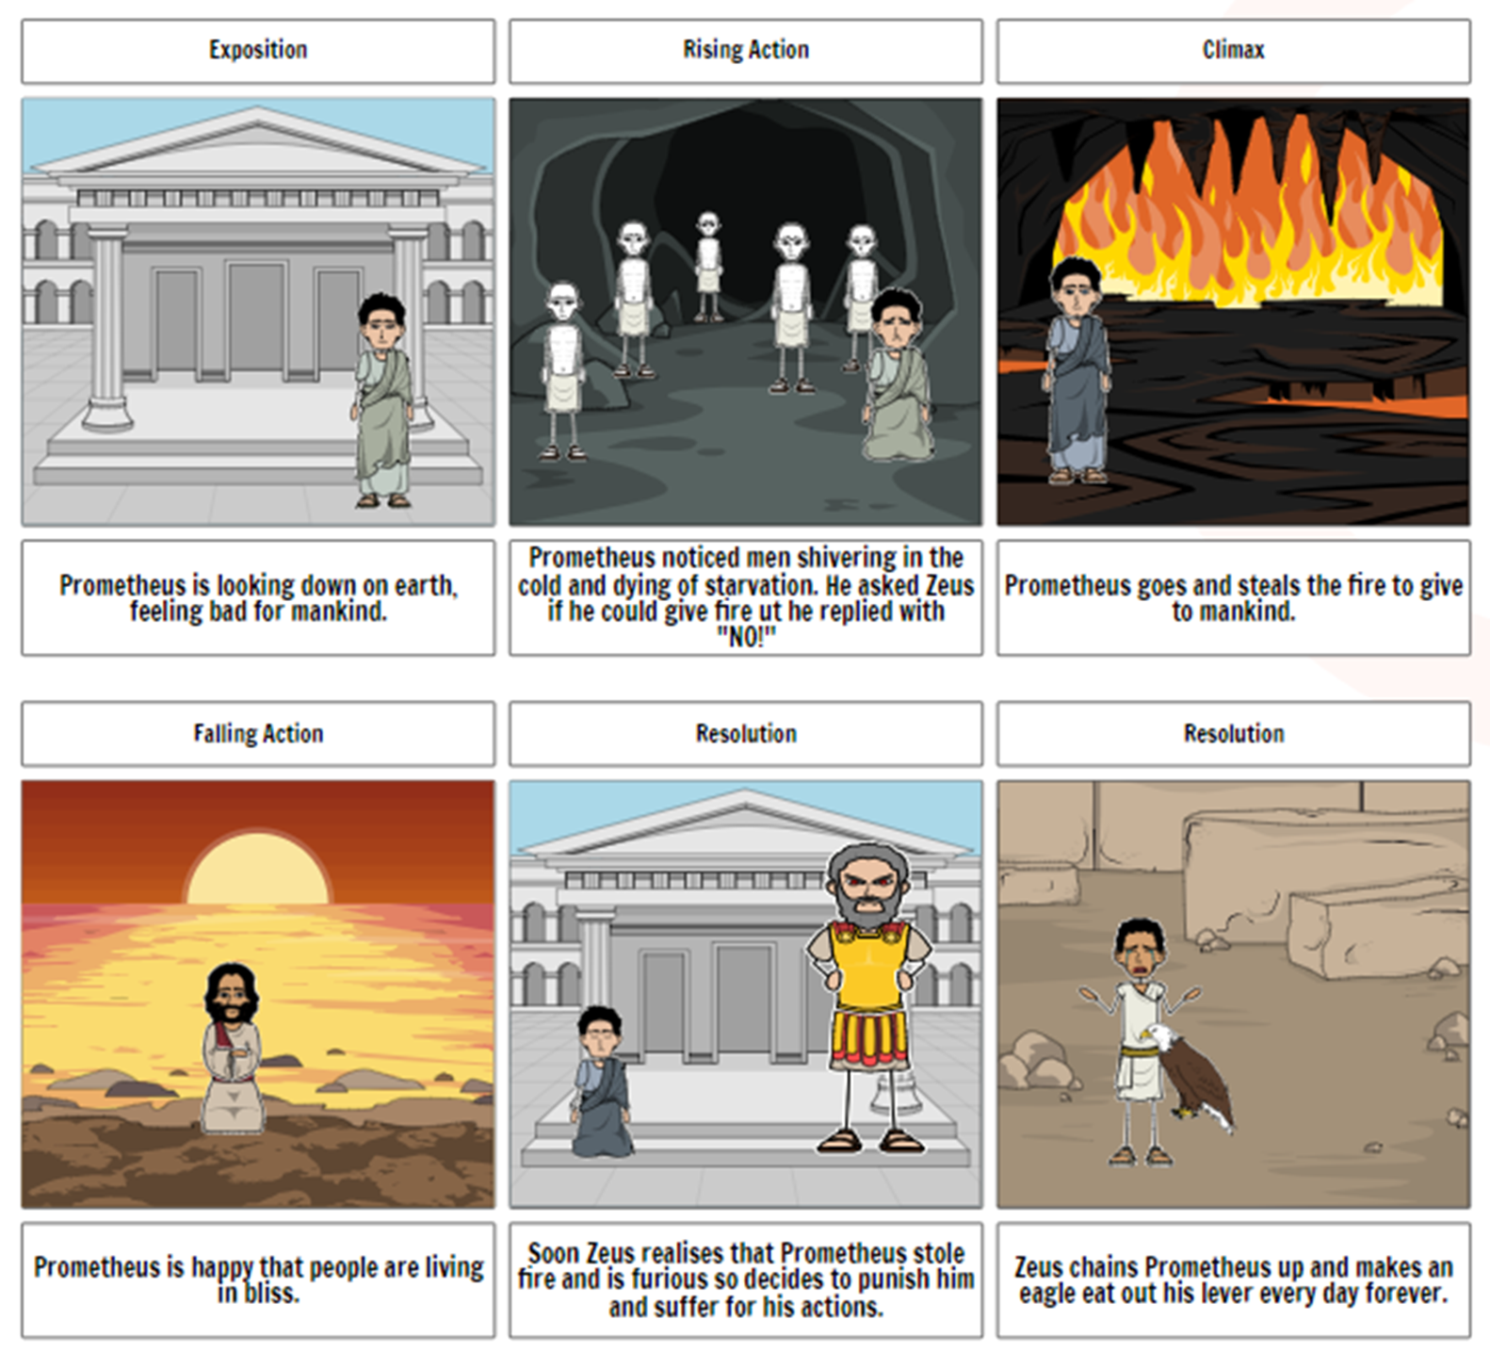

Resource 5: Pandora’s Box

Whilst Prometheus spent the rest of his days languishing in torment, the world moved on. But Zeus did not. He needed to punish mankind for their disobedience and arrogance in using the fire of the Gods.
Prometheus had a brother named Epimetheus, who was also very wise, and, like Prometheus, he was called the " common blessing of mankind." Epimetheus did not arouse the anger of Zeus, as his brother had done. Indeed, instead of binding him to a rock, Zeus sent a valuable present to Epimetheus' palace. A dear little maiden, Pandora, who was to live in the palace as a friend and helpmate for Epimetheus.
Pandora came in the swan chariot of the lady Aphrodite, and stood in the doorway to greet Epimetheus upon his return from the fields. It was a happy surprise to him, for he had grown very lonely in his grand and gloomy palace, which needed the sunshine of little Pandora's presence. Epimetheus was very rich, but very generous; and he could but grow more gentle and kind to the little Pandora, who reminded him constantly of the needs of others.
But we must not forget the strange gift which the gods had sent with Pandora. This was a strong box which Pandora desired at once to open. But when Epimetheus attempted to do so, he found this inscription upon the lid:
"OPEN NOT THE BOX UNTIL THE GODS SHALL SO DECREE."
So Epimetheus carried the box into the palace, and told Pandora that she could see it whenever she liked to do so, but begged her never to try to open it. Pandora promised she would not, and Epimetheus assumed that was the end of the discussion,
Pandora often found pleasure in sitting upon the box, tracing with her slender fingers the delicate scrolls and queer designs. The beauty of the box was a constant temptation to her. She often dreamed about the contents, and longed to take just a peep. But the kind face and warning voice of Epimetheus always prevented, for somehow he always appeared just at the dangerous moment.
One day Epimetheus went to the fields early in the morning; to stay until the shades of evening had fallen. Pandora tried to forget the box, but it seemed to call to her. That very morning she had found a curiously shaped key, and she was tempted to try it in the lock. She would not open the box; she would only see whether the key really did belong to it. Her hands trembled, and her breath came quickly; she thought she heard a footstep. No; it was only the water splashing in the fountain. With a little click, the key slid into the lock. It was a perfect fit. Pandora's left hand rested under the edge of the lid.
She raised it gently, and peeped in.
As she raised the lid, out flew all the bad things in the world today - envy, sickness, hate, disease. Pandora slammed the lid closed, but it was too late. Pandora had shut the lid down quickly after a very short space, and she hoped that they had not all escaped. She leaned her pretty head against the box and sobbed bitterly, listening; between sobs for the footsteps of Epimetheus.
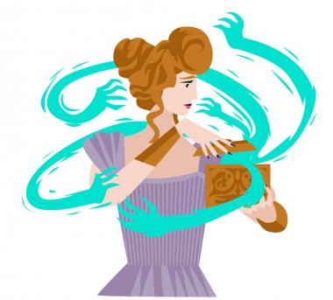
How she dreaded his return! It seemed as if a whole year passed while she waited. It was so silent in the great room. All at once a tiny voice which seemed to come from the box cried, " Pandora! Pandora! open the box, and let us out." Pandora raised the lid again, and seated upon the edge of the box was one little being, who said, " Foolish little Pandora! You have not prized the blessings which the gods sent you, else you would have guarded them more carefully. They have flown away, but we will stay with you. I am Hope.”





