“AAAAAAAaaaaargh!”
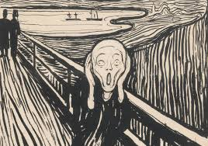
‘Ough, no!’

