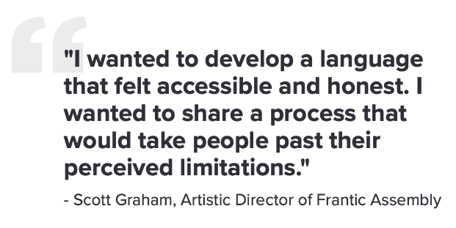
PHYSICAL THEATRE
Physical theatre is a form of theatre that puts emphasis on movement rather than dialogue. The human body and its movements are used for storytelling. Because of this, physical theatre is often very abstract, using movement in a stylised and representational way. The expression of ideas are choreographed through movement, meaning the actors are not relying on dialogue so often use very little or none at all!
Frantic Assembly are a British theatre company, co-founded by Scott Graham. Frantic Assembly creates thrilling, energetic and unforgettable theatre. Their unique physical style combines movement, design, music and text. Their beliefs are built on the notions of collaboration and ensemble. Their ambition is to remain committed to making brave and bold theatre.

Round-by-through
Music

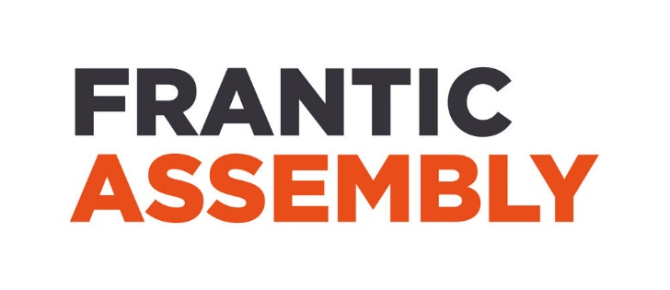
The Frantic Method:
The Frantic Method is approaching devising as a series of tasks, each broken down into building blocks. This is designed to establish progress from the simplest discoveries. Over the years this has helped performers understand how their bodies tell stories and how those bodies are capable of a strength and nuance they might not have recognised before.
Elements of a physical theatre include:
- Mime
- Gesture
- Status
- Proxemics - How close or far you are from your co-performers can be a source of very powerful impact.
- Stance
- Harshness/tenderness
- Stillness
- Motif - This is repeated use of a movement pattern which has meaning and reminds us of the central theme of the work.

Chair duetstion
The three universes
Push hands
Building blocks
Lifts
Collaboration

