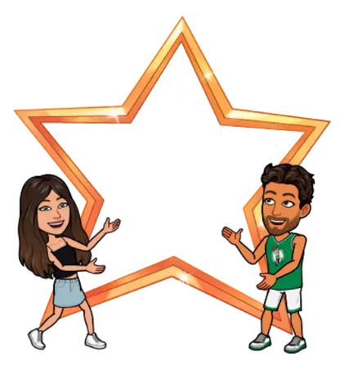


SPORTSMANSHIP
AWARD

Presented to:

--------------------------------

For displaying outstanding sportsmanship during physical education classes



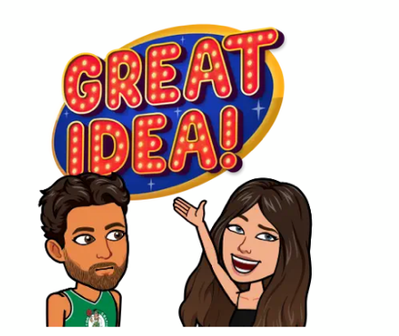
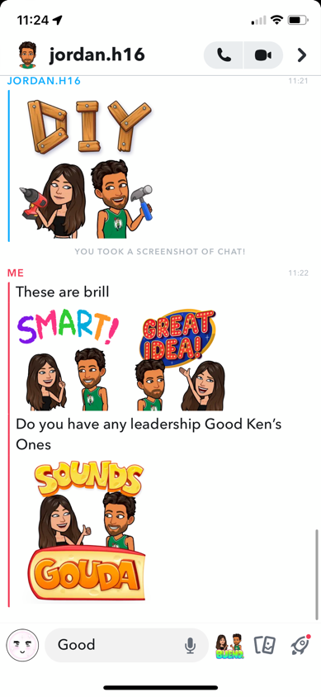
LEADERSHIP
AWARD

Presented to:

--------------------------------

For displaying outstanding, leadership during physical education classes by encouraging, listening, and communicating effectively with peers

