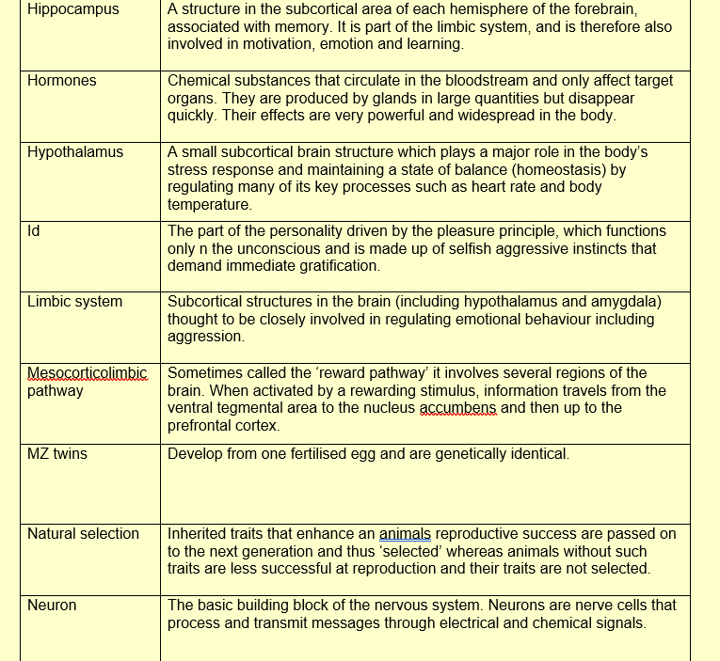
PSYCHOLOGY RESOURCES LA

