GLOBALISATION

- Process where world economies, political systems & cultures becoming more strongly connected to each other.
- Caused by movement of information, capital, products, services, and labour between different countries.
- Started to accelerate in 1980s.

- No globalisation = no interaction between countries.
- If there was complete globalisation = world would act as a single community. Real world is in between ; countries becoming more closely integrated.

5 FACTORS THAT PROMOTE GLOBALISATION
1) FLOWS OF INFORMATION
- Information can be spread very quickly across the world (financial)
- Internet , email, social media
- Makes world more interconnected.
- Can learn about cultures without leaving their own country

2) FLOWS OF CAPITAL
- Capital = Invested Money = produces an income or increased profit

- Historically – capital invested within a country.

- Foreign Direct Investments (FDI) = increases amount of capital invested in foreign countries.

- Global FDI – 1996 $400 Billion to 2016 $1500 Billion

- Information & Communications Technology (ICT) encourages flow of capital around the world – instantly moved around world via internet)

3) FLOWS OF PRODUCTS
- Historically, manufacturing industries = developed countries
- Nowadays, manufacturing rates fell in developed countries.
- 5 million in 1985 to 2.6 million in 2014

- Lower Labour costs in developing countries. Dyson move to Malaysia in 2002
- Changes international trade. £200 billion of manufactured goods = 1990 to £500 billion in 2008.

- Changing flows of products = making world more interconnected

4) FLOWS OF SERVICES
- Services = not materialistic goods

- Improvements of ICT allowed services to become global industries

- Allow to be anywhere in the world and still provide needs for customers

- 1970-80s = DERUGULATION of rules to increase competition and open up national finance markets to rest of world (UK/US)

- Makes it easier for banks to do business with other countries.

- Split into Low – Level Services ( customer services) and High Level Services (Financial Services).

5) FLOWS OF LABOUR
- Movements of people who work in sector from country to another

- More people m moving overseas – INTERNATIONAL MIGRATION (increased by over 40% between 2000 – 2015).

- Some Migrants = Highly Skilled Workers (ICT & Medical Workers), moving to more developed countries where wages & working conditions are better.

- Unskilled workers moved due to unemployment and poor wages in their own countries

MARKETING
Process of promoting & selling products or services
Global Marketing = treating world as one single market and using one marketing strategy to advertise a product to customers all over the world.
Global Marketing = Economies of Scale = cheaper to advertise one marketing campaign then do different one for each country.

Creates Global Brand Awareness = Consumer identifies with name or logo so will purchase that product instead of lesser-known competitor.

Marketing needs to be adapted to regional markets = different populations have different laws and cultural attitudes. ( different laws about consuming alcohol)

SUEZ CANAL
- Important Trade Route
- 2021 Blockage
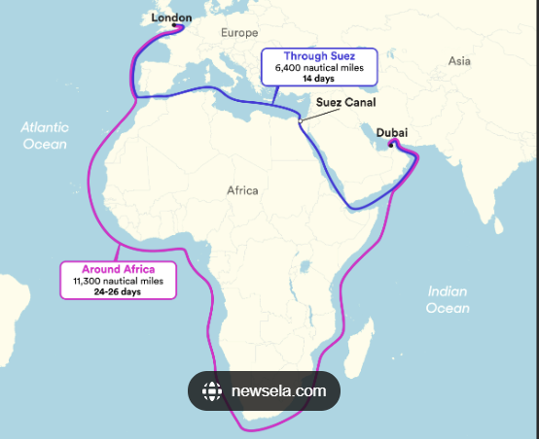

EVIDENCE OF GLOBALISATION
- People interconnected with one another via social media
- Online Shopping from Abroad Based Companies. E.g.: Shein in China
- Radio Stations
- International Food
- International TV Programmes ; Star Plus , Colours
- Range Of Diversity of People
- Product Diversity

ADVANTAGES | DISADVANTAGES
Easy communication | Deindustrialisation = unemployment in developed countries
Easy Travel | Transnational Cooperations are only winners.
Cultural Interchange | Exploitation of workers in developing world
International Trade | Money problems can easily spread.
Better & Cheaper Products | Mix of cultures can lead to loss of national identity.
Increases Purchasing Power with cheaper products | Small companies can’t compete with multi-national companies.
Transportation of products is easier / faster | Rich / Poor gap increases.

FACTORS AFFECTING GLOBALISATION

- Result of new systems, technology and relationships

- Systems : ways of working and methods of organisation for a particular function to be carried out. Eg: Just in Time manufacturing is a way of making products in response to demand. 1940s: many new systems been introduced to make it easier for information flow, capital flow to international boundaries.

Financial Systems promote globalisation.
Financial systems influences flow of capital between countries.

- Based on investment banks. Main role = help companies raise capital by selling shares on behalf of companies. Are investors that receive profits.

- 1980s made financial system more global:

- Information Technology (Internet): allowed investors have more information. Able to make an informed financial decision.

- Investment Banks : create new financial products that made foreign investment less risky. Allowed for currency exchange between countries to allow for tarde internationally

- Financial Deregulation : relaxed rules about what were allowed to do. Allowed banks to charge people more for their services and let banks invest a greater range of businesses. Removes barriers to capital coming in and out of country, making it easier for investment banks to buy and sell shares worldwide.

- Greater range of companies getting involved in finance. Commercial Banks: began selling shares.

Trade Agreements Remove Barriers To Trade (TRADE BLOC)

Global Trade System : flow of products between countries

1) Regulated by Government : control which products they let in to the country. Tariffs (taxes on products imported), Non – Tariff Barriers (Rules on Quality of products imported).

2) Controls = more expensive for companies to sell their products abroad and consumers to buy.

3) Trade Agreements = Cheaper for countries. Contracts – 1 country agrees to remove controls in exchange for other doing so. Benefits both countries companies and consumers.

4) Multilateral Trade Agreements = Trade agreements between several countries – all countries involved agree to remove tariffs & other controls. Between 2 countries = Bilateral Trade Agreement.

5) Global Trade System governed by World Trade Organisation. Sets rules on how countries can trade with each other. Acts as a forum for countries to negotiate trade deals with each other & settle trade disputes.

TRADE AGREEMENTS

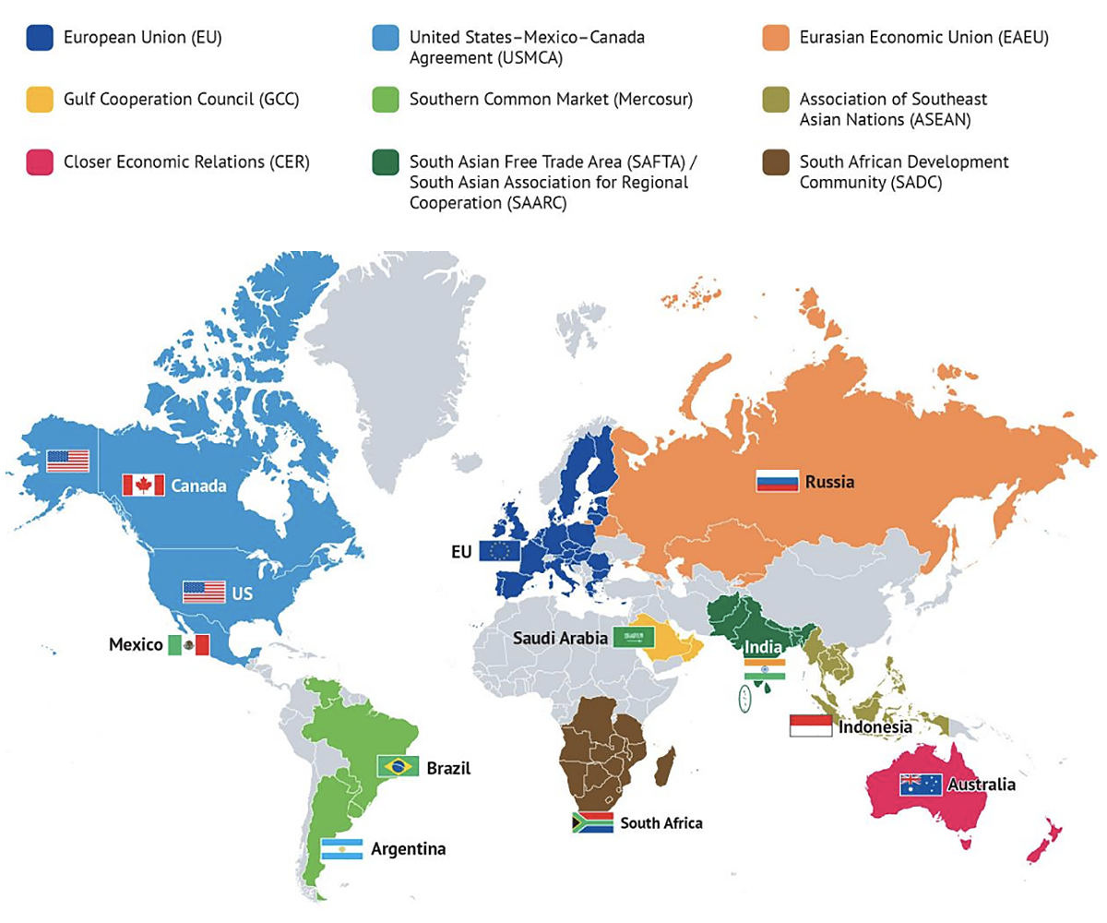
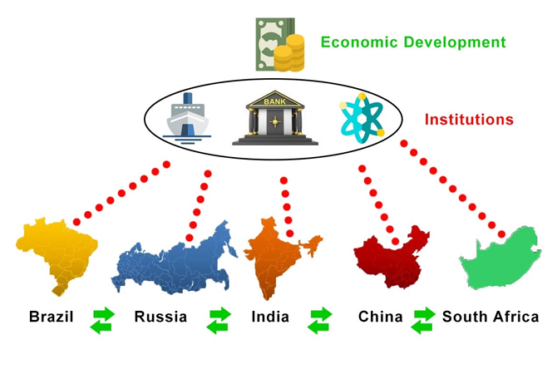

Transport & Communications
Improved Global Business
- Improved Transportation Systems (high speed railway, faster ships) allowed products to get around world.

- Shipping Container introduced in 1950s allowed goods to be moved quickly and cheaply.

- Communication Satellite – cheap wireless communication between 2 devices

- Optic Fibre Cables – Instant Communication

- Significant growth in software = free communication

Management & Information Systems
Increased companies Efficiency
- Supply Chains become global – minimise costs are manufacturing in HICs

- Large Companies benefit from economies of scale – minimise cost of product using production lines and buying raw materials at a lower price.

- Outsourcing (company pays another company to do work that would’ve been done in-house) = save costs = cheap labour costs means source from abroad

Security
Countries work together to prevent Security Threats
- Countries become interdependent
- Trade makes war less likely, and countries need each other to buy and sell products
- North Atlantic Treaty Organisation(NATO) – provide security during Cold War .
- Globalisation can make conflict ore likely. Developed Countries have intervened in conflicts in developing countries to secure resources like oil.

CAR MANUFACTURING

Cost Reduction: Manufacturing costs – Wages, lower taxes, regulations, operating costs = lower in developing countries. Significant savings for car manufacturers.

Increased Profit Margins: Lower production costs = increase their profit margins, especially if they maintain similar pricing for their vehicles in the market.

Employment Shift: While it may create job opportunities in the developing country. Unemployment = developed country = deindustrialisation. Social and economic impacts = unemployment and potential retraining needs for workers displaced by the shift.

Supply Chain Considerations: Moving manufacturing can also affect supply chains. Manufacturers may need to find new suppliers or adjust existing ones to accommodate the change in location. This can impact both the cost and reliability of the supply chain.

Quality Control Challenges: Developing countries may not always have the same level of infrastructure or regulatory oversight as developed countries. Challenges in maintaining quality control standards, affect the brand reputation of the car manufacturer.

Logistical Considerations: Shipping finished vehicles from a developing country transportation costs and potential delays.

Environmental Impact: increase carbon emissions = less stringent environmental

VOLKSWAGEN (GERMAN BRAND) BOUGHT BENTLEY IN 1998 for over $1 Billion
GLOBAL SYSTEMS

Globalisation Causes Interdependence
ECONOMIC
- Countries rely on each other for economic growth
- Eg: Oil
- Consumers rely on Producers to sell oil
- Producers rely on Consumers Money when they buy oil

SOCIAL
- Greater Connections between people in different countries = Social Independence
- 2015 - 244 million Migrants = build new relationships & interdependent with people from other countries

ENVIROMENTAL
- Every country reliable on others to look after environment
- Chernobyl 1986 nuclear reactor exploded. Led to birth defects in Ukraine, Russia & Belarus = radiation

POLITICAL
- Dependant on each other to resolve issues
- 2015-16 = EU worked together to solve migrant crisis in Syria

- Interdependence = inequality between countries & people within same country - Brings more benefits to developed countries than less developed = wealth & power. -Benefits the rich rather than poor = flows of people, money, idea, technology are unequal.
Benefits & Inequalities = Unequal Flow Of People
- Move to countries with more jobs. Eg: Developed Countries -- Refugees escape to nearest country = war, famine, persecution - Not always poor : need money for visa, living expenses etc. - - Countries let people in with specific skills, migrants often well educated

- Developed countries easier to migrate to less developed countries
- 2017, UK citizens could travel to 173 countries without a Visa, whilst Afghanistan = 24
REMITTANCE – send money back home to family. Increases amount of capital flow into developing country = economic growth in home country = people can afford to spend more thus boosting local industries

BENEFITS | LIMITATIONS
- Migrants = economic growth = do jobs that citizen can’t do (engineering –skilled) or won’t do (mining or logging = dangerous) | - Inequalities = Less developed countries suffer from ‘brain drain’ – skilled people leave with their knowledge. Reinforces existing inequalities between countries
 | - Conflict = Low skilled migrants happy to work for less money. Companies may depress wages for locals. Conflict between local & migrant population
- Injustice – Migrant workers = dangerous conditions for little money.

Eg: 2022 FIFA World Cup = Qatar several thousand migrants died building facilities

UNEQUAL FLOW OF MONEY = INEQUALTIES

STRENGTHS | LIMITATIONS
- Flow from DEVELOPED TO UNDEVEVELOPED | - Inequalities = Foreign Aid create Dependency – government improve their own countries.
- Foreign Direct Investment allow foreign companies/ countries to take advantage of cheap raw materials & low labour costs = host country can benefit from foreign capital & expertise. | - Conflict = Foreign Aid can find its way to Armed Groups which helps fund conflicts.  FDI conflict between foreign companies and local people.  Eg: FDI in agriculture can lead to peasant farmers being evicted to create larger plantations.
 | - Injustice = Companies may pressure underdeveloped countries to pass laws that make it cheaper to invest. Eg: [Weakening laws on Working Condition

NEO – LIBERLAISM
Before 1980
- Government took responsibility to for providing welfare for citizens & control imports through trade barriers to protect national industries.
1980s Onwards
- Developed countries thought economy = better without state intervention
- Maximum economic growth if trade barriers removed, state owned companies became privatised & government spending was cut. NEO-LIBERALISM
- Increased free trade = more development within countries, less conflict between them.
LIMITATIONS
Inequalities – Neo- liberalism started in developed countries & spread globally. Tends to concentrate wealth in hands of a few. Eg: large, wealthy businesses based in developed countries.
Conflict – If private companies and free tarde ion less developed country threatened by decision of country’s government, developed countries may believe intervention is justified = conflict
Injustice – Government & TNCs argue that free trade and privatisation are best way to help country develop. Justifies poor working conditions & environmental damage in developing country.

UNEQUAL FLOW OF TECHNOLOGY
- Most technology owned by Developed Countries.
-Help people all over the world – eg: California Silicon Valley
LIMITATIONS
Inequalities – Developed can afford latest technology, developing can’t. Countries that have the technology can make products cheaper and have better access to information and services due to better communications infrastructure. Eg: 2016, 97% of Netherlands had access to internet compared to 20% in Myanmar. Gives developed countries advantage over developing.

Conflict & Injustice – Repressive Governments of less developed used weapon technology distributed by developed countries to stop protests from their own people.

GLOBALISATION MAKES SOME COUNTRIES MORE POWERFUL THAN OTHERS
- Developed Countries or emerging economies with lots of money & technology able to drive global systems to own advantage
- Have a lot of control over global economies and political events
- Less Developed Countries = lack money & technology. Have limited power – are only able to respond to events instead of controlling global economy & political events.
- Climate Change = Developed Countries = Reluctant to agree to proposals as may harm economy. (loss of jobs in fossil fuels industry & higher energy process)
- Most Affected = Poorest countries. Bangladesh impacted by rising sea = difficult to influence other countries to reduce greenhouse gas emissions = lack power.

GLOBAL INSTITIUTIONS – UNEQUAL POWER RELATIONS
1) International Monetary Fund
- Monitors global economy and advises governments how they could improve their economic situation. - Gives loans out to countries with economic problems.
2) World Bank
- Provide loans to less developed countries to invest in areas such as health, education & infrastructure.
- Money for loans paid by subscription from its member countries.
- ALL MEMBERS MUST PAY IN, ONLY THOSE THAT NEED IT CAN TAKE MONEY OUT.
- Funds are redistributed from developed countries to less developed countries. Less Developed Expected to pay back loan.
IMF & WORLD BANK = United States based and are led by other developed countries. Less Developed countries who may need a loan have less influence over decisions of organisations.
Loans are conditional – less developed country has to make changes such as trade regulations in order to receive the loan.

World Trade Organisation
- Reduces trade barriers between countries
- Developed countries kept trade barriers in place, reducing imports from less developed ccountries
- Boost economy of developed country at expense of less developed countries

INTERNATIONAL TRADE
2008 Recession reduced volume of international trade.
Trade
- Import & Export of goods and services between countries.
- 8x value increase between 1980 – 2008 = volume increase
- Global Trade Pattern = Developed Countries remain biggest global traders, emerging economies catching up (China now biggest goods exporter)
- Less Developed Countries = bigger traders but slow growth. Poorest 49 countries make up 10% world’s population only account for 0.4% world trade.
- Opening up to international trade = removing trade barriers due to formation of trade blocs.
- Rise in Fair Trade = 1970s 1000 fair trade organisations set up in developing countries. Work with developed countries to ensure equal distribution of pay.

Investment
- FDI = person or company send money abroad to generate profit.
- Foreign Investors attracted by size of market , stability of market, possibility of extracting resources for themselves or ability to access financial services. Eg: Luxembourg large banking sectors.
- Volume FDI rose dramatically = $400 billion (1996) to $1500 Billion (2016)
- Changing investment pattern – 1980s onwards invested in emerging economies and developing countries. Eg: India.
- Emerging economies invest heavily in developing countries. Eg: China invests a lot of money in South America & Africa.
- Ethical Investment grown = only invest in socially responsible areas. Eg: Companies that cause environmental or humanitarian harm. Amount of ethical investment by US companies = tripled between 2005 - 2016

TRADE BLOCS= AGREEMENTS BETWEEN COUNTIRES
- Remove trade barriers between members
- Keeping common barriers to non-members
- Regional = 2016, German exports were £708 billion to EU. £501billion to other countries.
- Specific Industries = Oil= Saudi Arabia = members of Organisation of the Petroleum Exporting Countries (OPEC). Aims to standardise price preventing undercutting.

- Special Economic Zones (SEZ) = Increase Trade Volume with Emerging Economies and Developing Countries. Have different trade rules. Eg: companies may pay lower taxes on land & goods.

TRADING RELATIONSHIPS
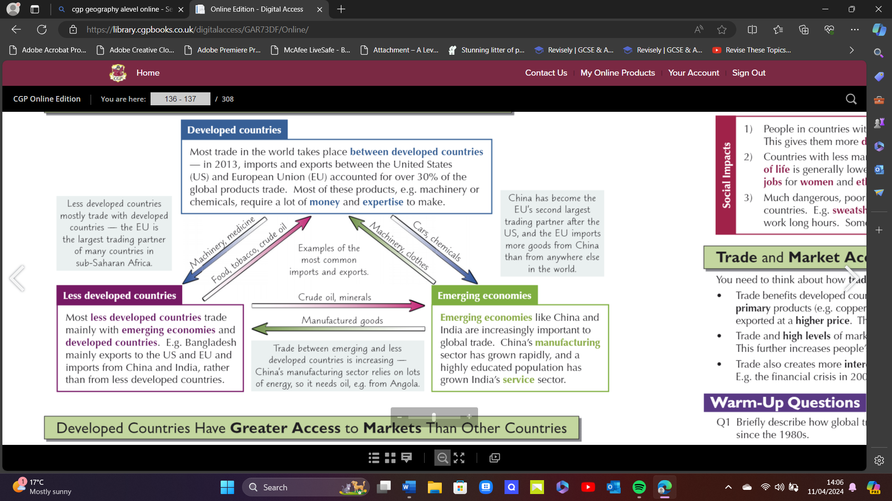

ACCESS TO MARKETS
- How easy it is for countries & companies to trade with another country.
- International access to markets determined by extent of import & export barriers between 2 countries.
- Affected by : Wealth – Developed countries put higher tariffs on goods imported from less developed countries – harder for less developed countries to access markets. Also have more money to invest so can avoid high tariffs put on by developing countries by opening factories within them. Less developed countries also rely on loans that demand on them removing barriers & increasing access to their markets.

- Access increased by being member of trading bloc = members have access to all markets of other member countries. Trade blocs of developed countries = access to lots of wealthy buyers. Less developed countries outside trading bloc = pay high tariffs to export their goods to those markets = less developed countries disadvantages.

SDT AGREEMENTS
- Special & Differential Treatments - let least developed countries bypass developed countries tariffs = greater market access. Eg: EU 2001 Everything But Arms (EBA). Allows least developed countries to export some of their products to EU without paying tariffs.
- Profits made SDT agreement = allow less developed countries to diversify the range of industries. Eg: introducing manufacturing/tourism sectors.
- SDT agreements have negative impacts on developed countries = allow cheap imports into country.

DIFFERNETIAL ACCESS = ECONOMIC & SOCIAL CONSEQUENCES
ECONOMIC IMPACTS
1) Hard for poor market access to establish new industries – high tariffs when selling aboard thus making products uncompetitive as may be undercut by domestic markets by TNCs.
2) Makes them dependant on selling low value primary products (agricultural goods) = fluctuate in price Countries with poor market access have low Gross National Income (GNI).
3) High level market access = more economic growth as can trade more. Citizens = wealthier = afford to import range of products = develop high tech industries.

SOCIAL IMPACTS
1) Better market access = higher paid jobs = disposable income = increase standard of living

2) Less market access = less money for education & healthcare = quality of life lower. Better access to education = better access for jobs for women & ethnic minorities giving more power to shape own lives & societies.

3) Dangerous, poor paid work moved to developed countries to less developed. Eg: sweatshops crowded, dangerous factories. Sweatshops employ children = illegal in developed countries.

TRADE & MARKET ACCESS AFFECTING PEOPLE AROUDN WORLD
- Many developing countries export mostly primary products (copper ore), which are processed in developed countries and exported at higher price.

- Trade & high level of market access = wide range of goods are available in developed countries.

- Trade creates interdependence between countries – something goes wrong, other countries affected. Eg: Financial Crisis in 2008 increased rates of unemployment.

GLOBAL COFFEE TRADE

Location = Hot, Wet Close to Equator
2 Types of Coffee Bean = - Arabica (expensive – South/Eastern Africa) = 70% world sassssssssssssssssssssslcoffee production aaaaaaaaaaaaaaaaa a l- Robusta (West Africa & Africa)

Grown = Nurseries to Farms where produce beans. Coffee grown on smallholdings rather than large plantations.
Produced = Low Income Countries (Brazil largest) & Developed Consume
ISSUES IN COFFEE PRODUCTION
- Plants susceptible to diseases. Eg: Coffee Berry Disease = dark spots on coffee beans & destroys in days.
- Insects = Black Twig Borer insect native to Asia that tunnels into coffee plants, destroying the plant.
- Weather Conditions : Bacterial Blight = spreads easily very wet weather, while droughts make Cicada more likely
- Fertilizers = Imported = Expensive

BRAZIL | USA
- Largest Coffee Producer | - Largest Importer
-2015 exported 20% worlds coffee | - 2015 Imported 20% of Worlds Coffee
-300,000 coffee farms
-Produces 2.5 million tonnes each year

DEMAND INCREASE, SUPPLY SAME = INCREASE PRICE
LOW PRICE = GOOD FOR CONSUMERS
HIGH PRICE = GOOD FOR PRODUCERS

If price is high = ore people grow more coffee for chance at making money = may drop price of coffee
If price low = consumers buy more = may increase in price

Price Fluctuations
- Eg: Vietnam exported Coffee steadily since 1987
- 1999 Vietnam = exporting over 450 million kg per year, caused price fall ffdramatically from $1.19 per kg in January 2000 to $0.68 per kg March 2001.
-Many South American coffee growers out of business = couldn’t keep producing at ffsuch a low price.

COFFEE TRADE DOMINATED BT TNCs
- Only 7-10% of price of coffee bought in supermarket goes to coffee farmers.
- TNCs buy unprocessed beans from farmer and roast them = max profit.
- TNCs based in Developed Countries
- 4 Companies = ECOM, Louis Dreyfus, Neumann & VOLCAFE = control 40% market
- Coffee producing countries compete with ach other to cut wages, labour regulations & environmental protection to attract TNCs.

FAIRTRADE COFFEE
- 1992 – Fairtrade Foundation
- Work with producer organisations – groups that are controlled by coffee farmers.
- Setting Fairtrade Minimum Price – minimum price hat a coffee buyer has to pay the producer.
- Fairtrade producer organisations = 175 in 2002 to 329 in 2011.
- Global sales of Fairtrade coffee grew 15,000 tonnes to 80,000 tonnes per year
- Fairtrade Premium = Pays additional money to communal fund for local communities. Eg: Peru – Schools, Machinery

TRANSNATIONAL COOPERATIONS
- Produce, sell or in located in 2 or more countries.
- Important in Global Economy – 2013, 80% global trade linked to TNCs.
- Operates in all industry types:
Primary – extracting natural resources. Eg: Shell Extracts & tarde oil/gas. Often in vest in countries with natural resoiurces.
Secondary – making material goods. Eg: Toyota. Often Invest in countries with low labour costs & cheap land, especially where govermnt investment with tax breaks.
Tertiary – providing services. Eg: Avia. Invest in countries with well educated population.

- Bring lots of investments into countries, spread new technologies & promote particular cultures.

- Potential Investment, creation of jobs and provision new technology means TNCs can have a political influence.

- Connect countries together due to spatial organisation – create global supply chain = different part of business located in different countries.

Headquarters : Big Cities in developed countries. These cities are well connected in global transport and communications.

LINKS BETWEEN COUNTRIES THROUGH INVESTMENT
1) Mergers : Eg: BP & Amco in 1998. Links form between countries where companies operate.
2) Acquisitions : One company buys another company. Eg: Volkswagen buys Ferrari
3) Using Subcontractors : TNCs use foreign companies to manufacture products without actually owning the business. Nike products don’t make products made in factories they own.
4) FDI – Foreign Direct Investment – can involve mergers, acquisitions and using subcontractors. Eg: If Lloyds acquires a bank in Indonesia, they’re investing money there.

TO GAIN MORE CONTROL OVER MARKETS :
1) Vertical Integration – company takes over other parts of supply chain, through mergers, acquisitions and FDI. Shell now owns every part of its supply chain, from extracting and refining oil through to selling it to consumers at petrol stations.

2) Horizontal Integration – merges with or takes over another company at the same stage of production. For Example: 2006 Disney took over PIXAR Studios – both film production companies making family-oriented animations.

IMPACT ON GLOBAL TRADE
- Intra – firm trading = 1 division of TNC trades with another part of TNC. Eg: Intel assembles its microchips in Costa Rica but sells them in the USA. To get products from Costa Rica to USA, Intel Costa Rican subsidiary ‘sells’ them to Intel in USA.

- TNC first invests in country = multiplier effect = knock on affects of community. Eg: More jobs = more money = benefits local economy.

- TNCs gain knowledge about local markets. Eg: McSpicy Paneer Burger India

STARBUCKS TNCs
Started = 1971, Seattle
Inspiration = Milan’s famous expresso bars
Stores = 27,000 in 65 countries. First store in Australia opened in July 2000
Market Value = $50 Billion (goal is $100 billion)
Customers : 100 million
Subsidiary : Japan joint venture 1995 = Sazaby League Ltd = Companies top performing market internationally = Since 2014, taken full control of Japan Subsidiary by $914.4 million

IMPORTANCE TO GLOBAL TRADE
- Wants to make Worlds first Sustainable Product. Would Improve lives of over 1 million people in coffee trade by increasing their economic status & living conditions.
- Buys 99% ethically sourced coffee = partnership with Conservation International
- Founding Member of Sustainable Coffee Challenge = plants trees to help create climate resistant coffee farms.
- Helps flows of ideas = share research & resources through farmer support centres
- 2018, spent $1.1 Billion purchasing green coffee = fuelled global coffee trade across world.

PRICING STRATEGIES
Value – based Pricing
- Value perceived by consumer rather than actual costs
- Based on country it operates in.
- Factors = Disposable Income, Tariffs, Exchange Rates, Local Market Needs
- Latte : Switzerland = £4.60, Bangkok, Thailand = £2.40

ADVANTAGES | DISADVANTAGES
- 99% ethically sourced coffee – farmer transactions are fair | - 23 million litres of water wasted each day as there store policy in all 27,000 stores is ‘leave the tap running all day’
- Invested over $100 million in supporting coffee communities (farmer support centre, loans and forest carbon project. | - Hindered Economic Growth in Ethiopia. Ethiopia tried to trademark regional coffees such as Sidamo = sell upwards of $26 with only $1 going yo Ethiopia farmers. Starbucks stopped trademark bid.
 | - Child Labour in Latin America (Brazil) below minimum wage
 | - Coffee beans price halved = farmers can’t support themselves as companies don’t pay fair trade price of $1.25.

Key Facts
- Classified as Multi – domestic Company = high local responsiveness and low level global integration.
- Products customised to suit local tastes & preferences
- MARKET ENTRY = 3 APPROACHES
- Wholly Owned Subsidiaries
- Joint Ventures
- Licensing
- Value based pricing adopted for markets worldwide = contributes to its premium image.
- Success of Starbucks International Strategy due to Cultural Mindfulness, Market Research, Local Partnership & Strong Brand Integrity.

GLOBAL GOVERNACE

Global governance is the process of multiple nations acting together in matters that affect the entire world.
- Issues can be International. Eg: Climate Change, Famine, War. Single nation can’t solve worldwide issues.
- Global Governance maintains Global Systems (Environment, Politics, Economies etc).

GLOBAL NORMS
- Accepted standards of behaviour that differ between countries.
-Negative consequences for countries and companies who don’t follow them. Eg: Gender Equality & Saudi Arabia.

GLOBAL LAWS
- Rules established by countries through international agreements.
- Cover human rights, labour and trade regulations.
- Countries may be deterred from global governance if they don’t agree with laws but must follow them = legally binding , failure to comply = prosecution

GLOBAL INSTITIUTIONS
- Political & legal organisations that pass/enforce laws
- Decide if laws have been broken
- Work together to make global governance a success.
- Discuss issues to keep international peace.
- Non – Governmental Organisations operate on a range of scales to monitor + support institutions.
- Decisions at local / regional level can affect institutions at global level (vice versa)
GLOBAL = UN
INTERNTAIONAL = EU
NATIONAL = UK PARLIAMNET
REGIONAL = SCOTTISH PARLIAMNET
LOCAL = LOCAL COUNCILS

GLOBAL GOVERNACE – PROMOTES GROWTH = STBALILTY
Problems
- Voluntary
- Difficult to make countries comply
Stabilise economies & loans , World Bank provides loans & aid International Military Fund.

GLOBAL COMMONS
Areas not owned by any one country:
- Antarctica - High Seas (Most more than 200 miles from land) = United Nations Convention on the Law of Sea (UNESCO) governs high seas - Earth Atmosphere (gases that support Earth) - Outer Space (Moon & rest of solar system)
Pressures
- ‘The Tragedy of the Commons’ = countries feel they can exploit global commons without having consequences as exploiting costs are explored by everyone.
- Industrialisation & Development = increasing resources demand. Extracted from Global Commons = added to atmospheric waste.
- New Technology = easy access to areas = vulnerable to exploitation.
- High Seas = Overfishing = not sustainable = affects food chains
- Increased C02 = Acidification of oceans = affects marine organisms.

Protection
- Countries rights to develop must be BALANCED by need to protect the global commons.
- Non – Governmental Organisations (NGOs) – WWF called for protection of Global Commons by ensuring any development/area use is sustainable.
- Sustainable development of global commons needs global cooperation. Eg: Artic Cod has increased due to cooperation between Norway & Russia (countries that fish for it).

ANTARTICA CASE STUDY
GLOBAL COMMONS
Area = 14 million km^2
Ice = 90 % ice on Earth
Global Commons = Antarctica, Southern Ocean & North of Antarctic Convergence
Rainfall = less than 166mm per year = desert. Most is frozen
Temperature = - 49’C
Plants = Mosses & Lichens
Food Chain = Antarctic Convergence = nutrient rich cold water = phytoplankton thrive = food for krill. Basis of Southern Ocean food chain
Animals = Fish, Whales, Seals, Albatrosses & Penguins. = Fragile Ecosystem.

INTERNATIONAL LAWS
Antarctic Treaty (1959)
- Signed by 59 countries - Peaceful reasons only - Cooperate on Scientific Research - Remains in Global Commons - All bases & equipment can be inspected by other countries at any time

Protection to Antarctic Treaty (1991) - Protects fragile environment. - Bans all mining in Antarctica - Rules to protect plants & animals & regulate waste disposal = prevent pollution hEnvironmental Impact Assessment (EIA) needed for any new activity

- However, no system to ensure countries abide by these rules. If they’re ate any disputes, they’re encourage to negotiate. Disputes can be taken to International Court of Justice.

- Slow & Difficult to settle disputes = 2012-2016 plans for marine reserves repeatedly failed due to disputes between Russia & Ukraine.

4 THREATS
CLIMATE CHANGE - 50 years = West Coast warmed 3’C. - Ice Shelves around Ross Sea to melt/retreat rapidly. - Species of Penguin adapted to Sea Ice declined rapidly. - Antarctic Krill depend on Sea Ice = Declined 80% since 1980s. Krill = mains source of for penguins, whales & seals. - Global Sea Levels increased = 3mm per year since 1990s - Ocean Acidification = Salt Water + CO2 Carbonic Acid. Decreases amount of Calcium Carbonate in water = Plankton cannot form their shells.

FISHING & WHALING - Patagonian Toothfish fished unsustainably = vulnerable to extinction -Antarctica Krill = most fished = 2013 over 200,000 tonnes - Knock on effect on other species - Legal Limits = how much fish can be caught per year = sustainable levels = Illegal Fishing hard to monitor. - Many die being caught on fishing line = Drown = Albatrosses - 1982 ban on all Whaling – some countries kill whales for ‘scientific purposes’ - Whaling significantly decreased whale population- starting to recover but are slow breeders

MINERAL MINING - Coal & Iron Core in Transatlantic Mountains = large underground deposits - Large Oil Reserves under Southern Ocean - Mining banned in Antarctica = conditions are not favourable = too far & expensive - May change in future due to need for Oil & Minerals.

TOURISM/RESEARCH - Increases Shipping & Air Travel to Antarctica = Water & Air Pollution - Risk of hitting Icebergs = Oil Spillages - Can disturb Bird Colonies by trampling on nests or vegetation = fragile environment - Invasive Species may enter via clothing = disrupt food webs - Important for Scientific & Environmental Research = need for bases, Food & Transport Supplies. Until 1980s, lots of waste created in bases were either burned, dumped, or thrown in sea.

GLOBAL INSTITUTIONS
International Whaling Commission (ICW) | United Nations Environment Programme (UNEP)
- Regulates Whaling  -1994 Whale Sanctuary in Southern Ocean around Antarctica.  - 1982 = Whaling Moratorium = banned all commercial Whaling.  - Critisced IWC for not monitoring number of whales in sanctuary by Greenspace (NGO).  - Australia & US say should be better monitoring system – registering all whaling boats with IWC & placing independent observers on all whaling boats.  Norway & Japan say IWC doesn’t have authority to do this. | - UNEP = UN agency govern world environment  - Reports Antarctica Activity to UN  - Antarctica programme run by Commission for the Conservation of Antarctic Marine Living Resources (CCAMLR) = stops illegal fishing & conserve Antarctic ecosystem.  - Limited Effectiveness = individual countries protecting their own interests.  5 years for CCALMR to negotiate creation of a Marine Protected Area IN Ross Sea

Antarctica & Southern Ocean Coalition (ASOC)
- Formed in 1978 by group of NGOs

- Trying to protect environment = countries were trying to exploit Antarctica for - - oil, gas, minerals.

- Monitors environmental changes in Antarctica & whether countries are sticking to 1991 Environmental Protocol, protecting krill populations & Southern Whale Sanctuary

- Monitors Climate change Affect – want to reduce greenhouse gas emissions.

IMPACTS OF GLOBALISATION

Benefits
Development
Foreign Investment brings capital into a country.
- Used to improve Education & Infrastructure= attract trade & investment.
- World Bank can help countries develop by directing resources.

Integration
Countries to pool their resources together to solve global issues that re too big for 1 country to deal with.
Greater Integration = better understanding between people of different backgrounds & cultures.

Stability
- More interconnected = more dependent on others
- Discourages actions that may upset world stability = negative consequences for all countries
Economic Growth
- Global trades participation allows countries to profit for their natural resources & specialist industries = generate wealth.
- Gain product & services that they’d unable to produce themselves.
- Greater Access to money & products = improves people standard of living

Costs Of Globalisation
- Inequalities – Divide between rich & poor = low skilled workers in developed countries find it more difficult to earn money as companies move to developing countries.

- Conflict - Developed countries have had conflicts to secure natural resources. Eg: Oil

- Injustice – Improved transport & communications = human trafficking easier for sweatshops.

Pollution (transportation), Deforestation, Overfishing.

