Name: ………………………… Date: …………………………

What is an Emergency?

Have a look at the list below, what would YOU feel would be an emergency, needing you, or someone else to call 999 (the emergency services)?

(circle your answers)

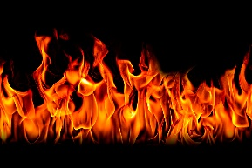

Your favourite toy There’s an uncontrolled or

has broken. unmonitored fire.





House or building You, or someone else,

has been broken into knocked over food or

or vandalised. drink.





Seeing someone in Someone is in a lot of pain,

water struggling. unconscious, or bleeding

a lot.

**When should you call 999?**

You should call the 999 emergency number if you are witnessing or are involved in an emergency situation. An emergency is defined as an unexpected, urgent and often dangerous situation which poses an immediate risk to life, health, property or the environment. Most emergency situations require immediate action to prevent the situation from getting any worse.

Some examples of emergency situations include:

* A person who needs immediate medical attention
* A structure on fire
* A crime that’s in progress or an offender is in the area