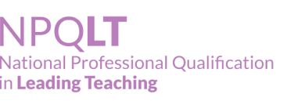

Assessment- Case with Questions and answers (newest cohort 2023) PASS

