Gothic Fiction Unit of Work
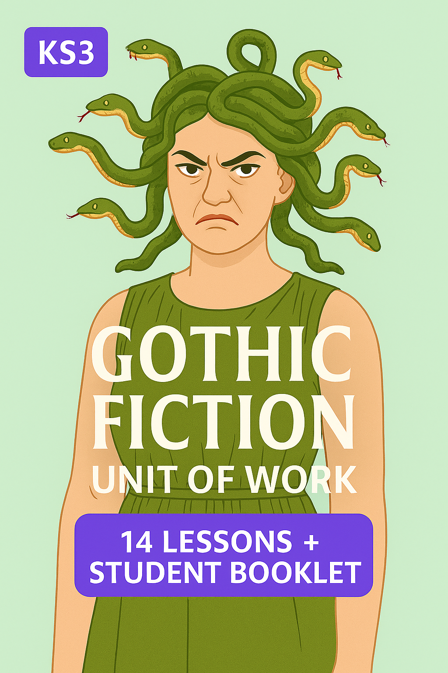
  - KS3 | 14 Lessons + Student Booklet

