
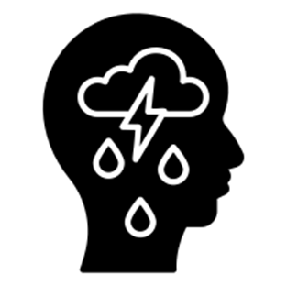

Unsure if a child you teach is SEMH? Feel free to come and see me!
Anxiety
Anxiety is a normal emotion. It can be unhelpful when it has an impact on the way you live your life, for example, your fears/worries last for a long time or are hard to control or your avoid situations that cause anxiety,

What to look for?
Lack of confidence
Difficulty concentrating
Problems with eating/sleeping
Anger outbursts
Negative thoughts
School/activity avoidance
Excessive worrying
Physical symptoms include: stomach ache, exhaustion and panic attacks.

What to do:
During a panic attack: sit with them, focus on breathing, offer water, calm tones, reassurance.
Ongoing anxiety: discuss triggers, create an anxiety plan that helps to identify things that help, regular check-ins

Anger
Anger is a normal emotion. Anger can be unhelpfuil when the individual is outwardly aggressive or violent. Anger can contribute to mental health difficulties. There is a fine line between a conduct disorder and anger.

What to look for?
Conduct disorder
Aggression towards people/animals
Property distruction
Deceptiveness or theft
Serious rule violation
A persistant pattern of these behaviours over a year.

What to do:
Personal space and time
Calm tones and clear language
Connect before correcting
Explain why behaviours are unacceptable
Help them to solve.
Avoid threats
Depression
We all feel low from time to time but depression tends to be long lasting and affect you everyday. This can be triggered by a trauma but can also be hereditary. Depression often develops along side anxiety.

What to look for?
Down, upset or tearful
Loss of appetite
Difficulty sleeping
Avoiding friends or social situations
Physical pain without visible symptoms
A feeling of worthlessness
Self-harm and suicidal behaviour

What to do:
Offer a safe space
Encourage them to socialise
Regular check-ins
‘Open door’ policy
Key adult that has a positive relationship
What is SEMH?
Social, Emotional & Mental Health (SEMH) is a term that was introduced in the Special Educational Need and Disabilities Code of Practice in 2014.
It replaced the terms BESD (Behaviour Emotional Social Development) and EBD (Emotional & Behaviour Difficulties).
The new abbreviation, SEMH, was the first term to drop the word ‘behaviour’ in an attempt to emphasise that behaviour is only ever a way of communicating something more significant.

SEMH at Ormiston NEW
35.07% on SEND register have SEMH as their primary area of need.

