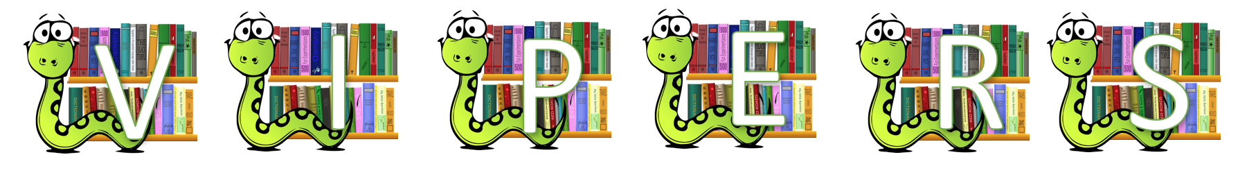

Text Title: Archie’s War by Marcia Williams p18-21
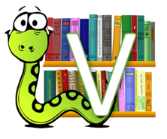 | Read the list of articles that are contained in the soldiers’ kit. Are there any words you don’t understand? What do you think they mean?
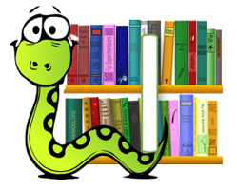 | Archie writes that Count Ferdinand Von Zeppelin is not a hero. What do you think a hero is in Archie’s eyes?  Why does Archie write ‘At first, being at war was like being in a comic strip. It ain’t like that now – IT’S REAL’?
 | What do you predict will happen with Dad? Try to use evidence from the text.
 | What have you learnt from reading Archie’s War about the roles played by women during the war?
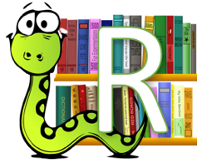 | Who informed the family that Uncle Teddy was killed in action?
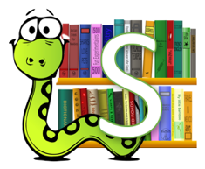 | Summarise the story-line so far in 20 words or less.

