Prefixes
What are prefixes
and how to spell prefix words
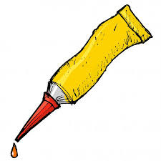

( (‘fix’ – get it?)

