Mon livret de conversation
French A-Level (Upper Sixth)

Unité 7 : Les aspects positifs d’une société diverse
Unité 8 : Quelle vie pour les marginalisés ?
Unité 9 : Comment on traite les criminels
Unité 10 : Les ados, le droit de vote et l’engagement politique
Unité 11 : Manifestations, grèves, à qui le pouvoir ?
Unité 12 : La politique et l’immigration

Prénom : ____________________________________
Professeur(e)s : ____________________________________
LES PARTIS POLITIQUES FRANÇAIS

France’s political landscape in 2025 is structured around a multi-party system with three major blocs: the left-wing alliance, the centrist coalition, and the right/far-right parties. Below is a spectrum of the main parties and alliances, ordered from the far left to the far right, including their key ideologies and positions.
- Nouveau Front Populaire (NFP): A broad left-wing alliance formed in 2024, bringing together LFI (far left), PS (centre-left), The Ecologists, and the Communists. It campaigns on social justice, increased minimum wage, pension reform, and environmental policies.
- Ensemble (Centrist Bloc): Led by Renaissance (formerly LREM), includes MoDem and Horizons. Pro-European, liberal, and centrist, it supports economic liberalism and social reforms13.
- Rassemblement National (RN): The main far-right party, advocating nationalism, anti-immigration policies, and Euroscepticism. It has moderated some positions to broaden its appeal but remains the dominant force on the far right
Recent Electoral Dynamics
- The 2024 snap parliamentary elections saw the New Popular Front emerge as the largest bloc, followed by Ensemble (Macron’s centrists) and National Rally.
- French politics has shifted to a tripolar system: radical left (NPF), centrist (Ensemble), and far right (RN).

Table des matières
- Présentation de l'oral .............................................................. p. 1
- Partie 1 : La carte de stimulus .................................................. p. 2
- Partie 2 : Le projet de recherche (IRP) ...................................... p. 4
- Conseils et techniques pour réussir l’oral .............................. p. 7
Unités thématiques
Unité 7 : Les aspects positifs d’une société diverse
- 1.1 Vocabulaire ........................................................................... p. 9
- 1.2 Test de connaissance ............................................................. p. 13
- 1.3 Fiche d’informations ............................................................. p. 16
- 1.4 Carte mentale ......................................................................... p. 18
- 1.5 Pratique de la carte photo .................................................... p. 19
- 1.6 Pratique du projet de recherche ........................................... p. 23
- 1.7 Questions de conversation ................................................... p. 24
Unité 8 : Quelle vie pour les marginalisés ?
- 2.1 Vocabulaire ............................................................................. p. 26
- 2.2 Test de connaissance ............................................................. p. 34
- 2.3 Fiche d’informations ............................................................. p. 35
- 2.4 Carte mentale ......................................................................... p. 36
- 2.5 Pratique de la carte photo .................................................... p. 37
- 2.6 Pratique du projet de recherche ........................................... p. 40
- 2.7 Questions de conversation ................................................... p. 41
Unité 9 : Comment on traite les criminel
- 3.1 Vocabulaire ............................................................................. p. 43
- 3.2 Test de connaissance ............................................................. p. 47
- 3.3 Fiche d’informations ............................................................. p. 49
- 3.4 Carte mentale ......................................................................... p. 50
- 3.5 Pratique de la carte photo .................................................... p. 51
- 3.6 Pratique du projet de recherche ........................................... p. 54
- 3.7 Questions de conversation ................................................... p. 55
Unité 10 : Les ados, le droit de vote et l’engagement politique
- 4.1 Vocabulaire ............................................................................. p. 57
- 4.2 Test de connaissance ............................................................. p. 62
- 4.3 Fiche d’informations ............................................................. p. 63
- 4.4 Carte mentale ......................................................................... p. 64
- 4.5 Pratique de la carte photo .................................................... p. 65
- 4.6 Pratique du projet de recherche ........................................... p. 68
- 4.7 Questions de conversation ................................................... p. 69
Unité 11 : Manifestations, grèves, à qui le pouvoir ?
- 5.1 Vocabulaire ............................................................................. p. 71
- 5.2 Test de connaissance ............................................................. p. 79
- 5.3 Fiche d’informations ............................................................. p. 81
- 5.4 Carte mentale ......................................................................... p. 83
- 5.5 Pratique de la carte photo .................................................... p. 84
- 5.6 Pratique du projet de recherche ........................................... p. 87
- 5.7 Questions de conversation ................................................... p. 88
Unité 12 : La politique et l’immigration
- 6.1 Vocabulaire ............................................................................. p. 90
- 6.2 Test de connaissance ............................................................. p. 95
- 6.3 Fiche d’informations ............................................................. p. 96
- 6.4 Carte mentale ......................................................................... p. 97
- 6.5 Pratique de la carte photo .................................................... p. 98
- 6.6 Pratique du projet de recherche ........................................... p. 101
- 6.7 Questions de conversation ................................................... p. 102

1. The examination
Speaking exam: 21-23 minutes (including 5 min preparation time)
60 marks in total
30% of A-level

Part 1: Stimulus Card (5-6 minutes + 5-minute prep time)
- Students prepare one of two cards, making notes (in any language) on a separate answer sheet.
- The examiner asks 3 printed questions and may ask follow-up questions.
- Students must ask the examiner 2 questions related to the sub-theme (e.g., "Et vous, qu’en pensez-vous?").
- Responses should be thoughtful, including justifications and connections to the broader theme, with possible references to France or other French-speaking countries.
- At the end, students hand in their notes and card.

Part 2: Research Project (2-minute presentation + 9-10-minute discussion)
- Students present a research project on a topic related to a French-speaking country (without notes).
- They submit their Research Project form, including 2-10 sources (at least one being from the internet).
- The exam focuses on spontaneous language use, developing ideas, answering questions, and justifying conclusions.
- Expect questions like "What do you mean by…?" or "Why did you choose this topic?"

Key tips:
- Prepare thoroughly, use sources effectively, and engage in the discussion with thoughtful, justified opinions.

Explanation of the Stimulus card

Question 1 – Summarising the Text:
- Key Focus: Summarise the main points from the card or title. Keep it simple and straightforward.
- Strategy: Use synonyms and paraphrase, avoiding direct repetition of the text.
  - For example: "les statistiques" → "les chiffres", "un sur deux" → "50%", "un sur dix" → "10%".
  - Key phrases to use: L'idée principale, Ici il s'agit de, Ici on parle de.
Question 2 – Reacting to Statistics/Image:
- Key Focus: React to the provided statistics or image. Are you surprised or shocked? Why or why not?
- Strategy: Give a balanced opinion using phrases like D’une part… D’autre part….
  - Link your reaction to the French-speaking world, offering examples.
  - Avoid vague opinions; always back up your reaction with reasoning.
Question 3 – Comparing with France or the French-Speaking World:
- Key Focus: Compare the topic with France or another French-speaking country.
- Strategy: Use your knowledge of the sub-theme to make comparisons. Mention any changes over time or suggest improvements.
  - Focus on what’s happening today (de nos jours) but also consider past situations or other groups.
Follow-up Questions:
Question 4 – Broad Opinion:
- Key Focus: Share your point of view, defending it with reasons and examples.
- Strategy: Expand the topic and show your range of vocabulary and knowledge. Mention both sides if comfortable.
Question 5 – Evaluating Importance:
- Key Focus: Evaluate the importance of an issue, discuss pros and cons, and suggest actions.
- Strategy: Focus on one major point and provide supporting arguments without rambling. Keep responses clear and to the point.
Other Possible Questions:
- Provide examples or explain your reasoning. Be ready to defend your opinion and give specific instances.

The markscheme STIMULUS CARD (total = 25)
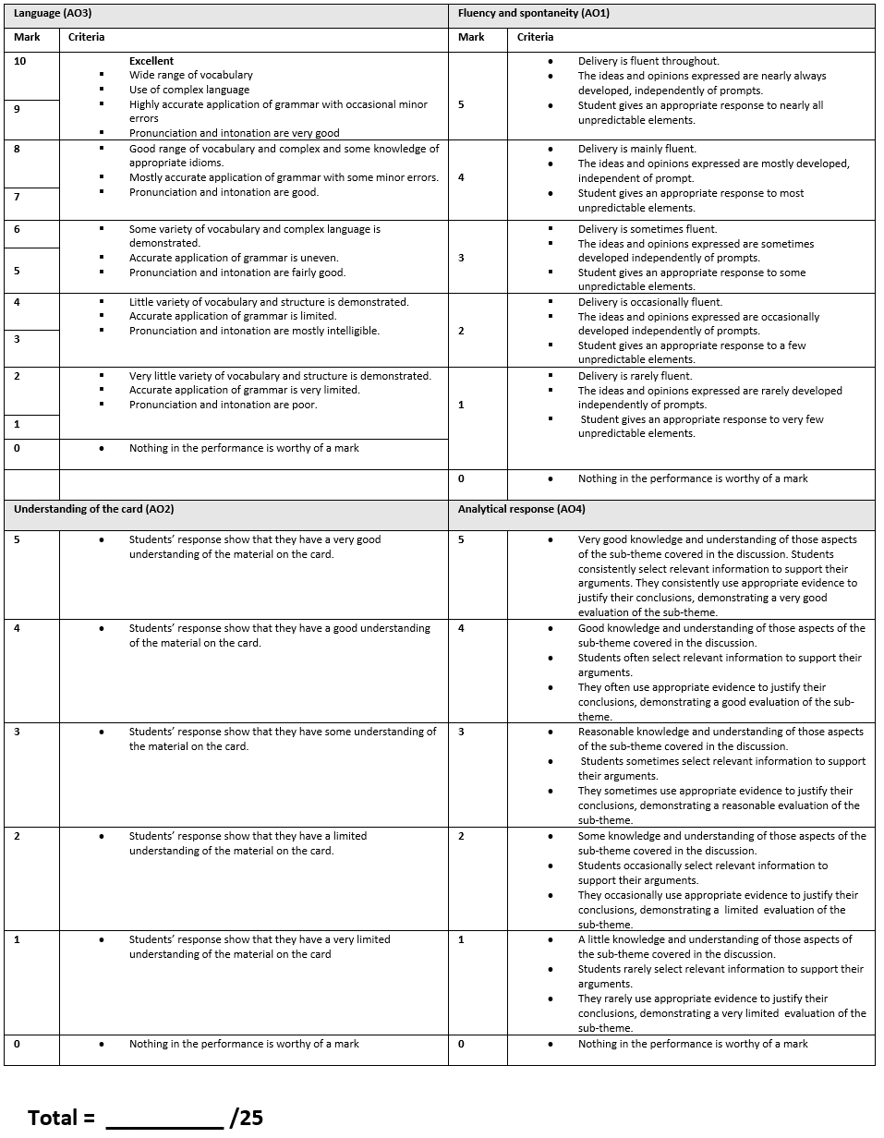
Explanation of the Independent Reasearch Project (IRP)
1. Choosing Your Topic:
- Key Focus: Select a topic that interests you and relates to a French-speaking country. This will make the research and presentation more engaging.
- Advice: Choose something that is specific enough to allow for detailed analysis but broad enough to have accessible sources.
  - Examples: "The role of social media in French politics," "The impact of immigration in contemporary France," "French cinema and its global influence."
2. Researching the Topic:
- Key Focus: Gather a variety of sources (minimum 2, maximum 10). At least one source should be from the internet.
- Advice: Focus on credible sources, such as articles, books, documentaries, and academic papers. Use reliable websites like French news outlets, academic journals, or government reports.
  - Take detailed notes and highlight key points, quotes, and statistics.
3. Planning Your Presentation:
- Key Focus: Your presentation should last 2 minutes and be well-structured.
- Advice:
  - Introduction: Briefly introduce your topic and why you chose it.
  - Main Body: Discuss the key findings, arguments, or points from your research. Use a logical order.
  - Conclusion: Summarize your findings and provide your personal opinion or reflection.
Practice delivering the presentation without notes to ensure fluency and confidence.
4. Giving Your Presentation:
- Key Focus: Speak clearly and confidently, using your own words. Avoid reading directly from your notes.
- Advice:
  - Use linking phrases like D'abord, Ensuite, Finalement to structure your presentation.
  - Include your own analysis and opinions, showing you can discuss the topic critically.
  - Be ready to give examples from your research and the French-speaking world.
  - Avoid overloading with information—focus on the key points that best showcase your research.
5. Handling the Q&A Session (Discussion):
- Key Focus: You will be asked questions for 9-10 minutes following your presentation. Prepare to discuss and defend your research in depth.
- Advice:
  - Think about potential questions beforehand, such as:
    - "Why did you choose this topic?"
    - "What was the most interesting discovery during your research?"
    - "Can you elaborate on a particular point?"
    - "Do you think this issue is important in the French-speaking world?"
  - Practice answering questions in French, using relevant vocabulary and providing detailed, thoughtful responses.
  - If you don’t understand a question, don’t hesitate to ask the examiner to repeat it.
6. Language Skills:
- Key Focus: Show a variety of language skills in the presentation and discussion.
- Advice:
  - Use different tenses (present, past, future) to demonstrate language flexibility.
  - Use complex structures and expressions like Il est important de noter que, Il est essentiel de souligner que, Cela montre que.
  - Avoid simple, repetitive phrases. Instead, vary your vocabulary and sentence structures.
7. Dealing with Challenges:
- Key Focus: Be prepared for unexpected questions or challenges during the discussion.
- Advice:
  - Stay calm if you don’t know the answer to a question. Offer a well-reasoned response or say that you’re unsure but would be happy to research it further.
  - Don’t be afraid to express personal opinions, as long as they are justified with relevant information.
  - If you make a mistake, don’t panic—correct yourself if needed and keep going. The examiner is more interested in your communication skills than in perfection.
8. Managing Time:
- Key Focus: Ensure your presentation fits within the 2-minute time limit, and you have enough time to answer questions.
- Advice: Practice your presentation several times to ensure it stays within the time frame. Focus on the main points and avoid unnecessary details.
9. Showing Your Knowledge of the French-Speaking World:
- Key Focus: Link your research to the wider context of the French-speaking world.
- Advice: Demonstrate how your topic connects to real-world issues in French-speaking countries. You might also compare France with other Francophone regions or explore historical developments.
The markscheme (IRP and ensuing conversation) (total = 35)
Language (AO3) |  | Fluency and spontaneity (AO1)
Mark | Criteria | Mark | Criteria
10 | - A wide range of vocabulary and complex and a good knowledge of appropriate idioms are demonstrated.  - Highly accurate application of grammar with occasional minor errors.  - Pronunciation and intonation are very good. | 10 | - Delivery is fluent throughout.  - The ideas and opinions expressed are nearly always developed, independently of prompts.  - Students engage very well in the discussion and give an appropriate response to nearly all questions.
9 |  | 9
8 | - A good range of vocabulary and complex and some knowledge of appropriate idioms are demonstrated.  - Mostly accurate application of grammar with some minor errors.  - Pronunciation and intonation are good. | 8 | - Delivery is mainly fluent.  - The ideas and opinions expressed are mostly developed, independently of prompts.  - Students engage well in the discussion and give an appropriate response to most questions.
7 |  | 7
6 | - Some variety of vocabulary and complex language is demonstrated.  - Accurate application of grammar is uneven.  - Pronunciation and intonation are fairly good | 6 | - Delivery is sometimes fluent.  - The ideas and opinions expressed are sometimes developed, independently of prompts.  - Students engage reasonably well in the discussion and give an appropriate response to some questions.
5 |  | 5
4 | - Little variety of vocabulary and structures is demonstrated.  - Accurate application of grammar is limited.  - Pronunciation and intonation are mostly intelligible. | 4 | - Delivery is occasionally fluent.  - The ideas and opinions expressed are occasionally developed, independently of prompts.  - Students engage to a limited extent in the discussion and give an appropriate response to a few questions.
3 |  | 3
2 | - Very little variety of vocabulary and structure is demonstrated.  - Accurate application of grammar is very limited.  - Pronunciation and intonation are poor. | 2 | - Delivery is rarely fluent.  - The ideas and opinions expressed are rarely developed, independently of prompts.  - Students engage to a very limited extent in the discussion and give an appropriate response to very few questions.
1 |  | 1
0 | - Nothing in the performance is worthy of a mark | 1
 |  | 0 | - Nothing in the performance is worthy of a mark
Quality of analytical response (AO4) |  | Knowledge and understanding (AO4)
10 | Excellent critical and analytic response  - From the research carried out, the student has acquired thorough knowledge and understanding of the culture and society relevant to the chosen topic. Students consistently select relevant information to support their arguments. They consistently use appropriate evidence to justify their conclusions, demonstrating an excellent evaluation of their chosen topic.  - Students’ response show that they have a good understanding of the material on the card. | 5 | - Thorough knowledge and understanding of the area of study are evident in the presentation.
9 |  | 4 | - Good knowledge and understanding of the area of study are evident in the presentation.
8 | Good critical and analytic response  - From the research carried out, the student has acquired good knowledge and understanding of the culture and society relevant to the chosen topic. Students often select relevant information to support their arguments. They often use appropriate evidence to justify their conclusions, demonstrating a good evaluation of their chosen topic. | 3 | - Reasonable knowledge and understanding of the area of study are evident in the presentation
7 |  | 2 | - Limited knowledge and understanding of the area of study are evident in the presentation
6 | Reasonable critical and analytic response  - From the research carried out, the student has acquired reasonable knowledge and understanding of the culture and society relevant to the chosen topic. Students sometimes select relevant information to support their arguments. They sometimes use appropriate evidence to justify their conclusions, demonstrating a reasonable evaluation of their chosen topic. | 1 | - Very limited knowledge and understanding of the area of study are evident in the presentation
5 |  | 0 | - Nothing in the performance is worthy of a mark
4 | Limited critical and analytic response  - From the research carried out, the student has acquired some knowledge and understanding of the culture and society relevant to the chosen topic. Students occasionally select relevant information to support their arguments. They occasionally use appropriate evidence to justify their conclusions, demonstrating a limited evaluation of their chosen topic. | What Went Well=  Even Better If=
3
2 | Very limited critical and analytic response  - From the research carried out, the student has acquired little knowledge and understanding of the culture and society relevant to the chosen topic. Students rarely select relevant information to support their arguments. They rarely use appropriate evidence to justify their conclusions, demonstrating a very limited evaluation of their chosen topic.
1
0 | - Nothing in the performance is worthy of a mark

Les techniques pour les oraux
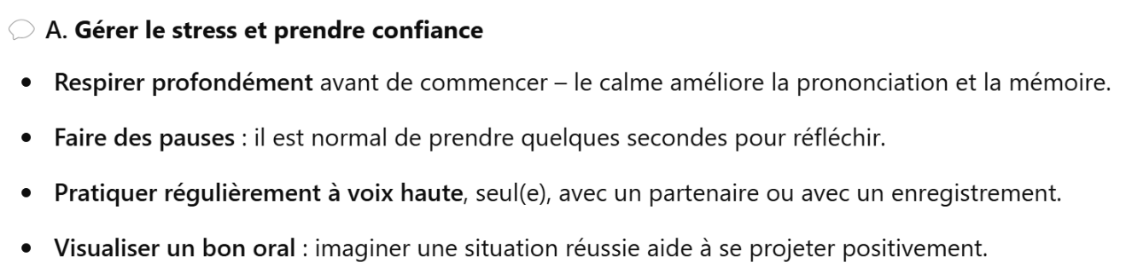
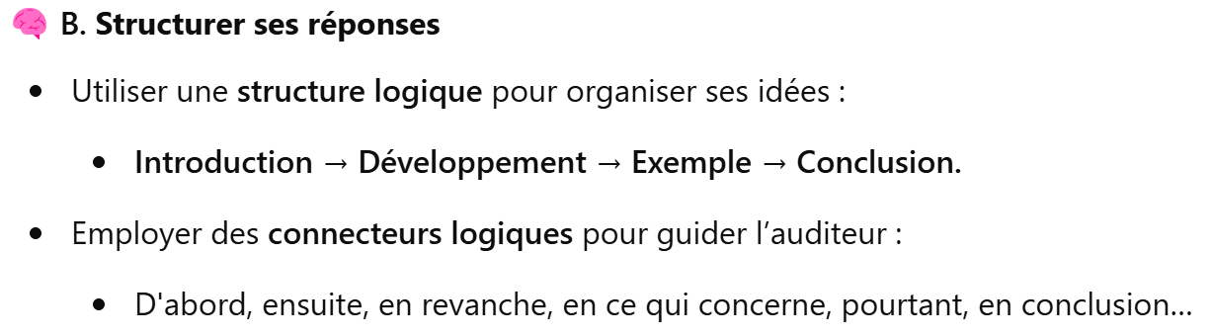
✅ Modèles de phrases types pour les oraux
🟡 Donner son opinion | 🟢 Justifier ou développer
- À mon avis, …  - Personnellement, je pense que…  - Il me semble que…  - Ce que je trouve intéressant, c’est que…  - Je dirais que… | - Cela peut s’expliquer par le fait que…  - En effet, …  - Prenons l’exemple de…  - Cela me fait penser à…  - D’un côté…, mais d’un autre…
🔵 Nuancer | 🟣 Réagir ou répondre à une question
- Certes…, mais…  - Bien que + subjonctif, …  - Il est vrai que…, cependant…  - On ne peut pas nier que…, néanmoins… | - C’est une question très pertinente.  - Je n’y avais jamais pensé, mais je dirais que…  - Si je comprends bien, vous me demandez si…  - Pour répondre à votre question, je pense que…
🟠 Suggérer ou proposer | Gérer l'intéraction avec l’examinateur
- On pourrait envisager que…  - Il serait peut-être utile de…  - Une solution serait de… | - Pourriez-vous répéter, s’il vous plaît ?  - Pourriez-vous reformuler ?  - Si je comprends bien, vous me demandez si…

UNITÉ 7 : LES ASPECTS POSITIFS D’UNE SOCIÉTÉ DIVERSE

1. Le vocabulaire
2. Test de connaissance
3. Factsheet
4. Carte mentale
5. Pratique de la carte photo
6. Pratique du projet de recherche
7. Questions de conversation

1. Le vocabulaire
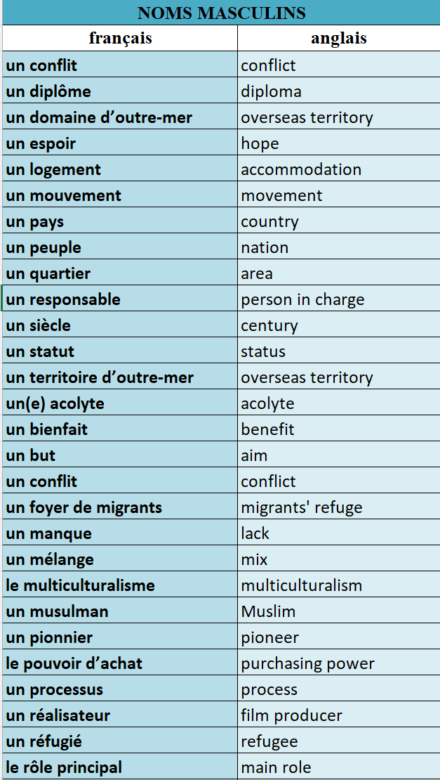
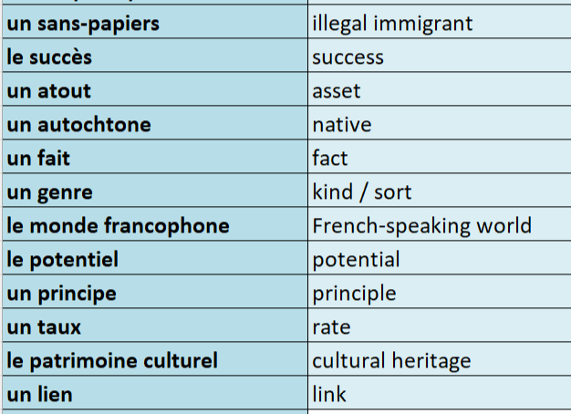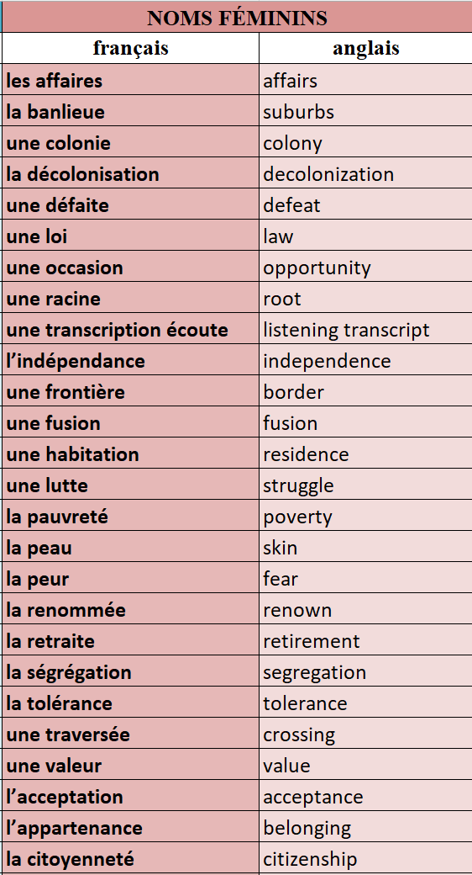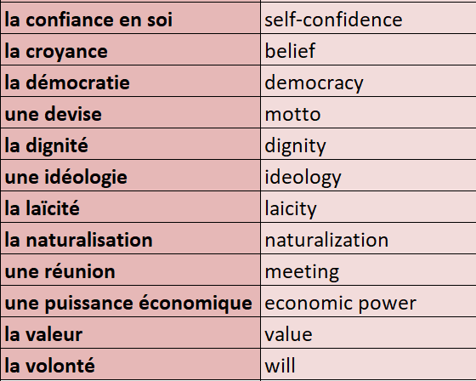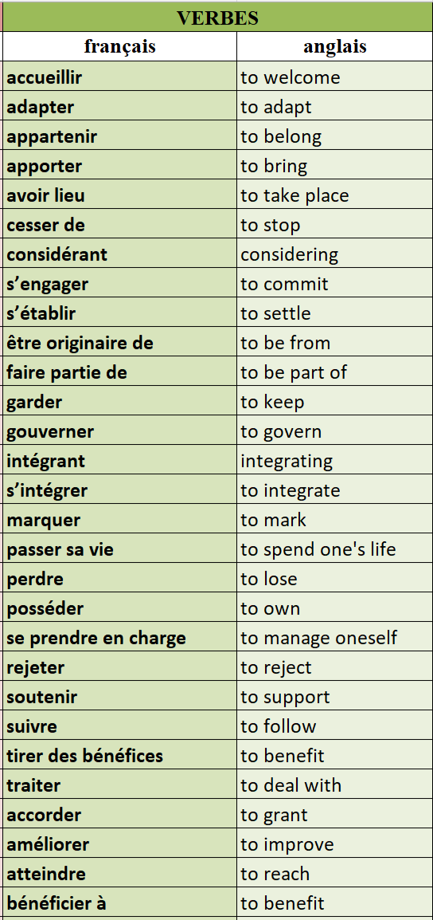
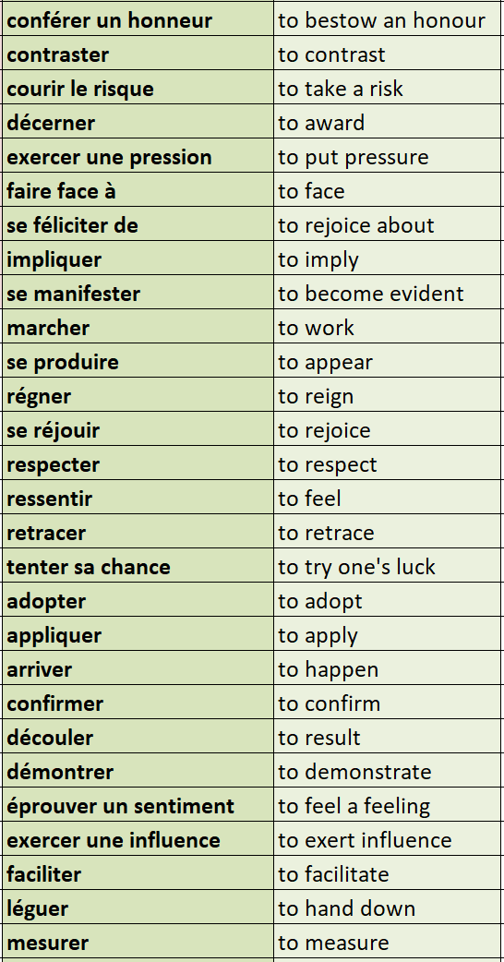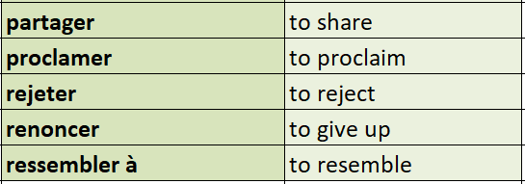
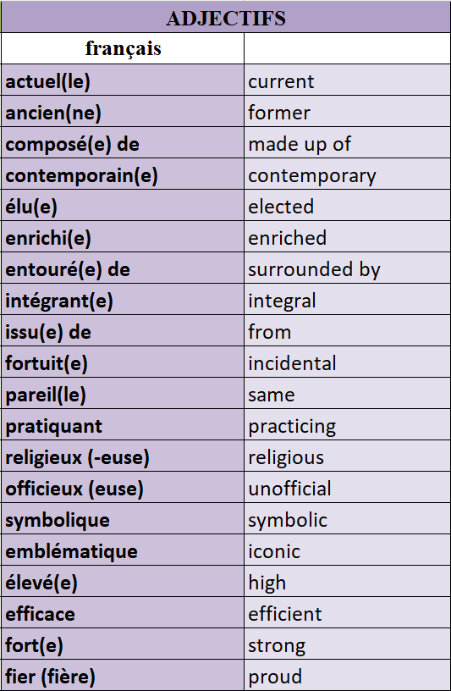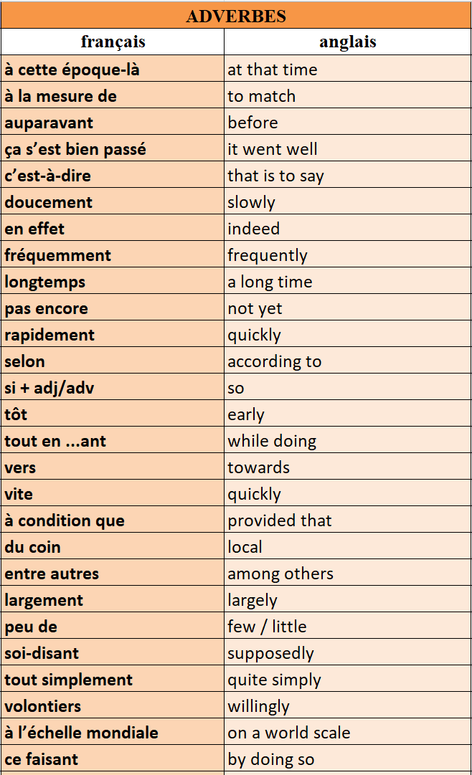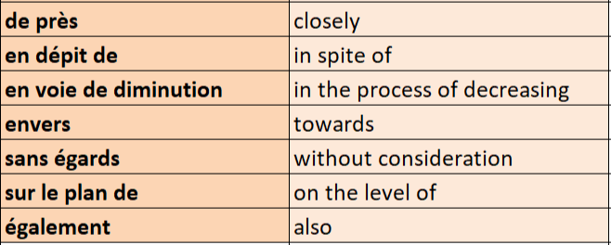

2. Test de connaissances
📝 QCM – Choisis la bonne traduction
- Que signifie “un foyer de migrants” ? o a) A family home
o b) A migrant center
o c) A university dorm
o d) A political group
- Que veut dire “la tolérance” ? o a) Tolerance
o b) Segregation
o c) Law
o d) Fear
- “S’intégrer” veut dire : o a) To leave one’s country
o b) To integrate
o c) To segregate
o d) To fight
🔄 Traduction – Traduis en anglais 4. Un territoire d’outre-mer = ❓
5. Une traversée = ❓
6. Se manifester = ❓
✅ Vrai ou Faux 7. “Un sans-papiers” signifie “an illegal immigrant”.
→ ❓
- “Le multiculturalisme” est le fait de mélanger plusieurs cultures dans une même société.
→ ❓
🧠 Quiz – Vocabulaire : Conflits, société et citoyenneté
📝 QCM
- Que veut dire “le pouvoir d’achat” ? o a) Purchasing power
o b) Voting power
o c) Financial aid
o d) Shopping habits
- “Un responsable” signifie : o a) A teacher
o b) A manager
o c) A person in charge
o d) A judge
- Que signifie “soutenir” ? o a) To support
o b) To suffer
o c) To resist
o d) To submit
🔄 Traduction 4. La citoyenneté = ❓
5. Rejeter = ❓
6. Un processus = ❓
✅ Vrai ou Faux 7. “Un pionnier” est quelqu’un qui commence ou développe quelque chose en premier.
→ ❓
- “La démocratie” est un système où le pouvoir est détenu par un seul individu.
→ ❓

3. Factsheet
📊 Knowledge: Information and trend
- En 2019, la France est le premier pays d’accueil non-anglophone pour les étudiants étrangers.
- Le motif étudiant est la première raison d’octroi de titres de séjour.
- En 2017, les étudiants internationaux représentaient 10% des inscrits dans le supérieur.
- Un auto-entrepreneur sur dix issu de l’immigration emploie plus de salariés que ses homologues français d’origine.
- En 2019, l’immigration professionnelle a augmenté de 15% ; elle représente 14% des titres délivrés.
- La majorité des joueurs de l’équipe de France championne du monde 2018 avaient des origines immigrées : 18 sur 23.
- Il y a une augmentation constante du nombre de médecins étrangers, leur nombre ayant doublé entre 2007 et 2017.
- En 2019, 150 000 emplois non pourvus en France ; 50% des entreprises peinent à recruter.
🧠 Understanding 1: Contextualisation
- Le système d’enseignement supérieur français est gratuit ou peu coûteux, ce qui le rend attractif pour les étudiants étrangers.
- Depuis 2016, le « passeport-talent » permet aux personnes qualifiées et entrepreneurs étrangers de s’installer en France (4 ans, renouvelable).
- Le visa French Tech simplifie l’installation des professionnels innovants.
- Dans les années 70-80, les footballeurs issus de l’immigration ont commencé à intégrer massivement l’équipe nationale.
- La France fait face à une pénurie de médecins, liée au déclin du nombre de jeunes diplômés.
- Les entreprises doivent justifier l’embauche de travailleurs étrangers, ce qui freine parfois l'immigration professionnelle.
🌍 Understanding 2: Cultural analysis
- La France affirme une volonté de rester compétitive à l’échelle internationale (étudiants, entrepreneurs, scientifiques).
- Le cas des joueurs de football illustre la fierté nationale autour de la diversité, notamment avec le slogan « black-blanc-beur » en 1998.
- La forte présence d’étrangers dans des métiers en tension reflète l’importance des immigrés dans l’économie française.
- Le Canada, comparé à la France :
  - est leader en immigration qualifiée selon l’OCDE,
  - a mis en place une stratégie globale d’attractivité,
  - valorise une politique assumée de multiculturalisme depuis 1971,
  - a vu 2/3 de sa croissance démographique (2011-2016) attribuée à l'immigration.
4. Carte mentale

5. Pratique de la carte photo
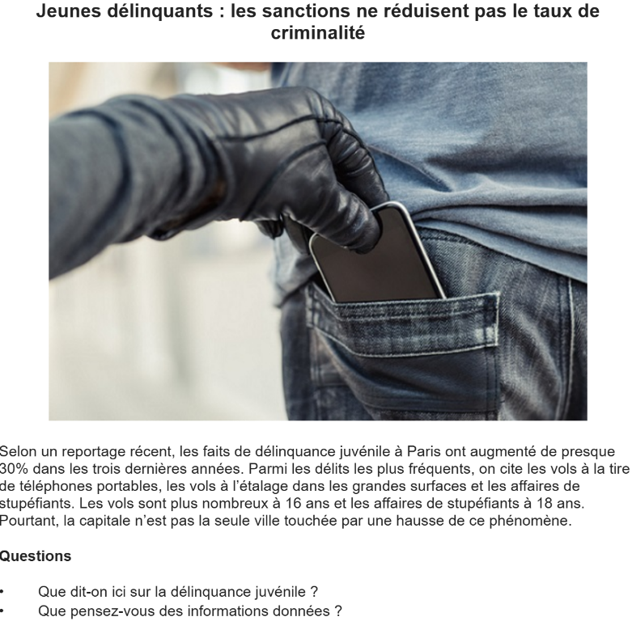
____________________________________________________________________________________________________________________________________________________________________________________________________________________________________________________________________________________________________________________________________________________________________________________________________________________________________________________________________________________________________________________________________________________________________________________________________________________________________________________________________________________________________________________________________________________________________________________________________________________________________________________________________________________________________________________________________________________________________________________________________________________________________________________________________________________________________________________________________________________________________________________________________________________________________________________________________________________________________________________________________________________________________________________________________________________________________________________________________________________________________________________________________________________________________________________________________________________________________________________________________________________________________________________________________________________________________________________________________________________________________________________________________________
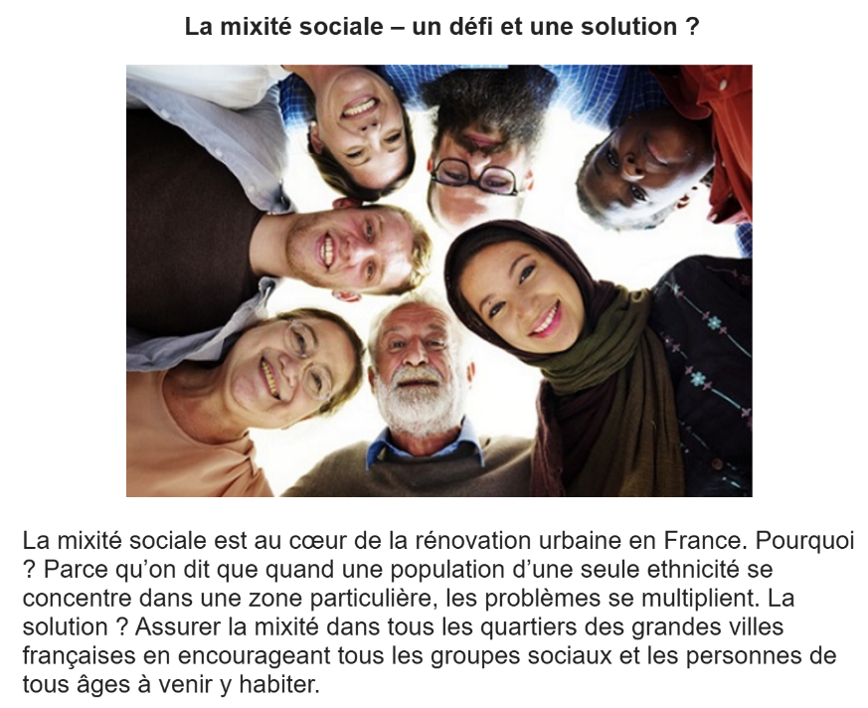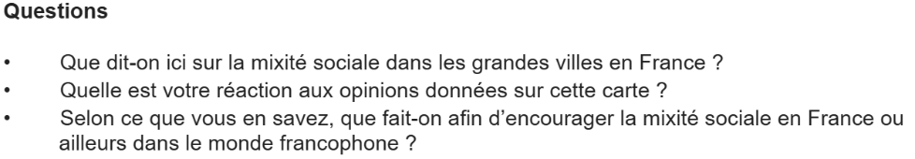
________________________________________________________________________________________________________________________________________________________________________________________________________________________________________________________________________________________________________________________________________________________________________________________________________________________________________________________________________________________________________________________________________________________________________________________________________________________________________________________________________________________________________________________________________________________________________________________________________________________________________________________________________________________________________________________________________________________________________________________________________________________________________________________________________________________________________________________________________________________________________________________________________________________________________________________________________________________________________________________________________________________________________________________________________________________________________________________________________________________________________________________________________________________________________________________________________________________________________________________________________________________________________________________________________________________________________________________________________________________________________________________________________________________________________________________________________________________________________________________________________________________________________________
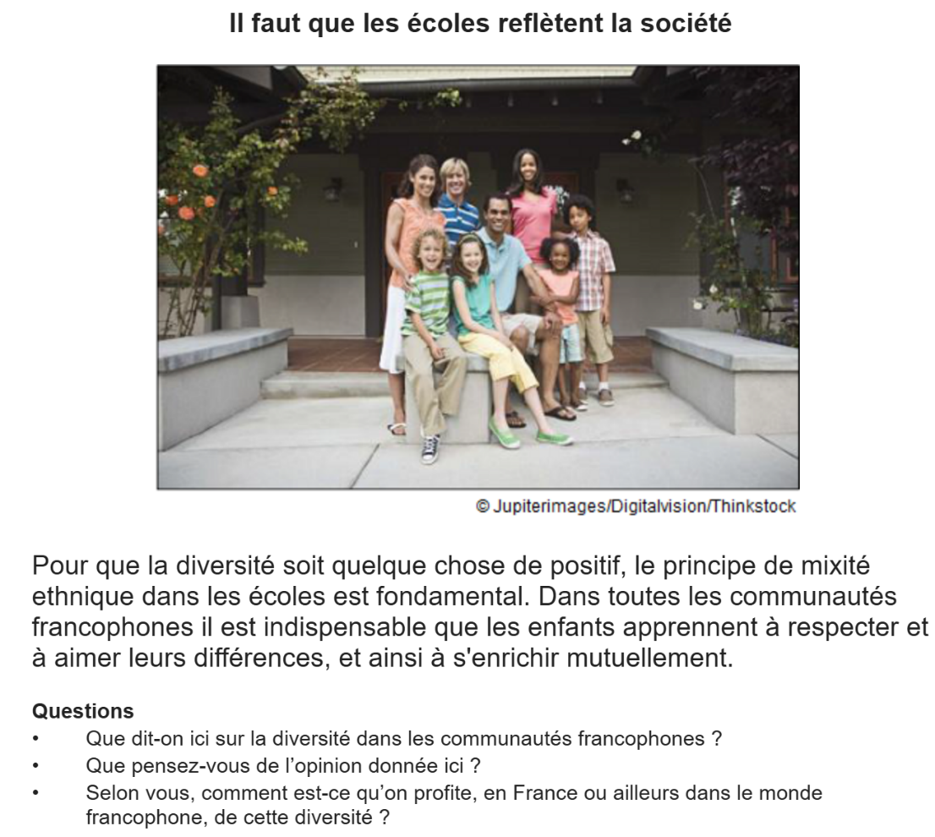
________________________________________________________________________________________________________________________________________________________________________________________________________________________________________________________________________________________________________________________________________________________________________________________________________________________________________________________________________________________________________________________________________________________________________________________________________________________________________________________________________________________________________________________________________________________________________________________________________________________________________________________________________________________________________________________________________________________________________________________________________________________________________________________________________________________________________________________________________________________________________________________________________________________________________________________________________________________________________________________________________________________________________________________________________________________________________________________________________________________________________________________________________________________________________________________________________________________________________________________________________________________________________________________________________________________________________________________________________________________________________________________________________________________________________________________________________________________________________________________________________________________________________________
6. Pratique du projet de recherche
Choisis un des quatre sujets suivants et prépare une présentation de deux minutes. Tu peux t’aider des bullets points ci-dessous.
A 5-year review and analysis of Canada’s ‘Express Entry’ scheme
- What is the ‘Express Entry’ scheme – how and why did it begin and what is its purpose?
- How does the scheme fit overall with Canada’s approach to immigration?
- What statistics exist regarding the scheme, and what conclusion can be drawn about its success or failure from these?
- What impact has the scheme had on key areas of Canada’s economy?
The causes and effects of migration from DROM-COMs to France
- What are the most significant facts, figures and statistics linked to migration from DROM-COMs to France?
- What is the historic link between DROM-COMs and France, and what role has migration played in the past?
- What are the main reasons for migration from DROM-COMs to France?
- What has been the impact on the economies of the source countries and destination country?
The achievements and success of Najat Vallaud-Belkacem
- How did Najat Vallaud-Belkacem build a career in politics and what have been her main achievements?
- What were the most significant events of her life, and how have these influenced her political activities?
- What have been the main challenges in her education and subsequent political career?
- How does Najat Vallaud-Belkacem embrace her migrant background?
An analysis of Mediterranean migration from francophone African countries
- What are the most significant facts, figures and statistics linked to Mediterranean migration from francophone African countries?
- What are the main reasons for Mediterranean migration from francophone African countries?
- What has been the impact on the economies of the source countries and destination countries?
- What role, if any, does France play in this migration?

7. Questions de conversation

- Comment définirais-tu une société multiculturelle ?
- Quels avantages vois-tu dans la diversité culturelle ?
- En quoi la diversité peut-elle enrichir une société comme la France, la Belgique ou le Canada?
- Comment l’immigration a-t-elle influencé la culture dans le monde francophone ?
- Quelles actions pourraient encourager plus de tolérance et de respect ?
- Connais-tu des figures francophones issues de la diversité qui t’inspirent ?
- As-tu participé à un événement culturel qui célèbre la diversité ?
- Penses-tu que la diversité est toujours bien perçue dans la société ? Pourquoi ?
- Comment l’école peut-elle jouer un rôle dans l’intégration ?
- La diversité culturelle est-elle toujours facile à vivre dans une société ?
- Qu’est-ce qui rend une société réellement diverse selon toi ?
- Quels bénéfices la diversité peut-elle apporter dans le monde du travail ?
- Comment la diversité culturelle influence-t-elle les arts (musique, cinéma, littérature) ?
- Quels défis une société multiculturelle peut-elle rencontrer au quotidien ?
- Que penses-tu de la représentation des minorités dans les médias francophones ?
- Comment les politiques peuvent-elles promouvoir le vivre-ensemble ?
- As-tu un exemple de réussite liée à la diversité dans un pays francophone ?
- Penses-tu que la diversité est bien acceptée partout dans la francophonie ?
- Comment l’éducation peut-elle favoriser une société plus inclusive ?
- La diversité est-elle une richesse ou un défi pour les générations futures ? Explique.

UNITÉ 8 : QUELLE VIE POUR LES MARGINALISÉS ?

1. Le vocabulaire
2. Test de connaissance
3. Factsheet
4. Carte mentale
5. Pratique de la carte photo
6. Pratique du projet de recherche
7. Questions de conversation

1. Le vocabulaire

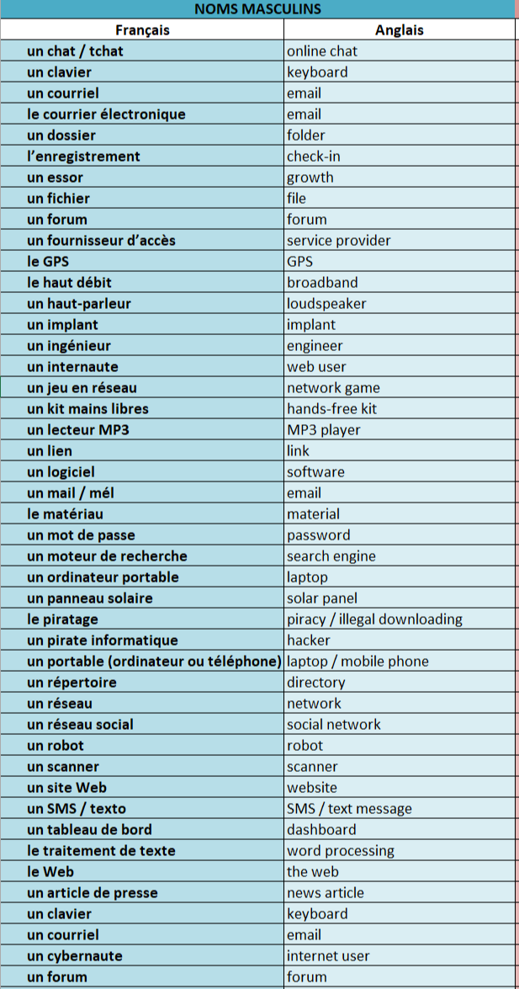
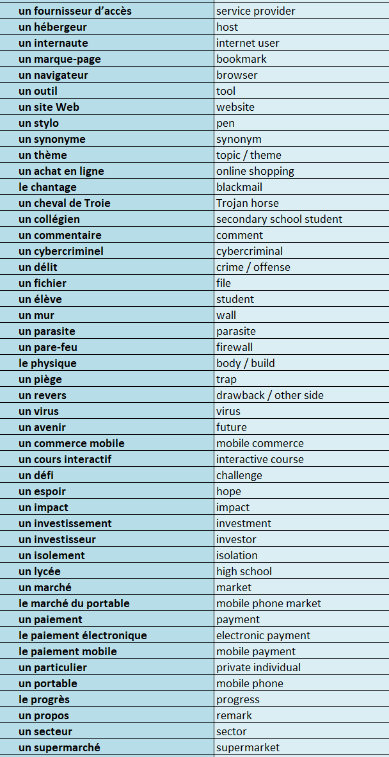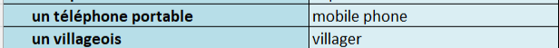
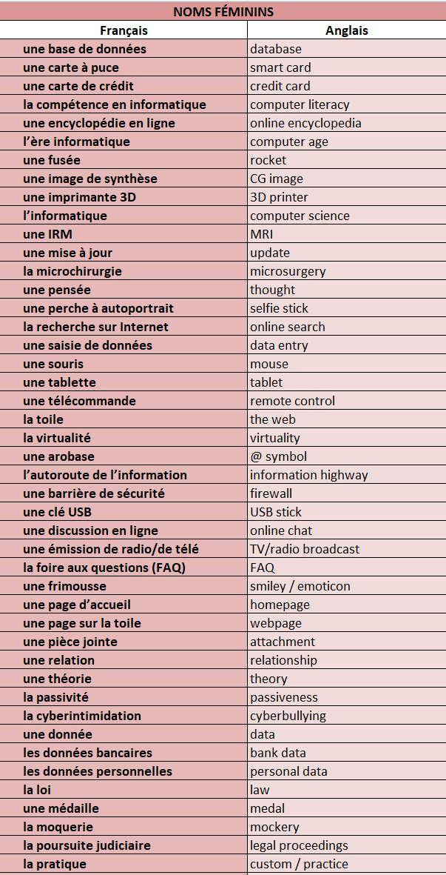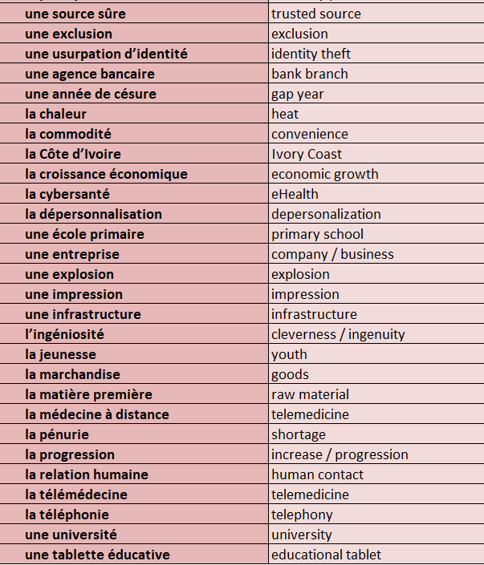
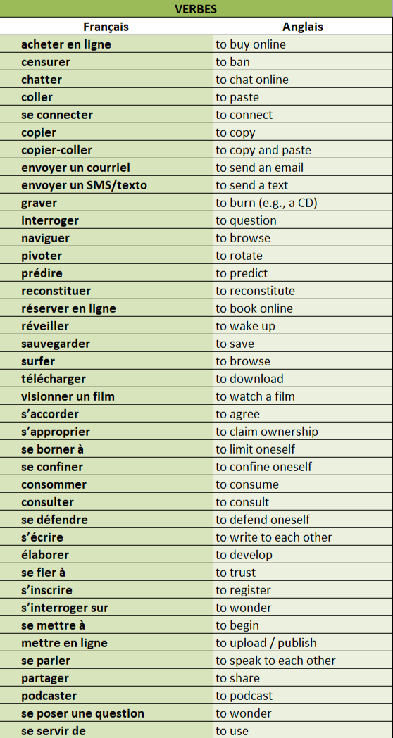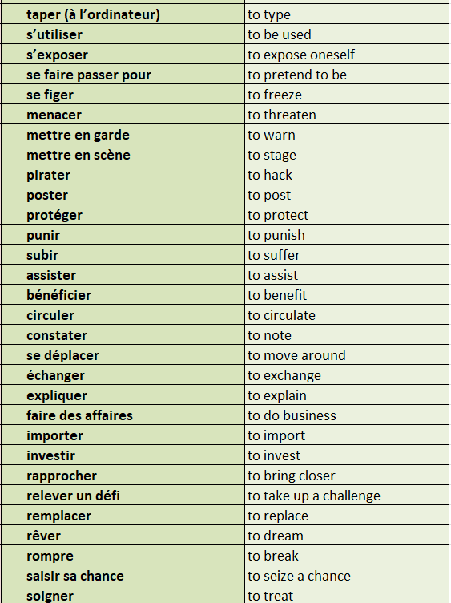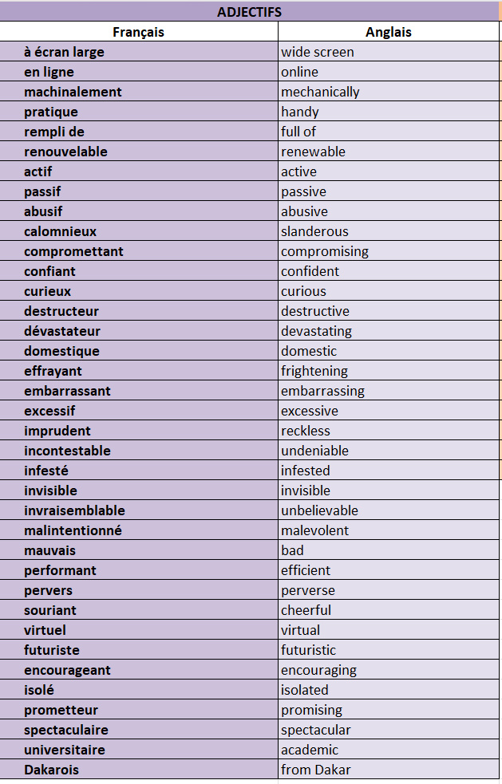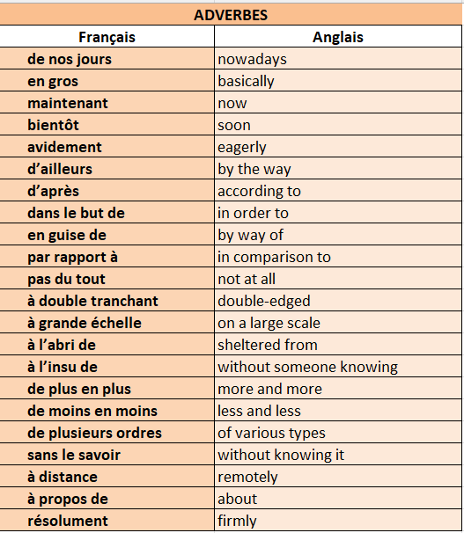

2. Test de connaissance
📝 QCM – Choisis la bonne traduction
- Que signifie “une cyberintimidation” ? o a) Online job interview
o b) Cyberbullying
o c) Cybersecurity
o d) A tech startup
- Que veut dire “un moteur de recherche” ? o a) A search engine
o b) A data file
o c) A chatbot
o d) A hard drive
- “Saisir sa chance” veut dire : o a) To miss your chance
o b) To lose hope
o c) To seize an opportunity
o d) To keep a secret
🔄 Traduction – Traduis en anglais 4. Une tablette éducative = ❓
5. Mettre en ligne = ❓
6. Un appareil de géolocalisation = ❓
✅ Vrai ou Faux 7. “Un pirate informatique” signifie “internet provider”.
️→ ❓
- “Un fichier” est un document numérique que l’on peut sauvegarder.
️→ ❓
🧠 Quiz – Vocabulaire : Pratiques et outils du numérique
📝 QCM
- Que veut dire “consommer” ? o a) To create
o b) To consume
o c) To communicate
o d) To control
- “Un pare-feu” signifie : o a) A keyboard
o b) A web server
o c) A firewall
o d) A backup system
- Que signifie “faire des affaires” ? o a) To do business
o b) To study
o c) To send messages
o d) To argue
🔄 Traduction 4. Une mise à jour = ❓
5. Partager = ❓
6. Un commerce mobile = ❓
✅ Vrai ou Faux 7. “S'exposer” veut dire "to protect oneself".
️→ ❓
- “Une souris” est un périphérique informatique.
️→ ❓

3. Factsheet
📊 Connaissances : Informations et tendances
- Les Français passent en moyenne 2h12 par jour en ligne, dont 1h24 sur mobile.
- 60 % utilisent les réseaux sociaux quotidiennement (notamment Facebook, Instagram, WhatsApp).
- 86 % ont une connexion internet fixe ; 75 % possèdent un smartphone.
- La Génération Z (10-25 ans) passe près de 4h par jour sur mobile ; 98 % ont un smartphone.
- La France prévoit un réseau 100 % 5G d’ici 2030 ; lancement initial prévu en 2020 dans 5 à 10 villes.
- La France est au 7e rang mondial pour les start-ups en intelligence artificielle.

🌍 Compréhension 1 : Contextualisation
- L’usage d’Internet en France est généralisé et en constante augmentation, tous appareils confondus.
- Le gouvernement et les écoles agissent contre la dépendance aux smartphones chez les jeunes (interdiction à l’école depuis 2018).
- Un campus cybersécurité en région parisienne rassemblera 700-800 experts dès 2021.
- Microsoft a ouvert une École IA en France pour faire face au besoin croissant en compétences IA.
- Le programme Digital Africa soutient l’innovation en Afrique avec 65 millions € financés par la France.

🎭 Compréhension 2 : Analyse culturelle
- La cyberdépendance des jeunes est un enjeu majeur de société en France, notamment au niveau éducatif.
- La cybercriminalité est un risque important : la France est le 2e pays le plus touché d’Europe.
- Le gouvernement adopte une stratégie proactive en intelligence artificielle (budget : 1,5 milliard €).
- L’aide au développement numérique en Afrique francophone illustre une volonté de moderniser les relations France-Afrique.
- Le déploiement de la 5G est vu comme une étape clé de modernisation, malgré son coût élevé (2 milliards €).

4. Carte mentale

5. Pratique de la carte photo
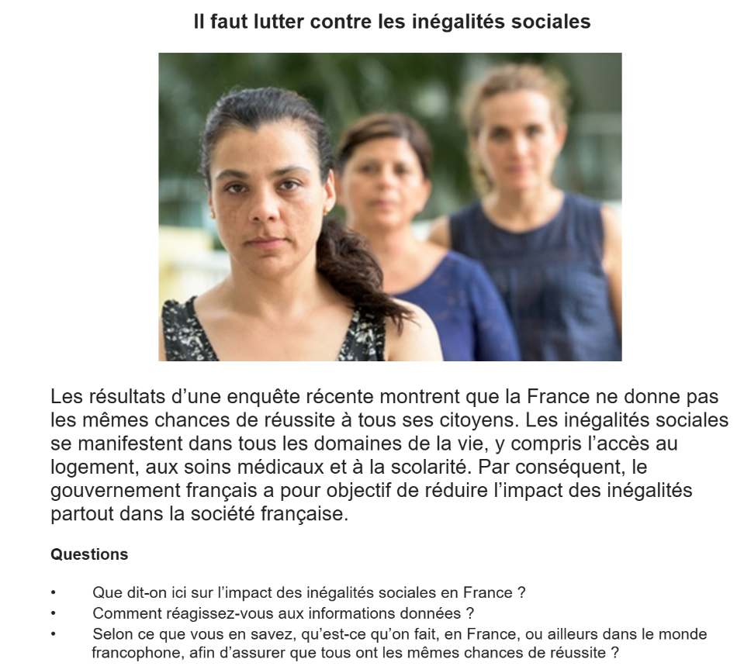
________________________________________________________________________________________________________________________________________________________________________________________________________________________________________________________________________________________________________________________________________________________________________________________________________________________________________________________________________________________________________________________________________________________________________________________________________________________________________________________________________________________________________________________________________________________________________________________________________________________________________________________________________________________________________________________________________________________________________________________________________________________________________________________________________________________________________________________________________________________________________________________________________________________________________________________________________________________________________________________________________________________________________________________________________________________________________________________________________________________________________________________________________________________________________________________________________________________________________________________________________________________________________________________________________________________________________________________________________________________________________________________________________________________________________________________________________________________________________________________________________________________________________________
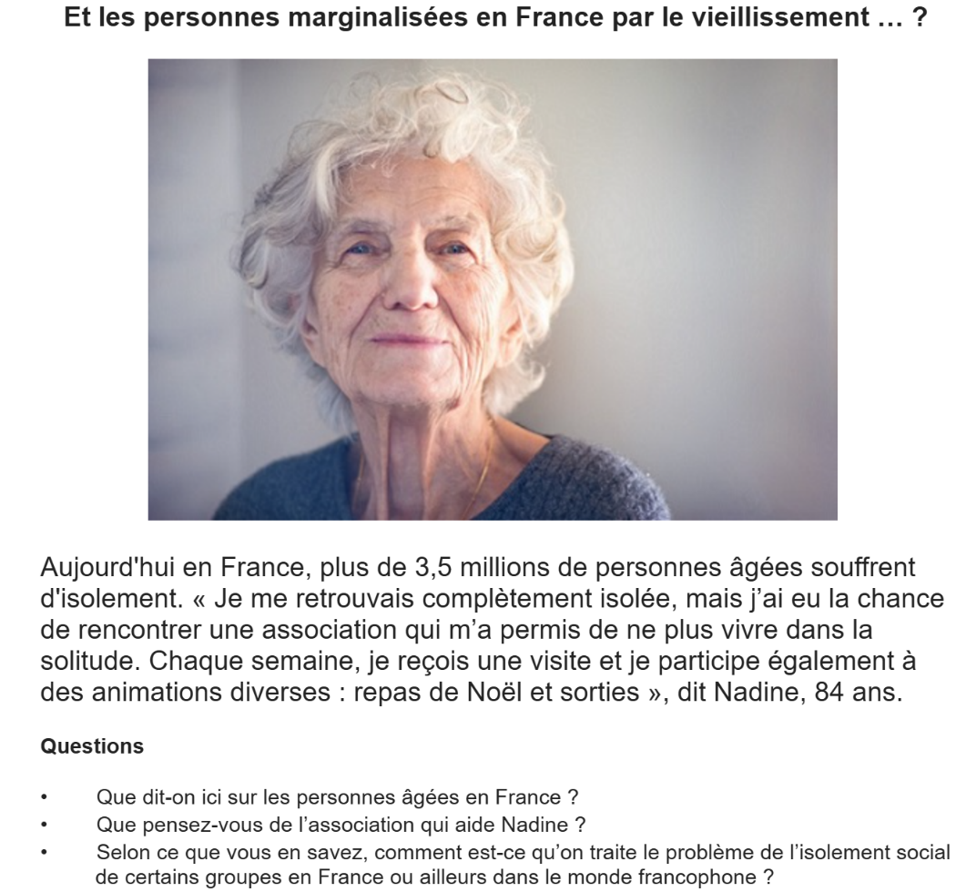
____________________________________________________________________________________________________________________________________________________________________________________________________________________________________________________________________________________________________________________________________________________________________________________________________________________________________________________________________________________________________________________________________________________________________________________________________________________________________________________________________________________________________________________________________________________________________________________________________________________________________________________________________________________________________________________________________________________________________________________________________________________________________________________________________________________________________________________________________________________________________________________________________________________________________________________________________________________________________________________________________________________________________________________________________________________________________________________________________________________________________________________________________________________________________________________________________________________________________________________________________________________________________________________________________________________________________________________________________________________________________________________________________________________________________________________________________________________________________________________________________________________________________________________________________________________________________________________________________________________________________________________________________________________
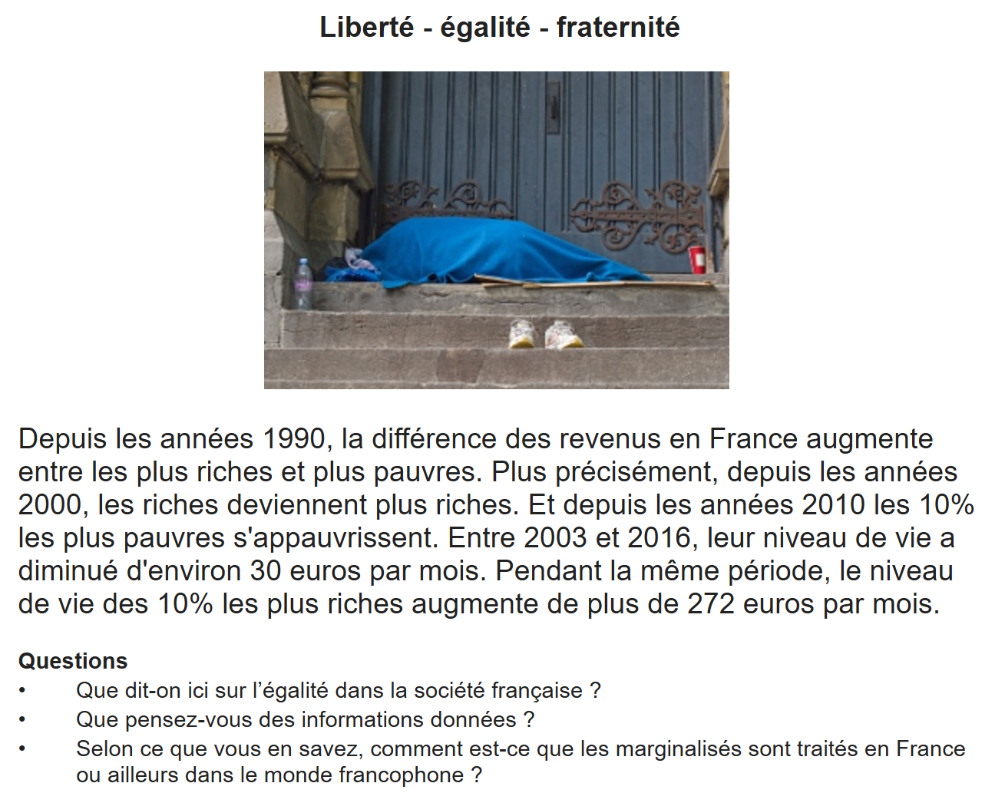
________________________________________________________________________________________________________________________________________________________________________________________________________________________________________________________________________________________________________________________________________________________________________________________________________________________________________________________________________________________________________________________________________________________________________________________________________________________________________________________________________________________________________________________________________________________________________________________________________________________________________________________________________________________________________________________________________________________________________________________________________________________________________________________________________________________________________________________________________________________________________________________________________________________________________________________________________________________________________________________________________________________________________________________________________________________________________________________________________________________________________________________________________________________________________________________________________________________________________________________________________________________________________________________________________________________________________________________________________________________________________________________________________________________________________________________________________________________________________________________________________________________________________________
6. Pratique du projet de recherche
Choisis un des quatre sujets suivants et prépare une présentation de deux minutes. Tu peux t’aider des bullets points ci-dessous.
The history and impact of digital education in francophone Africa
- What is the current status of digital education in francophone Africa (for adults and young people)?
- What role does the international community play regarding digital education in francophone Africa, for example investment or shared projects?
- What recent progress has been made or is planned regarding digital education in francophone Africa?
- What success stories exist linked to digital education in francophone Africa, for example important inventions or research?

The role of social media in French society — friend or foe?
- What are the most popular social networks in France, and how/when/why/by whom are they used?
- What are the most recent scandals involving social medias, and what was the impact of these events?
- What laws and regulations specific to France exist regarding social media?
- What projects and plans exist regarding the positive use of social media?

How does Switzerland manage cybersecurity?
- What are currently the biggest threats and risks regarding cybersecurity in Switzerland?
- What are the most up-to-date statistics regarding cyberattacks in Switzerland, for example number of citizens affected, potential financial losses/costs and effects on businesses and trading?
- What were the most recent cyberattacks in Switzerland and what was the impact of these?
- What government strategies exist regarding cybersecurity? How successful have these been?

An analysis of Macron’s 3-year technology and innovation plan in France
- What measures has Macron announced to boost the French technology market?
- What are the main areas of interest that have been identified?
- What has been the impact of any measures introduced so far?
- What potential problems have been identified with current or future measures?

7. Questions de conversation
- Qui sont les personnes marginalisées dans la société française aujourd’hui ?
- Quelles sont les principales causes de l’exclusion sociale ?
- Quel rôle jouent les préjugés dans l’exclusion de certains groupes ?
- À ton avis, pourquoi certaines personnes choisissent de vivre en marge de la société ?
- Penses-tu que l’exclusion sociale touche davantage certaines régions ou villes que d’autres ? Pourquoi ?
- Comment les médias présentent-ils les personnes marginalisées ?
- Peut-on vraiment lutter efficacement contre l’exclusion sociale ?
- Que sais-tu des lois françaises concernant l’inclusion des personnes handicapées ?
- Est-ce que les écoles et les lieux publics sont suffisamment accessibles aux personnes handicapées en France ?
- Quels obstacles peuvent rencontrer les personnes handicapées dans la vie quotidienne ?
- Comment peut-on encourager davantage l’autonomie des personnes en situation de handicap ?
- Quel est le rôle des entreprises dans l’intégration professionnelle des personnes handicapées ?
- Que penses-tu des aides sociales en France ? Sont-elles suffisantes pour les personnes marginalisées ?
- Les sans-abri sont-ils bien traités par les autorités et la population ? Pourquoi ou pourquoi pas ?
- Quelle est l’efficacité des centres d’hébergement d’urgence en France ?
- À ton avis, que pourrait faire le gouvernement pour mieux soutenir les jeunes en difficulté ?
- Penses-tu que la prison est la bonne solution pour les personnes marginalisées ayant commis un délit ?
- Quel rôle jouent les associations caritatives comme les Restos du Cœur ou Emmaüs ?
- La société française est-elle suffisamment tolérante envers les différences ?
- Quelles actions concrètes peux-tu, personnellement, entreprendre pour soutenir les marginalisés ?

UNITÉ 9: COMMENT ON TRAITE LES CRIMINELS

1. Le vocabulaire
2. Test de connaissance
3. Factsheet
4. Carte mentale
5. Pratique de la carte photo
6. Pratique du projet de recherche
7. Questions de conversation

1. Le vocabulaire
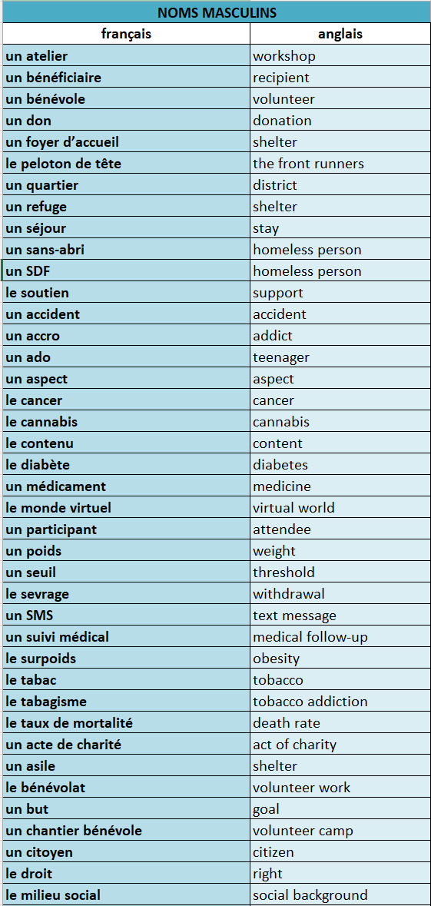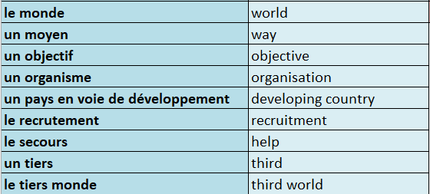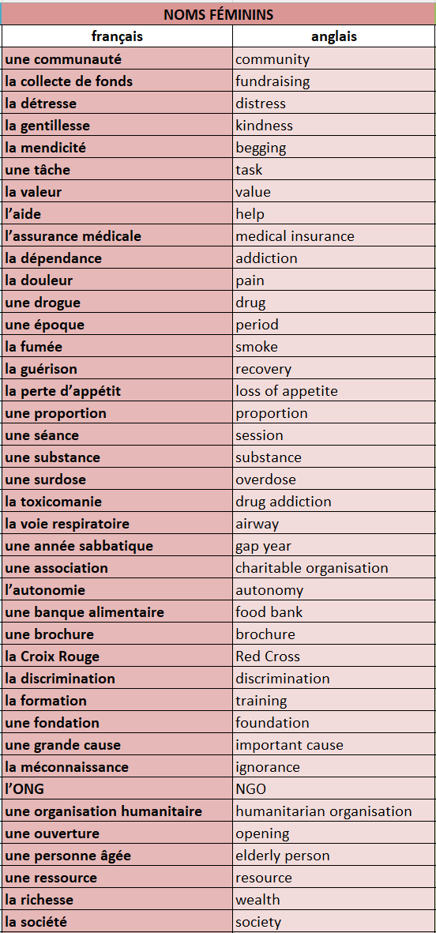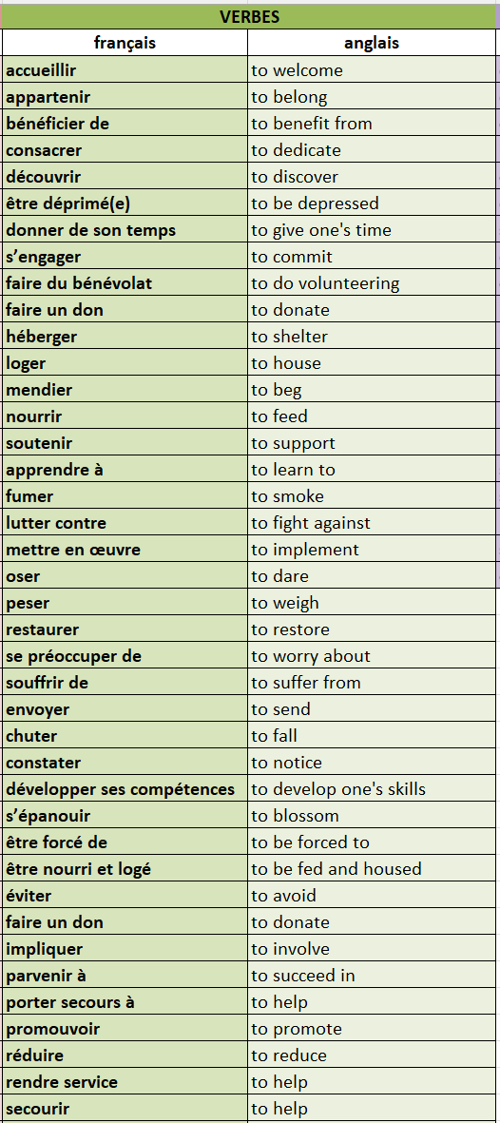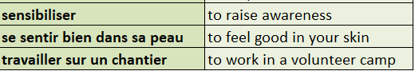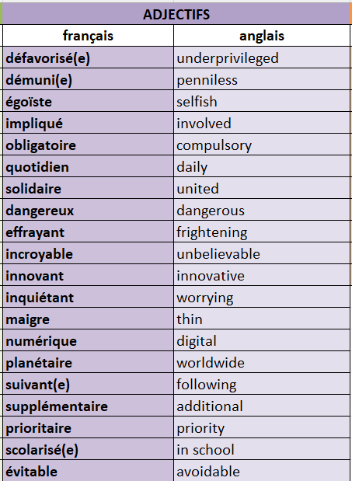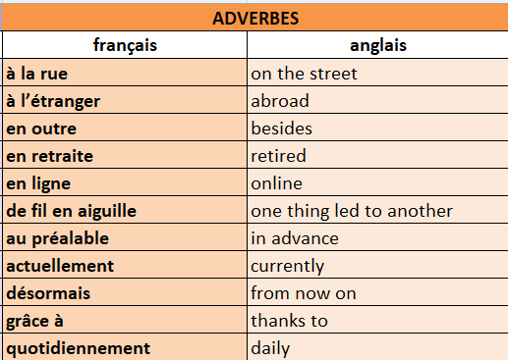

2. Test de connaissances
📜 QCM – Choisis la bonne traduction
- Que signifie “faire du bénévolat” ? o a) To raise funds
o b) To donate money
o c) To do volunteering work
o d) To feed the poor
- Que veut dire “un(e) sans-abri” ? o a) A volunteer
o b) A social worker
o c) A homeless person
o d) A sick person
- “La détresse” veut dire : o a) Happiness
o b) Distress
o c) Confidence
o d) Loneliness
🔄 Traduction – Traduis en anglais 4. Un foyer d’accueil = ❓
5. Défavorisé(e) = ❓
6. La collecte de fonds = ❓
✅ Vrai ou Faux 7. “Mendier” signifie “begging”.
️→ ❓
- “La gentillesse” est un synonyme de “selfishness”.
️→ ❓
🧠 Quiz – Vocabulaire : Le bénévolat transforme les vies
📜 QCM
- Que veut dire “souffrir de” ? o a) To heal
o b) To suffer from
o c) To weigh
o d) To breathe
- “Le tabac” signifie : o a) A drug
o b) Tobacco
o c) Sugar
o d) Smoke
- Que signifie “le monde virtuel” ? o a) The real world
o b) The virtual world
o c) The media
o d) The social network
🔄 Traduction 4. Une drogue = ❓
5. Le taux de mortalité = ❓
6. Quotidiennement = ❓
✅ Vrai ou Faux 7. “Inquiétant” veut dire “worrying”.
️→ ❓
- “Le sevrage” est une phase de dépendance.
️→ ❓
🫠 Quiz – Vocabulaire : L’expérience d’être volontaire
📜 QCM
- Que signifie “une ONG” ? o a) A government office
o b) A social group
o c) A non-governmental organisation
o d) A medical institution
- Que veut dire “une banque alimentaire” ? o a) A food delivery service
o b) A supermarket
o c) A food bank
o d) A restaurant
- “Se sentir bien dans sa peau” veut dire : o a) To feel good about yourself
o b) To be in pain
o c) To wear new clothes
o d) To hide your feelings
🔄 Traduction 4. Un chantier bénévole = ❓
5. Une soupe populaire = ❓
6. Scolarisé(e) = ❓
✅ Vrai ou Faux 7. “Le tiers monde” veut dire “the third world”.
️→ ❓
- “Envoyer” signifie “to receive”.
️→ ❓

3. Factsheet
📊 Knowledge: Information and trend
- En 2019, 1 Français sur 4 est bénévole, soit plus de 12,5 millions de personnes.
- L’engagement est plus élevé chez les retraités.
- Les secteurs les plus populaires : caritatif, sport, loisirs, et culture.
- Les jeunes s’engagent de plus en plus, notamment depuis les attentats de 2015.
- Croix-Rouge française : plus de 60 000 bénévoles en 2020, dont 13 000 de moins de 18 ans.
- Le Passeport Bénévole (depuis 2007) aide à valoriser les compétences acquises.
- Les Banques Alimentaires : 79 banques, 6 500 bénévoles (« Gilets Orange »), 130 000 tonnes de nourriture distribuées/an.
- La loi anti-gaspillage alimentaire (2016, étendue en 2018) impose le don des invendus aux associations.
- Le service civique est accessible aux jeunes de 16 à 25 ans (30 si handicap).
- En 2019, lancement pilote du Service National Universel (SNU) : entre service civique et militaire.
🧠 Understanding 1: Contextualisation
- Législation de 2015 et 2017 : facilite l’engagement des jeunes tout en poursuivant leurs études.
- Les attentats terroristes de 2015 ont renforcé le désir d’engagement citoyen chez les jeunes.
- À la Croix-Rouge, engagement possible dès 7 ans ; dès 16 ans pour les actions sociales comme aider les sans-abri.
- Le Passeport Bénévole est reconnu par l’Éducation nationale et utilisé souvent comme complément de CV.
- Les Banques Alimentaires bénéficient de la loi interdisant le gaspillage alimentaire.
- Le SNU, introduit par Macron, ouvre la voie à un engagement plus large dans la culture, l’environnement ou le tutorat.
🌍 Understanding 2: Cultural analysis
- Le bénévolat est fortement ancré dans la culture française, notamment à travers associations, solidarité et engagement civique.
- Le bénévolat des jeunes est perçu comme une réponse sociale aux crises (terrorisme, précarité).
- Le service civique et le SNU reflètent un changement culturel vers une responsabilité collective plus consciente.
- Le Passeport Bénévole illustre la volonté de professionnaliser et valoriser le bénévolat.
- Les lois contre le gaspillage alimentaire montrent un engagement éthique et social à l’échelle nationale.
- La France se positionne comme pionnière dans la lutte contre le gaspillage et la promotion de l’engagement solidaire.
4. Carte mentale

5. Pratique de la carte photo
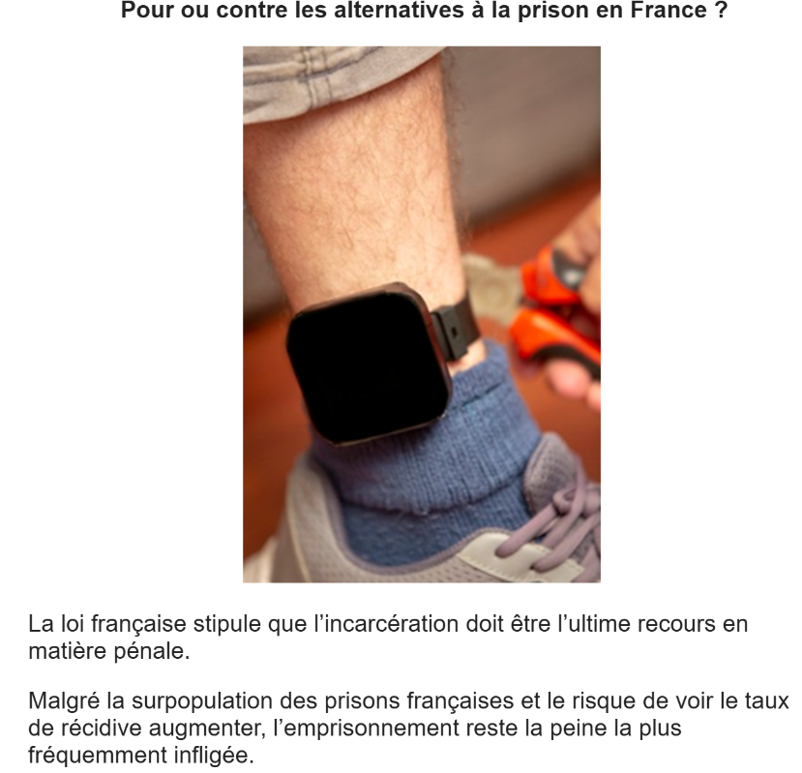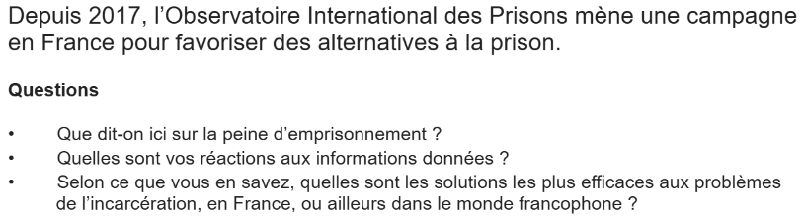
____________________________________________________________________________________________________________________________________________________________________________________________________________________________________________________________________________________________________________________________________________________________________________________________________________________________________________________________________________________________________________________________________________________________________________________________________________________________________________________________________________________________________________________________________________________________________________________________________________________________________________________________________________________________________________________________________________________________________________________________________________________________________________________________________________________________________________________________________________________________________________________________________________________________________________________________________________________________________________________________________________________________________________________________________________________________________________________________________________________________________________________________________________________________________________________________________________________________________________________________________________________________________________________________________________________________________________________________________________________________________________________________________________
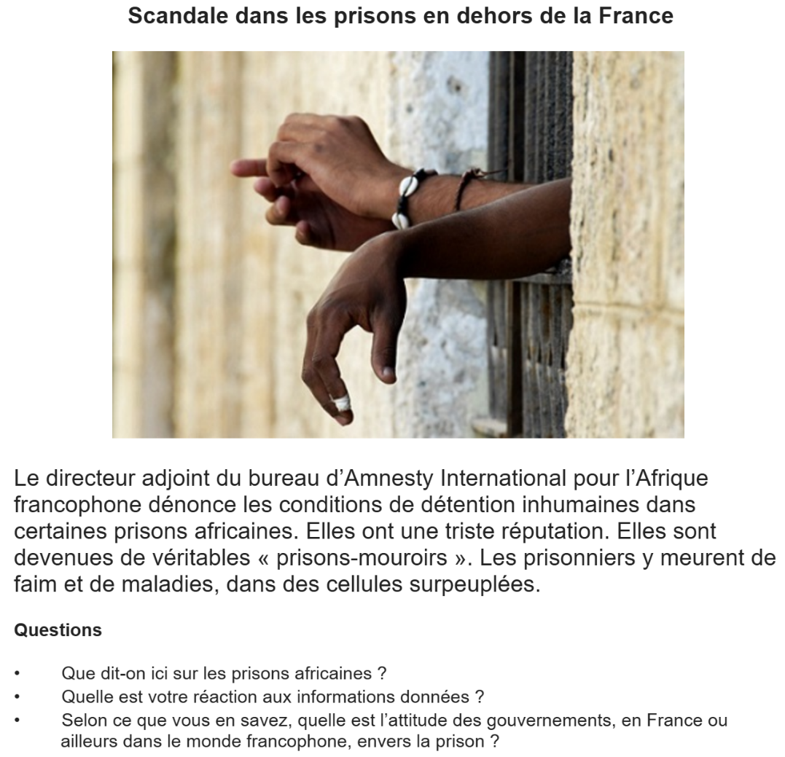

____________________________________________________________________________________________________________________________________________________________________________________________________________________________________________________________________________________________________________________________________________________________________________________________________________________________________________________________________________________________________________________________________________________________________________________________________________________________________________________________________________________________________________________________________________________________________________________________________________________________________________________________________________________________________________________________________________________________________________________________________________________________________________________________________________________________________________________________________________________________________________________________________________________________________________________________________________________________________________________________________________________________________________________________________________________________________________________________________________________________________________________________________________________________________________________________________________________________________________________________________________________________________________________________________________________________________________________________________________________________________________________________________________
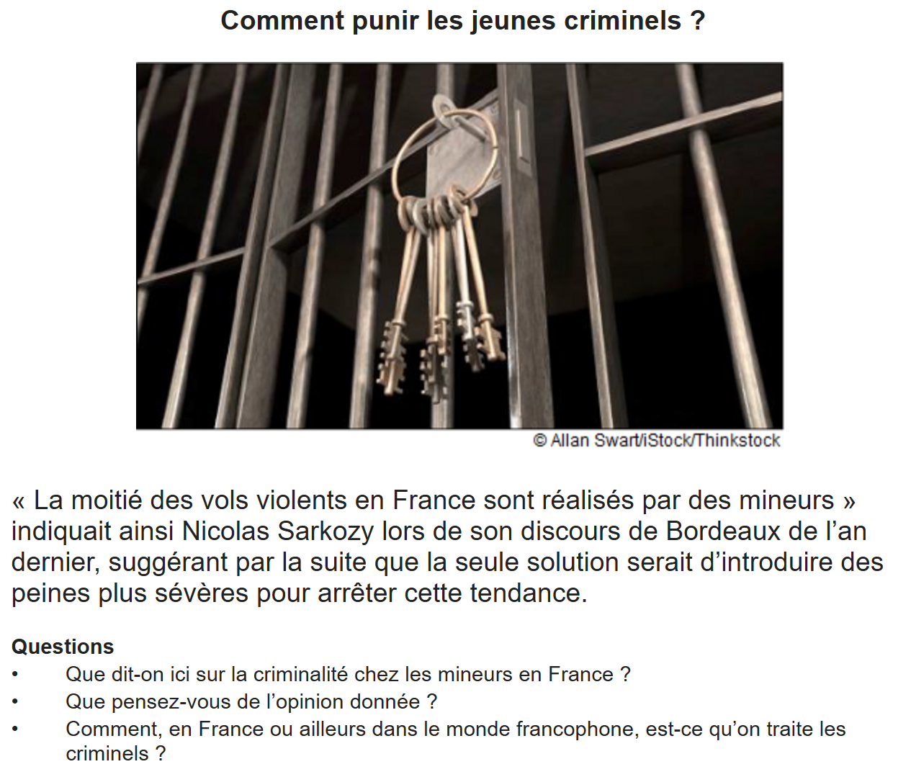
____________________________________________________________________________________________________________________________________________________________________________________________________________________________________________________________________________________________________________________________________________________________________________________________________________________________________________________________________________________________________________________________________________________________________________________________________________________________________________________________________________________________________________________________________________________________________________________________________________________________________________________________________________________________________________________________________________________________________________________________________________________________________________________________________________________________________________________________________________________________________________________________________________________________________________________________________________________________________________________________________________________________________________________________________________________________________________________________________________________________________________________________________________________________________________________________________________________________________________________________________________________________________________________________________________________________________________________________________________________________________________________________________________
6. Pratique du projet de recherche
Choisis un des quatre sujets suivants et prépare une présentation de deux minutes. Tu peux t’aider des bullets points ci-dessous.
The importance of Restos du Cœur in Belgium
- How and why did Restos du Cœur begin in Belgium, and how has the organisation grown and developed since then?
- What kind of services does the organisation offer, and what impact do these have in the community? Who benefits significantly from these?
- What are the most significant projects that the organisation has been involved in, and what has been the impact of these?
- What role do volunteers play in the organisation?
50 years of Médecins Sans Frontières – how has the organisation contributed to humanitarianism in francophone Africa?
- How and why did MSF begin?
- What have been the most significant changes to the organisation in the last 50 years?
- What influence and impact has MSF had on other humanitarian aid organisations?
- What have been its main achievements and/or most significant emergency aid projects in francophone Africa?
Charity in Canada – what impact does volunteer work have?
- What statistics are available regarding time and money linked to volunteer work and/or donations in Canada? Are there any regional differences?
- How many young people take part in volunteer work, and what do they do?
- What are some of the main volunteer programmes or organisations in Canada?
- What has been the impact of volunteer work, for example financially, economically or within the community? Which particular examples demonstrate this impact?
Military and civil service in Switzerland – benefits and challenges
- What legislation and conditions exist around participation in military and civil service?
- What is the Swiss public’s attitude to military and civil service, and how has this been expressed (e.g. surveys, political manifestos, referenda, demonstrations)?
- What are the main arguments in favour of military or civil service?

7. Questions de conversation

- Quelles sont, selon toi, les causes principales de la criminalité en France ?
- Est-ce que certains groupes sociaux sont plus exposés à la criminalité ? Pourquoi ?
- La criminalité a-t-elle augmenté en France ces dernières années ? Pourquoi ?
- Quelle est la différence entre une infraction, un délit et un crime ?
- Que penses-tu des peines pour les mineurs délinquants ? Sont-elles adaptées ?
- Que sais-tu du fonctionnement du système judiciaire en France ?
- Quel est le rôle d’un juge d’instruction ?
- Quelles sont les peines alternatives à la prison ? Sont-elles efficaces ?
- À ton avis, la peine de prison est-elle dissuasive ?
- Quelle est la différence entre une peine ferme et une peine avec sursis ?
- Devrait-on instaurer des peines plus sévères pour certains crimes ? Lesquels ?
- Que penses-tu des conditions de vie dans les prisons françaises ?
- Pourquoi y a-t-il de la surpopulation carcérale ? Quelles en sont les conséquences ?
- Est-ce que la prison permet de réhabiliter les criminels ? Pourquoi ou pourquoi pas ?
- Quelle est ton opinion sur le travail des détenus pendant leur peine ?
- La prison est-elle toujours la meilleure solution ? Pourquoi ou pourquoi pas ?
- Quels sont les avantages des peines alternatives (bracelet électronique, TIG…) ?
- Quels obstacles rencontrent les anciens détenus lorsqu’ils sortent de prison ?
- Comment peut-on favoriser la réinsertion des ex-détenus ?
- Que faire pour réduire le taux de récidive en France ?

UNITÉ 10 : LES ADOS, LE DROIT DE VOTE ET L’ENGAGEMENT POLITIQUE

1. Le vocabulaire
2. Test de connaissance
3. Factsheet
4. Carte mentale
5. Pratique de la carte photo
6. Pratique du projet de recherche
7. Questions de conversation

1. Le vocabulaire 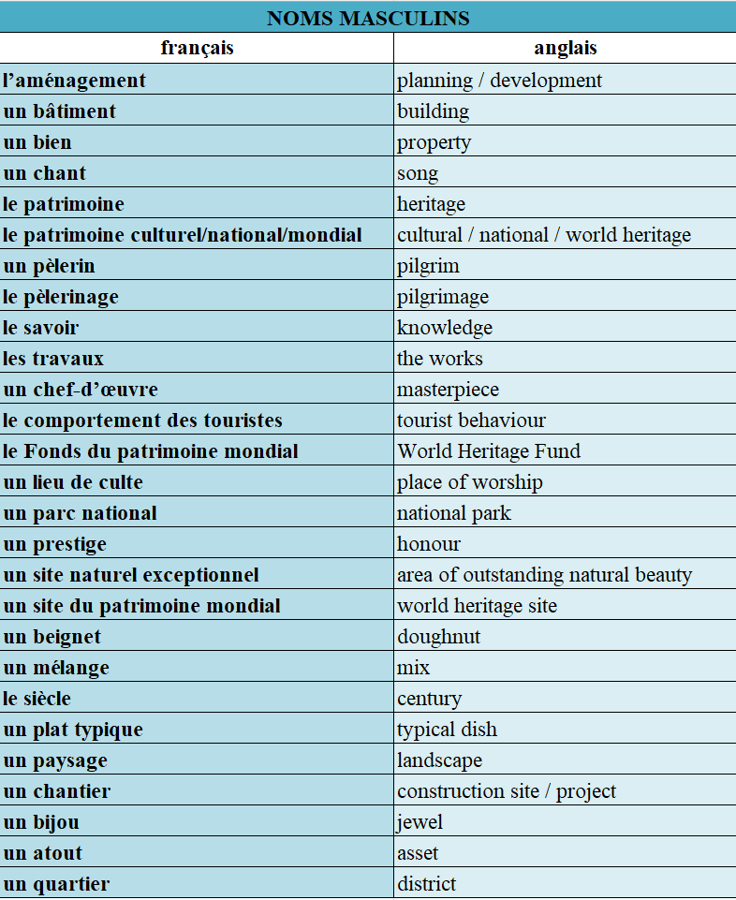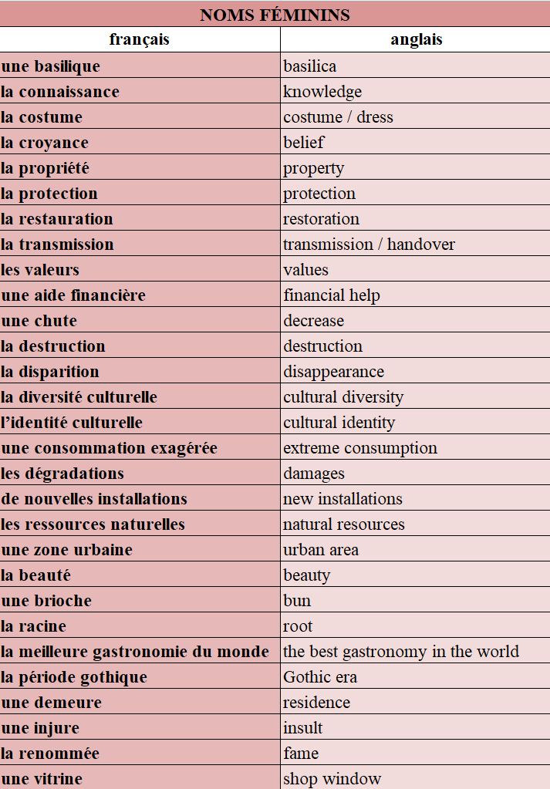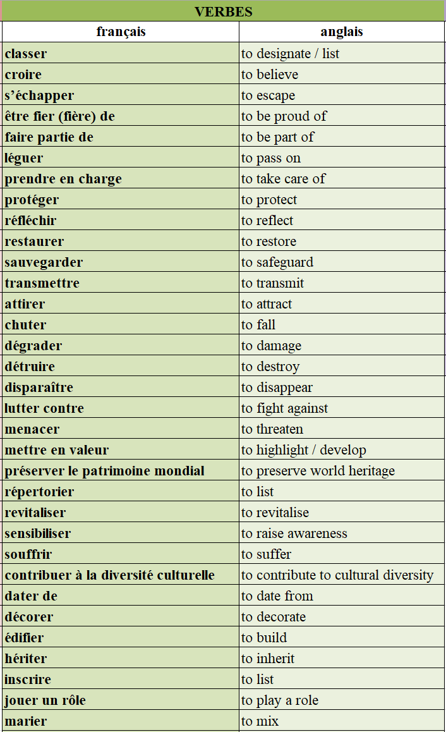
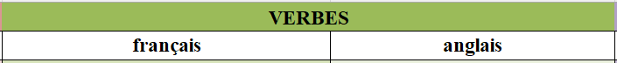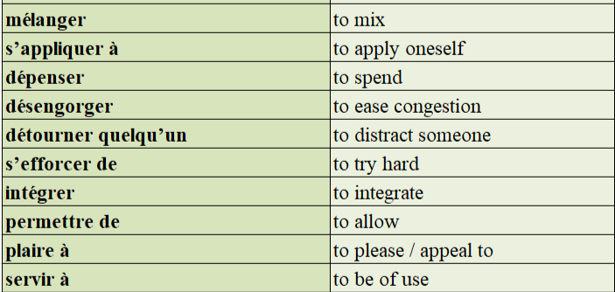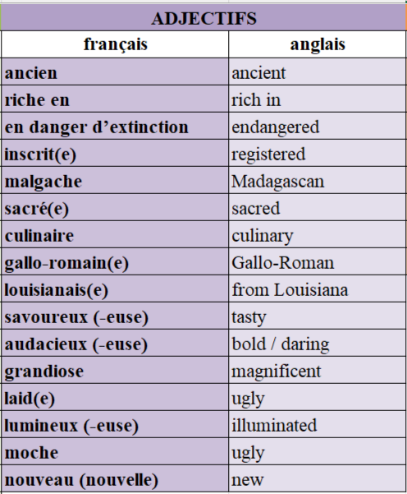
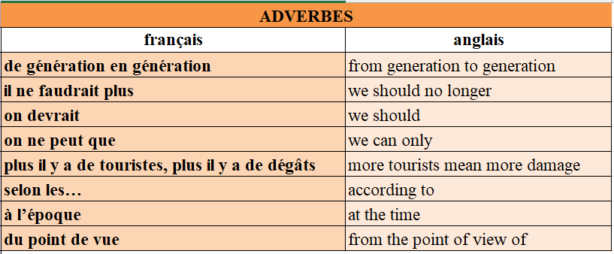
2. Test de connaissances
📜 QCM – Choisis la bonne traduction
- Que veut dire "le patrimoine" ? o a) Heritage
o b) Landscape
o c) Government
o d) Tradition
- "Un site classé" signifie : o a) A classified ad
o b) A protected site
o c) A closed museum
o d) A destroyed monument
- Que signifie "la restauration" (du patrimoine) ? o a) Catering
o b) Restoration
o c) Decoration
o d) Transportation
🔄 Traduction – Traduis en anglais 4. Un monument historique = ❓
5. La préservation = ❓
6. L’UNESCO = ❓
✅ Vrai ou Faux 7. “Une ruine” veut dire “a ruin”.
️→ ❓
- “Transmettre aux générations futures” signifie “to pass on to future generations”.
️→ ❓
🗺️ Quiz – Vocabulaire : Le patrimoine et le tourisme
📜 QCM – Choisis la bonne traduction
- Que veut dire "attirer" ? o a) To destroy
o b) To attract
o c) To build
o d) To welcome
- "Les dégradations" signifie : o a) Beautifications
o b) Costs
o c) Damages
o d) Installations
- Que signifie "préserver le patrimoine mondial" ? o a) To ignore world heritage
o b) To protect world heritage
o c) To classify new lands
o d) To build new cities
🔄 Traduction – Traduis en anglais 4. Une aide financière = ❓
5. Un lieu de culte = ❓
6. Un site du patrimoine mondial = ❓
✅ Vrai ou Faux 7. “Disparaître” veut dire “to disappear”.
️→ ❓
- “Mettre en valeur” signifie “to devalue”.
️→ ❓

3. Factsheet
📊 Knowledge: Information and trend
- En 2020, la France compte 45 sites inscrits au patrimoine mondial (39 culturels, 5 naturels, 1 mixte).
- En 2019, l’alpinisme est reconnu comme patrimoine culturel immatériel.
- La France est 1re destination touristique mondiale depuis 2019 avec 89 millions de visiteurs étrangers en 2018.
- Le tourisme représente près de 8% du PIB français et 2 millions d’emplois.
- Paris est la 2e ville la plus visitée au monde (Global Destination Cities Index 2019).
- Le Louvre est le musée le plus visité au monde en 2019, avec 9,6 millions de visiteurs, dont 75% d’étrangers. Disneyland Paris est le parc d’attraction le plus visité d’Europe.
- Le Loto du Patrimoine lancé en 2018 soutient la restauration de monuments historiques, avec 22 millions d'euros récoltés cette année-là.
🧠 Understanding 1: Contextualisation
- La liste du patrimoine mondial a été révisée en 2019 pour inclure les terres et mers australes françaises.
- Le Fonds du patrimoine mondial dispose d'environ 4 millions $/an, la France ayant contribué 300 000 $ en 2018-2019.
- Depuis 2010, Paris reste dans le top 3 des destinations touristiques, malgré un recul après les attentats de 2015.
- En 2019, rénovation de la salle de la Joconde au Louvre = baisse temporaire de fréquentation.
- Le Loto du Patrimoine propose des jeux à gratter et lotos spéciaux dont les profits sont reversés à la Fondation du patrimoine.
- En 2020, l’Organisation Internationale de la Francophonie fête ses 50 ans.
- La Journée Internationale de la Francophonie est célébrée chaque 20 mars depuis 1990.
- En 2018, Macron a lancé une stratégie pour faire du français la 3e langue mondiale.
🌍 Understanding 2: Cultural analysis
- La France valorise à la fois son patrimoine matériel et immatériel.
- Le tourisme est une fierté nationale, mais le surtourisme soulève des enjeux écologiques (pollution, pression sur les infrastructures).
- L’Académie française, créée en 1635, défend la langue française contre les anglicismes et le franglais.
- Depuis 1994, la loi Toubon impose l’usage du français dans la publicité et le monde du travail.
- L’usage croissant de l’anglais inquiète certains, comme le collectif Langue française, qui a interpellé Macron en 2018.
- Le Loto du Patrimoine ne vise pas que les grands monuments mais aussi le patrimoine méconnu (ouvrier, industriel, vernaculaire).
4. Carte mentale

5. Pratique de la carte photo
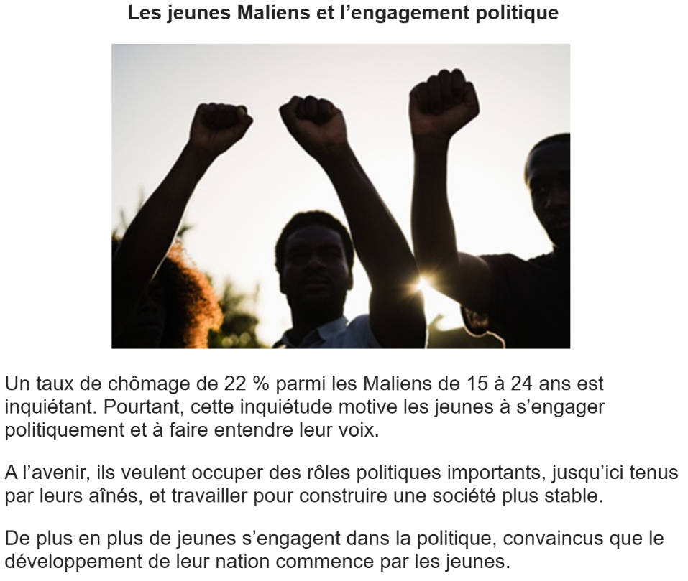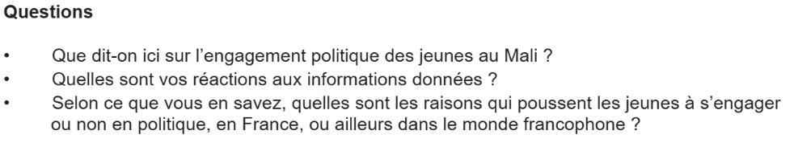
____________________________________________________________________________________________________________________________________________________________________________________________________________________________________________________________________________________________________________________________________________________________________________________________________________________________________________________________________________________________________________________________________________________________________________________________________________________________________________________________________________________________________________________________________________________________________________________________________________________________________________________________________________________________________________________________________________________________________________________________________________________________________________________________________________________________________________________________________________________________________________________________________________________________________________________________________________________________________________________________________________________________________________________________________________________________________________________________________________________________________________________________________________________________________________________________________________________________________________________________________________________________________________________________________________________________________________________________________________________________________________________________________________
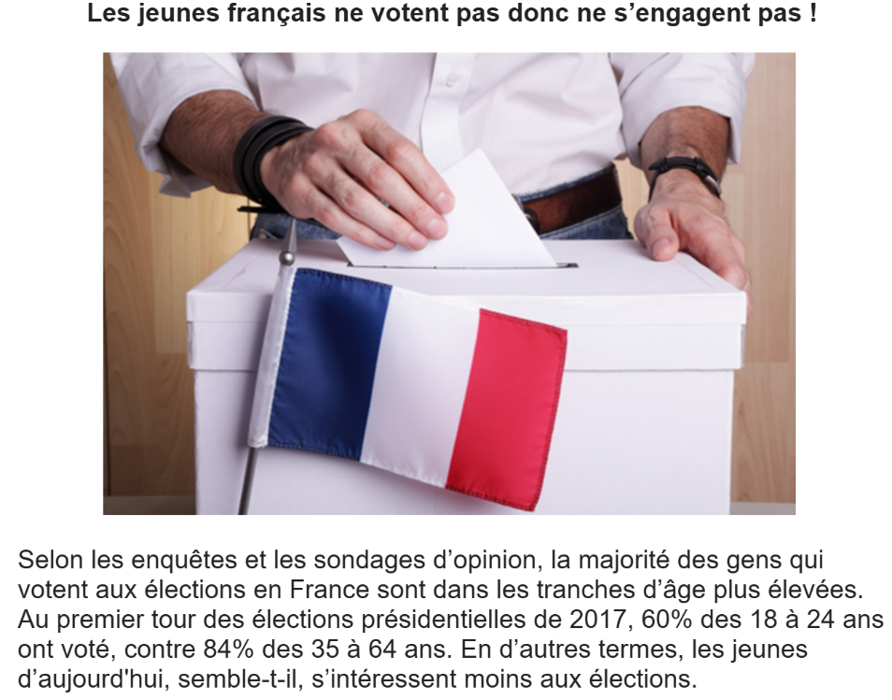
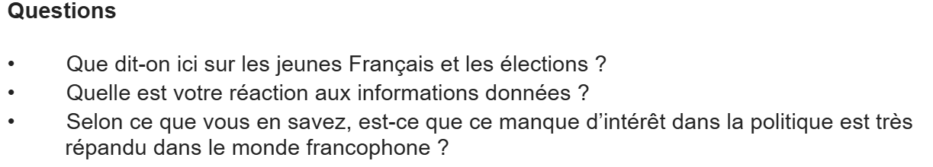
________________________________________________________________________________________________________________________________________________________________________________________________________________________________________________________________________________________________________________________________________________________________________________________________________________________________________________________________________________________________________________________________________________________________________________________________________________________________________________________________________________________________________________________________________________________________________________________________________________________________________________________________________________________________________________________________________________________________________________________________________________________________________________________________________________________________________________________________________________________________________________________________________________________________________________________________________________________________________________________________________________________________________________________________________________________________________________________________________________________________________________________________________________________________________________________________________________________________________________________________________________________________________________________________________________________________________________________________________________________________________________________________________________________________________________________________________________________________________________________________________________________________________________
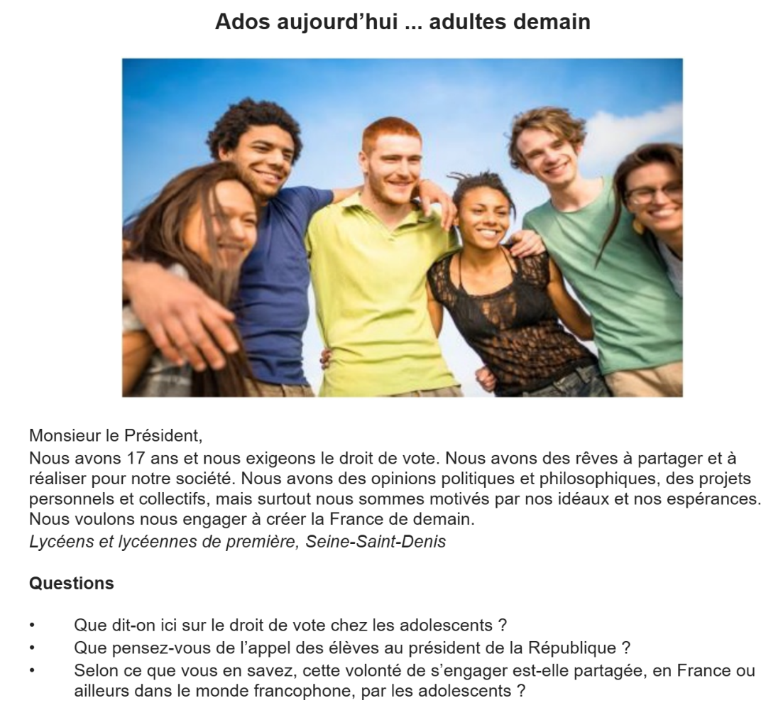
_______________________________________________________________________________________________________________________________________________________________________________________________________________________________________________________________________________________________________________________________________________________________________________________________________________________________________________________________________________________________________________________________________________________________________________________________________________________________________________________________________________________________________________________________________________________________________________________________________________________________________________________________________________________________________________________________________________________________________________________________________________________________________________________________________________________________________________________________________________________________________________________________________________________________________________________________________________________________________________________________________________________________________________________________________________________________________________________________________________________________________________________________________________________________________________________________________________________________________________________________________________________________________________________________________________________________________________________________________________________________________________________________________________________________________________________________________________________________________________________________________________________________________________
6. Pratique du projet de recherche
Choisis un des quatre sujets suivants et prépare une présentation de deux minutes. Tu peux t’aider des bullets points ci-dessous.
How successful is the Académie française in protecting the French language?
- What are the legal requirements and recommendations regarding the use of the French language in France?
- What is in the remit of the Académie française in promoting and protecting the French language?
- How does the Académie française encourage public interest and engagement in the correct usage and protection of the French language?
- What have been the recent issues involving the use of the French language, and how has the Académie française reacted to these?
Tourism in Corsica — benefits and challenges
- How and why has Corsica become a popular tourist destination?
- How has the island responded to its increasing popularity as a tourist destination, and what impact — both positive and negative — has this had on key areas (e.g. employment, economy, ecology)?
- How have the locals reacted to the increased arrival of tourists, and how has this affected daily life?
- What plans, strategies and/or measures are or will be in place to encourage and manage tourism in future?
Will any of Belgium’s three regions ever become independent?
- What are the main differences and distinct cultures/languages of Belgium’s three regions?
- What (if any) support has been shown so far regarding future independence (e.g surveys, political manifestos, referenda, demonstrations)?
- What would be the impact of independence in key areas of everyday life (e.g. finance, employment, education, business, politics)?
- What is the expert opinion about the possibility and/or feasibility of independence, and what conclusions can be drawn?
The restoration of Notre-Dame — is it worth the money?
- What is the current financial situation – costs of restoration, amount donated, key contributors, the role/responsibilities of different organisations? How does the separation of Church and State affect this situation?
- What is the current status of the restoration work and when will it be complete?
- What are the main arguments in favour of restoration, despite the high costs?
What are the main arguments against

7. Questions de conversation

- Penses-tu que les jeunes s’intéressent à la politique ? Pourquoi (pas) ?
- Devrait-on abaisser l’âge du droit de vote à 16 ans ? Quels en seraient les avantages ou les risques ?
- Quelles sont les formes d’engagement politique des jeunes en dehors du vote ?
- Pourquoi certains jeunes choisissent-ils de ne pas s’engager politiquement ?
- À ton avis, les partis politiques s’adressent-ils suffisamment aux jeunes ?
- Le vote est-il un devoir ou un droit, selon toi ?
- Quelles sont les principales préoccupations politiques des jeunes aujourd’hui ?
- Le système démocratique en France permet-il une réelle participation des jeunes ?
- Les réseaux sociaux influencent-ils l’engagement politique des jeunes ? Comment ?
- Comment pourrait-on encourager davantage de jeunes à voter ?
- Que penses-tu des campagnes de sensibilisation au vote dans les lycées ?
- Le militantisme est-il plus populaire que le vote chez les jeunes ? Pourquoi ?
- As-tu déjà participé ou envisagé de participer à une action politique ?
- Comment les jeunes perçoivent-ils les figures politiques traditionnelles ?
- Les jeunes sont-ils désabusés par la politique ? Si oui, pourquoi ?
- La politique doit-elle être enseignée plus tôt à l’école ?
- L'engagement des jeunes est-il plus fort dans les causes sociales qu'électorales ?
- Penses-tu que les jeunes ont le pouvoir de changer les choses en politique ?
- Les manifestations étudiantes sont-elles efficaces ?
- Quel est ton avis sur les jeunes qui s’abstiennent de voter volontairement ?

UNITÉ 11 : MANIFESTATIONS ET GRÈVES- À QUI LE POUVOIR ?

1. Le vocabulaire
2. Test de connaissance
3. Factsheet
4. Carte mentale
5. Pratique de la carte photo
6. Pratique du projet de recherche
7. Questions de conversation

1. Le vocabulaire
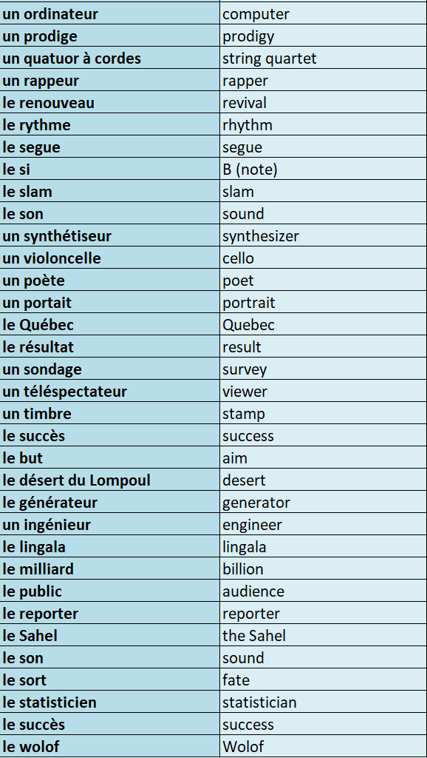
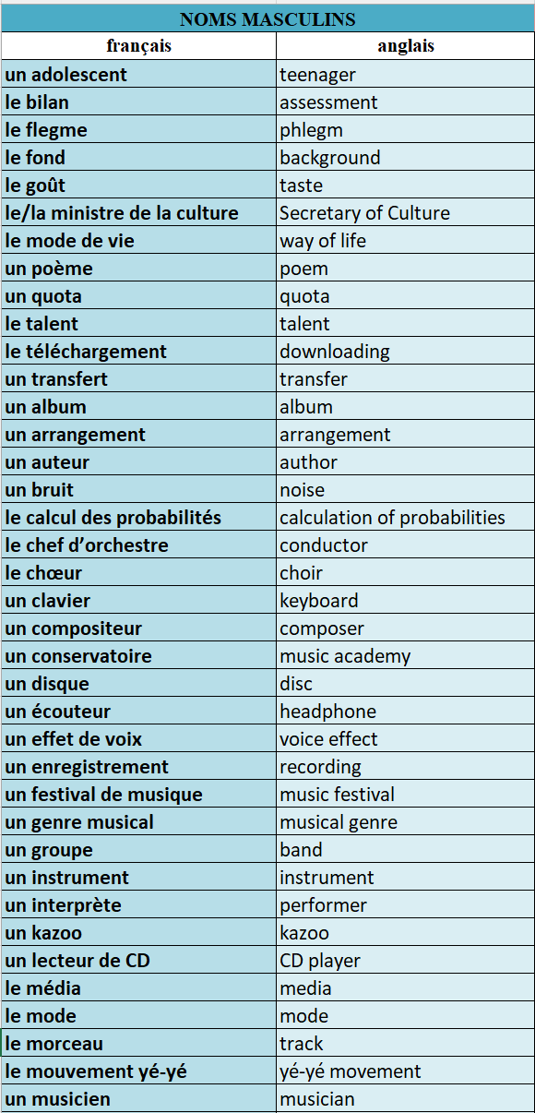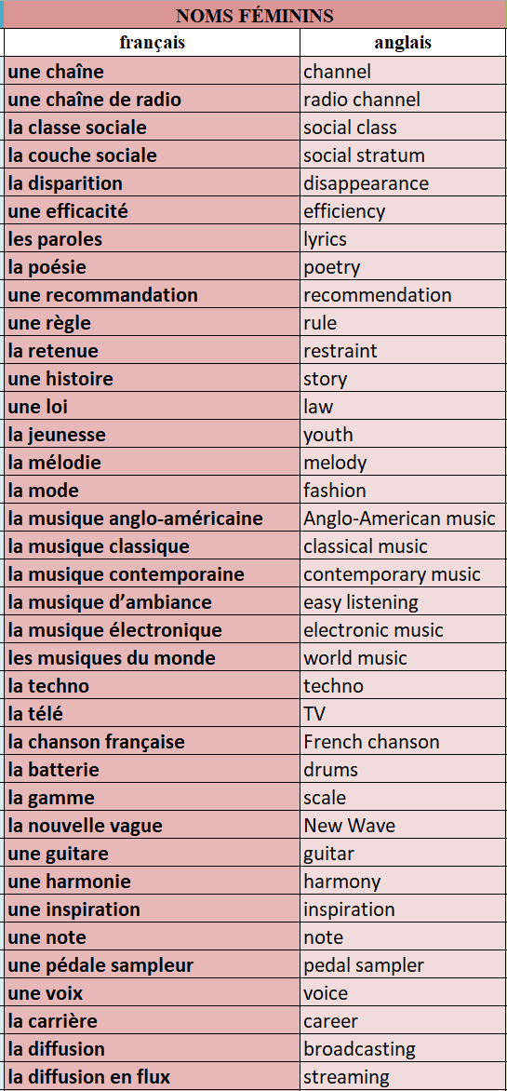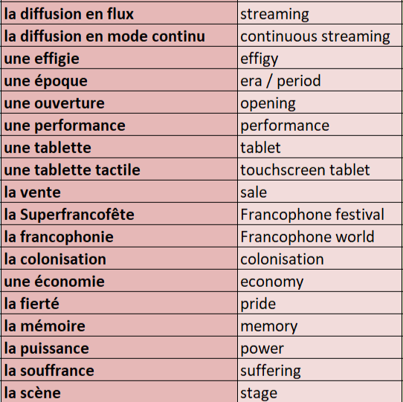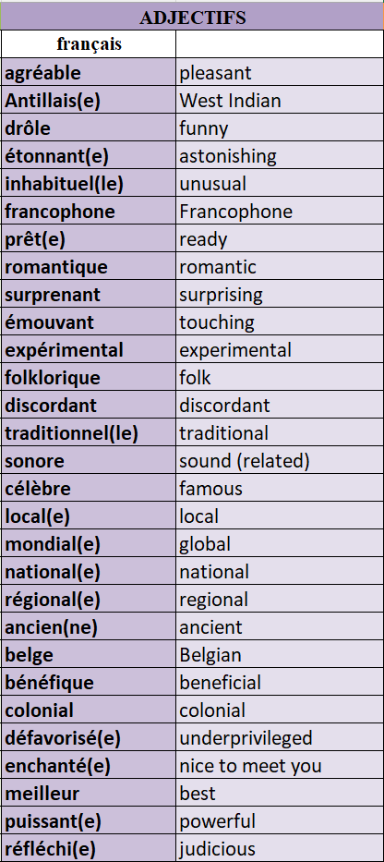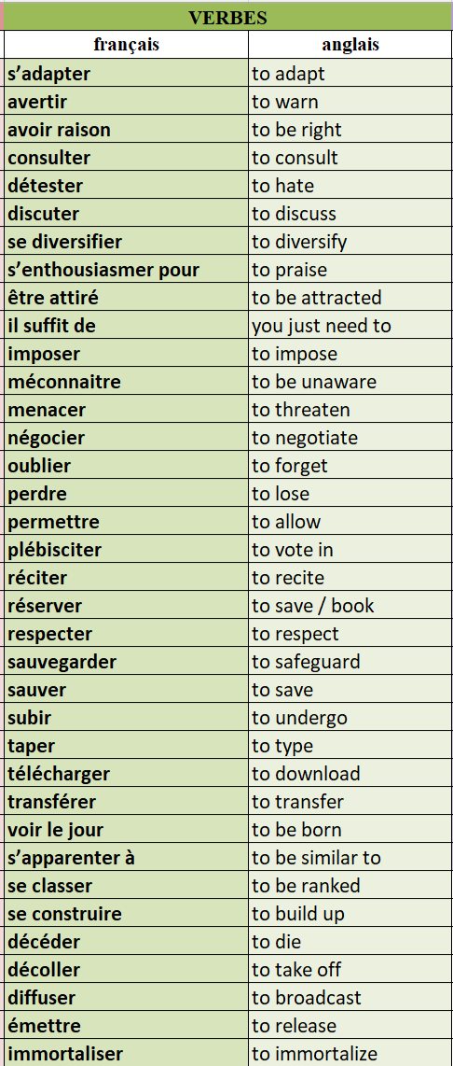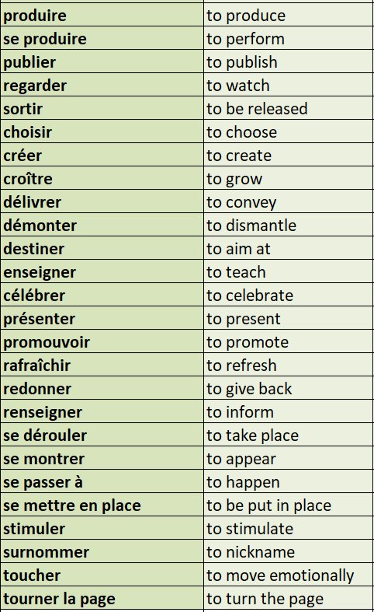
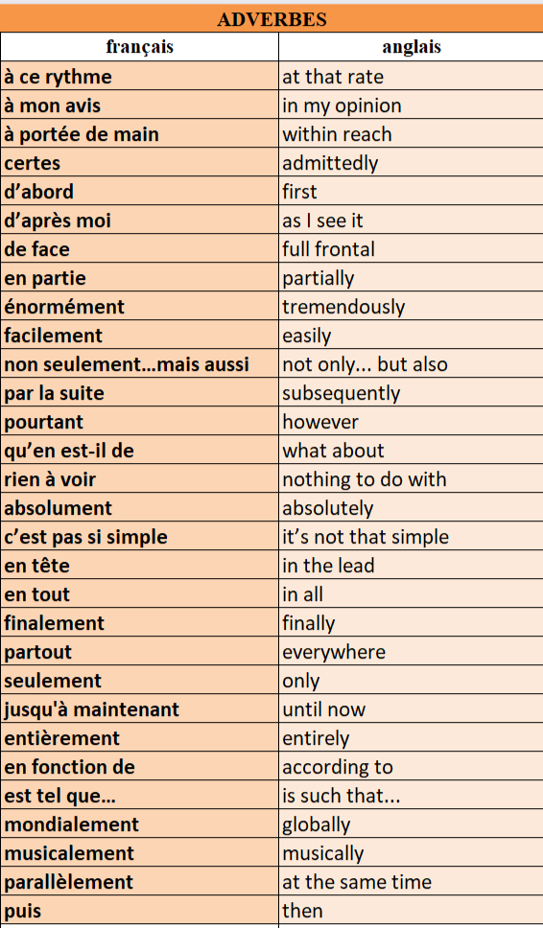
2. Test de connaissances
📜 QCM
- Que veut dire "un chanteur" ?
o a) A painter
o b) A singer
o c) A conductor
o d) A writer
- “Un disque” signifie :
o a) A folder
o b) A disc/record
o c) A microphone
o d) A flash drive
- “Une mélodie” veut dire :
o a) A poem
o b) A concert
o c) A melody/tune
o d) A rhythm
🔄 Traduction
4. Une voix = ❓
5. Le téléchargement = ❓
6. Le talent = ❓
✅ Vrai ou Faux
7. “Surprenant” veut dire “surprising”.
️→ ❓
8. “Un groupe” est un synonyme de “band”.
️→ ❓
📜 QCM
- Que signifie “colonial” ?
o a) Related to colonies
o b) Musical
o c) Historical
o d) Traditional
- “Le lingala” veut dire :
o a) A dance
o b) A language spoken in Congo
o c) A song
o d) A drum
- “Promouvoir” signifie :
o a) To destroy
o b) To sing
o c) To promote
o d) To remember
🔄 Traduction
4. Le désert du Lompoul = ❓
5. Un évènement = ❓
6. La francophonie = ❓
✅ Vrai ou Faux
7. “Puissant” veut dire “powerful”.
️→ ❓
8. “Créer” est un synonyme de “to destroy”.
️→ ❓
📜 QCM
- Que signifie “à mon avis” ?
o a) Of course
o b) In my opinion
o c) As a result
o d) I agree
- “Avoir raison” veut dire :
o a) To be right
o b) To argue
o c) To reason
o d) To change your mind
- Que signifie “énormément” ?
o a) Just a little
o b) Slowly
o c) Enormously, tremendously
o d) Exactly
🔄 Traduction
4. S’adapter = ❓
5. À portée de main = ❓
6. Se priver = ❓
✅ Vrai ou Faux
7. “Qu’en est-il de” veut dire “what’s the situation regarding”.
️→ ❓
8. “Non seulement… mais aussi” signifie “not only… but also”.
️→ ❓

3. Factsheet
📊 Knowledge: Information and trend
- En 2018, les Français écoutent environ 15 heures de musique par semaine, contre une moyenne mondiale de 18 heures.
- En 2019, le streaming représente 51% des ventes de musique en France ; Deezer est leader national avec 2 millions d'abonnés.
- Plus de 50% de la musique téléchargée en France est obtenue illégalement ; la France est le premier pays européen en visites sur des sites pirates.
- Peace & Lobe est un concert pédagogique sensibilisant les ados aux risques auditifs liés à la musique amplifiée.
- Depuis 1994, 40% de la musique diffusée à la radio doit être française, avec des taux variables selon les stations.
- En 2018, les 19 des 20 meilleures ventes d'albums en France étaient des productions francophones.
- En 2019, 516 albums francophones ont été commercialisés, en hausse par rapport à 2018.
- Depuis 2015, la France envoie chaque année des chansons en franglais à l’Eurovision.
- La musique engagée est bien présente en France avec des artistes comme David Guetta, Louane, Amir.
- Le MASA (Marché des Arts du Spectacle d’Abidjan) est l’un des plus grands événements culturels d’Afrique francophone, organisé tous les deux ans.
🧠 Understanding 1: Contextualisation
- La montée du streaming facilite l’accès à la musique, mais la piraterie reste un défi majeur.
- Peace & Lobe existe depuis plus de 10 ans et s’adresse aux élèves pour expliquer les risques liés à l’écoute prolongée au casque.
- Un tiers des jeunes écoutent plus de deux heures de musique par jour, ce qui atteint la limite d’exposition recommandée.
- La loi sur les quotas vise à préserver la chanson française, mais est critiquée et contournée par certaines radios.
- Le streaming francophone augmente grâce à des mesures gouvernementales obligeant les plateformes à mieux exposer ces contenus.
- À l’Eurovision, le choix du franglais vise à séduire un public jeune et international.
- Le MASA, soutenu par la Francophonie et la Côte d’Ivoire, cherche à renforcer les industries culturelles africaines.
🌍 Understanding 2: Cultural analysis
- L’écoute musicale est ancrée dans le quotidien français mais pose des enjeux sanitaires (troubles auditifs chez les jeunes).
- La protection de la langue française dans la musique reste un sujet sensible, entre législation, diversité linguistique et mondialisation.
- Le succès des artistes francophones montre un attachement culturel à la musique en français, malgré une production qui avait chuté.
- Le recours au franglais à l’Eurovision crée un débat entre modernité et défense de la langue française.
- La musique engagée est un vecteur d’expression politique et sociale en France, depuis Mai 68 jusqu’au rap des banlieues.
- En Afrique, la musique francophone se développe fortement grâce au numérique et au soutien institutionnel (ex. MASA), reflétant la vitalité de la Francophonie culturelle.

4. Carte mentale

5. Pratique de la carte photo
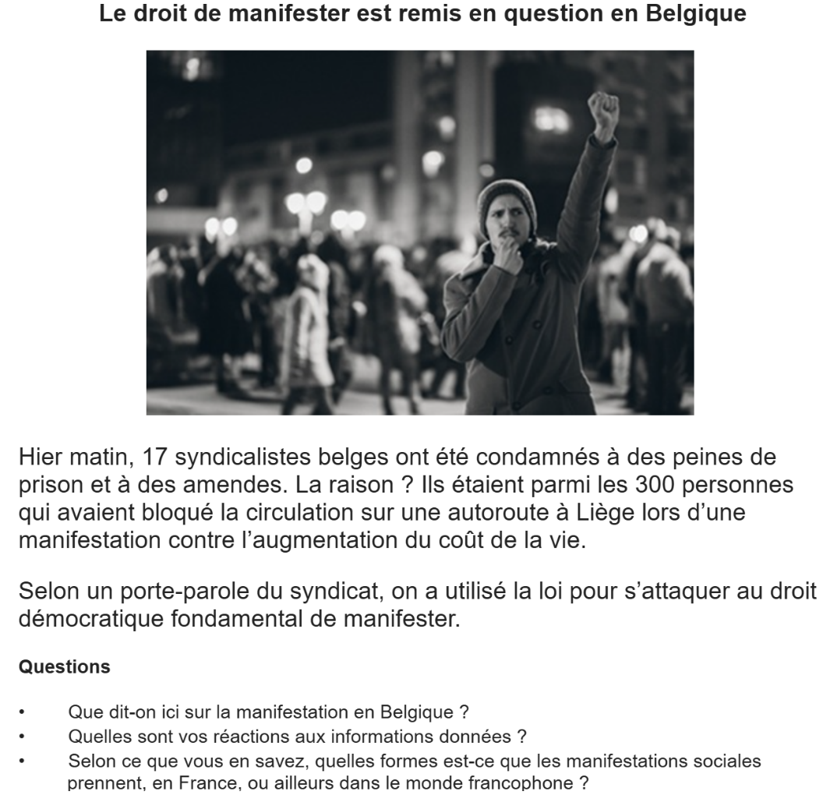
____________________________________________________________________________________________________________________________________________________________________________________________________________________________________________________________________________________________________________________________________________________________________________________________________________________________________________________________________________________________________________________________________________________________________________________________________________________________________________________________________________________________________________________________________________________________________________________________________________________________________________________________________________________________________________________________________________________________________________________________________________________________________________________________________________________________________________________________________________________________________________________________________________________________________________________________________________________________________________________________________________________________________________________________________________________________________________________________________________________________________________________________________________________________________________________________________________________________________________________________________________________________________________________________________________________________________________________________________________________________________________________________________________
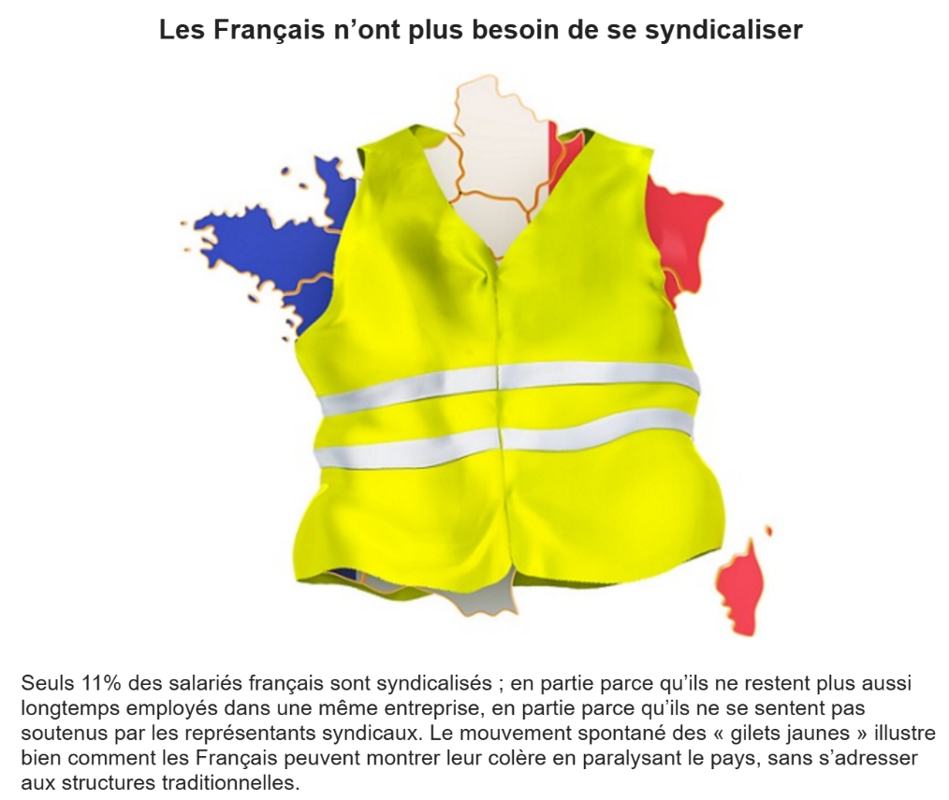
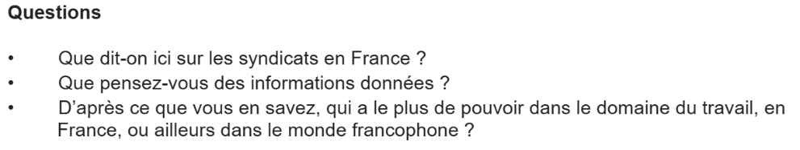
____________________________________________________________________________________________________________________________________________________________________________________________________________________________________________________________________________________________________________________________________________________________________________________________________________________________________________________________________________________________________________________________________________________________________________________________________________________________________________________________________________________________________________________________________________________________________________________________________________________________________________________________________________________________________________________________________________________________________________________________________________________________________________________________________________________________________________________________________________________________________________________________________________________________________________________________________________________________________________________________________________________________________________________________________________________________________________________________________________________________________________________________________________________________________________________________________________________________________________________________________________________________________________________________________________________________________________________________________________________________________________________________________________
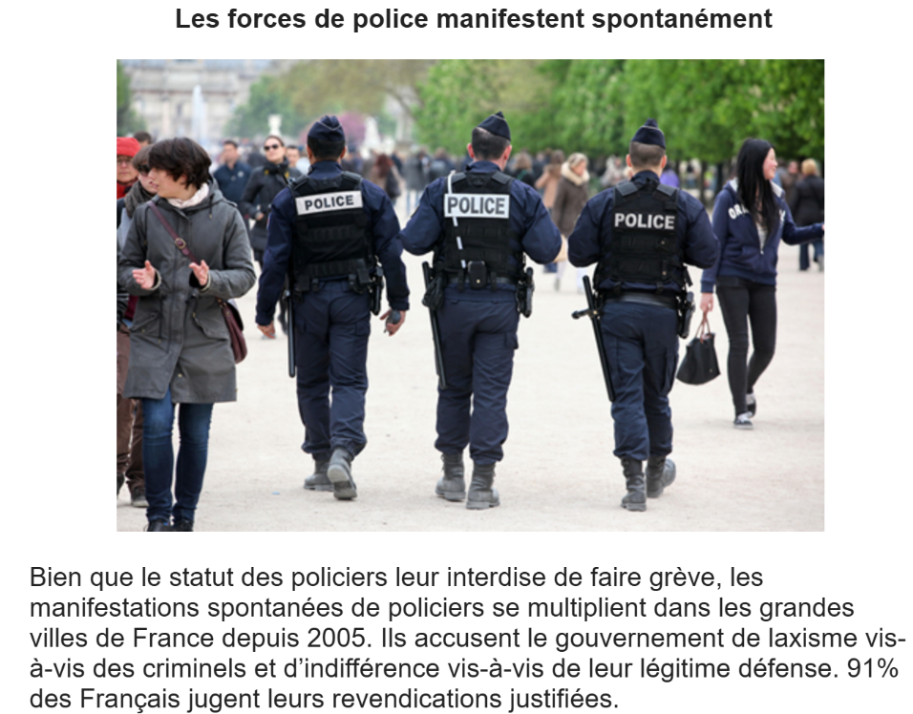
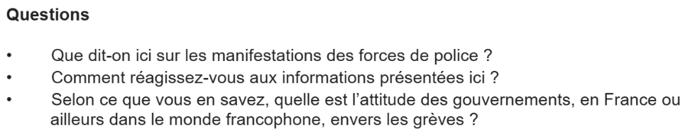
________________________________________________________________________________________________________________________________________________________________________________________________________________________________________________________________________________________________________________________________________________________________________________________________________________________________________________________________________________________________________________________________________________________________________________________________________________________________________________________________________________________________________________________________________________________________________________________________________________________________________________________________________________________________________________________________________________________________________________________________________________________________________________________________________________________________________________________________________________________________________________________________________________________________________________________________________________________________________________________________________________________________________________________________________________________________________________________________________________________________________________________________________________________________________________________________________________________________________________________________________________________________________________________________________________________________________________________________________________________________________________________________________________________________________________________________________________________________________________________________________________________________________________
6. Pratique du projet de recherche
Choisis un des quatre sujets suivants et prépare une présentation de deux minutes. Tu peux t’aider des bullets points ci-dessous.
‘L’exception française’ and its influence on the music industry
- What is ‘l’exception française’ – how and why did it begin and what is its purpose?
- What laws, rules and regulations exist regarding ‘l’exception française’ and music, and what are the benefits of these?
- In what way does ‘l’exception française’ directly influence music in France, and what impact has been seen?
- Are there any ways in which ‘l’exception française’ influences music in France less directly, for example the industry and musicians in general, and what impact has been seen?
An analysis of music as a form of protest in francophone Africa
- How, why and against what do francophone African musicians use their songs as a form of protest?
- How has music been used as a form of protest in francophone Africa in the past? What were the most significant cases, and what was the impact?
- What are the most recent significant cases where music in francophone Africa has been used as a form of protest, and what was the impact?
- How do those being protested against (such as governments, public figures or organisations) react to the use of music as a form of protest in francophone Africa?
The significance of Édith Piaf in French popular culture
- How and why did Édith Piaf rise to fame?
- What were the most significant events of her career, and how did these influence her music?
- How is her influence still evident in popular culture (including music) today, and what is the evidence of this?
- What does she represent for French people and how is she portrayed in the media?
DJ Arafat and coupé-décalé*: how modern francophone African music became mainstream
[*You could choose a different artist and music genre here if preferred]
- How and why did DJ Arafat rise to fame?
- How and why did coupé-décalé music begin?
- What significant events and/or statistics demonstrate the increasing popularity of DJ Arafat and coupé-décalé, and its popularity today?
Which other music styles

7. Questions de conversation

- Quelle est l’histoire des grèves en France ?
- Pourquoi la France est-elle souvent associée à une culture de la grève ?
- Les grèves sont-elles toujours justifiées selon toi ?
- Quels sont les secteurs les plus touchés par les grèves en France ?
- Que penses-tu des conséquences des grèves pour les usagers (ex : transports) ?
- Les manifestations sont-elles un moyen efficace de faire entendre sa voix ?
- Comment le gouvernement réagit-il généralement aux grèves ?
- Penses-tu que le droit de grève est essentiel en démocratie ?
- Que sais-tu du rôle des syndicats en France ?
- Les syndicats ont-ils encore de l’influence aujourd’hui ?
- Quelles différences y a-t-il entre une manifestation pacifique et une violente ?
- Les jeunes participent-ils souvent aux mouvements sociaux ? Pourquoi ?
- La violence lors des manifestations est-elle parfois justifiable ?
- Quel est ton point de vue sur les manifestations étudiantes ?
- Quels autres moyens que les grèves pourraient être efficaces pour revendiquer ?
- Les grèves à répétition sont-elles nuisibles à l’économie ?
- Qui a le véritable pouvoir dans les conflits sociaux : le peuple ou l’État ?
- Les réseaux sociaux renforcent-ils le pouvoir des manifestants ?
- Quelle a été, selon toi, la manifestation la plus marquante en France ces dernières années ?
- Quel rôle les médias jouent-ils dans la perception des grèves et manifestations ?

UNITÉ 12 : LA POLITIQUE ET L’IMMIGRATION

1. Le vocabulaire
2. Test de connaissance
3. Factsheet
4. Carte mentale
5. Pratique de la carte photo
6. Pratique du projet de recherche
7. Questions de conversation

1. Le vocabulaire
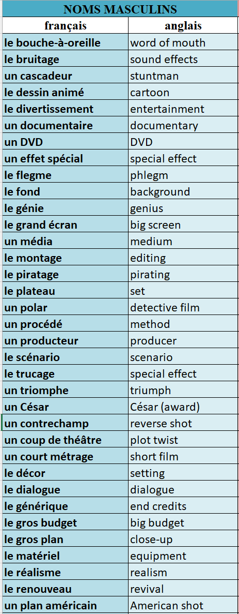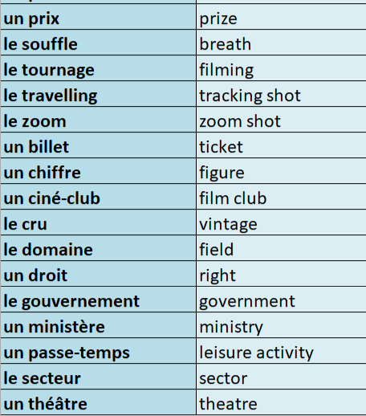
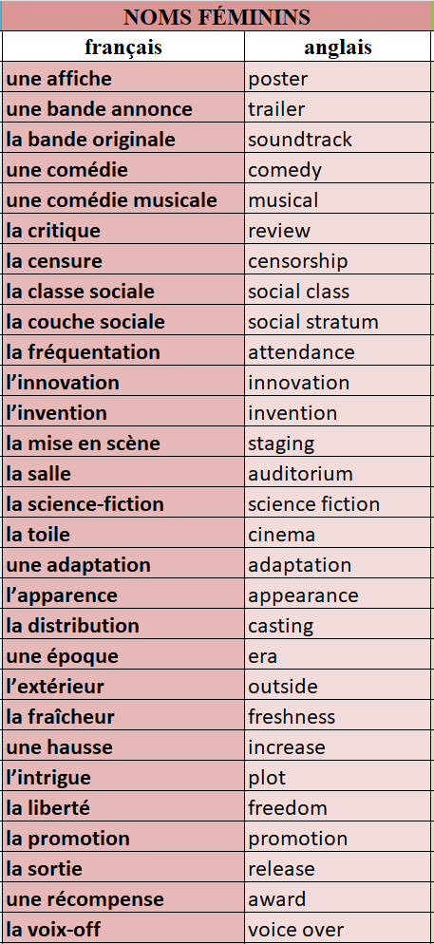c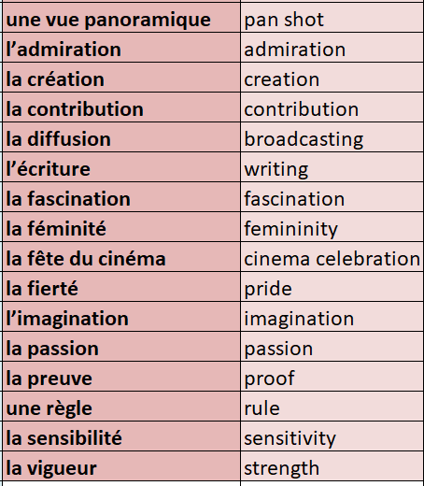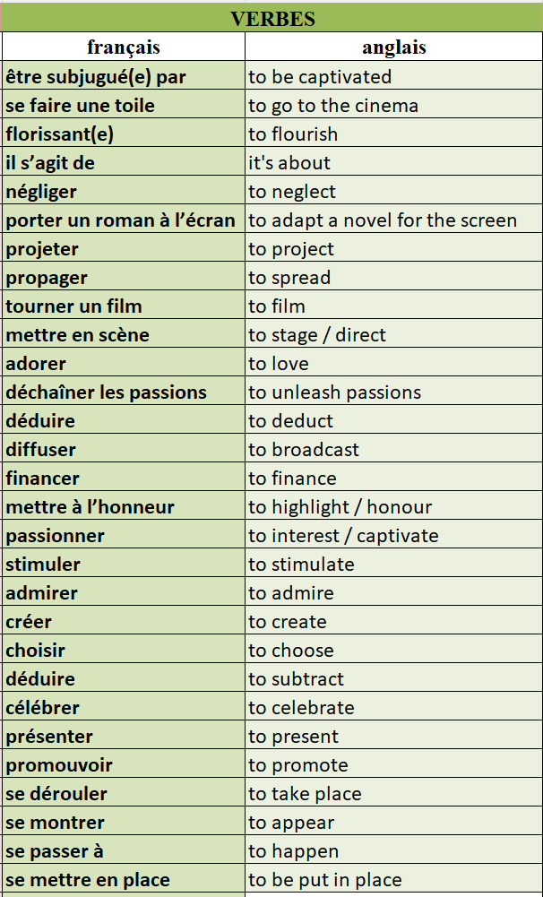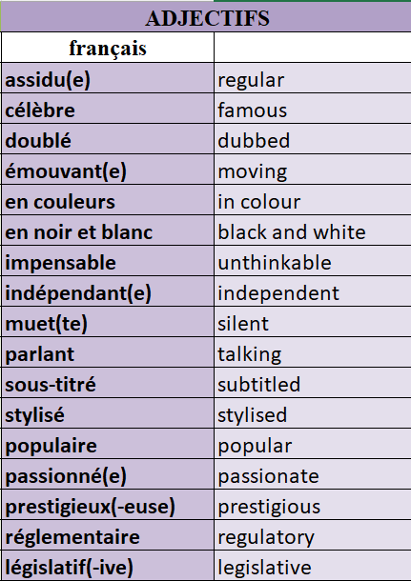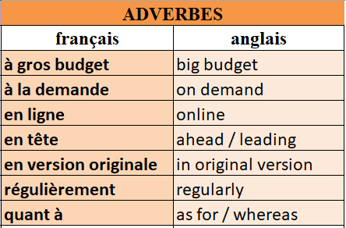
2. Test de connaissances
📜 QCM – Choisis la bonne traduction
- Que veut dire "une bande annonce" ? o a) A scene o b) A soundtrack o c) A trailer o d) A poster
- "Un film d’action" signifie : o a) A romantic movie o b) An action film o c) A documentary o d) A cartoon
- Que veut dire "le piratage" ? o a) Editing o b) Broadcasting o c) Pirating o d) Filming
🔄 Traduction – Traduis en anglais 4. Un(e) cinéphile = ❓
5. Le bruitage = ❓
6. Un film en noir et blanc = ❓
✅ Vrai ou Faux 7. “Un documentaire” veut dire “a documentary”. ️→ ❓
- “Le grand écran” signifie “the small screen”. ️→ ❓
🍿 Quiz – Vocabulaire : Les moments forts du cinéma en France
📜 QCM – Choisis la bonne traduction
- Que signifie "un contrechamp" ? o a) A subtitle o b) A reverse shot o c) A wide shot o d) A zoom
- "Un court métrage" veut dire : o a) A long film o b) A short film o c) A cartoon o d) A drama
- Que veut dire "un César" ? o a) A music festival o b) A film award in France o c) A theatre play o d) A director
🔄 Traduction – Traduis en anglais 4. Un plan américain = ❓
5. Une récompense = ❓
6. Une vue panoramique = ❓
✅ Vrai ou Faux 7. “Muet” signifie “silent”. ️→ ❓
- “Un lieu” est un synonyme de “character”. ️→ ❓
🎥 Quiz – Vocabulaire : La passion du cinéma
📜 QCM – Choisis la bonne traduction
- Que veut dire "être fana de" ? o a) To be tired of o b) To be angry about o c) To be a fan of o d) To be far from
- "Déchaîner les passions" signifie : o a) To calm emotions o b) To unleash passions o c) To forget the past o d) To silence the critics
- Que signifie "la recette" dans le contexte du cinéma ? o a) The cooking recipe o b) The film’s earnings o c) The plot o d) The screenplay
🔄 Traduction – Traduis en anglais 4. La fête du cinéma = ❓
5. Une particularité = ❓
6. Financer = ❓
✅ Vrai ou Faux 7. “Un billet” veut dire “a cinema ticket”. ️→ ❓
- “Quant à” signifie “whereas/as for”. ️→ ❓

3. Factsheet
📊 Knowledge: Information and trend
- En 2019, les Français sont les plus gros consommateurs de cinéma en Europe, avec 200 millions d’entrées en 2018 (contre 176 millions au Royaume-Uni).
- En 2017, plus des deux tiers des Français sont allés au cinéma au moins une fois, avec une moyenne de 5 visites par spectateur.
- Les jeunes de moins de 25 ans sont les plus assidus au cinéma.
- En 2018, les films francophones ont représenté 40% des entrées, une hausse de 1%.
- 3 des 5 films les plus vus en 2018 étaient français.
- Le cinéma américain est en recul : baisse de 6% entre 2017 et 2018.
- Les cinémas Art et Essai représentent 60% des salles en France avec 1 200 établissements. Leur fréquentation est en hausse depuis 10 ans.
- Entre 2016 et 2017, leurs bénéfices ont augmenté de 12 millions d’euros.
🧠 Understanding 1: Contextualisation
- La France a une longue tradition cinématographique, initiée par les frères Lumière en 1895.
- La hausse actuelle de la fréquentation est inférieure à celle d’avant-guerre, époque où le cinéma était l’unique moyen de voir un film.
- L’exception culturelle française soutient activement la production locale via :
  - une taxe sur les billets de cinéma,
  - une taxe sur les services de télé,
  - une taxe sur les ventes/locations de vidéos.
- Le dispositif “avance sur recettes” (1959) aide chaque année environ 60 films.
- Les cinémas Art et Essai sont soutenus financièrement pour mieux diffuser les films de petits distributeurs (16,5 millions d’euros d’aide).
🌍 Understanding 2: Cultural analysis
- L’exception culturelle vise à protéger l’identité cinématographique française face à l’hégémonie d’Hollywood.
- Ces politiques permettent de valoriser la francophonie et la diversité culturelle au sein d’un marché mondialisé.
- Bien que Titanic reste le plus gros succès en France, 89 des 200 plus grands succès au box-office depuis 1945 sont français.
- Le cinéma Art et Essai incarne la volonté de favoriser des productions artistiques, indépendantes et souvent moins commerciales.
- Il existe cependant une inégalité persistante entre les grosses productions et les films indépendants, malgré les efforts de soutien.

4. Carte mentale
5. Pratique de la carte photo
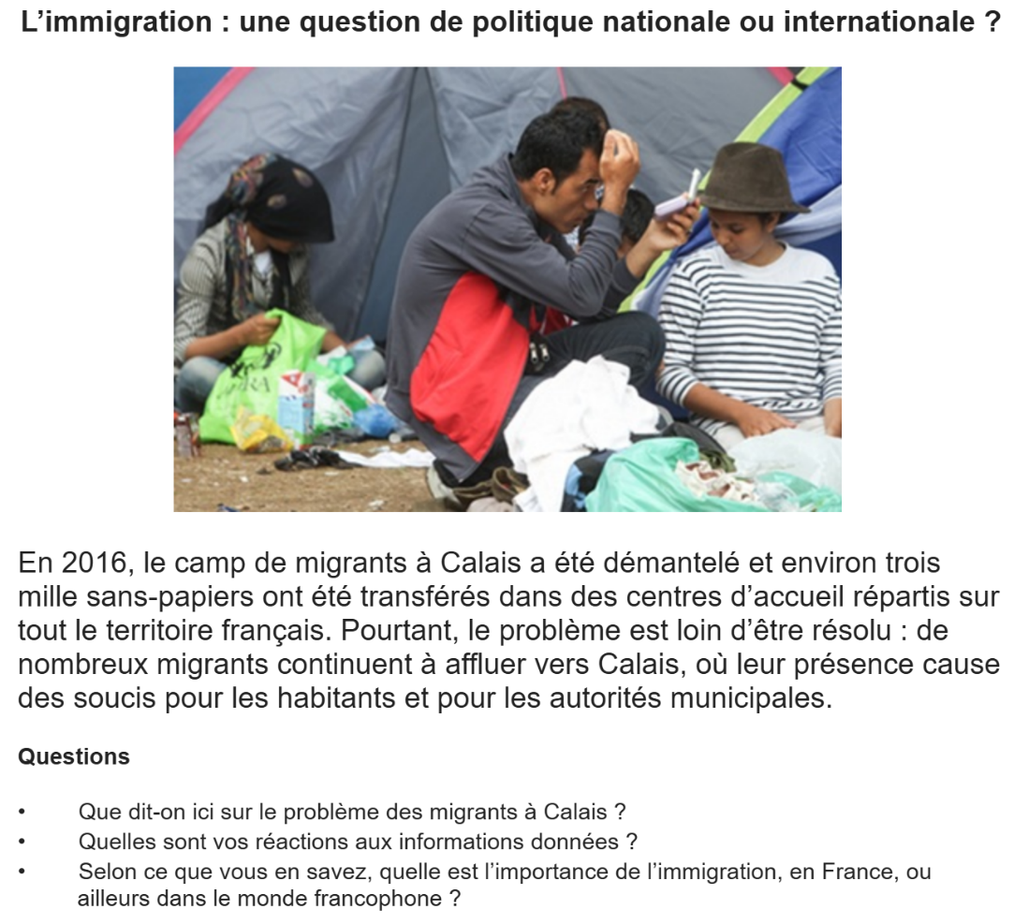
______________________________________________________________________________________________________________________________________________________________________________________________________________________________________________________________________________________________________________________________________________________________________________________________________________________________________________________________________________________________________________________________________________________________________________________________________________________________________________________________________________________________________________________________________________________________________________________________________________________________________________________________________________________________________________________________________________________________________________________________________________________________________________________________________________________________________________________________________________________________________________________________________________________________________________________________________________________________________________________________________________________________________________________________________________________________________________________________________________________________________________________________________________________________________________________________________________________________________________________________________________________________________________________________________________________________________________________________________________________________________________________________________________________________________________________________________________________________
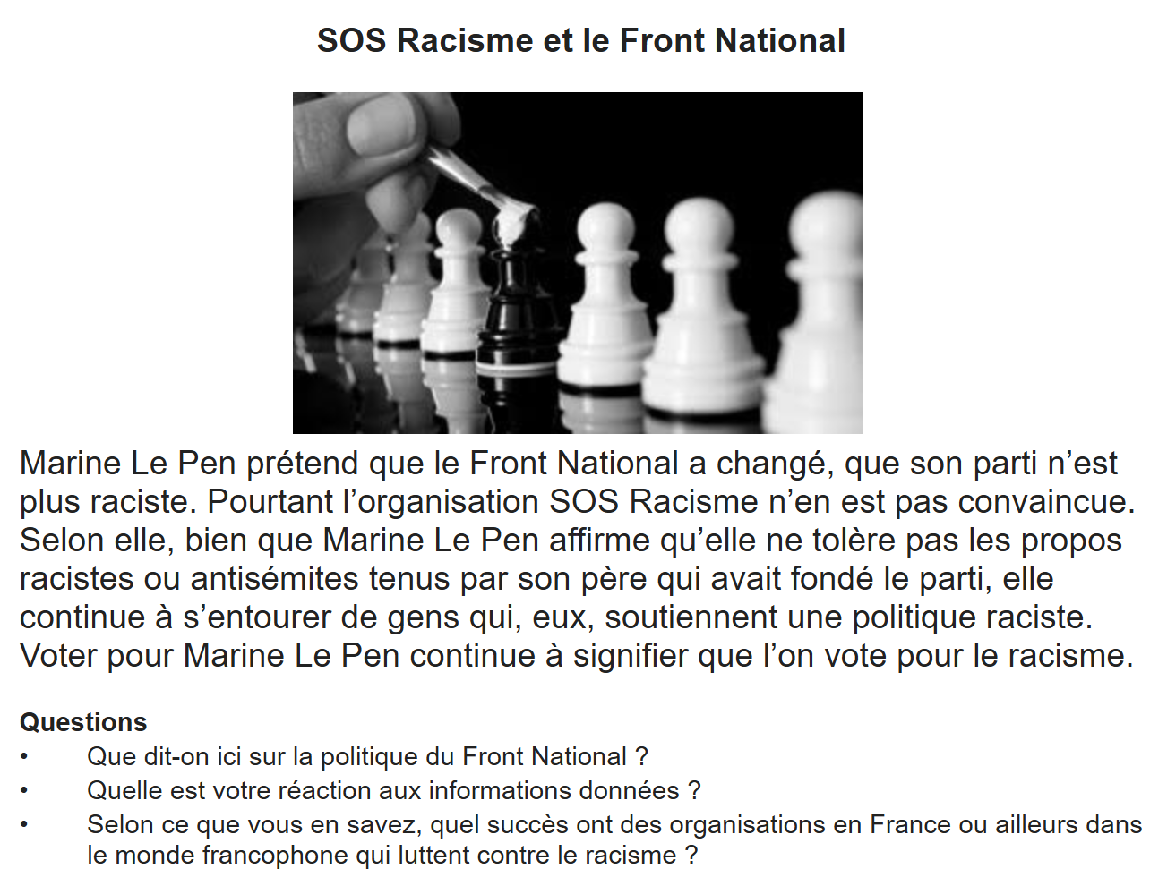
________________________________________________________________________________________________________________________________________________________________________________________________________________________________________________________________________________________________________________________________________________________________________________________________________________________________________________________________________________________________________________________________________________________________________________________________________________________________________________________________________________________________________________________________________________________________________________________________________________________________________________________________________________________________________________________________________________________________________________________________________________________________________________________________________________________________________________________________________________________________________________________________________________________________________________________________________________________________________________________________________________________________________________________________________________________________________________________________________________________________________________________________________________________________________________________________________________________________________________________________________________________________________________________________________________________________________________________________________________________________________________________________________________________________________________________________________________________________________________________________________________________________________________
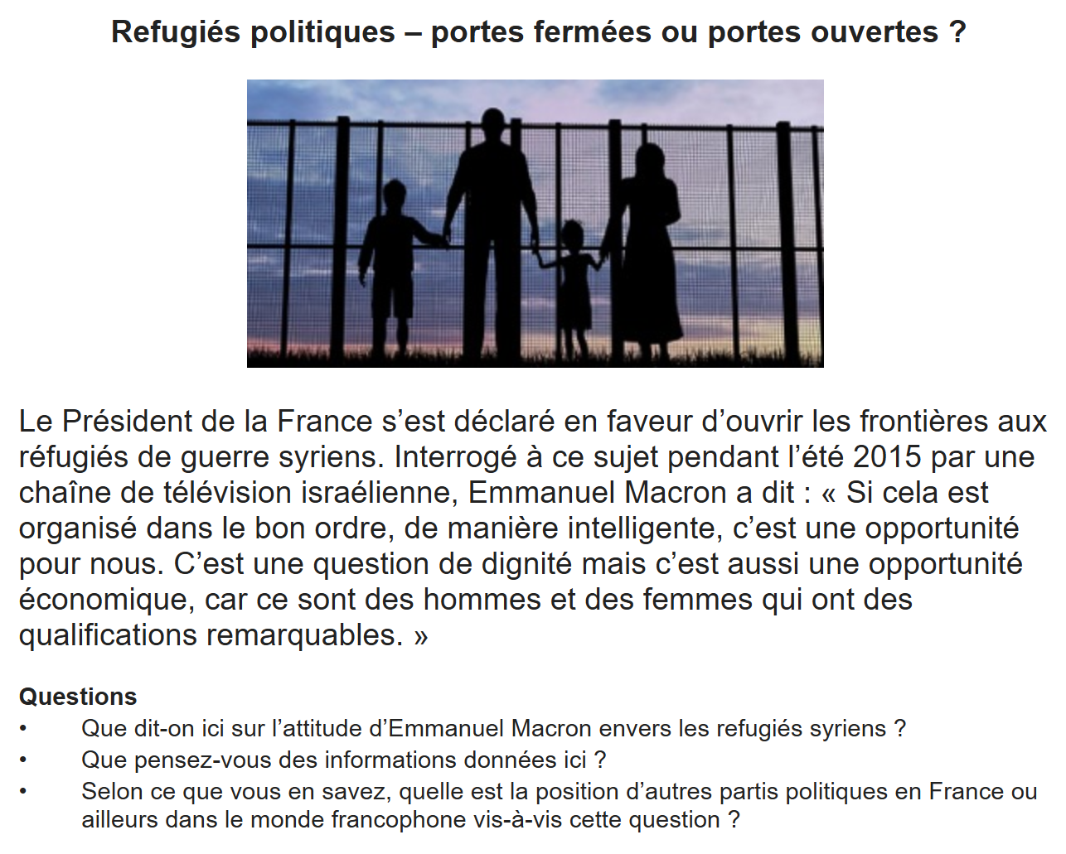
________________________________________________________________________________________________________________________________________________________________________________________________________________________________________________________________________________________________________________________________________________________________________________________________________________________________________________________________________________________________________________________________________________________________________________________________________________________________________________________________________________________________________________________________________________________________________________________________________________________________________________________________________________________________________________________________________________________________________________________________________________________________________________________________________________________________________________________________________________________________________________________________________________________________________________________________________________________________________________________________________________________________________________________________________________________________________________________________________________________________________________________________________________________________________________________________________________________________________________________________________________________________________________________________________________________________________________________________________________________________________________________________________________________________________________________________________________________________________________________________________________________________________________

6. Pratique du projet de recherche

Choisis un des quatre sujets suivants et prépare une présentation de deux minutes. Tu peux t’aider des bullets points ci-dessous.
‘L’exception française’ and its influence on the film industry
- What is ‘l’exception française’ – how and why did it begin and what is its purpose?
- What laws, rules and regulations exist regarding ‘l’exception française’ and the film industry, and what are the benefits of these?
- In what way does ‘l’exception française’ directly influence film makers and others who work in the industry in France, and what impact has been seen?
- Are there any arguments against the influence of ‘l’exception française’ in the French film industry? What evidence is given in support of these arguments?
Why was Les Intouchables* so successful outside France?
- What are the most significant facts, figures and statistics that demonstrate the film’s success?
- What are the main themes of the film and how did viewers/critics react to these? Did these contribute to the film’s success? If so, how?
- How significant a role did the actors and director play in the film’s success?
- What was the impact of the film’s success on the French film industry as a whole?
The significance of Truffaut in modern French cinema
- How and why did Truffaut become famous in the world of cinema and film-making?
- What were the most significant events of his career, and how did these influence his films?
- How is his influence still evident in French cinema today, and what is the evidence of this?
- What does he represent for French people and how is he portrayed in the media?
Is the French film industry surviving or thriving in the digital age?
- What statistics demonstrate the rise of digital technology and its effect on the film industry?
- How has the film industry reacted to the rise of digital technology, and what is the impact of this?
- What are the main advantages of the rise of digital technology for the film industry? How is the film industry embracing these?
- What are the main disadvantages of the rise of digital technology for the film industry? How is the film industry mitigating these?

7. Questions de conversation

- Comment la politique française a-t-elle évolué face à l’immigration ?
- Quels sont les partis politiques les plus engagés dans le débat sur l’immigration ?
- En quoi l’immigration est-elle un enjeu politique majeur en France ?
- La France accueille-t-elle trop ou pas assez d’immigrés ? Justifie ta réponse.
- Que penses-tu de la politique d’asile en France ?
- Comment les lois encadrent-elles l'immigration légale et illégale ?
- Quels sont les arguments principaux des partis contre l'immigration ?
- Quels sont les effets positifs de l’immigration en France ?
- L’immigration peut-elle être une richesse pour un pays ?
- En quoi l’immigration est-elle liée aux questions d’intégration ?
- Comment l’immigration est-elle perçue dans les médias français ?
- Le gouvernement français est-il trop strict ou trop laxiste en matière d’immigration ?
- Que penses-tu des centres de rétention pour les immigrés illégaux ?
- Pourquoi l’immigration est-elle un sujet si sensible lors des élections ?
- Comment pourrait-on mieux intégrer les immigrés en France ?
- L’école joue-t-elle un rôle important dans l’intégration ?
- Quelle est la différence entre immigration, intégration et assimilation ?
- Le multiculturalisme est-il compatible avec la société française ?
- Que penses-tu de la laïcité dans le contexte de l’immigration ?
- Quelle est ton opinion sur les contrôles aux frontières et les politiques migratoires européennes ?

