
Year 11 Required Practical Booklet

Name:……………………………………….
Target :……..
Teacher : ……………………….

WWW | EBI | Revision Focus
 | MIB:

Year 11 Science – Required Practical Booklet
Student Checklist | 1st SA | 2nd SA
I can state the 3 variables in a practical
I can explain why we only have 1 independent variable
I know the difference between accuracy and precision
I can state what the resolution of a device is
I can calculate the mean
I can calculate the range
I can state how to improve a method
I can state the difference between a risk and a hazard
I can calculate percentage change
I can state what the two types of data are
I can state which graph we use for each type of data
I know what an anomaly is
I can draw a line of best fit
I can make conclusions from a practical
I know the difference between a positive correlation and directly proportional

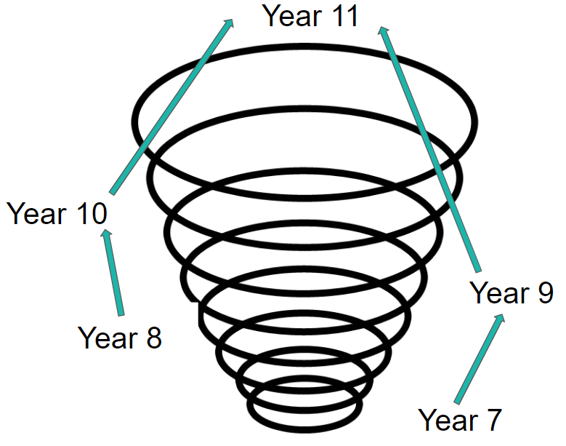
11
9
7
Year 7 content covered:
Building on it in Year 9
Broader applications in Year 11

Year 11 Science – Required Practical Booklet
Title: 1 - Microscopy + Food Tests
Date: __________________
Keywords: Variable, Accuracy, Precision, Mean, Range
Key Learning: To understand how the science required practical’s apply to real life
Big Picture:
This lessons helps us understand the practical aspects of science and apply it to life

Silent Starter – Recall
Starter 1 | Starter 2 | Extension
What are the 3 variables in a practical? | What do the 3 variables mean? | Why do we only have 1 independent variable?

Microscopy:
What is the purpose of the practical? ____________________________________________
What key equipment do I use? _________________________________________________
What was the dependant variable? ______________________________________________
What was the independent variable? ____________________________________________
State 3 control variables ______________________________________________________
What do the results show and why? _____________________________________________ ___________________________________________________________________________
Put the Method in order:
Stain the cell sample
Place the slide on the stage of the microscope on the lowest magnification
Increase the magnification and re-focus
Put a layer of onion cells onto a slide
Carefully place a coverslip on the cell sample
Adjust the focusing wheel the focus the sample

Exam Questions:
Q1. The diagram below shows a human bone cell.
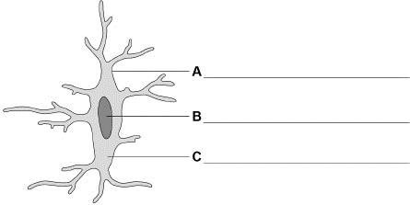
(a) Label the cell structures A, B and C on the diagram above.
(3)
(b) Which structure in the cell contains DNA?
Tick (✓) one box.

A |  | B |  | C
(1)
(c) A student used a microscope to view a cell.
The length of the image of the cell was 40 mm
The real length of the cell was 0.25 mm
Calculate the magnification of the image.
Use the equation:
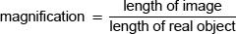
___________________________________________________________________
Magnification = ×_______________(2)

Info Sheet:
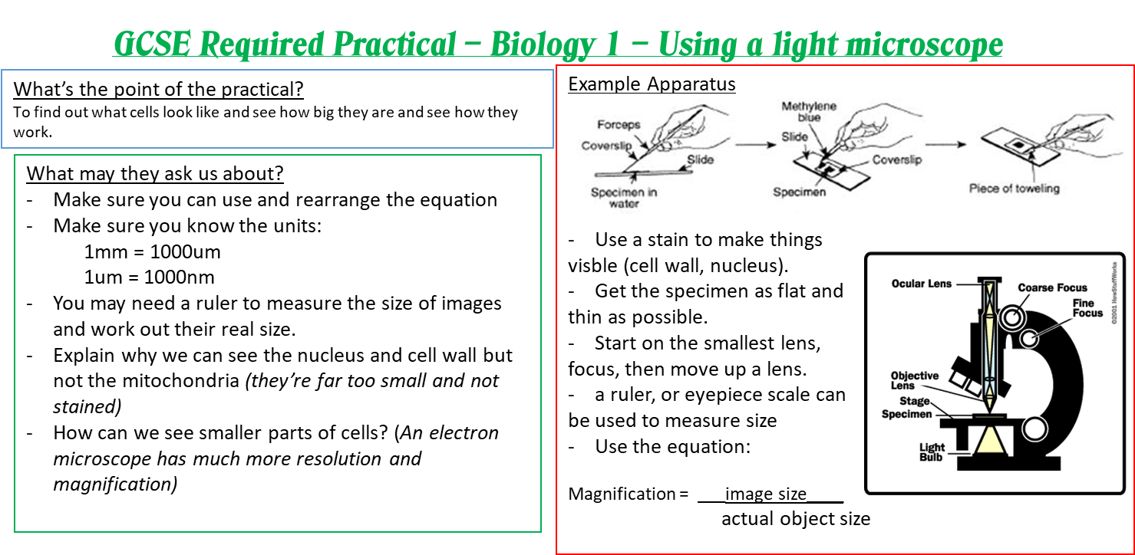

Food Tests:
What is the purpose of the practical? ____________________________________________
What key equipment do I use? _________________________________________________
What was the dependant variable? ______________________________________________
What was the independent variable? ____________________________________________
State 3 control variables ______________________________________________________
What do the results show and why? _____________________________________________ ___________________________________________________________________________

Tests we need to know:
Food Type | Reagent | Positive result

Exam Questions:
The chemical composition of fatbergs can be tested.
Describe how a sample from a fatberg could be tested for fat and for protein.
Test for fat __________________________________________________________
___________________________________________________________________
Positive result for fat __________________________________________________
Test for protein ______________________________________________________
___________________________________________________________________
Positive result for protein ______________________________________________
(4)

Info Sheet:

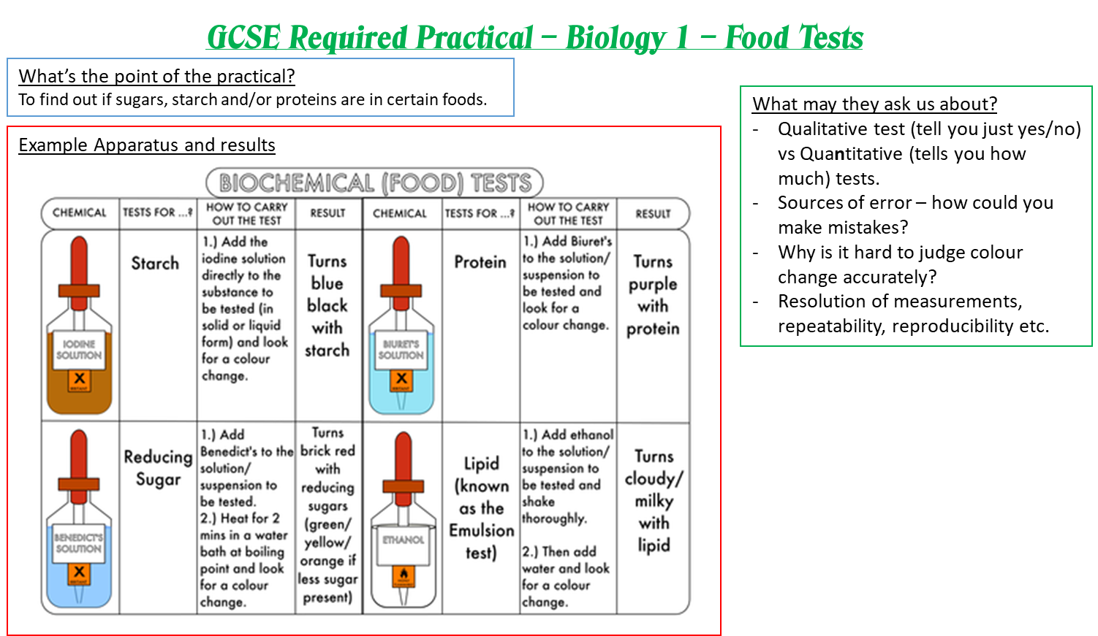

Year 11 Science – Required Practical Booklet
Title: 2 –Photosynthesis and Enzymes
Date: __________________
Keywords: Variable, Accuracy, Precision, Mean, Range
Key Learning: To understand how the science required practical’s apply to real life
Big Picture:
This lessons helps us understand the practical aspects of science and apply it to life

Silent Starter – Recall
Starter 1 | Starter 2 | Extension
What does accuracy mean | What does precision mean? | What does resolution mean in terms of a measuring device?

Photosynthesis:
What is the purpose of the practical? ____________________________________________
What key equipment do I use? _________________________________________________
What was the dependant variable? ______________________________________________
What was the independent variable? ____________________________________________
State 3 control variables ______________________________________________________
What do the results show and why? _____________________________________________ ___________________________________________________________________________
Put the Method in order:
Count the number of bubbles produced in one minute
Move the pondweed 20cm away from the light source
Cut the tip of a piece of pondweed and put it into a beaker
Repeat the practical twice more and calculate an average
Put the pondweed 10cm away from a light source
Repeat the investigation with new distances

Exam Questions:
Q1. Plants absorb light to photosynthesise.
(a) Complete the word equation for photosynthesis.
(1)
Light intensity affects the rate of photosynthesis.
The diagram below shows some of the equipment used to measure the rate of photosynthesis.
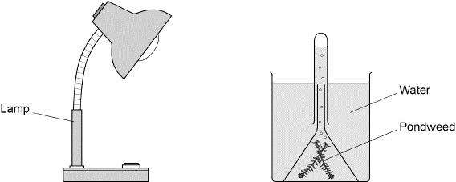
(b) Describe a method to investigate the effect of light intensity on the rate of photosynthesis.
Use the equipment in the diagram above and other laboratory equipment.
________________________________________________________________________________________________________________________________________________________________________________________________________________________________________________________________________________________________________________________________________________________________________________ (6)
Info Sheet:
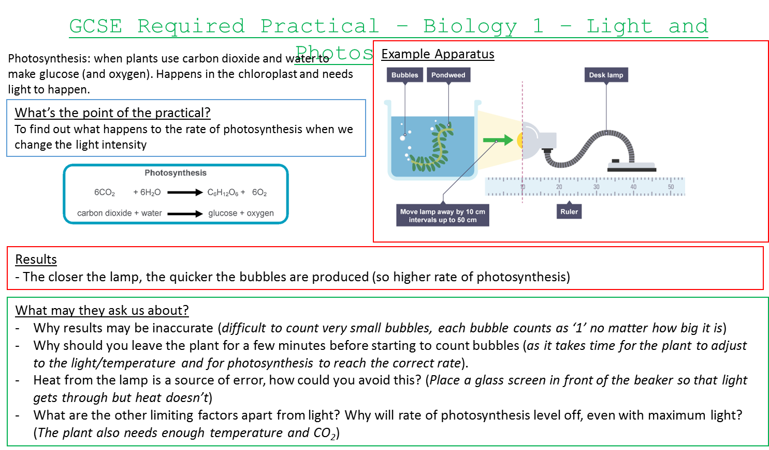
Enzymes:
What is the purpose of the practical? ____________________________________________
What key equipment do I use? _________________________________________________
What was the dependant variable? ______________________________________________
What was the independent variable? ____________________________________________
State 3 control variables ______________________________________________________
What do the results show and why? _____________________________________________ ___________________________________________________________________________
Put the Method in order:
Remove one drop of the amylase-starch mixture after 30 seconds
Add 2 cm³ of amylase solution at pH 5.0 to a test tube
Remove a drop of the amylase-starch mixture every 30 seconds until no starch is detected
Add 2 cm³ of starch solution to the same test tube and start a timer
Test the drop for starch
Repeat the investigation using amylase solution at different pHs

Exam Questions:
Describe the test for starch.
Give the result of the test if starch is present.
Test _______________________________________________________________
___________________________________________________________________
Result _____________________________________________________________
___________________________________________________________________(2)
The table below shows the results.

pH | Time for no starch to be detected in seconds
5.0 | 420
5.5 | 330
6.0 | 270
6.5 | 240
7.0 | 120
7.5 | 90
8.0 | 120
8.5 | 180
9.0 | 270
(c) What is the pH range the student used?
Use the table above.
pH range from _____ to _____
(1)
(d) At the optimum pH the enzyme works fastest.
What is the optimum pH for amylase enzyme?
Use the table above.
Optimum pH = _______________
(1)

Info Sheet:
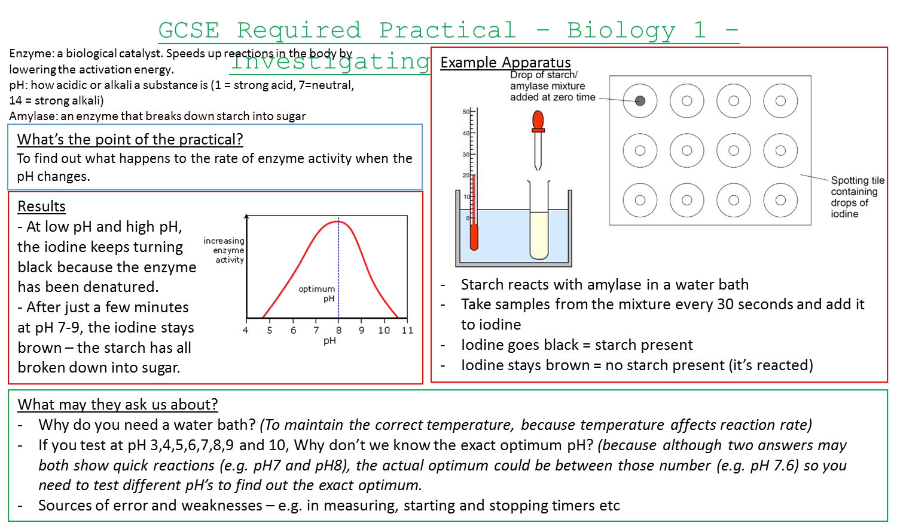

Year 11 Science – Required Practical Booklet
Title: 3 – Sampling Techniques + Making Salts
Date: __________________
Keywords: Variable, Accuracy, Precision, Mean, Range
Key Learning: To understand how the science required practical’s apply to real life
Big Picture:
This lessons helps us understand the practical aspects of science and apply it to life

Silent Starter – Recall
Starter 1 | Starter 2 | Extension
How do I calculate the mean? | How do I calculate the range? | How can I improve a method?

Sampling Techniques:
What is the purpose of the practical? ____________________________________________
What key equipment do I use? _________________________________________________
What was the dependant variable? ______________________________________________
What was the independent variable? ____________________________________________
State 3 control variables ______________________________________________________
What do the results show and why? _____________________________________________ ___________________________________________________________________________
Put the Method in order:
Count and record the number of the chosen plant species inside the quadrat
Choose two random numbers corresponding with the sample grid
Repeat the steps until you have counted in 10 different quadrats
Lay the quadrat in that section
Separate the sample area into grid sections
Estimate the total number of the chosen plant species

Exam Questions:
Q1.This question is about biodiversity.
A farmer:
• grows only wheat crops
• has used all his small fields to make a few large fields
• cuts down trees in his woodlands to burn as fuel.
(a) What are two ways the farmer could increase biodiversity on his farm?
Tick (✓) two boxes.

Cut down trees to grow wheat
Plant hedgerows around his fields
Plant many different crops in his fields
Put fences around his fields
Put fertiliser on his wheat crop
(2)
Students investigated the effect of cutting down trees in the woodland.
This is the method used.
1. Mark out a 10 m by 10 m area where trees have been removed.
2. Place a 1 m × 1 m quadrat at six random positions in the area.
3. Record the number of plant species present.
4. Record the number of invertebrate species seen among dead leaves on the ground.
5. Repeat steps 1 to 4 in an area where there are trees.
(b) Suggest one improvement the students could make to their method.
___________________________________________________________________
___________________________________________________________________(1)
(c) The students made this prediction:

‘There will be more invertebrate species living in the area where there are trees.’
Explain why the students’ prediction may be correct.
___________________________________________________________________
__________________________________________________________________(2)
Info Sheet: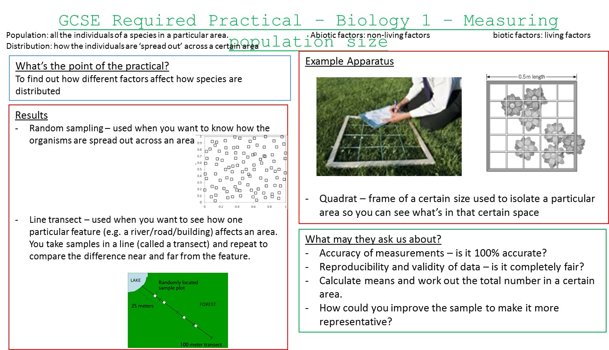
Making Salts:
What is the purpose of the practical? ____________________________________________
What key equipment do I use? _________________________________________________
What was the dependant variable? ______________________________________________
What was the independent variable? ____________________________________________
State 3 control variables ______________________________________________________
What do the results show and why? _____________________________________________ ___________________________________________________________________________

Put the Method in order:
Filter the contents of the beaker into an evaporating basin
Gently heat sulphuric acid in a beaker until crystals start to form
Evaporate the filtrate from the basin
Add a small amount of copper oxide to the acid and stir
Leave the evaporating basin in a cool place for 24 hours
Keep adding copper oxide until no more dissolves

Exam Questions:
Q1. A student wanted to make blue copper sulfate crystals from green copper carbonate powder and sulfuric acid.
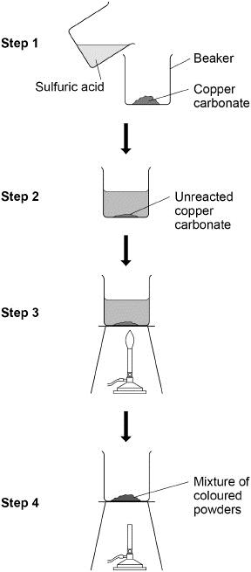
The student obtained a mixture of coloured powders not blue crystals.
Describe how the method could be improved so that blue copper sulfate crystals are produced.
__________________________________________________________________________________________________________________________________________________________________________________________________________________________________________________________________________________________________________________________________________________________________________________________________________________________________________________________________
Info Sheet:
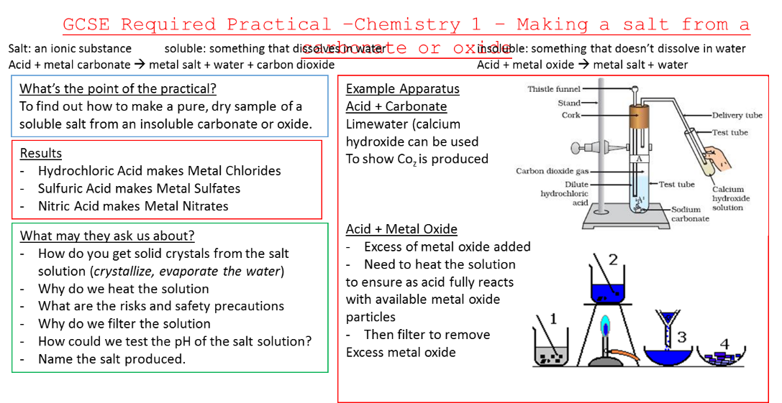
Year 11 Science – Required Practical Booklet
Title: 4 - Electrolysis + Temp. Changes in Solutions
Date: __________________
Keywords: Variable, Accuracy, Precision, Mean, Range
Key Learning: To understand how the science required practical’s apply to real life
Big Picture:
This lessons helps us understand the practical aspects of science and apply it to life

Silent Starter – Recall
Starter 1 | Starter 2 | Extension
What is a risk? | What is a hazard? | How do I calculate percentage change?

Electrolysis:
What is the purpose of the practical? ____________________________________________
What key equipment do I use? _________________________________________________
What was the dependant variable? ______________________________________________
What was the independent variable? ____________________________________________
State 3 control variables ______________________________________________________
What do the results show and why? _____________________________________________ ___________________________________________________________________________
Put the Method in order:
Insert carbon rods (electrodes) to the solution
Turn on the power pack
Connect the rods to a power pack
Pour copper chloride solution into a beaker
Record your observations at each electrode

Exam Questions:
What are the independent and dependent variables in this investigation?
Draw one line from each type of variable to the correct description.

Type of variable |  | Description
 |  | Concentration of copper sulfate solution
Independent variable
 |  | Distance between electrodes
 |  | Mass of copper deposited
Dependent variable
 |  | Time circuit is switched on for
(2)
The table below shows the student’s results.

Concentration of copper sulfate solution in g/dm³ | Mass of copper deposited in grams
30 | 0.04
60 | 0.08
90 | 0.12
120 | 0.07
150 | 0.20
(d) The result for the concentration of 120 g/dm³ is anomalous.
What may have caused the anomalous result?
Tick one box.

Some copper fell off the electrode | 
The circuit was switched on for too much time
The concentration of the solution was too high
(1)
(e) Predict the expected mass of copper deposited for the concentration of 120 g/dm³
Use the table above.
Mass of copper = _______________ g
(1)
(f) During the investigation copper ions move to the negative electrode.
Choose the answer from the box.

a negative charge | a positive charge | no charge
Copper ions move to the negative electrode because copper ions have
__________________________________________________ .
(1)
Info Sheet: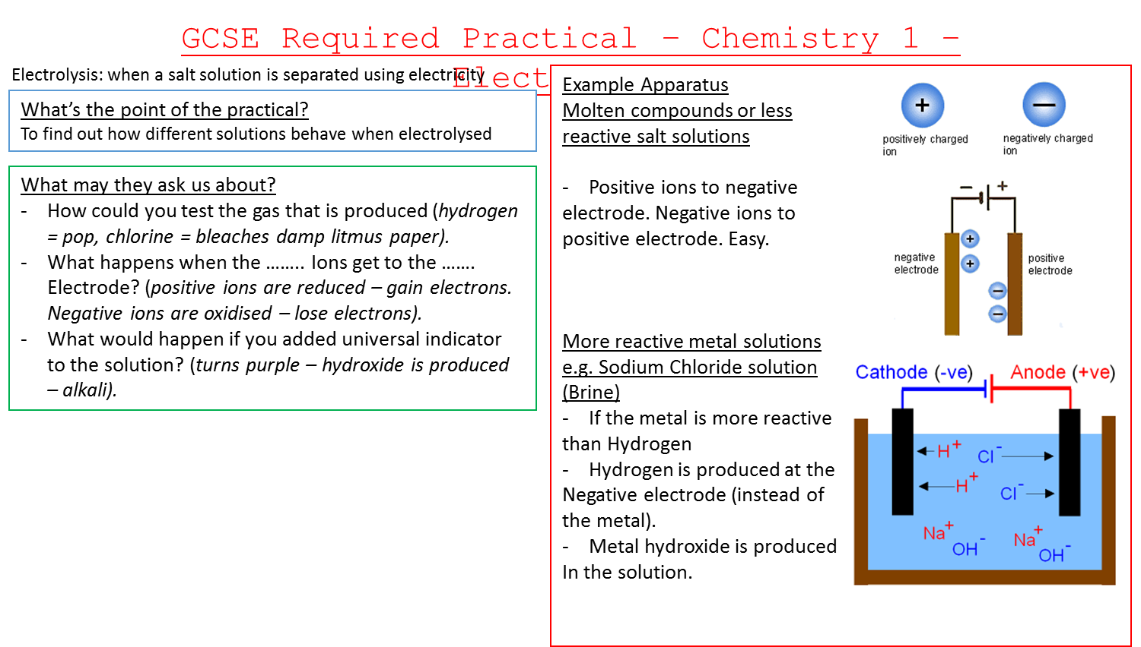
Temperature Changes in Solutions:
What is the purpose of the practical? ____________________________________________
What key equipment do I use? _________________________________________________
What was the dependant variable? ______________________________________________
What was the independent variable? ____________________________________________
State 3 control variables ______________________________________________________
What do the results show and why? _____________________________________________ ___________________________________________________________________________

Put the Method in order:
Add 5ml of sodium hydroxide to the acid
Stir until the temperature stops increasing and record the temperature
Add 30cm3 of hydrochloric acid to a polystyrene cup
Draw a graph of the amount of sodium hydroxide added in cm3 on the x axis and the mean temperature in °C on the y axis
Record the starting temperature of the acid
Add 5ml of sodium hydroxide again and measure the new temperature

Exam Questions:
Q1. A student investigated the temperature change when metal X was added to copper sulfate solution.
This is the method used.
1. Add 25 cm³ of copper sulfate solution to a beaker.
2. Measure the temperature of the copper sulfate solution.
3. Add 1.0 g of metal X and stir.
4. Measure the highest temperature reached when metal X is added to copper sulfate solution.
5. Repeat steps 1 to 4 with different metals.
Figure 1 shows the apparatus used.
Figure 1
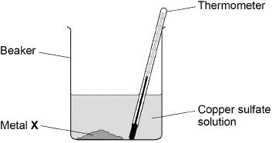
Figure 2 shows the thermometer reading of the copper sulfate solution at the start of the investigation.
Figure 2
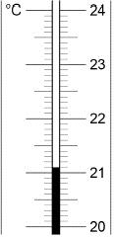
(a) The highest temperature reached when metal X was added to copper sulfate solution was 35.5 °C
Determine the temperature change when metal X is added to copper sulfate solution.
Use Figure 2.
Highest temperature = 35.5 °C
Temperature at start = __________°C
Temperature change = __________°C
(2)
(b) Give two variables the student should keep the same in this investigation.
1. _________________________________________________________________
2. _________________________________________________________________ (2)

Info Sheet:
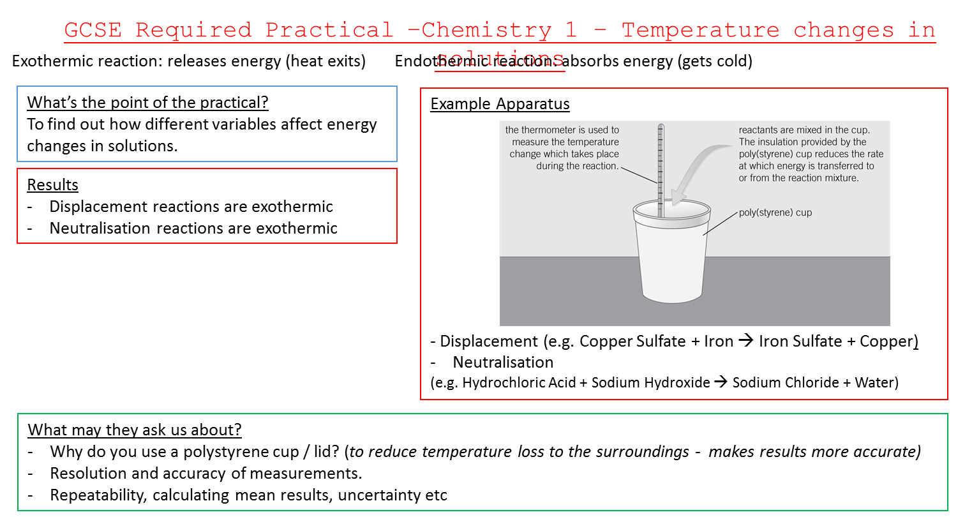

Year 11 Science – Required Practical Booklet
Title: 5 - Rates of Reaction + Chromatography
Date: __________________
Keywords: Variable, Accuracy, Precision, Mean, Range
Key Learning: To understand how the science required practical’s apply to real life
Big Picture:
This lessons helps us understand the practical aspects of science and apply it to life

Silent Starter – Recall
Starter 1 | Starter 2 | Extension
What are the two types of data? | What graph do I use for each type of data? | What variable goes on each axis on a graph?

Rates of Reaction:
What is the purpose of the practical? ____________________________________________
What key equipment do I use? _________________________________________________
What was the dependant variable? ______________________________________________
What was the independent variable? ____________________________________________
State 3 control variables ______________________________________________________
What do the results show and why? _____________________________________________ ___________________________________________________________________________
Put the Method in order:
Add sodium thiosulphate solution to a conical flask
Add hydrochloric acid to the flask and stir
Start a stopwatch
Draw a cross on a piece of paper and place the flask on top of the cross
Repeat the investigation but with different concentrations of sodium thiosulphate
Look through the solution in the flask to the drawn cross, record the time when you can no longer see the cross

Exam Questions:
Draw one line from each type of variable to the correct example of the variable.

Type of variable |  | Example of variable
 |  | Mass lost from flask
Independent |  | Size of flask
 |  | Size of marble chips
Control |  | Time taken
 |  | Volume of acid
(2)
(b) The equation for the reaction is:
CaCO₃(s) + 2HCl(aq) CaCl₂(aq) + H₂O(l) + CO₂(g)
Name the three products.
1. ______________________________
2. ______________________________
3. ______________________________
(2)
(c) Another student suggests putting some cotton wool in the top of the flask.
Suggest why this improves the investigation.
___________________________________________________________________ (1)
Info Sheet:
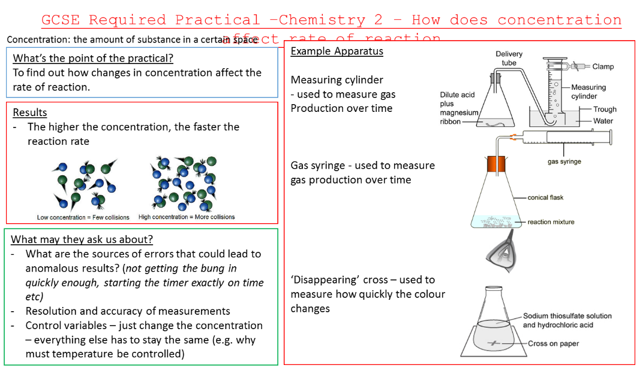
Chromatography:
What is the purpose of the practical? ____________________________________________
What key equipment do I use? _________________________________________________
What was the dependant variable? ______________________________________________
What was the independent variable? ____________________________________________
State 3 control variables ______________________________________________________
What do the results show and why? _____________________________________________ ___________________________________________________________________________

Put the Method in order:
Add a small spot of each colouring on the pencil spots
Use a ruler to draw a pencil line 2cm form the bottom of chromatography paper
Take the chromatography paper out and leave to dry
Mark 5 pencil spots at equal intervals across the origin line
Hang the chromatography paper on a wooden splint into a beaker so that the paper touches water
Leave the chromatography paper until the water travels 3 quarters up the paper

Exam Questions:
Q1.
A student used paper chromatography to identify the colours in a black ink.
The diagram below shows the student’s results.
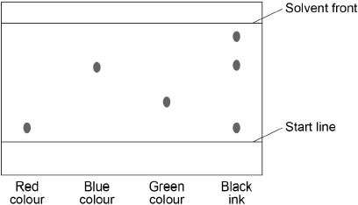
(a) What colours are in the black ink?
___________________________________________________________________
___________________________________________________________________
(2)

(b) Suggest which colour is least soluble in the solvent.
Give a reason for your answer.
Colour ______________________
Reason __________________________________________________________
___________________________________________________________________
(2)

Info Sheet:
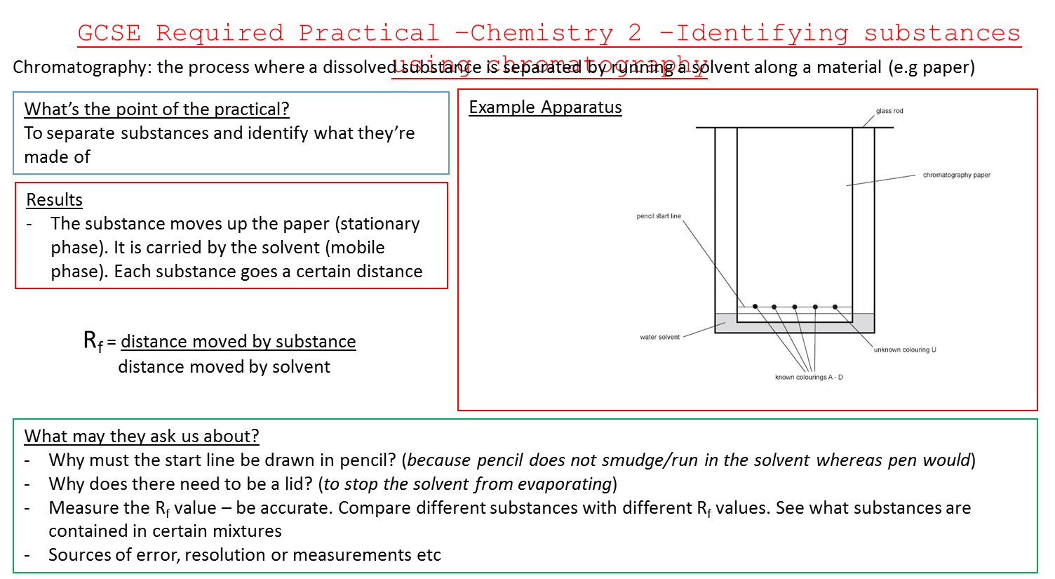

Year 11 Science – Required Practical Booklet
Title: 6 - Specific Heat capacity + I/V Characteristics
Date: __________________
Keywords: Variable, Accuracy, Precision, Mean, Range
Key Learning: To understand how the science required practical’s apply to real life
Big Picture:
This lessons helps us understand the practical aspects of science and apply it to life

Silent Starter – Recall
Starter 1 | Starter 2 | Extension
What is an anomaly? | How do I draw a line of best fit on a graph? | How do I draw a line of best fit when there is an anomaly?

Specific Heat Capacity:
What is the purpose of the practical? ____________________________________________
What key equipment do I use? _________________________________________________
What was the dependant variable? ______________________________________________
What was the independent variable? ____________________________________________
State 3 control variables ______________________________________________________
What do the results show and why? _____________________________________________ ___________________________________________________________________________
Put the Method in order:
Measure the mass of the copper block
Place a thermometer in the smaller hole in the block and measure the starting temperature
Measure the temperature of the block every 30 seconds
Connect the heater to a power pack and switch on
Make a graph of temperature and energy provided
Place the heater in the larger hole in the block

Exam Questions:
The student measured the temperature of the metal block every 60 seconds.
The table below shows the student’s results.

Time in s | Temperature in °C
0 | 20.0
60 | 24.5
120 | 29.0
180 | 31.0
240 | 31.5
(a) Complete the graph of the data from the table above on the graph below.
• Choose a suitable scale for the x-axis.
• Label the x-axis.
• Plot the student’s results.
• Draw a line of best fit.
Figure 2
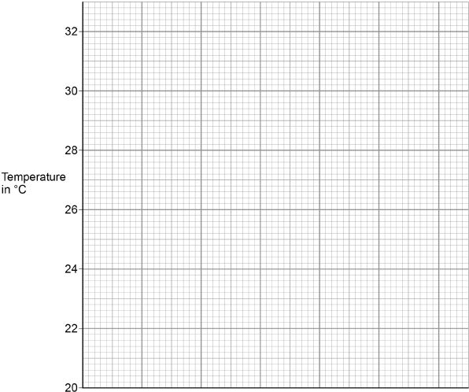
(4)
(b) The rate of change of temperature of the block is given by the gradient of the graph.
Determine the gradient of the graph over the first 60 seconds.
___________________________________________________________________
___________________________________________________________________
Gradient = _____________________ (2)
Info Sheet:
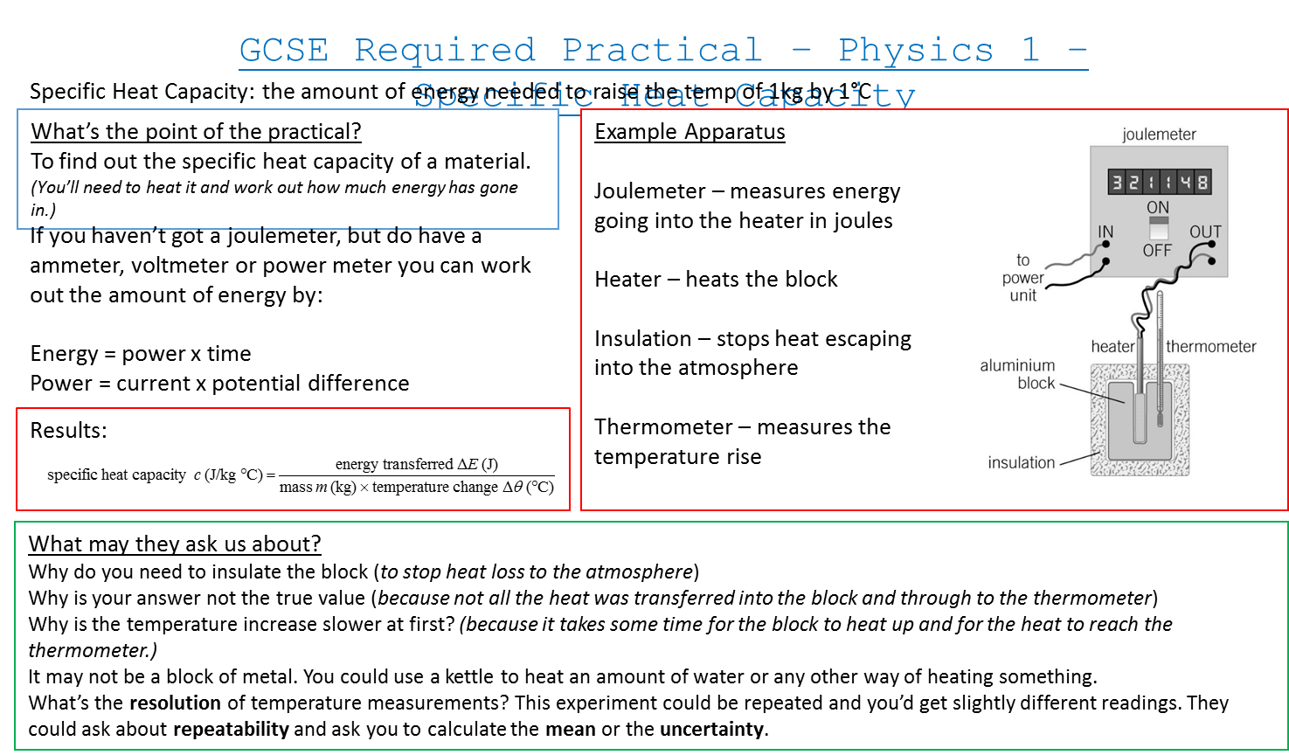
I/V Characteristics:
What is the purpose of the practical? ____________________________________________
What key equipment do I use? _________________________________________________
What was the dependant variable? ______________________________________________
What was the independent variable? ____________________________________________
State 3 control variables ______________________________________________________
What do the results show and why? _____________________________________________ ___________________________________________________________________________
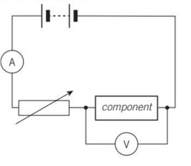
Put the Method in order:
Set up the circuit as shown
Adjust the variable resistor and record the new ammeter and voltmeter readings
Draw a current/PD graph of you results and add a line of best fit
Repeat to obtain several pairs of results
Repeat the experiment for the other components
Record the ammeter and voltmeter readings

Exam Questions:
Q1. A student investigated how the power output of a filament lamp varied with the current in the lamp.
The diagram below shows part of the circuit the student used.
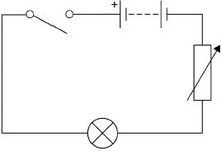

(a) To calculate power output the student measured the current in the lamp and the potential difference across the lamp.
Complete the diagram above by adding an ammeter and a voltmeter to make the measurements.
Use the correct circuit symbols. (3)
(b) Which energy store in the battery decreases when the lamp is switched on?
_________________________________________________________________ (1)
(c) What happens to the energy transferred by the lamp?
___________________________________________________________________ (1)

Info Sheet:
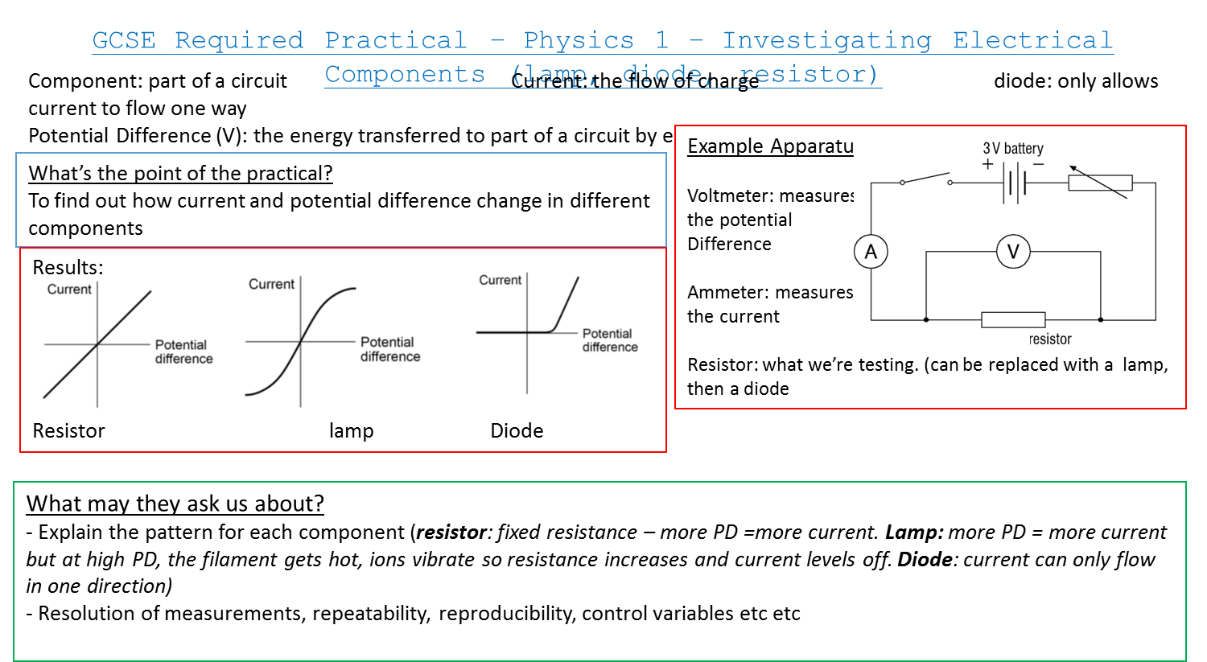
Year 11 Science – Required Practical Booklet
Title: 7 – Infrared Radiation
Date: __________________
Keywords: Variable, Accuracy, Precision, Mean, Range
Key Learning: To understand how the science required practical’s apply to real life
Big Picture:
This lessons helps us understand the practical aspects of science and apply it to life

Silent Starter – Recall
Starter 1 | Starter 2 | Extension
Define positive correlation | Define directly proportional | What is a conclusion?

Infrared Radiation:
What is the purpose of the practical? ____________________________________________
What key equipment do I use? _________________________________________________
What was the dependant variable? ______________________________________________
What was the independent variable? ____________________________________________
State 3 control variables ______________________________________________________
What do the results show and why? _____________________________________________ ___________________________________________________________________________
Put the Method in order:
Use a detector to measure the amount of Infrared radiation emitted from each surface
Put boiling water in the cube and put the lid on the cube
Draw a bar chart to show the amount of Infrared radiated by each surface
Put the Leslie cube on a heat proof mat

Exam Questions:
Table 1 shows some of the variables in this investigation.

Table 1
Variable | Independent | Dependent | Control
Distance between infrared detector and surface of cube |  |  | ✓
Starting temperature of water inside cube
Temperature measured by infrared detector
Type of surface
Identify each variable as an independent, dependent or control variable.
Tick (✓) one box in each row on Table 1.
One row has been completed for you. (3)
Table 2 shows the results.

Table 2
Type of surface | Temperature in °C
Shiny black | 66.5
Matt white | 61.0
Matt black | 69.0
Shiny silver | 26.0
(c) What was the resolution of the infrared detector?
___________________________________________________________________________
(d) What was the range of temperatures recorded?
Range = _______________ °C to _______________ °C (1)

Info Sheet:
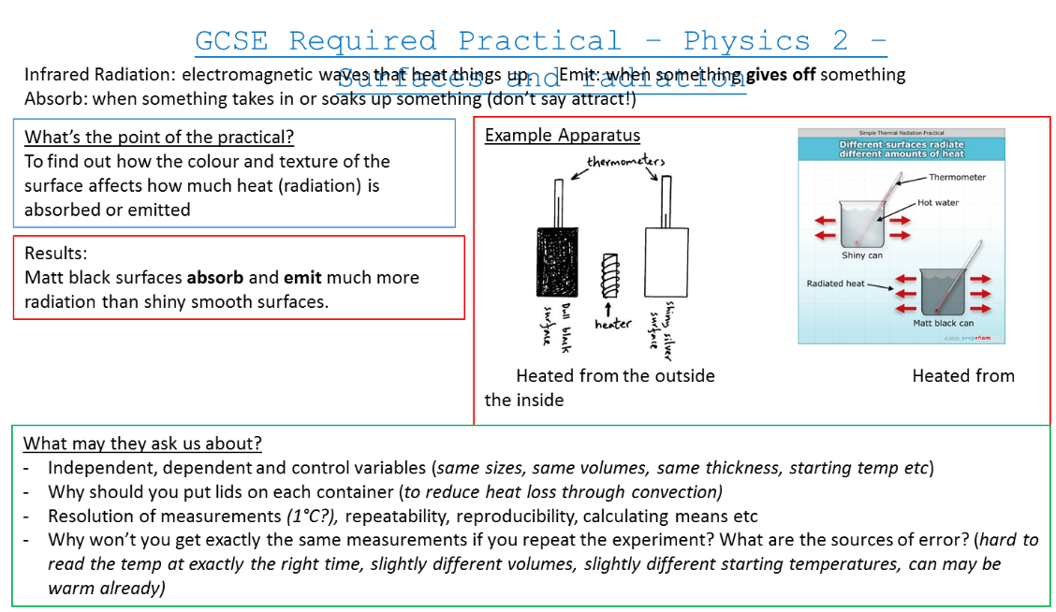
Year 11 Science – Required Practical Booklet
Title: 8 – Equation Triangles
Date: __________________
Keywords: _______________________________________________________
Key Learning:
Big Picture:

Silent Starter – Recall
Starter 1 | Starter 2
What are speed, distance and time measured in? | Can you draw the speed/distance/time triangle?

New learning
What are the steps to using an equation triangle?
____________________________________________________________________________________________________________________________________________________________________________________________________________________________________________________________________________________________________________
Complete your calculations here:
____________________________________________________________________________________________________________________________________________________________________________________________________________________________________________________________________________________________________________
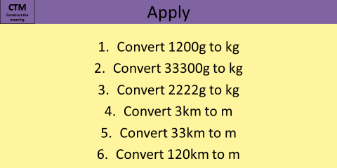
Stretch
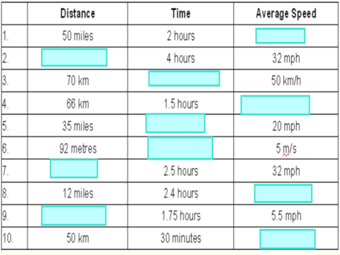

Glue in your physics equations here

Year 11 Science – Required Practical Booklet
Title: 9 – Answering Equation Questions
Date: __________________
Keywords: _______________________________________________________
Key Learning:
Big Picture:

Silent Starter – Recall
Component | Component Symbol | Unit | Unit Symbol
Energy
Time
Current
Resistance
Power
PD
Work Done
Charge
Displacement
Mass
Velocity
Gravitational Field Strength
Height
Spring Constant
Extension
Specific Heat Capacity
Temperature Change
Force
Volume
Density
Specific Latent Heat
Wave Speed
Frequency
Wavelength
Time Period
Weight
Acceleration

New learning
Write down your equations here:
____________________________________________________________________________________________________________________________________________________________________________________________________________________________________________________________________________________________________________
What are the 4 steps to answering an equation question?
____________________________________________________________________________________________________________________________________________________________________________________________________________________________________________________________________________________________________________
Stretch
Q1. The ball travels along the lane at an average speed of 4.5 m/s
It takes the ball 4.0 seconds to travel the length of the lane.
Calculate the length of the lane.
Use the equation: distance travelled = speed × time
Equation = _____________________________________________________________
Substitution = ___________________________________________________________
Answer = _______________________________________________________________
Units = ______________________________________________________________ (2)

(b) The velocity of the pin changes from 0 to 12 m/s
It takes 0.15 seconds for the velocity to change.
Calculate the acceleration of the pin.
Use the equation: 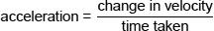
Equation = _____________________________________________________________
Substitution = ___________________________________________________________
Answer = _______________________________________________________________
Units = ______________________________________________________________ (2)

Q2. The mass of a car is 850 kg
Calculate the weight of the car.
Use the equation:
weight = mass × gravitational field strength
gravitational field strength = 9.8 N/kg
Equation = _____________________________________________________________
Substitution = ___________________________________________________________
Answer = _______________________________________________________________
Units = ____________________________________________________________ (2)
(b) A car is travelling at a constant speed.
A constant braking force of 5100 N is applied by the brakes.
The car decelerates and stops.
The braking distance is 38 m
Calculate the work done by the braking force.

work done = force × distance
Equation = _____________________________________________________________
Substitution = ___________________________________________________________
Answer = _______________________________________________________________
Units = _______________________________________________________________(3)
Q3.The diagram below shows a girl skateboarding on a semi-circular ramp.
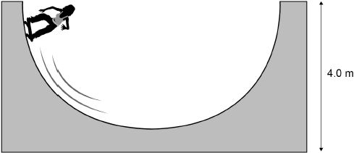
The girl has a mass of 50 kg
(a) Calculate the gravitational potential energy (g.p.e.) of the girl at the top of the ramp.
Use the equation: g.p.e. = mass × gravitational field strength × height
gravitational field strength = 9.8 N/kg
Equation = _____________________________________________________________
Substitution = ___________________________________________________________
Answer = _______________________________________________________________
Units = _________________________________________________________________
(2)
(b) The girl has a speed of 7 m/s at the bottom of the ramp.
Calculate the kinetic energy of the girl at the bottom of the ramp.
Use the equation: kinetic energy = 0.5 × mass × (speed)²
Equation = _____________________________________________________________
Substitution = ___________________________________________________________
Answer = _______________________________________________________________
Units = ____________________________________________________________ (2)

Notes
____________________________________________________________________________________________________________________________________________________________________________________________________________________________________________________________________________________________________________________________________________________________________________________________________________________________________________________________________________________________________________________________________________________________________________________________________________________________________________________________________________________________________________________________________________________________________________________________________________________________________________________________________________________________________________________________________________________________________________________________________________________________________________________________________________________________________________________________________________________________________________________________________________________________________________________________________________________________________________________________________________________________________________________________________________________________________________________________________________________________________________________________________________________________________________________________________________________________________________________________________________________________________________________________________________________________________________________________________________________________________________________________________________________________________________________________________________________________________________________________________________________________________________________________________________________________________________________________________________________________________________________

