Alternative to practical 6 mark questions
2019

2020
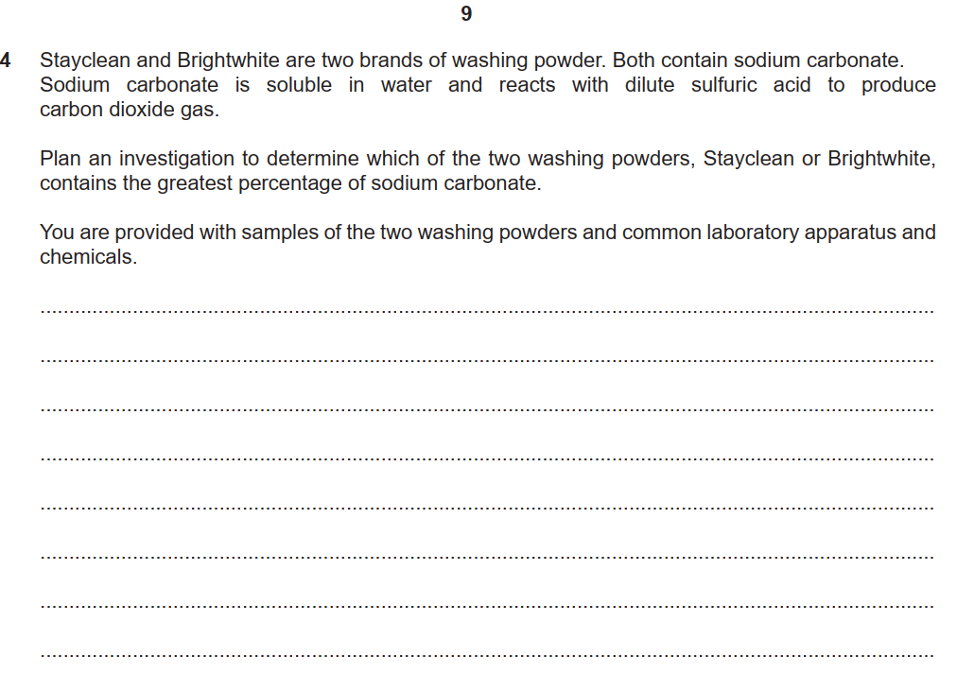

2021

2022

2023

