Year 5 Summer 2
How do Muslims live and embrace their faith in a diverse world?
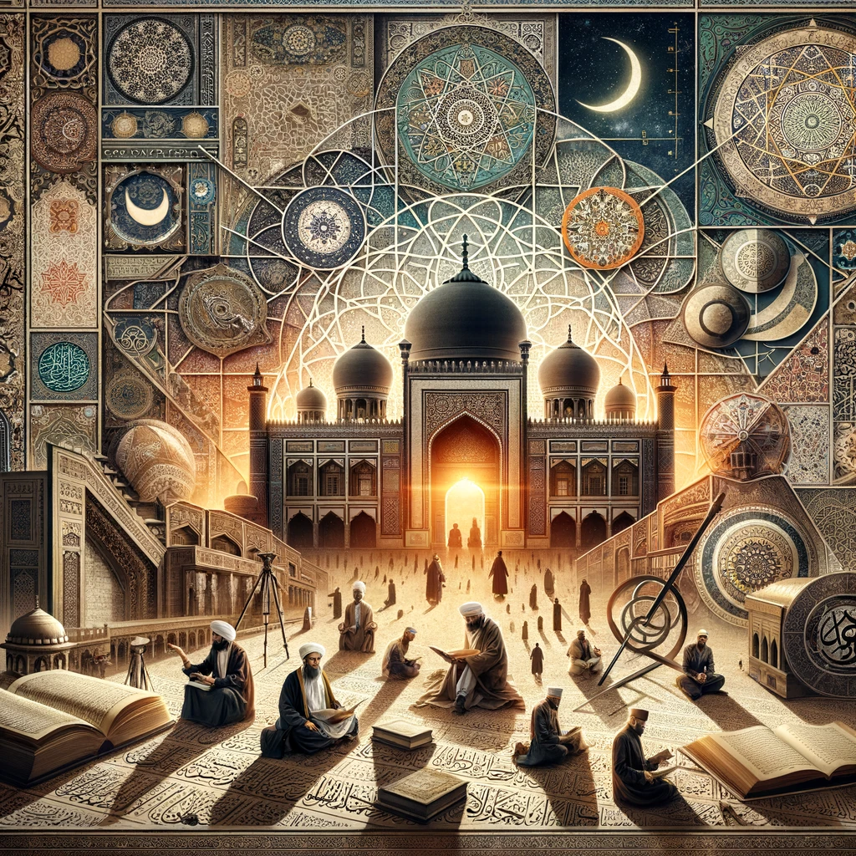
We will learn:
- To know and understand the fundamentals of Islam
- To recognise the similarities in the Abrahamic Religions
- To understand the role of Jesus (peace be upon him) in Islam
- To understand Muhammad’s (peace be upon him) role in Islam
- To understand the impact of the Golden Age of Islam
- To understand how Muslim’s practice their faith today and reflect on the lessons learnt
We now understand
What we know already

