Shimna Integrated College
GCSE English


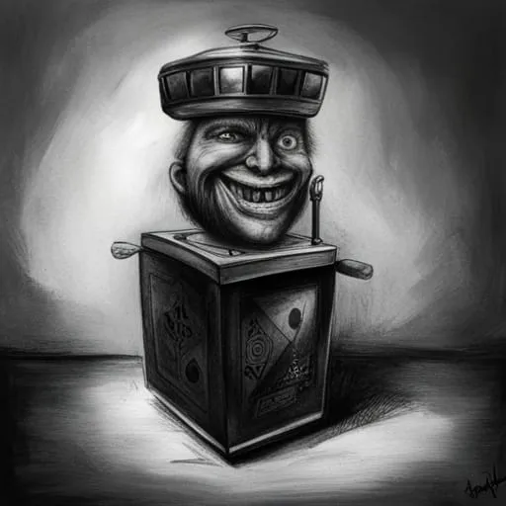
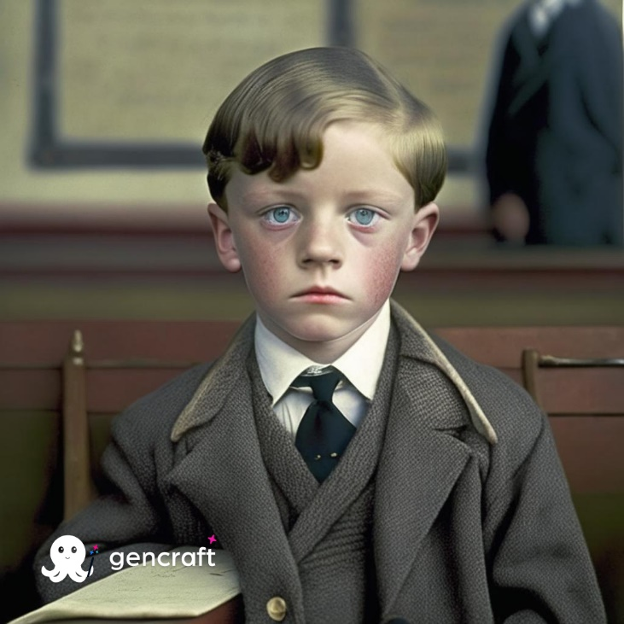

Childhood

Childhood
- What are some of your earliest memories?
- What are some of your favourite least favourite memories of childhood?
- What do you miss most about being a child?
- What were some of your favourite toys?
- When did your childhood end?
- Do you think the experiences of your childhood shape the person you become as an adult?

In this unit we will be reading a range of texts based around the theme of childhood.
At the end you will write an essay about one of these texts, this will be a controlled assessment done under exam conditions and it will be worth 10% of your GCSE in English language.

________________________________________________________________________
Our first text is by an author you may well have read during your own childhood, Roald Dahl. In this extract from his autobiography, ‘Boy’, he is writing about a memory from his own childhood.
-What do you know about Roald Dahl?

-What is an autobiography?

The Sweet Shop
The sweet-shop in Llandaff in the year 1923 was the very centre of our lives. Without it, there would have been very little to live for. But it had one terrible drawback, this sweet-shop. The woman who owned it was a horror. We hated her and we had good reason for doing so.
Her name was Mrs Pratchett. She was a small skinny old hag with a moustache on her upper lip and a mouth as sour as a green gooseberry. She never smiled. She never welcomed us when we went in, and they only times she spoke were when she said things like, “I’m watchin’ you so keep yer thievin’ fingers off them chocolates!” Or “I don’t want you in ‘ere just to look around! Either you forks out or you gets out!”
But by far the most loathsome thing about Mrs Pratchett was the filth that clung around her. Her apron was grey and greasy. Her blouse had bits of breakfast all over it, toast-crumbs and tea stains and splotches of dried egg-yolk. It was her hands, however, that disturbed us most. They were disgusting. They were black with dirt and grime. They looked as though they had been putting lumps of coal on the fire all day long. And do not forget please that it was these very hands and fingers that she plunged into the sweet jars when we asked for a pennyworth of Treacle Toffee or Wine Gums or Nut Clusters or whatever. The mere sight of her grimy right hand, with its black fingernails, digging an ounce of Chocolate Fudge out of a jar would have caused a starving tramp to go running from the shop. But not us. Sweets were our life-blood. We would have put up with far worse than that to get them. So we simply stood and watched in sullen silence while this disgusting old woman stirred around inside the jars with her foul fingers.
The other thing we hated Mrs Pratchett for was her meaness. Unless you spent a whole sixpence in one go, she wouldn’t give you a bag. Instead you got your sweets twisted up in a small piece of newspaper which she tore off a pile of old Daily Mirrors lying on the counter.
So you can well understand that we had it in for Mrs Pratchett in a big way, but we didn’t quite know what to do about it. Many schemes were put forwards but none of them was any good. None of them, that is, until suddenly, one memorable afternoon, we found the dead mouse.
Check Your Understanding
Answer these questions in full sentences in your book.
1. Where was the sweet-shop?
2. Find and copy a phrase from the text which shows how important the sweet-shop was to Dahl and his friends.
3. What does Mrs Pratchett mean by “Either you forks out or you gets out!”?
4. Explain, in your own words, what Dahl means when he says sweets were the boys “life-blood”.
5. Using information from the text, decide which statement is true or false.
-Mrs Pratchett was small and very thin.
-Mrs Pratchett’s blouse was stained with tea.
-The sweet-shop sold liquorice.
-Sweets were always wrapped in newspaper.
6. How does Mrs Pratchett treat Dahl and his friends when they visit her sweet-shop? Use evidence from the text to support your answer. PEE
7. “We simply stood and watched in sullen silence...” The word sullen is closest in meaning to:
Gloomy Quiet Bored Content
8. What do you think will happen next?

Creative Writing
Imagine you are Mrs Pratchett. Write down your thoughts about the children who visit your sweet shop.

The Great Mouse Plot
The following extract is a continuation of the story you have just read.
My four friends and I had come across a loose floor-board at the back of the classroom, and when we prised it up with the blade of a pocket knife, we discovered a big hollow space underneath. This, we decided, would be our hiding place for sweets and other small treasures such as conkers, monkey-nuts and birds’ eggs.
One day, when we lifted it up, we found a dead mouse lying among our treasures. It was an exciting discovery. Thwaites took it out by its tail and waved it in front of our faces. “What shall we do with it?” he cried.
“It stinks!” someone shouted. “Throw it out of the window quick!”
“Hold on a tick,” I said. “Don’t throw it away.” Thwaites hesitated. They all looked at me. When writing about oneself, one must strive to be truthful. Truth is more important than modesty. I must tell you, therefore, that it was I and I alone who had the idea for the great and daring Mouse Plot. We all have our moments of brilliance and glory, and this was mine.
“Why don’t we,” I said, “slip it into one of Mrs Pratchett’s jars of sweets? Then when she puts her dirty hand in to grab a handful, she’ll grab a stinky dead mouse instead.” The other four stared at me in wonder. Then, as the sheer brilliance of the plot began to sink in they started grinning. They cheered me and danced around the classroom. “We’ll do it today!” they cried. “We’ll do it on the way home! You had the idea,” they said to me, “so you can be the one to put the mouse in the jar.”
Thwaites handed me the mouse. I put it into my trouser pocket. Then the five of us left the school, crossed the village-green and headed for the sweetshop. We felt tremendously jazzed up. We felt like a gang of desperadoes setting out to rob a train or blow up the sheriff’s office.
“Make sure you put it into a jar which is used often,” someone said.
“I’m putting it in Gobstoppers,” I said. “The Gobstoppers jar is never behind the counter.”
“I’ve got a penny,” Thwaites said, “so I’ll ask for one Sherbert Sucker and one Bootlace. And when she turns away to get them, you slip the mouse in quickly with the Gobstoppers”
Thus everything was arranged. We were strutting a little as we entered the shop. We were the victors now and Mrs Pratchett was the victim. She stood behind the counter, and her small malignant pig-eyes watched up suspiciously as we came forward. “One Sherbert Sucker, please,” Thwaites said to her holding out his penny.
I kept to the rear of the group, and when I saw Mrs Pratchett turn her head away for a couple of seconds, I lifted the heavy glass lid of the Gobstopper jar and dropped the mouse in. Then I replaced the lid as silently as possible. My heart was thumping like mad and my hands had gone all sweaty.
“And one Bootlace, please,” I heard Thwaites saying. When I turned round, I saw Mrs Pratchett holding out a Bootlace in her filthy fingers. “I don’t want all the lot of you troopin’ in ‘ere if only one of you is buyin,” she screamed at us. “Now beat it! Go on, get out!”
As soon as we were outside, we broke into a run. “Did you do it?” they shouted at me.
“Of course I did!” I said.
“Well done you!” they cried. “What a super show!”
I felt like a hero. I was a hero. It was marvellous to be so popular.

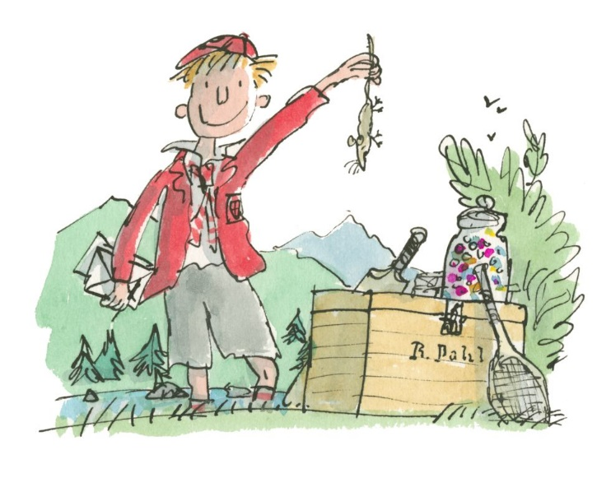

Check Your Understanding
Answer these questions in full sentences in your book.
1. Is the extract written in the first, second or third person perspective?
2. List three items that Dahl and his friends used to hide under the loose floorboard:
3. How did the boys decide who should be the one to hide the dead mouse?
4. Using information from the text, state whether each statement is true or false.
- Thwaites carried the dead mouse to Mrs Pratchett’s sweet-shop.
- The Great Mouse Plot took place on the way to school.
- At the sweetshop, Thwaites ordered a Gobstopper.
- Thwaites paid for his sweets with a penny.

5. Find and copy a group of words from the text which suggest that boys were very excited on the way to the sweet-shop.
6. “We were strutting a little as we entered the shop”. What does this tell you about the way they were feeling?
7. Why did Thwaites buy one Sherbert Sucker and one Bootlace?
8. Why did Dahl choose to hide the mouse in the Gobstopper’s Jar?
9. How can you tell Dahl was nervous while carrying out the Great Mouse Plot?
10. Why do you think the boys “broke into a run” after leaving the sweet-shop?
Personal Writing
Write a recount about a memory from childhood where you did something you should not have!
- Plan your writing
- Write using paragraphs
- Keep your writing in the past tense-Include dialogue (make it up if you don’t remember exactly what you/ others said.

Don’t Ask Jack
NOBODY KNEW WHERE the toy had come from, which great-grandparent or distant aunt had owned it before it was given to the nursery.
It was a box, carved and painted in gold and red. It was undoubtedly attractive and, or so the grown-ups maintained, quite valuable—perhaps even an antique. The latch, unfortunately, was rusted shut, and the key had been lost, so the Jack could not be released from his box. Still, it was a remarkable box, heavy and carved and gilt.
The children did not play with it. It sat at the bottom of the old wooden toy
box, which was the same size and age as a pirate’s treasure chest, or so the
children thought. The Jack-in-the-Box was buried beneath dolls and trains,
clowns and paper stars and old conjuring tricks, and crippled marionettes with
their strings irrevocably tangled, with dressing-up clothes (here the tatters of a
long-ago wedding dress, there a black silk hat, crusted with age and time) and
costume jewellery, broken hoops and tops and hobbyhorses. Under them all was Jack’s box.

The children did not play with it. They whispered among themselves, alone in
the attic nursery. On gray days when the wind howled about the house and rain rattled the slates and pattered down the eaves, they told each other stories about Jack, although they had never seen him. One claimed that Jack was an evil wizard, placed in the box as punishment for crimes too awful to describe; another (I am certain that it must have been one of the girls) maintained that Jack’s box was Pandora’s Box and he had been placed in the box as guardian to prevent the bad things inside it from coming out once more. They would not even touch the box, if they could help it, although when, as happened from time to time, an adult would comment on the absence of that sweet old Jack-in-the- Box, and retrieve it from the chest, and place it in a position of honor on the mantelpiece, then the children would pluck up their courage and, later, hide it away once more in the darkness.

The children did not play with the Jack-in-the-Box. And when they grew up
and left the great house, the attic nursery was closed up and almost forgotten.
Almost, but not entirely. For each of the children, separately, remembered
walking alone in the moon’s blue light, on his or her own bare feet, up to the
nursery. It was almost like sleepwalking, feet soundless on the wood of the
stairs, on the threadbare nursery carpet. Remembered opening the treasure chest, pawing through the dolls and the clothes and pulling out the box.

And then the child would touch the catch, and the lid would open, slow as a
sunset, and the music would begin to play, and Jack came out. Not with a pop
and a bounce: he was no spring-heeled Jack. But deliberately, intently, he would rise from the box and motion to the child to come closer, closer, and smile.

And there in the moonlight, he told them each things they could never quite
remember, things they were never able entirely to forget.

The oldest boy died in the Great War. The youngest, after their parents died,
inherited the house, although it was taken from him when he was found in the
cellar one night with cloths and paraffin and matches, trying to burn the great
house to the ground. They took him to the madhouse, and perhaps he is there
still.

The other children, who had once been girls and now were women, declined, each and every one, to return to the house in which they had grown up; and the windows of the house were boarded up, and the doors were all locked with huge iron keys, and the sisters visited it as often as they visited their eldest brother’s grave, or the sad thing that had once been their younger brother, which is to say, never.
Years have passed, and the girls are old women, and owls and bats have made
their homes in the old attic nursery, rats build their nests among the forgotten
toys. The creatures gaze uncuriously at the faded prints on the wall, and stain
the remnants of the carpet with their droppings.

And deep within the box within the box, Jack waits and smiles, holding his
secrets. He is waiting for the children. He can wait forever.
Check your understanding: True or False
Task: Read the following statements and decide if they are true or false.
- The Jack-in-the-box had come from the children’s great aunt
- The box was carved.
- The box was painted in blue and gold
- The grown-ups thought it was quite valuable
- The latch was in good working order.
- The key had been lost
- The children regularly played with the toy
- The children grew up to have happy, successful lives.
- The children had no memories of the toy when they grew up.
- The Jack could not be released from its box

Check Your Understanding
Answer these questions in full sentences in your book.
- How does the opening line create a sense of mystery?
- What is the toy box compared to, what impression might this create of the box for the reader?
- What evidence is there in the third paragraph that the toy is not played with? What might this suggest about the toy?
- ‘The Children did not play with it’. Why is this line repeated throughout the text?
- What stories do the children tell each other about Jack, what impression does this create for the reader of the toy?
- What evidence is there that the children really don’t like the toy in the fourth paragraph?
- Describe the memories the children have of the Jack in the Box when they are gown.
- Explain how their actions as they walked towards the nursery add to the toy’s sense of mystery.
- Comment on the movements of the toy when it comes out of the box, ‘ he would rise… and smile’. what impression is created of the toy?
- ‘ And then in the moonlight…they were never able to forget’. What does this short paragraph add to our impressions of the toy? How does this further add to the sense of mystery surrounding the toy?
- What happens to the children when they grow up. Why do you think the author includes this information?
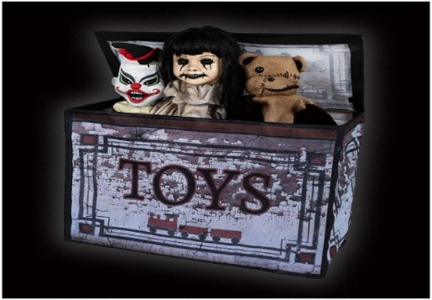
- How does the author use language and sentence structure in the last paragraph to create a menacing, sinister atmosphere?
- What do you think the title means after having read the story?
The Writer’s Craft: Use of Language
Q: How does the author, Neil Gaiman create a sense of mystery in the short story, ‘Don’t Ask Jack’?
Let’s look at two language techniques the writer uses to create a sense of mystery.
- Simile – comparing the toy chest to a pirate’s chest.
Copy the following into your book.
The writer uses a simile, ‘ ……………………. ‘ this creates the impression for the reader that………
- Long sentence- listing the contents of the box
The writer uses a long sentence, ‘…………………………..’ This is used to suggest to the reader that…..
Basic response
The writer compares it to ‘a pirate’s treasure chest’ which makes the toy box sound interesting like finding treasure. The long sentence lists all the toys ‘costume jewellery, broken hoops and hobbyhorses’ that were hidden.

Better Response
First, the writer uses the simile ‘same size and age as a pirate’s treasure chest’ makes the toy box sound interesting. It makes the reader think that the toys in the toys box will be exciting like finding treasure.
Finally, the long sentence lists all the toys ‘costume jewellery, broken hoops and hobbyhorses’. This shows the variety of toys in the box.

Brilliant Response
First, the writer uses a simile to describe the toy box as the ‘same size and age as a pirate’s treasure chest’ which makes the toy box sound interesting. It suggests the age and wealth of riches it contains. It makes the reader think that the contents will be exciting like finding treasure. However, treasure can also make a reader think that the contents will be ominous and threatening as it makes me think of pirates who are menacing.

Furthermore, the long complex sentence lists the contents as ‘costume jewellery, broken hoops and hobbyhorses’. This shows the endless number of different toys in the box and suggests it is overflowing with the possibility of never ending enjoyment, excitement and magic.
Creative Writing
Imagine you are one of the children who grew up in the house. Write a recount of your time in the house.
Try to include some of the words from the box below.
Key words
Sinister menacing threatening eerie alarming
Ominous disturbing chilling horrifying appalling
Frightening strange peculiar unsettling inexplicable
Mysterious Unnatural Scary unnerving uncanny

Group Discussion: The Curse of Shimna
- In groups discuss what makes a good mystery story.
- What are some of the best mysteries you have watched, read, heard about?
- Come up with an idea for a short film that revolves around a cursed object. The film must be set in Shimna and can feature staff and students.
- Pitch your ideas to the rest of the class.

Next Term we will Mash You
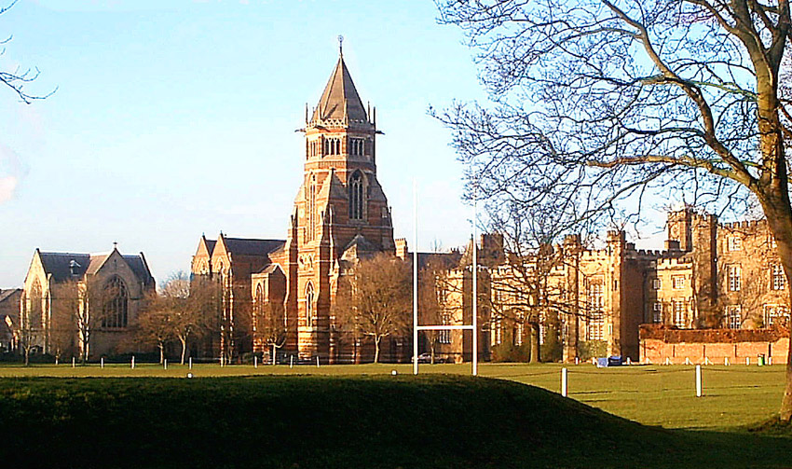
Context:
Private schools in England (called public schools there) are often expensive, exclusive, highly conscious of class distinctions, and set up as boarding schools where children live and are subjected to guidance and discipline by older students. Every spring, parents take their children to visit and inspect schools where they may be enrolled in the autumn term.
Vocabulary
Study the following vocabulary words and definitions. Write each one in a sentence.
subdued: quiet; controlled
Indulgent: lenient; permissive
geniality: friendliness;
amiable: friendly; likeable
untainted: untarnished; without a trace of anything offensive
inaccessible: not accessible; impossible to reach
condescension: behavior that is patronizing
haggard: gaunt; worn and exhausted from anxiety

Inside the car it was quiet, the noise of the engine even and subdued, the air just thenright temperature, the windows tight-fitting. The boy sat on the back seat, a box of chocolates, unopened, beside him, and a comic, folded. The trim Sussex landscape flowed past the windows: cows, white-fenced fields, highly-priced period houses. The sunlight was glassy, remote as a coloured photograph. The backs of the two heads in front of him swayed with the motion of the car.
His mother half-turned to speak to him. "Nearly there now, darling."
The father glanced downwards at his wife's wrist. "Are we all right for time?"
"Just right, nearly twelve."
"I could do with a drink. Hope they lay something on."
"I'm sure they will. The Wilcoxes say they're awfully nice people. Not really the
schoolmaster-type at all, Sally says."
The man said, "He's an Oxford chap."
"Is he? You didn't say."
"Mmn."
“Of course, the fees are that much higher than the Seaford place.”
“Fifty quid or so. We’ll have to see.”
The car turned right, between white gates and high, dark, tight-clipped hedges. The whisper of the road under the tires changed to the crunch of gravel. The child, staring sideways, read black lettering on the white board: “St. Edward’s Preparatory School. Please Drive Slowly.” He shifted on the seat, and the leather sucked at the bare skin under his knees, stinging.
The mother said, “It’s a lovely place. Those must be the playing fields. Look, darling, there are some of the boys.” She clicked open her handbag, and the sun caught her mirror and flashed in the child’s eyes; the comb went through her hair and he saw the grooves it left, neat as distant ploughing.
“Come on, then, Charles, out you get.”
The building was red brick, early nineteenth century, spreading out long arms in which windows glittered blackly. Flowers, trapped in neat beds, were alternate read and white. They went up the steps, the man, the woman, and the child two paces behind. The woman, the mother, smoothing down a skirt that would be ridged from sitting, thought: I like the way they’ve got the maid all done up properly. The little white apron and all that. She’s foreign, I suppose. Au pair. Very nice. If he comes here, there’ll be Speech Days and that kind of thing. Sally Wilcox says it’s quite dressy—she got that cream linen coat for coming down here. You can see why it costs a bomb. Great big grounds and only an hour and a half from London.
They went into a room looking out onto a terrace. Beyond, dappled lawns, gently shifting trees, black and white cows grazing behind iron railings. Books, leather chairs, a table with magazines—Country Life, The Field, The Economist. "Please, if you would wait here. The
Headmaster won't be long."
Alone, they sat, inspected. "I like the atmosphere, don't you, John?"
"Very pleasant, yes." Four hundred a term, near enough. You can tell it's a cut above the Seaford place, though, or the one at St. Albans. Bob Wilcox says quite a few City people send their boys here. One or two of the merchant bankers, those kind of people. It's the sort of contact that would do no harm at all. You meet someone, get talking at a cricket match or what have you... Not at all a bad thing.
"All right, Charles? You didn't get sick in the car, did you?"
The child had black hair, slicked down smooth to his head. His ears, too large, jutted out, transparent in the light from the window, laced with tiny, delicate veins. His clothes had the shine and crease of newness. He looked at the books, the dark brown pictures, his parents. Said nothing.
"Come here, let me tidy your hair."
The door opened. The child hesitated, stood up, sat, then rose again with his father.
"Mr and Mrs Manders? How very nice to meet you - I'm Margaret Spokes, and will you please forgive my husband who is tied up with some wretch who broke the cricket pavilion window and will be just a few more minutes. We try to be organized but a schoolmaster's day is always just that bit unpredictable. Do please sit down and what will you have to revive you after that beastly drive? You live in Finchley, is that right?"
"Hampstead, really," said the mother. "Sherry would be lovely." She worked over the headmaster's wife from shoes to hair-style. Pricing and assessing. Shoes old but expensive - Russell and Bromley. Good skirt. Blouse could be Marks and Sparks - not sure. Real pearls. Super Victorian ring. She's not gone to any particular trouble - that's just what she'd wear anyway. You can be confident, with a voice like that, of course. Sally Wilcox says she knows all sorts of people.
The headmaster's wife said, "I don't know how much you know about us? Prospectuses don't tell you a thing, do they? We'll look round everything in a minute, when you've had a chat with my husband. I gather you're friends of the Wilcoxes, by the way. I'm awfully fond of Simon.
“He's down for Winchester, of course, but I expect you know that."
The mother smiled over her sherry. Oh, I know that all right. Sally Wilcox doesn't let you forget that.
"And this is Charles? My dear, we've been forgetting all about you! In a minute, I'm going to borrow Charles and take him off to meet some of the boys because after all, you're choosing a school for him, aren't you, and not for you, so he ought to know what he might be letting himself in for and it shows we've got nothing to hide."
The parents laughed. The father, sherry warming his guts, thought that this was an amusing woman. Not attractive, of course, a bit homespun, but impressive all the same. Partly the voice, of course; it takes a bloody expensive education to produce a voice like that. And other things, of course, background and all that stuff.
"I think I can hear the thud of the Fourth Form coming in from games, which means my husband is on his way, and then I shall leave you with him while I take Charles off to the common room."
For a moment the three adults centred on the child, looking, judging. The mother said,
"He looks so hideously pale, compared to those boys we saw outside."
"My dear, that's London, isn't it? You just have to get them out, to get some colour into them. Ah, here's James. James - Mr and Mrs Manders. You remember, Bob Wilcox was mentioning at Sports Day."

The headmaster reflected his wife's style, like paired cards in Happy Families. His clothes were mature rather than old, his skin well-scrubbed, his shoes clean, his geniality untainted by the least condescension. He was genuinely sorry to have kept them waiting, but in this business one lurches from one minor crisis to the next ... And this is Charles? Hello, there Charles. His large hand rested for a moment on the child's head, quite extinguishing the thin, dark hair. It was as though he had but to clench his fingers to crush the skull, but he took his hand away and moved the parents to the window, to observe the mutilated cricket pavilion, with indulgent laughter.

And the child is borne away by the headmaster's wife. She never touches him or tells him to come, but simply bears him away like some relentless tide, down corridors and through swinging glass doors, towing him like a frail craft, not bothering to look back to see if he is following, confident in the strength of magnetism, or obedience.
And delivers him to a room where boys are scattered among inky tables and rungless chairs, and sprawled on a mangy carpet. There is a scampering and a rising, and a silence falling as she opens the door.

"Now, this is the Lower Third, Charles, who you'd be with if you come to us in
September. Boys, this is Charles Manders, and I want you to tell him all about things and answer any questions he wants to ask. You can believe about half of what they say, Charles, and they will tell you the most fearful lies about the food, which is excellent."
The boys laugh and groan; amiable, exaggerated groans. They must like the headmaster's wife: there is licensed repartee. They look at her with bright eyes in open, eager faces. Someone leaps to hold the door for her, and close it behind her. She is gone. The child stands in the centre of the room, and it draws in around him. The circle of children contracts, faces are only a yard or so from him, strange faces, looking, assessing.
Asking questions. They help themselves to his name, his age, his school. Over their heads he sees beyond the window an inaccessible world of shivering trees and high racing clouds and his voice which has floated like a feather in the dusty schoolroom air dies altogether and he becomes mute, and he stands in the middle of them with shoulders humped, staring down at feet: grubby plimsolls and kicked brown sandals. There is a noise in his ears like rushing water, a torrential din out of which voices boom, blotting each other out so that he cannot always hear the words. Do you? they say, and Have you? and What's your? and the faces, if he looks up, swing into one another in kaleidoscopic patterns and the floor under his feet is unsteady, lifting and falling.
And out of the noises comes one voice that is complete, that he can hear. "Next term we'll mash you," it says. "We always mash new boys."

And a bell goes, somewhere beyond doors and down corridors, and suddenly the children are all gone, clattering away and leaving him there with the heaving floor and the walls that shift and swing. And the headmaster's wife comes back and tows him away, and he is with his parents again, and they are getting into the car, and the high hedges skim past the car windows once more, in the other direction. And the gravel under the tyres changes to black tarmac.
"Well?"
"I liked it, didn't you?" The mother adjusted the car around her, closing windows, shrugging into her seat.
"Very pleasant, really. Nice chap."
"I like him. Not quite so sure about her."
"It's pricey, of course."
"All the same ..."
"Money well spent, though. One way and another."
"Shall we settle it, then?"
"I think so. I'll drop him a line."
The mother pitched her voice a notch higher to speak to the child in the back of the car.
"Would you like to go there, Charles? Like Simon Wilcox. Did you see that lovely gym, and the swimming pool? And did the other boys tell you all about it?"The child does not answer. He looks straight ahead of him, at the road coiling beneath the bonnet of the car. His face is haggard with anticipation.
Reading for Understanding
Answer these questions in full sentences in your book.
1. Why are Charles and his parents going to the prep school?
2. Who takes Charles to see some of the students?
3. What do the students plan to do to Charles?
4. At the end of the story, what do Charles’s parents plan to do?
5. How are Mr. and Mrs. Manders presented? What is important to them? Use specific evidence from the story text.
6. What does the treatment of Charles by the headmistress and her husband reveal about their characters?
7. How is the character of Charles presented in this story? Find evidence from the story to support your answer.
9. What point do you think the writer is trying to make by showing the reader the contrast between the parents’ approval of the school and Charles’s dread of it?
10. What do you think is the theme of this story—its comment on life?
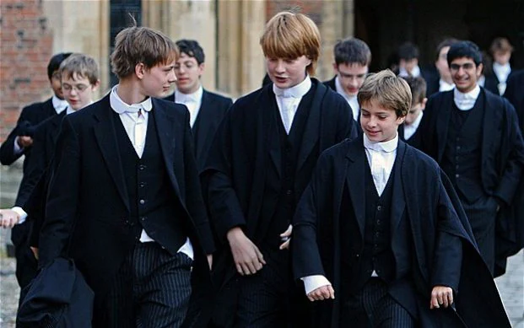

The Writer’s Craft: Analysing Character
Charles
1. . What do the following images reveal his attitude toward the situation? …an “inaccessible world” of “shivering trees” and “shoulders humped”
2. What is the impact of the simile ‘like rushing water when describing the boys’ questions’?
3. What is interesting about the last sentence in the story? How does this reveal Charles’ discomfort?

Look carefully at the start of the story. Consider how the following details help establish Charles’s sense of discomfort.
• a box of chocolates, unopened, beside him, and a comic, folded.’
• ‘to the crunch of gravel’
• ‘spreading out long arms in which windows glittered blackly’
• Flowers, trapped in neat beds

Writing about Literature
When you write about literature, you need to write in a formal style which uses examples from the text to support your comments. Copy out the following essay, adding in your own explanations to the missing parts.
Copy the following paragraphs into your exercise book. Fill in the missing parts.
The first indication of the visit being unpleasant for Charles is implied when the writer reveals that, ‘a box of chocolates, unopened, beside him, and a comic, folded.’ These details suggest that…

Further signs of discomfort are hinted with the use of onomatopoeia , the ‘whisper of the road’ changes ‘to the crunch of gravel’ when the family enter the school grounds. This implies that as he comes closer to the school he feels………

The school’s buildings are personified, ‘spreading out long arms in which windows glittered blackly’ this makes the school appear ……. The verb ‘trapped’ is used to describe the flowers, ‘Flowers, trapped in neat beds …’ This foreshadows how Charles will feel later in the story when the boys…..

Charles is established as a ……………….child, who is terrified of moving to the school in the story. What makes us feel sympathetic towards him is the ……………………………………………. The main theme of the story that the writer wants us to think about is….
The Darkness Out There
She walked through flowers, the girl, ox-eye daisies and vetch and cow parsley, keeping to the track at the edge of the field. She could see the cottage in the distance, shrugged down into the dip beyond the next hedge. Mrs Rutter, Pat had said, Mrs Rutter at Nether Cottage, you don’t know her, Sandra? She’s a dear old thing, all on her own, of course, we try to keep an eye. A wonky leg after her op and the home help’s off with a bad back this week. So could you make that your Saturday afternoon session, dear? Lovely. There’ll be one of the others, I’m not sure who.
Pat had a funny eye, a squint, so that her glance swerved away from you as she talked. And a big chest jutting under washed-out jerseys. Are people who help other people always not very nice-looking? Very busy being busy; always in a rush. You didn’t get people like Mrs Carpenter at the King’s Arms running the Good Neighbours’ Club. People with platinum highlights and spike-heel suede boots.
She looked down at her own legs, the girl, bare brown legs brushing through the grass, polleny summer grass that glinted in the sun.
She hoped it would be Susie, the other person. Or Liz. They could have a good giggle, doing the floors and that. Doing her washing, this old Mrs Rutter.
They were all in the Good Neighbours’ Club, her set at school. Quite a few of the boys, too. It had become a sort of craze, the thing to do. They were really nice, some of the old people. The old folks, Pat called them. Pat had done the notice in the library: Come and have fun giving a helping hand to the old folks. Adopt a granny. And the jokey cartoon drawing of a dear old bod with specs on the end of her nose and a shawl. One or two of the old people had been a bit sharp about that.
The track followed the hedge round the field to the gate and the plank bridge over the stream. The dark reach of the spinney came right to the gate there so that she would have to walk by the edge of it with the light suddenly shutting off the bare wide sky of the field. Packer’s End.
You didn’t go by yourself through Packer’s End if you could help it, not after teatime, anyway. A German plane came down in the war and the aircrew were killed and there were people who’d heard them talking still, chattering in German on their radios, voices coming out of the trees, nasty, creepy. People said.
She kept to the track, walking in the flowers with corn running in the wind between her and the spinney. She thought suddenly of blank-eyed helmeted heads, looking at you from among branches. She wouldn’t go in there for a thousand pounds, not even in bright day like now, with nothing coming out of the dark slab of trees but birdsong – blackbirds and thrushes and robins and that. It was a rank place, all whippy saplings and brambles and a gully with a dumped mattress and bedstead and an old fridge. And, somewhere, presumably, the crumbling rusty scraps of metal and cloth and … bones?
It was all right out here in the sunshine. Fine. She stopped to pick grass stems out of her sandal; she saw the neat print of the strap-marks against her sunburn, pinkwhite on brown. Somebody had said she had pretty feet, once; she looked at them, clean and plump and neat on the grass. A ladybird crawled across a toe.
When they were small, six and seven and eight, they’d been scared stiff of Packer’s End. Then, they hadn’t known about the German plane. It was different things then; witches and wolves and tigers. Sometimes they’d go there for a dare, several of them, skittering over the field and into the edge of the trees, giggling and shrieking, not too far in, just far enough for it to be scary, for the branch shapes to look like faces and clawed hands, for the wolves to rustle and creep in the greyness you couldn’t quite see into, the clotted shifting depths of the place.
But after, lying on your stomach at home on the hearthrug watching telly with the curtains drawn and the dark shut out, it was cosy to think of Packer’s End, where you weren’t.
After they were twelve or so the witches and wolves went away. Then it was the German plane. And other things too. You didn’t know who there might be around, in woods and places. Like stories in the papers. Girl attacked on lonely road. Police hunt rapist. There was this girl, people at school said, this girl some time back who’d been biking along the field path and these two blokes had come out of Packer’s End. They’d had a knife, they’d threatened to carve her up, there wasn’t anything she could do, she was at their mercy. People couldn’t remember what her name was, exactly, she didn’t live round here any more. Two enormous blokes, sort of gypsy types.
She put her sandal back on. She walked through the thicker grass by the hedge and felt it drag at her legs and thought of swimming in warm seas. She put her hand on the top of her head and her hair was hot from the sun, a dry burning cap. One day, this year, next year, sometime, she would go to places like on travel brochures and run into a blue sea. She would fall in love and she would get a good job and she would have one of those new Singers that do zig-zag stitch and make an embroidered silk coat.
One day.
Now, she would go to this old Mrs Rutter’s and have a bit of a giggle with Susie and come home for tea and wash her hair. She would walk like this through the silken grass with the wind seething the corn and the secret invisible life of birds beside her in the hedge. She would pick a blue flower and examine its complexity of pattern and petal and wonder what it was called and drop it. She would plunge her face into the powdery plate of an elderflower and smell cat, tom-cat, and sneeze and scrub her nose with the back of her hand. She would hurry through the gate and over the stream because that was a bit too close to Packer’s End for comfort and she would …
He rose from the plough beyond the hedge.
She screamed.
‘Christ!’ she said, ‘Kerry Stevens you stupid so-and-so, what d’you want to go and do that for, you give me the fright of my life.’
He grinned. ‘I seen you coming. Thought I might as well wait.’
Not Susie. Not Liz either. Kerry Stevens from Richmond Way. Kerry Stevens that none of her lot reckoned much on, with his black licked-down hair and slitty eyes. Some people you only have to look at to know they’re not up to much.
‘Didn’t know you were in the Good Neighbours.’

He shrugged. They walked in silence. He took out an Aero bar, broke off a bit, offered it. She said oh, thanks. They went chewing towards the cottage, the cottage where old Mrs Rutter with her wonky leg would be ever so pleased to see them because they were really sweet, lots of the old people. Ever so grateful, the old poppets, was what Pat said, not that you’d put it quite like that yourself.
‘Just give it a push, the door. It sticks, see. That’s it.’
She seemed composed of circles, a cottage-loaf of a woman, with a face below which chins collapsed one into another, a creamy smiling pool of a face in which her eyes snapped and darted.
‘Tea, my duck?’ she said. ‘Tea for the both of you? I’ll put us a kettle on.’
The room was stuffy. It had a gaudy lino floor with the pattern rubbed away in front of the sink and round the table; the walls were cluttered with old calendars and pictures torn from magazines; there was a smell of cabbage. The alcove by the fireplace was filled with china ornaments: big-eyed flop-eared rabbits and beribboned kittens and flowery milkmaids and a pair of naked chubby children wearing daisy chains.
The woman hauled herself from a sagging armchair. She glittered at them from the stove, manoeuvring cups, propping herself against the draining-board. ‘What’s your names, then? Sandra and Kerry. Well, you’re a pretty girl, Sandra, aren’t you. Pretty as they come. There was – let me see, who was it? – Susie, last week. That’s right, Susie.’ Her eyes investigated, quick as mice. ‘Put your jacket on the back of the door, dear, you won’t want to get that messy. Still at school, are you?’
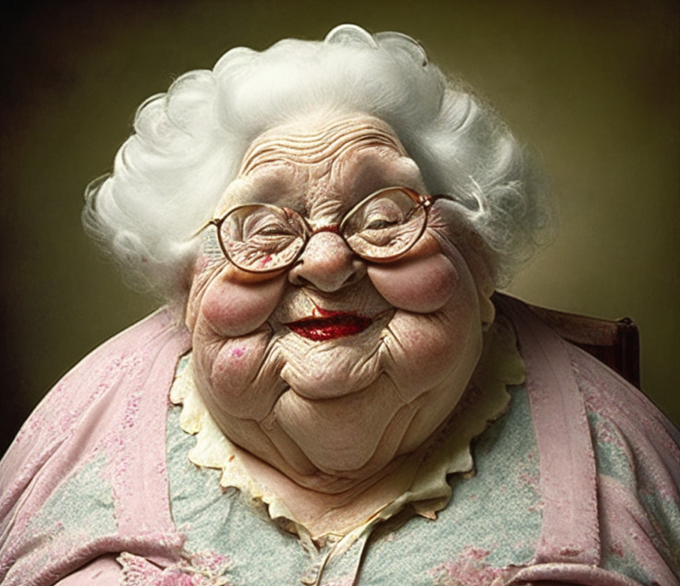
The boy said, ‘I’m leaving, July. They’re taking me on at the garage, the Blue Star. I been helping out there on and off, before.’
Mrs Rutter’s smiles folded into one another. Above them, her eyes examined him. ‘Well, I expect that’s good steady money if you’d nothing special in mind. Sugar?’
There was a view from the window out over a bedraggled garden with the stumps of spent vegetables and a matted flower bed and a square of shaggy grass. Beyond, the spinney reached up to the fence, a no-man’s-land of willowherb and thistle and small trees, growing thicker and higher into the full density of woodland. Mrs Rutter said, ‘Yes, you have a look out, aren’t I lucky – right up beside the wood. Lovely it is in the spring, the primroses and that. Mind, there’s not as many as there used to be.’
The girl said, ‘Have you lived here for a long time?’
‘Most of my life, dear. I came here as a young married woman, and that’s a long way back, I can tell you. You’ll be courting before long yourself, I don’t doubt. Like bees round the honeypot, they’ll be.’
The girl blushed. She looked at the floor, at her own feet, neat and slim and brown. She touched, secretly, the soft skin of her thigh; she felt her breasts poke up and out at the thin stuff of her top; she licked the inside of her teeth, that had only the one filling, a speck like a pin-head. She wished there was Susie to have a giggle with, not just Kerry Stevens.
The boy said, ‘What’d you like us to do?’
His chin was explosive with acne; at his middle, his jeans yawned from his T-shirt, showing pale chilly flesh. Mrs Rutter said, ‘I expect you’re a nice strong boy, aren’t you? I daresay you’d like to have a go at the grass with the old mower. Sandra can give this room a do, that would be nice, it’s as much as I can manage to have a dust of the ornaments just now, I can’t get down to the floor.’
When he had gone outside the girl fetched broom and mop and dustpan from a cupboard under the narrow stair. The cupboard, stacked with yellowing newspapers, smelt of damp and mouse. When she returned, the old woman was back in the armchair, a composite chintzy mass from which cushions oozed and her voice flowed softly on. ‘That’s it, dear, you just work round, give the corners a brush, if you don’t mind, that’s where the dust settles. Mind your pretty skirt, pull it up a bit, there’s only me to see if you’re showing a bit of bum. That’s ever such a nice style, I expect your mum made it, did she?’
The girl said, ‘Actually I did.’
‘Well now, fancy! You’re a little dressmaker, too, are you? I was good with my needle when I was younger, my eyesight’s past it now, of course. I made my own wedding dress, ivory silk with lace insets. A Vogue pattern it was, with a sweetheart neckline.’
The door opened. Kerry said, ‘Where’ll I put the clippings?’
‘There’s the compost heap down the bottom, by the fence. And while you’re down there could you get some sticks from the wood for kindling, there’s a good lad.’
When he had gone she went on, ‘That’s a nice boy. It’s a pity they put that stuff on their hair these days, sticky-looking. I expect you’ve got lots of boyfriends, though, haven’t you?’
The girl poked in a crack at a clump of fluff. ‘I don’t really know Kerry that much.’
‘Don’t you, dear? Well, I expect you get all sorts, in your club thing, the club that Miss Hammond runs.’
‘The Good Neighbours. Pat, we call her.’
‘She was down here last week. Ever such a nice person. Kind. It’s sad she never married.’
The girl said, ‘Is that your husband in the photo, Mrs Rutter?’
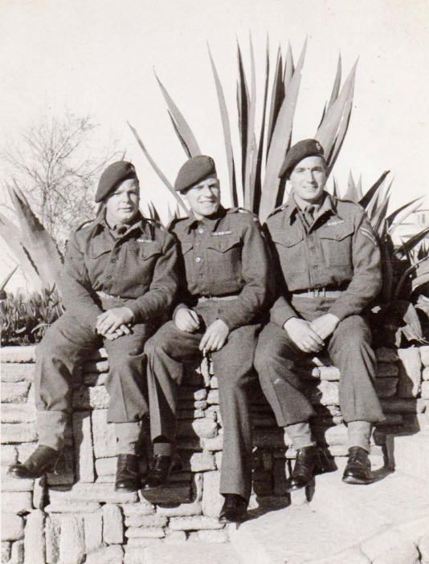
‘That’s right, dear. In his uniform. The Ox and Bucks. After he got his stripes. He was a lovely man.’
She sat back on her heels, the dustpan on her lap. The photo was yellowish, in a silver frame. ‘Did he …?’
‘Killed in the war, dear. Right at the start. He was in one of the first campaigns, in Belgium, and he never came back.’
The girl saw a man with a toothbrush moustache, his army cap slicing his forehead. ‘That’s terrible.’
‘Tragic. There was a lot of tragedies in the war. It’s nice it won’t be like that for you young people nowadays. Touch wood, cross fingers. I like young people, I never had any children, it’s been a loss, that, I’ve got a sympathy with young people.’
The girl emptied the dustpan into the bin outside the back door. Beyond the fence, she could see the bushes thrash and Kerry’s head bob among them. She thought, rather him than me, but it’s different for boys, for him anyway, he’s not a nervy type, it’s if you’re nervy you get bothered about things like Packer’s End.
She was nervy, she knew. Mum always said so.
Mrs Rutter was rummaging in a cupboard by her chair. ‘Chocky? I always keep a few chockies by for visitors.’ She brought out a flowered tin. ‘There. Do you know, I’ve had this twenty years, all but. Look at the little cornflowers. And the daisies.
They’re almost real, aren’t they?’
‘Sweet,’ said the girl.
‘Take them out and see if what’s-’is-name would like one.’
There was a cindery path down the garden, ending at a compost heap where eggshells gleamed among leaves and grass clippings. Rags of plastic fluttered from sticks in a bed of cabbages. The girl picked her way daintily, her toes wincing against the cinders. A place in the country. One day she would have a place in the country, but not like this. Sometime. A little white house peeping over a hill, with a stream at the bottom of a crisp green lawn and an orchard with old apple trees and a brown pony. And she would walk in the long grass in this orchard in a straw hat with these two children, a boy and a girl, children with fair shiny hair like hers, and there’d be this man.
She leaned over the fence and shouted, ‘Hey …’
‘What?’
She brandished the box.
He came up, dumping an armful of sticks. ‘What’s this for, then?’
‘She said. Help yourself.’
He fished among the sweets, his fingers etched with dirt. ‘I did a job on your dad’s car last week. That blue Escort’s his, isn’t it?’
‘Mmn.’
‘July, I’ll be starting full-time. When old Bill retires. With day-release at the tech.’
She thought of oily workshop floors, of the fetid undersides of cars. She couldn’t stand the feel of dirt; if her hands were the least bit grubby she had to go and wash; a rim of grime under her nails could make her shudder. She said, ‘I don’t know how you can, all that muck.’
He fished for another chocolate. ‘Nothing wrong with a bit of dirt. What you going to do, then?’
‘Secretarial.’
Men didn’t mind so much. At home, her dad did things like unblocking the sink and cleaning the stove; Mum was the same as her, just the feel of grease and stuff made her squirm. They couldn’t either of them wear anything that had a stain or a spot.
He said, ‘I don’t go much on her.’
‘Who?’
He waved towards the cottage.
‘She’s all right. What’s wrong with her, then?’
He shrugged. ‘I dunno. The way she talks and that.’
‘She lost her husband,’ said the girl. ‘In the war.’ She considered him, across the fence, over a chasm. Mum said boys matured later, in many ways.
‘There’s lots of people done that.’
She looked beyond him, into distances. ‘Tragic, actually. Well, I’ll go back and get on. She says can you see to her bins when you’ve got the sticks. She wants them carried down for the dustmen.’
Mrs Rutter watched her come in, glinting from the cushions. ‘That’s a good girl. Put the tin back in the cupboard, dear.’
‘What would you like me to do now?’
‘There’s my little bit of washing by the sink. Just the personal things to rinse through. That would be ever so kind.’
The girl ran water into the basin. She measured in the soap flakes. She squeezed the pastel nylons, the floating sinuous tights. ‘It’s a lovely colour, that turquoise.’
‘My niece got me that last Christmas. Nightie and a little jacket to go. I was telling you about my wedding dress. The material came from Macy’s, eight yards. I cut it on the cross, for the hang. Of course, I had a figure then.’ She heaved herself round in the chair. ‘You’re a lovely shape, Sandra. You take care you stay that way.’
‘I can get a spare tyre,’ the girl said. ‘If I’m not careful.’
Outside, the bin lids rattled.
‘I hope he’s minding my edging. I’ve got lobelia planted out along that path.’
‘I love blue flowers.’
‘You should see the wood in the spring, with the bluebells. There’s a place right far in where you get lots coming up still. I used to go in there picking every year before my leg started playing me up. Jugs and jugs of them, for the scent. Haven’t you ever seen them?’
The girl shook her head. She wrung out the clothes, gathered up the damp skein. ‘I’ll put these on the line, shall I?’
When she returned the boy was bringing in the filled coal-scuttle and a bundle of sticks.
‘That’s it,’ said Mrs Rutter. ‘Under the sink, that’s where they go. You’ll want to have a wash after that, won’t you? Put the kettle on, Sandra, and we’ll top up the pot.’
The boy ran his hands under the tap. His shirt clung to his shoulder-blades, damp with sweat. He looked over the bottles of detergent, the jug of parsley, the handful of flowers tucked into a coronation mug. He said, ‘Is that the wood where there was that German plane came down in the war?’
‘Don’t start on that,’ said the girl. ‘It always gives me the willies.’
‘What for?’
‘Scary.’
The old woman reached forward and prodded the fire. ‘Put a bit of coal on for me, there’s a good boy. What’s to be scared of? It’s over and done with, good riddance to bad rubbish.’
‘It was there, then?’
‘Shut up,’ said the girl.
‘Were you here?’
‘Fill my cup up, dear, would you. I was here. Me and my sister. My sister Dot. She’s dead now, two years. Heart. That was before she was married of course, nineteen forty-two, it was.’
‘Did you see it come down?’
She chuckled. ‘I saw it come down all right.’
‘What was it?’ said the boy. ‘Messerschmitt?’
‘How would I know that, dear? I don’t know anything about aeroplanes. Anyway, it was all smashed up by the time I saw it, you couldn’t have told t’other from which.’
The girl’s hand hovered, the tea-cup halfway to her mouth. She sipped, put it down. ‘You saw it? Ooh, I wouldn’t have gone anywhere near.’
‘It would have been burning,’ said the boy. ‘It’d have gone up in flames.’
‘There weren’t any flames; it was just stuck there in the ground, end up, with mess everywhere. Drop more milk, dear, if you don’t mind.’
The girl shuddered. ‘I s’pose they’d taken the bodies away by then.’
Mrs Rutter picked out a tea-leaf with the tip of the spoon. She drank, patted the corner of her mouth delicately with a tissue. ‘No, no, ’course not. There was no one else seen it come down. We’d heard the engine and you could tell there was trouble, the noise wasn’t right, and we looked out and saw it come down smack in the trees. ’Course we hadn’t the telephone so there was no ringing the police or the Warden at Clapton. Dot said we should maybe bike to the village but it was a filthy wet night, pouring cats and dogs, and fog too, and we didn’t know if it was one of ours or one of theirs, did we? So Dot said better go and have a look first.’
‘But either way …’ the boy began.
‘We got our wellies on, and Dot had the big lantern, and we went off. It wasn’t very far in. We found it quite quick and Dot grabbed hold of me and pointed and we saw one of the wings sticking up with the markings on and we knew it was one of theirs. We cheered, I can tell you.’
The boy stared at her over the rim of the cup, blank-faced.
‘Dot said bang goes some more of the bastards, come on let’s get back into the warm and we just started back when we heard this noise.’
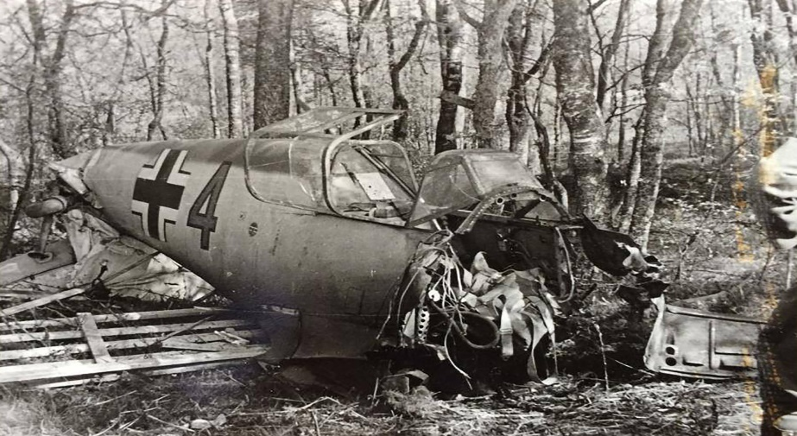
‘Noise?’
‘Sort of moaning.’
‘Oh,’ cried the girl. ‘How awful, weren’t they …’
‘So we got up closer and Dot held the lantern so we could see and there was three of them, two in the front and they were dead, you could see that all right, one of them had his …’
The girl grimaced. ‘Don’t.’
Mrs Rutter’s chins shook, the pink and creamy chins. ‘Good job you weren’t there, then, my duck. Not that we were laughing at the time, I can tell you, rain teeming down and a raw November night, and that sight under our noses. It wasn’t pretty but I’ve never been squeamish, nor Dot neither. And then we saw the other one.’
‘The other one?’ said the boy warily.
‘The one at the back. He was trapped, see, the way the plane had broken up. There wasn’t any way he could get out.’
The girl stiffened. ‘Oh, lor, you mean he …’
‘He was hurt pretty bad. He was kind of talking to himself. Something about mutter, mutter … Dot said he’s not going to last long, and a good job too, three of them that’ll be. She’d been a VAD so she knew a bit about casualties, see.’ Mrs Rutter licked her lips; she looked across at them, her eyes darting. ‘Then we went back to the cottage.’
There was silence. The fire gave a heave and a sigh. ‘You what?’ said the boy.
‘Went back inside. It was bucketing down, cats and dogs.’
The boy and girl sat quite still, on the far side of the table.
‘That was eighteen months or so after my hubby didn’t come back from Belgium.’ Her eyes were on the girl; the girl looked away. ‘Tit for tat, I said to Dot.’
After a moment she went on. ‘Next morning it was still raining and blow me if the bike hadn’t got a puncture. I said to Dot, I’m not walking to the village in this, and that’s flat, and Dot was running a bit of a temp, she had the ’flu or something coming on. I tucked her up warm and when I’d done the chores I went back in the wood, to have another look. He must have been a tough so-and-so, that Jerry, he was still mumbling away. It gave me a turn, I can tell you. I’d never imagined he’d last the night. I could see him better, in the day-time; he was bashed up pretty nasty. I’d thought he was an old bloke, too, but he wasn’t. He’d have been twentyish, that sort of age.’
The boy’s spoon clattered to the floor; he did not move.
‘I reckon he may have seen me, not that he was in a state to take much in. He called out something. I thought, oh no, you had this coming to you, mate, there’s a war on. You won’t know that expression – it was what everybody said in those days. I thought, why should I do anything for you? Nobody did anything for my Bill, did they? I was a widow at thirty-nine. I’ve been on my own ever since.’
The boy shoved his chair back from the table.
‘He must have been a tough bastard, like I said. He was still there that evening, but the next morning he was dead. The weather’d perked up by then and I walked to the village and got a message to the people at Clapton. They were ever so surprised; they didn’t know there’d been a Jerry plane come down in the area at all. There were lots of people came to take bits for souvenirs, I had a bit myself but it’s got mislaid, you tend to mislay things when you get to my age.’
The boy had got up. He glanced down at the girl. ‘I’m going,’ he said. ‘Dunno about you, but I’m going.’
She stared at the lacy cloth on the table, the fluted china cup. ‘I’ll come too.’
‘Eh?’ said the old woman. ‘You’re off, are you? That was nice of you to see to my little jobs for me. Tell what’s-’er-name to send someone next week if she can, I like having someone young about the place, once in a while, I’ve got a sympathy with young people. Here – you’re forgetting your pretty jacket, Sandra, what’s the hurry? ’Bye then, my ducks, see you close my gate, won’t you?’
The boy walked ahead, fast; the girl pattered behind him, sliding on the dry grass. At the gateway into the cornfield he stopped. He said, not looking at her, looking towards the furzy edge of the wood. ‘Christ!’
The wood sat there in the afternoon sun. Wind stirred the trees. Birds sang. There were not, the girl realised, wolves or witches or tigers. Nor were there prowling blokes, gypsy-type blokes. And there were not chattering ghostly voices. Somewhere there were some scraps of metal overlooked by people hunting for souvenirs.
The boy said, ‘I’m not going near that old bitch again.’ He leaned against the gate, clenching his fists on an iron rung; he shook slightly. ‘I won’t ever forget him, that poor sod.’
She nodded.
‘Two bloody nights. Christ!’
And she would hear, she thought, always, for a long time anyway, that voice trickling on, that soft old woman’s voice; would see a tin painted with cornflowers, pretty china ornaments.
‘It makes you want to throw up,’ he said. ‘Someone like that.’
She couldn’t think of anything to say. He had grown; he had got older and larger. His anger eclipsed his acne, the patches of grease on his jeans, his lardy midriff. You could get people all wrong, she realised with alarm. You could get people wrong and there was a darkness that was not the darkness of tree shadows and murky undergrowth and you could not draw the curtains and keep it out because it was in your head, once known, in your head for ever like lines from a song. One moment you were walking in long grass with the sun on your hair and birds singing and the next you glimpsed darkness, an inescapable darkness. The darkness was out there and it was a part of you and you would never be without it, ever.
She walked behind him, through a world grown unreliable, in which flowers sparkle and birds sing but everything is not as it appears, oh no.
Check your understanding:
Answer these questions in full sentences in your book.
- How does the writer create a pleasant setting at the start of the story?
- What work do Pat and Sandra do?
- What happened at Packer’s End during the war? How is afraid of Packer’s End, adults or kids?
- What are Sandra’s dreams for the future?
- Why is she disappointed with her partner for the assignment?
- Mrs Rutter is described as ‘a cottage loaf of a woman’? What can we infer about her from this metaphor?
- What does the description of the cottage tell you about the person who lives there?
- How are Mrs Rutter’s opinions on marriage and youth rather old-fashioned?
- Does Mrs. Rutter’s attitude towards the injured men surprise you? Explain your answer.
- Why didn’t Mrs Rutter help the injured men?
- Do you think Mrs Rutter’s behaviour was justified? Explain your answer.
- Why is Kerry horrified by what he is told? What does he decide to do?
- How has Sandra’s opinion of Kerry changed?
- How have Sandra’s opinions of the world in general changed? Look at the last part of the story.
- What does the story suggest to you about how the younger generation differ from the older generation in their feelings about war?
- What, if anything, have you learned from the story? What do you think the writer intended you to learn?

The Writer’s Craft: Close Language Analysis
Sometimes if we look closely at what writers say we can tell a lot from a little. Examiners want you to write A LOT about A LITTLE!
Let’s work through an example of how you could do this. Look at this sentence describing Sandra.
she walked through flowers ... keeping to the track at the edge of the field.’
‘walked through flowers’- pleasant imagery – flowers are symbolic of innocence, /beauty, idyllic setting
‘keeping to’ keeping to..’ symbolic of Sandra’s desire to be seen as normal and conform to expectations people had of her
‘edge of the field’ metaphor suggests Sandra is on the ‘edge’ of innocence symbolised by the flowers

If we put all these things together, we produce written ANALYSIS:
Sandra’s character is revealed to the reader at the beginning of the story, ‘she walked in flowers..’ the flowers symbolise beauty and innocence. It also helps to create an idyllic setting for the story.

We are told Sandra keeps to, ‘the track at the edge of the field’. This implies she is fearful and cautious- the ‘track’ is symbolic of her tendency to do what’s expected of her, following others’ expectations rather than thinking independently.

The metaphorical phrase ‘edge of the field’ connotes that she’s on the verge of her journey towards maturity, foreshadowing her loss of innocence later in the story

Idealistic natural imagery denotes her purity and her narrow view on the world, she’s limiting herself to the positive aspects of life. The track is also symbolic of guidance and safety, something people are expected to follow, conforming to conventional beliefs rather than coming up with her own thoughts. The verb ‘keeping’, and the preposition ‘edge’ suggest she’s almost off the track she is currently on. From this the reader might infer a change is about to take place in Sandra’s life.

- Circle where the writer mentions language devices
- Underline the quotes used
- Highlight where the writer explain what the quotes mean

The Writer’s Craft: Themes
Themes are general ideas about a topic that writers want their readers to think about. Here are a few themes in ‘TDOT’. In pairs discuss what the story wants us to think about them and then rank them from most to least important.
- War and peace.
- Youth and Old Age.
- First Impressions.
- Looks can be deceptive.
- Anger and vengeance.
- Good and Evil
- Anything else??

Group Discussion: Do the Right Thing: Moral Dilemmas
Mrs Rutter did something most of us would never imagine ourselves doing, but what could you do if you were forced to?
Discuss the following scenarios in small groups.
- Your friend tells you that they committed a crime. They explain that they are having trouble sleeping at night and feel you are the only one they can trust with their confession. A few days later, you read in the paper that someone has been arrested for your friend’s crime. Do you:

- Go to the police and tell them what you know?
- Encourage your friend to confess and warn him if he does not do so, you will tell?
- Say nothing because you will not betray a friend’s confidence?

- Late one night you are driving home in a bad rainstorm. A drunk reels out in front of your car and you try to stop, but hit him. Nobody sees you. The guy looks and smells as if he is homeless. You check to see how badly he is hurt and realize he is dead. You have never even had a speeding ticket and are an upright, professional, with a family and are well-known and respected in your community.

Do you make a report anonymously, confess your crime, or drive on home and forget about it, knowing no one is going to pursue the death of a homeless drunk?

Creative Writing

Use this image to write the opening of a story based on the theme of fears and the unknown. Aim to include these language devices metaphors, similes and personification.
The Flowers
It seemed to Myop as she skipped lightly from hen house to pig pen to smokehouse that the days has never been as beautiful as these. The air held a keenness that made her nose twitch. The harvesting of the corn and cotton, peanuts and squash, made each day a golden surprise that caused excited little tremors to run up her jaws.
Myop carried a short, knobbly stick. She struck out at random at chickens she liked and worked out the beat of a song on the fence around the pig pen. She felt light and good in the warm sun. She was ten, and nothing existed for her but her song, the stick clutched in her dark brown hand, and the tat-de-ta-ta-ta of accompaniment.
Turning her back on the rusty boards of her family’s sharecropper cabin, Myop walked along the fence till it ran into the stream made by the spring. Around the spring, where the family got drinking water, silver ferns and wildflowers grew. Along the shallow banks, pigs rooted. Myop watched the tiny white bubbles disrupt the thick black scale of soil and the water that silently rose and slid away down the stream.

She had explored the woods behind the house many times. Often, in late autumn, her mother took her to gather nuts among the fallen leaves. Today she made her own path, bouncing this way and that way, vaguely keeping an eye out for snakes. She found, in addition to various common but pretty ferns and leaves, an armful of strange blue flowers with velvety ridges and a sweet suds bush full of the brown fragrant buds.
By twelve o’clock, her arms laden with springs of her findings, she was a mile or more from home. She had often been as far before, but the strangeness of the land made it not as pleasant as her usual haunts. It seemed gloomy in the little cove in which she found herself. The air was damp, the silence close and deep.
Myop began to circle back to the house, back to the peacefulness of the morning. It was then she stepped smack into his eyes. Her heel became lodged in the broken ridge between brow and nose, and she reached down quickly, unafraid, to free herself. It was only when she saw his naked grin that she gave a little yelp of surprise.
He had been a tall man. From feet to neck covered a long space. His head lay beside him. When she pushed back the leaves and layers of earth and debris Myop saw that he’d had large white teeth, all of them cracked or broken, long fingers, and very big bones. All his clothes had rotted away except some threads of blue denim from his overalls. The buckles of the overall had turned green.
Myop gazed around the spot of interest. Very near where she’d stepped into the head was a wild pink rose. As she picked it to add to her bundle, she noticed a raised mound, a ring, around the rose’s root. It was the rotted remains of a noose, a bit of shredding plowline, now blending benignly into the soil. Around an overhanging limb of a great spreading oak clung another piece. Frayed, rotted, bleached, and frazzled – barely there – but spinning restlessly in the breeze. Myop laid down her flowers.
And the summer was over.

Check your understanding: True or False
Task: Read the following statements and decide if they are true or false.
1. The protagonist of the story is a young girl named Myop.
2. The story takes place during the summer, and Myop is out of school for the holidays.
3. The flowers Myop picks in the beginning of the story are colorful and cheerful.
4. Myop discovers a small path leading to a dark and secluded area where the skull is found.
5. Myop's family lives in a grand mansion surrounded by beautiful gardens.
6. Myop finds a human skull while she is picking flowers in the woods.
7. After finding the skull, Myop feels disturbed and frightened by the discovery.
8. As Myop returns home, she encounters a group of joyful children playing games.

9. The story ends on a hopeful note as Myop embraces the beauty of the natural world around her.
10. The man she finds has been murdered.

Context
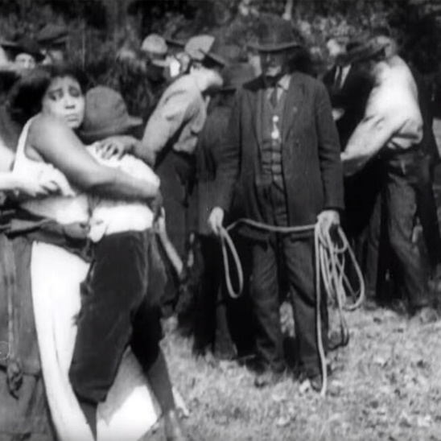
The Southern States of America is renowned for being a very racist place. In the last decades of the nineteenth century, thousands black people in the Southern and border states were lynched. This means they were attacked by a mob and punished for a crime they were believed to have committed. The mob who attacked them were usually white and the punishments given were inhumane, they were tortured or murdered. Most of the lynchings were by hanging or shooting, or both. However, many were of a more hideous nature burning at the stake, maiming, dismemberment, castration, and other brutal methods of physical torture.
Many of the people who were lynched were innocent, some of the ‘crimes’ they were said to commit were as ridiculous as talking to a white woman.
Lynching therefore was a cruel combination of racism and sadism, which was used primarily to sustain white supremacy in the South. Many white people believed that black people could only be controlled by fear. To them, lynching was seen as the most effective means of control.
How does this help us to understand who the body might have been?
Research Task
Find out who was Emmet Till.
What happened to him?

Check your understanding:
Answer these questions in full sentences in your book.
1. What time of the year is it when the story begins?
2. How was Myop thinking and feeling in the beginning of the story? Look at the following lines, for clues. line 1 she skipped lightly from hen house to pigpen to smokehouse. lines 8-9 she was 10 and nothing existed for her but her song
3. After she left the farm, where did she go?
4. What kind of farm does she live on? Is she rich or poor?
5. What was she watching out for as she walked. Why?
6. How might this be an example of FORESHADOWING?
7. Where did things start to change in the story? This could be called the turning point.
8. How did Myop react when she found the man? Why do you think she reacted that way?
9. Do you think she understood what had happened to him?
10. Why do you think Myop “laid down her flowers”? What might this SYMBOLISE?
11. What does the last sentence of the story mean, “and the summer was over”?
12. What happens to Myop’s childhood innocence in this story?

The Writer’s Craft
Symbolism: the use of symbols to represent ideas or qualities.
Symbolism can be found in colours:
- Black is sometimes used to represent death or evil.
- White stands for life and purity.
- Red can symbolize blood, passion, danger, or immoral character.
Symbolism can be found in objects:
- Roses stand for romance.
- A dove is a symbol of peace.

Symbolism can be found in times of the year
- Spring an represent new birth and youth
- Winter can represent the end of something and old age.

Explain what you think the following symbols in the story might represent.
- Flowers
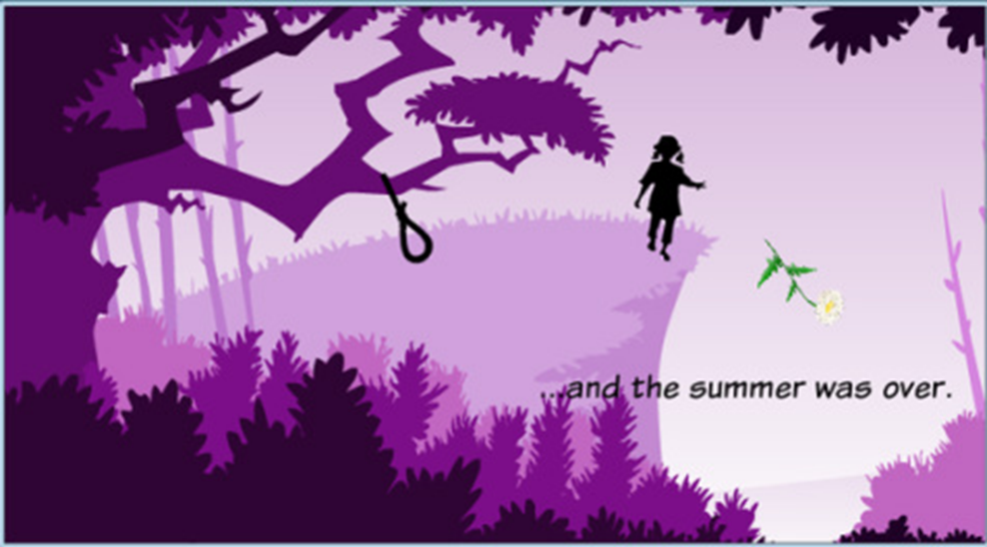
- Summer
- Snake
- Myop ( Myopia)

GCSE English Language
Controlled Assessment (one hour)
How does Alice Walker explore the protagonist’s loss of childhood innocence in the short story ‘The Flowers’?
Use the following questions to help you structure and plan your responses to this question.
- How does the author create an image of a perfect idyllic childhood in the opening paragraph?
- What do Myop’s actions in the second paragraph suggest about her youthful innocence?
- How does the third paragraph suggest that Myop is slowly maturing?
- How does the atmosphere begin to change in the fourth paragraph, how might this foreshadow what is to come?
- How is the shocking nature of Myop’s discovery shown in paragraph five?
- How does the detailed description of the man add to the horror of her discovery?
- How does the writer use the last paragraph to suggest that this discovery has changed Myop’s life and destroyed her childhood innocence?
TOP TIPS for writing your CAT
- Structure your essay – introduction- main body- conclusion
- Include evidence from the text to support your argument.
- Explain how the writer uses language devices and structure of the story to present the theme of childhood.

