Roles in the theatre:

Box office staff- ticket sales
Choreographer- create routines and movement to perform
Director- Theatre directors take responsibility for the overall creative production of plays.
Playwright- Writes the play
Stage manager- Stage managers coordinate all aspects of a theatre production or event, including actors, technical staff, props, scenery and costumes. They make sure technicians and performers alike are in the right place at the right time and ready to meet their cues.
Stagehand- behind scenes support staff for a production
Technical manager- coordinates a production's technical staff.
Theatre manager- budget, health and safety
Front of house manager- Box office staff, cleaners, ushers and drinks sales/ programmes

Roles in the theatre:

COSTUME DESIGNER- Member of the creative team for a show responsible for the clothes worn by the actors throughout the performance
FLYMAN -Term for the operator of the theatre's flying system
LIGHTING DESIGNER- Member of the production team for a show who is responsible for the overall look of the lighting.
PRODUCER- That person or body responsible for the financial and contractual side of a production. This can include the raising of money to stage the production, hiring the facilities, employing the technical crew, front of house and publicity staff, director and cast. The producer usually works closely with the director before embarking on a production.
PROMPTER- Person whose role is to follow the text of a play, and be ready to remind the actors of their lines.
PUBLICITY- The department in the theatre whose job it is to entice the audience into the theatre, and to tell them what they need to know in order to get the most from the production

SECTION B – BLOOD BROTHERS – DO NOT READ ANYTHING ELSE.

You will be given an extract and then 5 questions-
You answer the first 4 questions.
You should spend –
- 7 mins on the first question – half a page
- 10 mins on the second – 1 page
- 15 mins on third 1.5 pages
- 20 mins on 4 2pages
- 8 mins to proof read your work

Always leave about 4/5 lines in between each question so you can add if you need too and it is clear you have moved on to the next question.
Clearly put the number in the margin of the paper. FOR EXAMPLE 6.1

Section B- Blood Brothers
The play was written early 1980’s but is set between 1960-1980.
There was a strong class divide in Britain at the time.
Middle class had more opportunities than the working class, this is reflected in education and jobs. In the play there are many moments that address this.
Mickey and Eddie are fictional characters but are created to look at the difference in class divide.
Liverpool suffered badly from Thatcher closing down traditional industries (shipbuilding and mines)
In the early 1980’s Liverpool had one of the highest rates of unemployment.
There was an increase in depression and crime rates.
The play focuses on economic instability
Social status
Poverty in Liverpool in 1980’s and how it effected families.

This question could be based on anything about the production elements of the extract!!
Costume- When describing YOUR ideas think about the characters personality. What do the clothes say about them?
How do the clothes reflect the – Class of the character, the time of year, How they feel about themselves, How they want others to view them
Think about the colours, do they wear accessories? Link back to what you know about the characters.
Props- When describing YOUR ideas think where the scene is set. Link the set back to the year- what did they have in the year the scene is set?
How does the prop link back to the class? Is it looked after? Is it damaged? Describe it.
Why is the prop needed?
What does it say in the extract that says a prop is needed?
How does the prop enhance the scene?

Question 6.1 – 4 marks Production Elements

Lights
When describing YOUR ideas think about the mood of the scene. Also think about the time of day, what do the lights say about the time of day?
Backlight- lighting from behind to create shadows
Barn doors- used to block or shape the light size
Cross-lighting: Illumination from two sources on opposite sides of the subject (used on the narrator or Mrs Lyons to create tension)
Flood lights- light a large area of the stage (Warm wash day time scenes)
Gobo creates patterns (windows, leaves on the floor, prison bars)
Spot lights to focus audience attention
Gels- these are for colours, blue gel to indicate it is cold and sad in Liverpool in the 1970’s due to the decline of jobs.
Moving heads- bright lights that move around the stage, maybe for the police.

Question 6.1 – 4 marks Production Elements

Question 6.1 – 4 marks Production Elements
Set- When describing YOUR ideas think where the scene is set. Start with saying the stage is a proscenium arch with 6 wing entrances and exits.
Link the set back to the year- what did they have in the year the scene is set?
How does the set link back to the class? Is it looked after? Is it damaged? Describe it.
Is there a back drop? Why? What does it indicate?
Is there any props needed? Why?
Think about graffiti and link to the time of the scene?
How does the set get on and off? Is it on wheels so it is practical?
Sound- When describing YOUR ideas think where and when the scene is set.
What sounds would enhance the scene?
How loud are they? Are they fast/slow?
Are they made on stage or by the band/ speakers?
What impact will the sounds have? Why are the sounds important?

Question 6.2 – 8 marks Delivery of a line 10 mins ¾ page
How would you perform a line from the extract? It will state what skills to write about- physical/ vocal skills.
For vocal skills - pitch, pace, pause, tone of voice. Volume, emphasis, accent, delivery of specific moments and timing.
Physical skills- interaction, eye-contact, physical contact, movement, gesture, posture, energy, facial expressions.
What effect does the line need to give? How does your description of skills support this?
A paragraph on vocal 5 minutes- half a page
A paragraph on physical 5 minutes- half a page
Rememeber describe the actions/ facial expressions very deatailed. Can you perform them from your description????

Question 6.3 How would you use the performance space to create an effect- 12 minutes 1.5 pages 15 mins
In this question there will be a shaded part of your exract. FOCUS ON THIS!!!
You will be asked how you would use a certain skill, maybe performance space to give a specific effect.
State the staging! How close to the audience?
Is there any set that could be used?
Interaction, staring, physical contact, proxemics, does the character run? Do they get in someone's face? How fast do they move? Link back to the effect it is creating and why this important.
Eye contact
Then say why this moment is creating the effect stated! How do you know?

Question 6.4- 20 MARKS- 20/25 MINS 2 pages
This will be based on the same extract of the text
This in the bulk of this section- take your time and make sure you sound like you know the play!!!
This question will be based on your interpretation of the character in this extract but also in the play as a whole. When you comment on other scenes give practical examples. SEE EXAMPLE
Consider the age change, how has this affected their personality?
Does this link to any themes in the play?
Is this influenced by any historical context?

Question 6.4- example
In this scene Linda is 7 years old, she is a carefree young girl. During the scene Mickey is being bullied by his older brother Sammy. Whilst playing Linda, I would use close proxemics to show my close relationship with Mickey. This is also clear later on in Act 2 when the pair get married. When saying “well, well, you’s lot all swear” I would run towards the other actors playing the gang to try and intimidate them and show bravery and her loyalty to Mickey. This loyalty is also reflected in the teacher scene when she shows a disregard for her education to show her loyalty to Mickey, this may also show her lower class. In this scene I would stand in front of Mickey to defend him, folding her arms to try and show her authority even though she has non in either of the scenes.
When Linda says “leave him alone” I would use an aggressive tone with a pause after every word, while stamping my foot and clenching my fists. I would do this because it would emphasise that she is a 7 year old having a little tantrum because everything is not going her way. It would also show her anger towards the gang because she doesn’t want Mickey to be sad. This is also shown further on in the play when Mickey takes anti-depressants and Linda hides them because she feels they harm him. I would in this scene play her angry in this scene too, shaking Mickey and trying to keep eye contact to make him see sense

Question 6.4 example
After Linda says “leave him alone” I would scrunch up my eyes, furrow my eyebrows and purse my lips. This will show her immaturity and childishness as a 7 year old. After saying “I’ll tell my mother” I would poke my tongue out and raise my eyebrows. This would show how smug Linda is that she now has something to use against Sammy. I would add in the gesture of folding my arms to further demonstrate her smug attitude and childish nature. This is mirrored later in the play when Linda sticks up for Mickey in the bus scene when he is accused of stealing, in this scene I would use a cocky tone of voice to protest his innocence. Shouting when I say, “leave him alone you big worm, sticking my tongue out to defy the teacher.
When playing Linda in this scene I would stand on my tiptoes with an upright posture to show confidence and that she will not back down. This contradicts the scene where she gives in and gives Mickey his pills in the end. This demonstrates how when she is a child she was full of confidence, however as she grows up and experiences the hardships of life in Liverpool during a time of unemployment she loses her confidence and self-belief. In the scene where I give him the pill I would, look down at the floor to show I have been defeated and have given in and slowly hand over the pills to how I do not want to but I love him so much I would do anything for him.

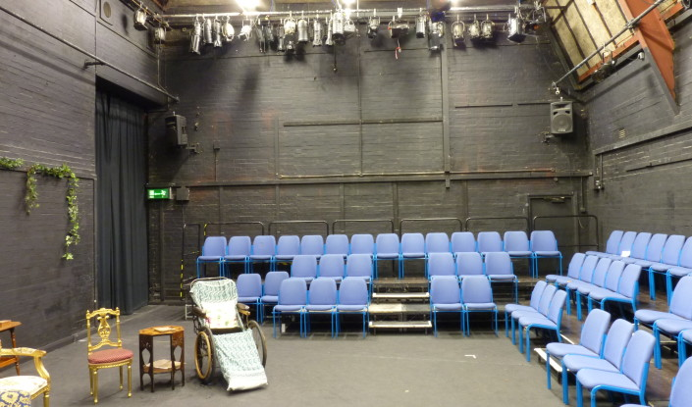
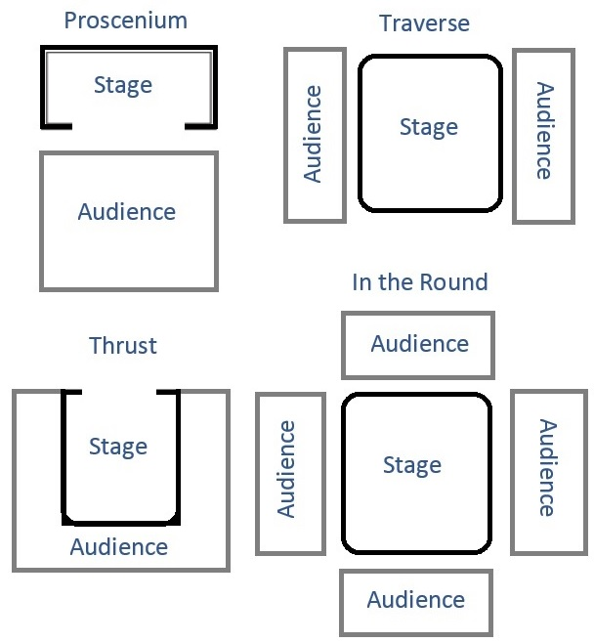
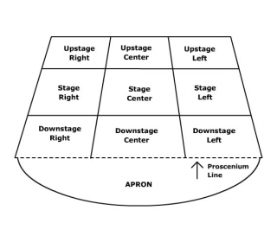
Stages

Above is a black box stage

- Section A- 3/5 minutes.
- Section B- 55 minutes
- Section C- 35 minutes
- Reading through 10 minutes
Section A- Four multiple choice questions.
Answer all of them!!!!
Stage positions
Remember it is always the actors
Left or right looking at the audience.

GCSE DRAMA REVISION

